1. What are escape characters, and how do you use them?

Ans1: To insert characters that are illegal in a string, use an escape character.An escape character is a backslash \ followed by the character you want to insert.

2. What do the escape characters n and t stand for?

Ans2: \n is newline and \t is tab

3. What is the way to include backslash characters in a string?

Ans3: The \\ escape character will represent a backslash character.

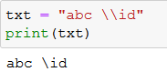

4. The string "Howl's Moving Castle" is a correct value. Why isn't the single quote character in the word Howl's not escaped a problem?

Ans4: The single quote in Howl's is fine because you’ve used double quotes to mark the beginning and end of the string.

5. How do you write a string of newlines if you don't want to use the n character?

Ans5: Multiline strings allow you to use newlines in strings without the \n escape character.

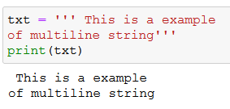

6. What are the values of the given expressions?

'Hello, world!'[1]

'Hello, world!'[0:5]

'Hello, world!'[:5]

'Hello, world!'[3:]

Ans:

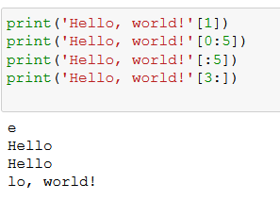

7. What are the values of the following expressions?

'Hello'.upper()

'Hello'.upper().isupper()

'Hello'.upper().lower()

Ans:7

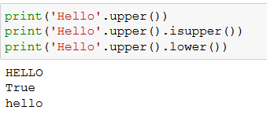

8. What are the values of the following expressions?

'Remember, remember, the fifth of July.'.split()

'-'.join('There can only one.'.split())

Ans8:

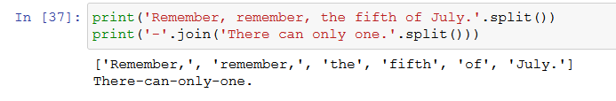

9. What are the methods for right-justifying, left-justifying, and centering a string?

Ans9: The rjust(), ljust(), and center() string methods, respectively

10. What is the best way to remove whitespace characters from the start or end?

Ans10: The lstrip() and rstrip() methods remove whitespace from the left and right ends of a string, respectively.