1. Is the Python Standard Library included with PyInputPlus?

Ans1: PyInputPlus is not a part of the Python Standard Library, so we must install it separately using Pip.

2. Why is PyInputPlus commonly imported with import pyinputplus as pypi?

Ans2: The as pyip code in the import statement saves us from typing pyinputplus each time we want to call a PyInputPlus function. Instead we can use the shorter pyip name

3. How do you distinguish between inputInt() and inputFloat()?

Ans: If the number has decimal it will be a float number and inputFloat() must be used for these type of input.

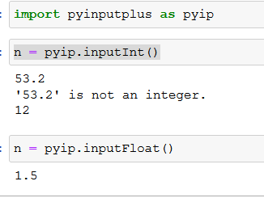

4. Using PyInputPlus, how do you ensure that the user enters a whole number between 0 and 99?

Ans4: The inputNum(), inputInt(), and inputFloat() functions, which accept int and float numbers, also have min, max, greaterThan, and lessThan keyword arguments for specifying a range of valid values.

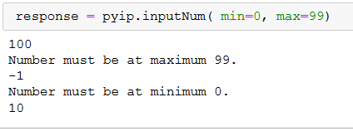

5. What is transferred to the keyword arguments allowRegexes and blockRegexes?

Ans5: The allowRegexes and blockRegexes keyword arguments take a list of regular expression strings to determine what the PyInputPlus function will accept or reject as valid input.

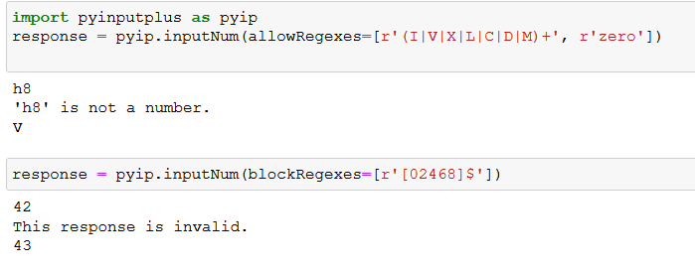

6. If a blank input is entered three times, what does inputStr(limit=3) do?

Ans6: In this case , ValidationException error will occur.

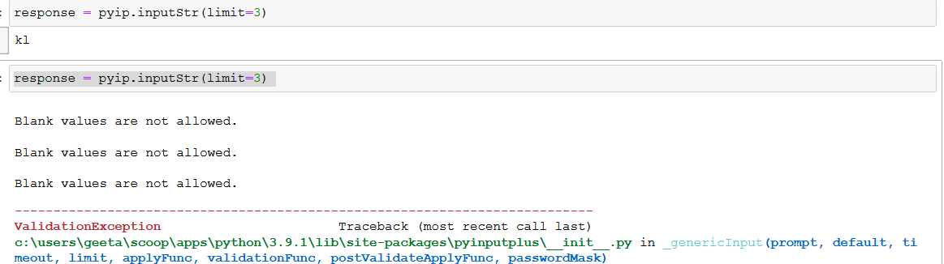

7. If blank input is entered three times, what does inputStr(limit=3, default='hello') do?

Ans7: ‘hello’ will be the output after prompting invalid input three times.

