< INTRODUCTION TO DATA MANAGEMENT>
(Project Semester January-April 2025)

(TITLE OF THE PROJECT)
Metal Content of Consumer Product Tested

Submitted by
(Geetanjali Jena) Registration No: 12318394
Programme and Section: Computer Science and Engineering(K23GW)
Course Code: INT217

Under the Guidance of (Mam Baljinder Kaur)

Discipline of CSE/IT
Lovely School of Computer Science and Engineering Lovely Professional University, Phagwara

DECLARATION

I hereby declare that this project titled “Metal Content of Consumer Product Tested” submitted for the subject of Microsoft Excel is my original work and has not been submitted earlier for the award of any degree or diploma. All the data used in this project has been taken from reliable sources and has been used only for academic purposes.

Signature:
Date:13-04-2025
Name: Geetanjali Jena

CERTIFICATE

This is to certify that the project titled “Metal Content of Consumer Product Tested” is a bonafide work completed by Geetanjali Jena under my guidance for the course requirements of Introduction to Data Management. The work is found to be satisfactory.

Signature of the Guide Name: Mam Baljinder Kaur Department of CSE
Institution Name: Lovely Professional University

ACKNOWLEDGEMENT

I extend my heartfelt thanks to MAM BALJINDER KAUR for her invaluable guidance and support throughout this project. The dataset, which includes detailed information on metal concentrations found in various consumer products, has been an essential resource for my analysis. It has enabled me to explore the presence of potentially hazardous metals, assess compliance with safety standards, and understand broader patterns across product categories.
I deeply appreciate the effort that went into compiling and providing access to this data. It has played a vital role in shaping the insights and conclusions of this project. My sincere gratitude goes out to everyone involved in the preparation and maintenance of this dataset, whose work has significantly contributed to the success of my research.

Geetanjali Jena
12318394
Computer Science and Engineering

Introduction

The “Metal Content of Consumer Products Tested” dataset presents a detailed compilation of laboratory-tested consumer goods, focusing on the presence and concentration of various metals such as lead and others that may pose potential health risks. This dataset is designed to support analytical exploration into the safety and regulatory compliance of everyday products across multiple countries and product categories.
The data includes critical fields such as metal type, concentration levels, product types (like cosmetics, dietary supplements and food items), country of manufacture, and purchase location. It offers a comprehensive view into the origin and safety status of products used globally, making it a valuable resource for quality control professionals, health and safety researchers, and regulatory bodies.
The interactive Excel dashboard developed for this project leverages pivot tables, slicers, bar and line charts, heatmaps, and pie charts to provide dynamic visual insights. Users can filter by product type, country, and metal concentration to identify patterns, detect outliers, and draw meaningful conclusions. This project demonstrates how conventional spreadsheet tools can be transformed into powerful instruments for public safety monitoring and product quality assurance.
Objective
The key objectives of this project are as follows:
- PRODUCT_TYPE– To analyze the distribution of different product types tested.
- METAL – To visualize the occurrence of different metals found in products.
- CONCENTRATION – To analyze the concentration levels of metals in products.
- MADE_IN_COUNTRY – To compare metal content based on the country of manufacture.
- INVESTIGATION TYPE – To see the distribution of different investigation categories.

Scope
The scope of the Metal Content of Consumer Products Tested project is defined by the diverse range of countries involved in product manufacturing and testing, as illustrated in the "Made in Country" chart. Countries such as India, China, Bangladesh, the United States, and Mexico are prominently featured, offering a global perspective on metal concentration in consumer goods. The analysis will focus on products manufactured in these countries, unless additional geographic data is integrated.
This project encompasses a broad spectrum of product types, including cosmetics, dietary supplements, food items, jewellery, and religious powders, as shown in the "Product Type" bar and slicer charts. Each category will be analysed for its metal content trends, enabling an in-depth understanding of product safety concerns across different consumer segments.
A key area of focus is the type and concentration of metals, with specific attention to hazardous substances such as Lead and other toxic metals, as represented in the "Product Type vs Concentration" chart. This includes evaluating both the average metal concentration and frequency of occurrence across products, identifying items with potential regulatory or health implications.
The scope further includes an analysis of investigation types, offering insights into the classification and purpose of testing (e.g., surveillance, compliance checks), as seen in the "Investigation Type" chart. This helps determine how testing is prioritized across product categories and regions.
Lastly, data segmentation and interactive visualization are integral to the project's scope. Tools like pivot charts, slicers, and pie graphs are used to explore key metrics, support dynamic filtering, and deliver clear, visual insights. These interactive elements allow for an intuitive exploration of complex data, transforming static figures into actionable intelligence for stakeholders.

Methodology

The project methodology is structured into the following phases:
- Data Collection
The dataset used in this project was obtained from a credible source and contains detailed information on the metal content found in various consumer products. Key attributes include product type, type of metal, metal concentration levels, manufacturing origin, and investigation types. The dataset reflects global coverage, incorporating data from multiple countries and product categories.
- Data Cleaning and Preparation
The raw data was reviewed for accuracy and completeness. Missing values were identified and addressed, inconsistent entries such as varying country or product names were standardized, and non-relevant fields were filtered out. This ensured the data was ready for pivot analysis and visual representation in Excel.
- Data Analysis Using Excel Tools
Microsoft Excel was employed as the primary analysis tool. Pivot tables were used to summarize data by product type, country, metal, and concentration. Slicers were added to allow dynamic filtering across charts, and calculated fields were used to derive metrics like average concentration. This enabled quick comparative analysis between various attributes.
- Visualization and Dashboard Development
A fully interactive dashboard was created using bar charts, pie charts, line plots, and 3D columns to depict relationships such as product type vs. concentration, country-wise distribution, and metal occurrence. Conditional formatting and visual cues were used to enhance readability and data-driven storytelling.
- Interpretation and Insight Generation
Final insights were derived from trends, outliers, and comparative metrics identified through the visualizations. These insights were then contextualized to inform discussions around product safety, regional compliance trends, and potential regulatory implications.

Source of Dataset
This data is from the Data.gov
And here is the link of the dataset: https://catalog.data.gov/dataset/metal-content-of-consumer-products-tested-by-the-nyc-health-department

LinkedIn:
https://www.linkedin.com/feed/update/urn:li:activity:7316784624909578240/

Key Columns:
- Product Type
- Metal
- Concentration
- Made in Country
- Purchase Location
- Investigation Type
- Product Name

Analysis on Dataset
Objective 1: PRODUCT TYPE VS CONCENTRATION
The bar chart compares the "Average of CONCENTRATION" (brown bar) and "Count of PRODUCT_TYPE" (yellow bar) for the metal "Lead." The average concentration is approximately 1.468888889, and the count is 9, both displayed on a y-axis ranging from 0 to 10. A dropdown menu for "METAL" suggests filtering by different metals is possible.
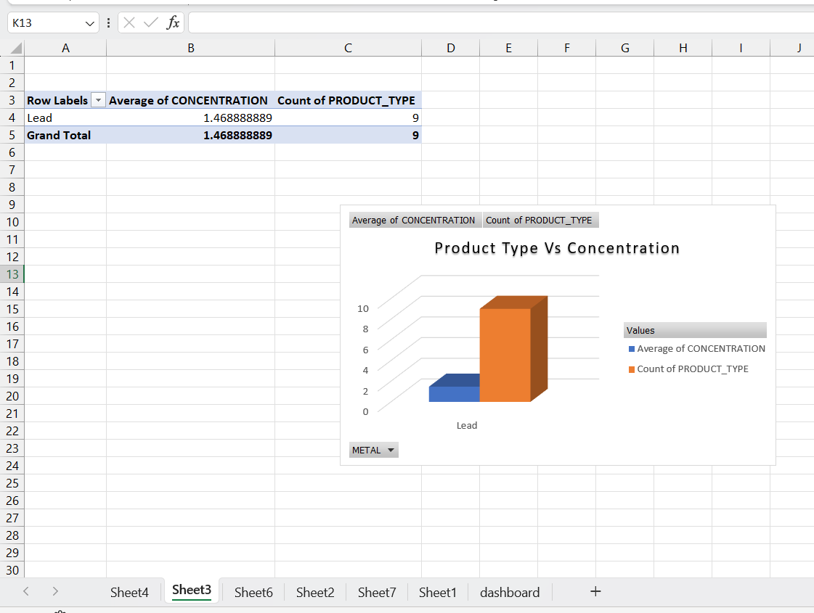
Objective 2: PRODUCT TYPE
The bar chart shows the count of "MADE_IN_COUNTRY" for the "Cosmetics" category, with a single yellow bar label "Total" reaching a value of approximately 8 on the y-axis (ranging from 0 to 10). An interactive dropdown menu for "PRODUCT_TYPE" suggests the ability to filter by different product types.
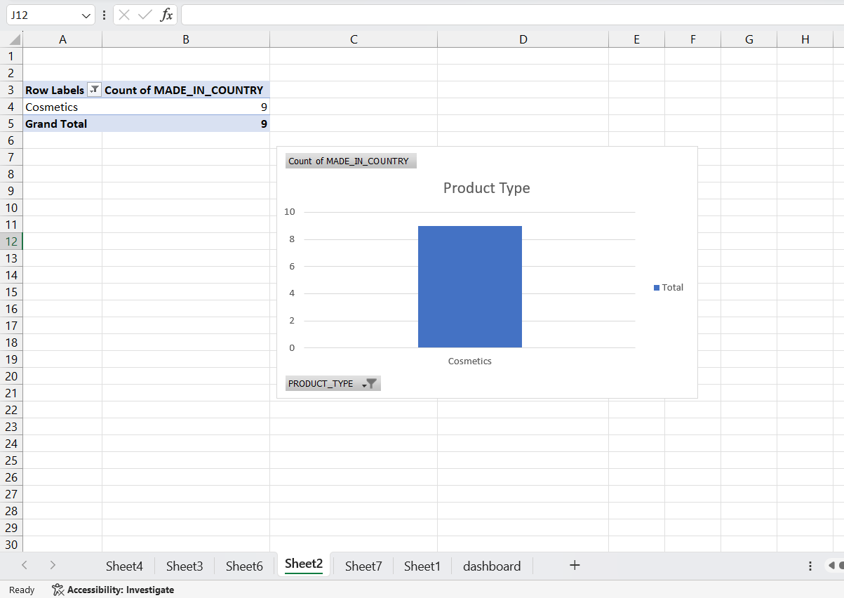

Objective 3: MANUFACTURER
The pie chart displays the count of "MANUFACTURER" categorized by "PURCHASE_COUNTRY." The chart includes three segments: Bangladesh (largest portion, light beige), Barbados (smaller yellow segment), and the United States (medium yellow segment). An interactive dropdown menu for "PURCHASE_COUNTRY" allows filtering by these countries.
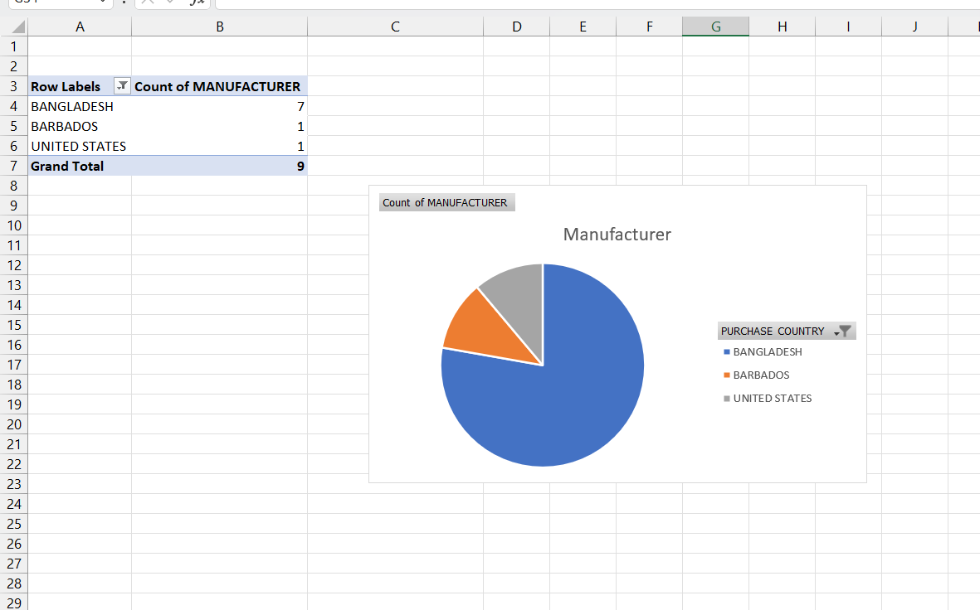

Objective 4: MADE IN COUNTRY
The line chart illustrates the count of "PRODUCT_TYPE" across various countries, with the y-axis ranging from 0 to 4000. India has the highest count, approximately 3500, while other countries like Bangladesh, China, Dominican Republic, Ecuador, Georgia, Mexico, Morocco, Pakistan, and the United States show counts around 500 or less. The chart includes an interactive dropdown menu for "MADE_IN_COUNTRY," enabling users to filter the data by specific countries.
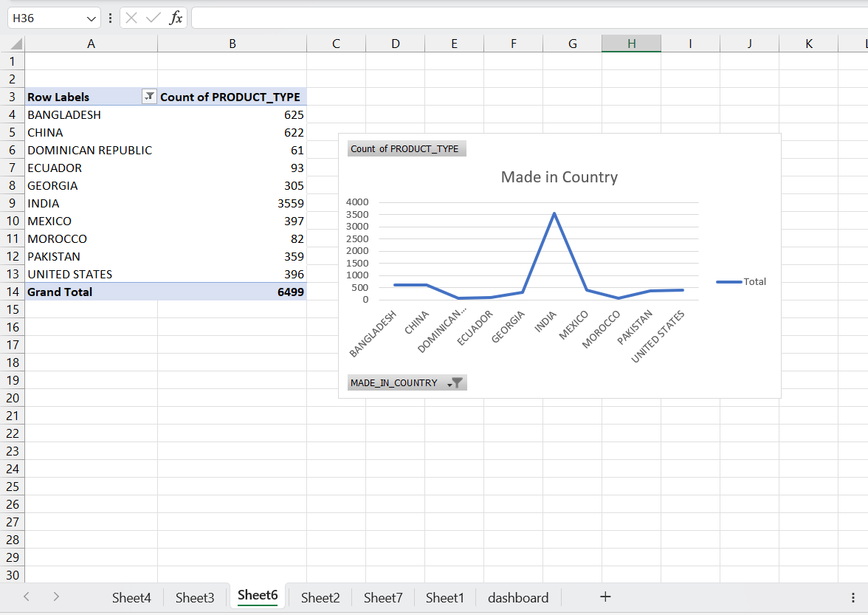
Objective 5: INVESTIGATION TYPE
The objective of the bar chart is to represent and compare the count of investigations on "METAL" across different investigation types and product types. The interactive dropdown menus suggest the goal is to allow users to select specific categories for a detailed analysis of investigation frequencies, with the current view showing a total count of 10 as a baseline or aggregate measure.
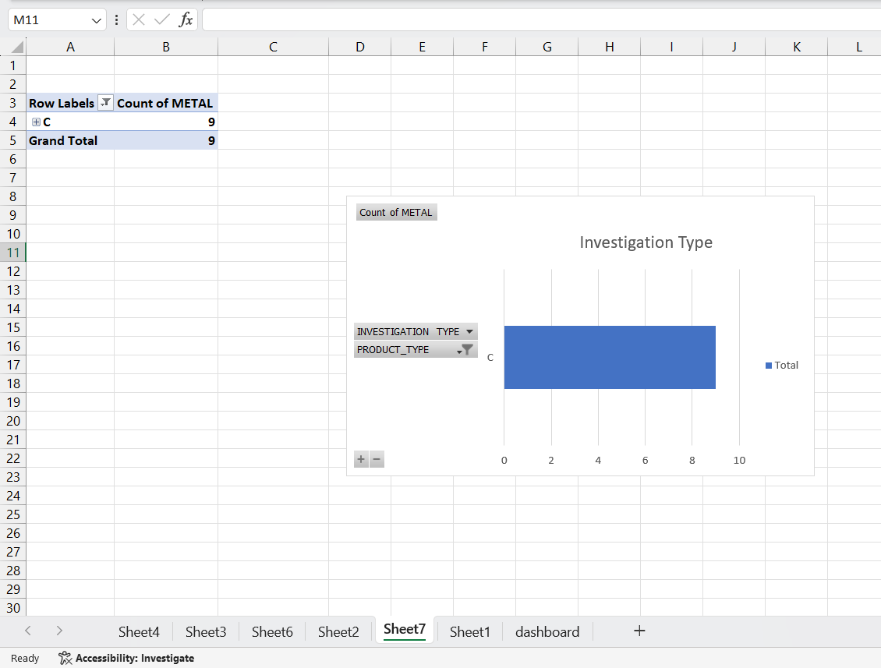

Final Dashboard:

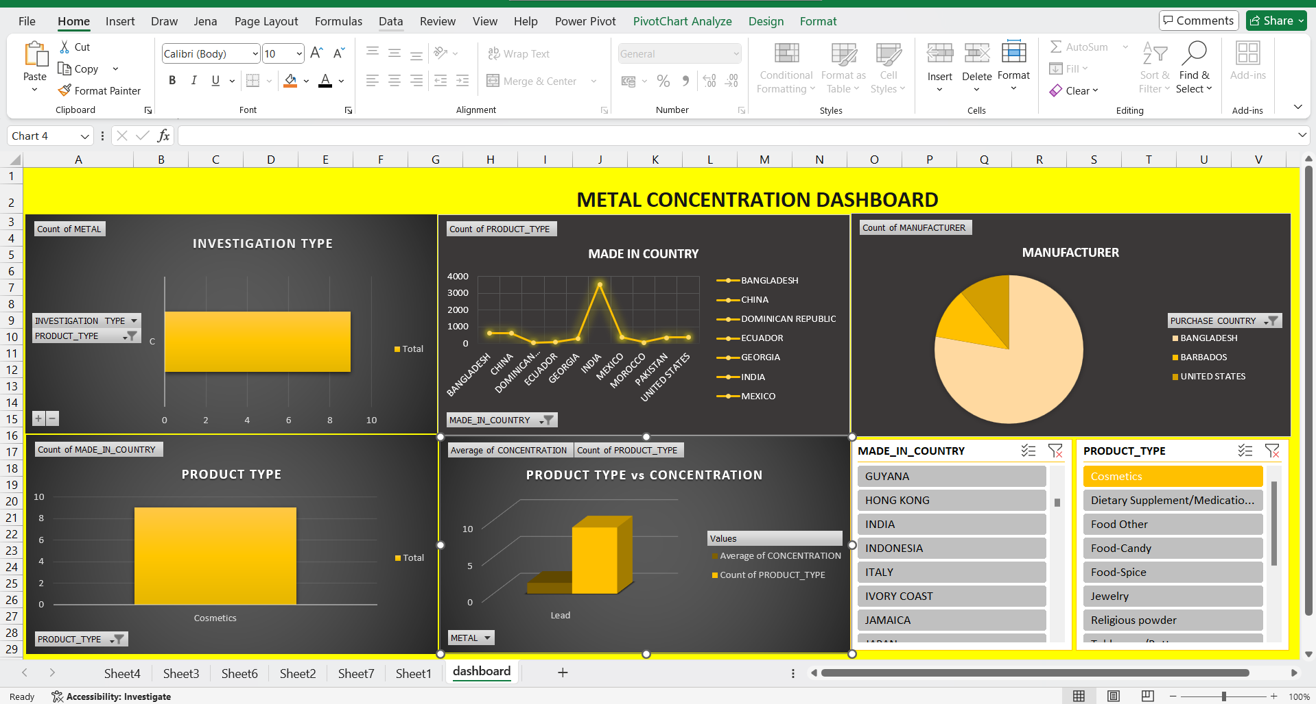
Screenshot of LINKEDIN:



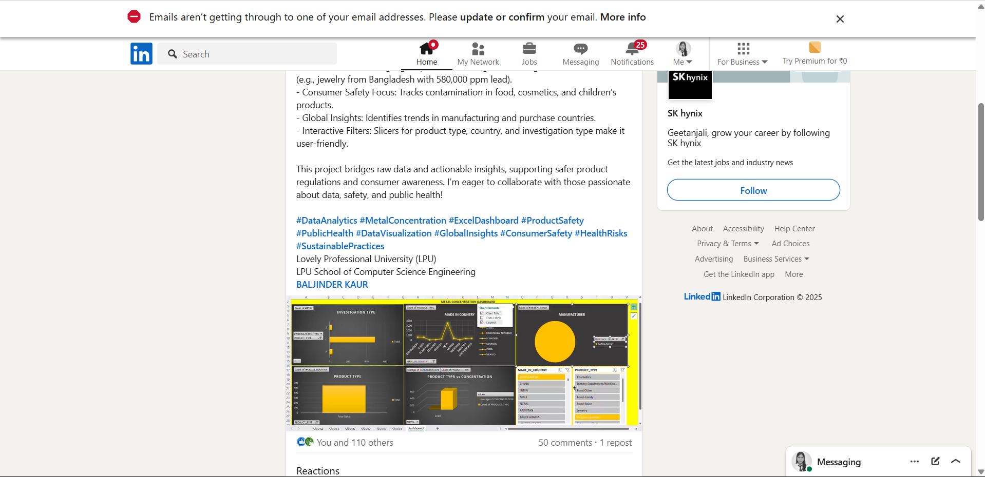

Conclusion

The analysis of the “Metal Content of Consumer Products” dataset provides crucial insights into the presence and distribution of potentially harmful metals in consumer goods. The breakdown of average concentrations and product counts for metals like Lead reveals areas of concern, particularly in widely used categories such as cosmetics. Significant variations across countries of manufacture and manufacturers underscore the need for more stringent global quality control and regulatory oversight.
The data also highlights key patterns in investigation types and purchase countries, reflecting how different regions respond to and are impacted by metal contamination. This comprehensive overview equips regulatory bodies, manufacturers, and consumers with the knowledge necessary to make informed decisions, promote safer production practices, and prioritize further investigations. Moreover, the findings suggest a continued need for regular testing and transparency in labelling to protect public health and reinforce trust in product safety.

Future Scope
The “Metal Content of Consumer Products Tested” dataset holds strong potential for deeper analysis and broader application. Future work could include more recent data to track trends over time and evaluate the impact of regulations. Expanding the dataset to include more metals, product categories, or geographic regions would provide a wider safety overview.
Integrating external data—such as health reports or global safety standards—could offer richer insights into potential risks. Predictive modelling could help identify high-risk products or manufacturers, supporting proactive regulation. Additionally, interactive dashboards could make the findings more accessible, aiding public awareness and informed decision-making.

References
- Microsoft Excel Documentation
- Official documentation and user guides provided by Microsoft for understanding the features and functionalities of Excel,
including advanced analysis tools like Power Query, Power Pivot, and data visualizations.
  - URL: https://support.microsoft.com/excel
- TutorialsPoint / W3Schools Excel Guide
  - Extensive guides and tutorials on Excel’s functionality, formulas, pivot tables, data analysis, and visualization techniques. Useful for beginners to advanced users seeking to leverage Excel for analytics.
  - URL: https://www.tutorialspoint.com/excel
  - URL: https://www.w3schools.com/excel
- Stack Overflow Discussions on Excel Analytics
  - A collection of relevant discussions and solutions regarding Excel’s capabilities in data analysis, including formula assistance, pivot tables, and dynamic data visualizations. This forum is an essential resource for resolving common issues encountered during Excel projects.
URL: https://stackoverflow.com/questions/tagged/excel

