First empirical study: Effect of class size on software maintainability
Group Assignment 1
BY
Group 4
Section 1 — Goal–Question–Metric (GQM) Definition
Objective
This is an empirical study to analyze the effect of class size on software maintainability in Java-based systems. The purpose is investigative, focusing on understanding whether larger classes tend to be less maintainable. This perspective is that of software engineers and researchers who want to assess maintainability by using objective software metrics derived from the Chidamber & Kemerer metric suite.
Question
How does class size, in terms of Lines of Code per class, relate to software maintainability as reflected by selected C&K metrics, namely Weighted Methods per Class and Coupling Between Objects?
Metrics
Three metrics were examined to answer this question:
Class Size (LOC):
Total number of lines of code in each class, with higher numbers indicating more complex classes that could also require more maintenance.
Weighted Methods per Class (WMC):
Reflects the sum of complexities of all methods within a class. It captures the internal class complexity. Coupling Between Objects (CBO): Measures the number of classes that a given class is dependent on. The higher the coupling, the lower the modularity and maintainability. This paper investigates whether larger classes tend to be more complex and tightly coupled, implying lower maintainability, by examining the correlations among these metrics.

Section 2 – Subject Programs
# | Project | GitHub URL | Contributors | Age (yrs) | Description
1 | advanced-java | https://github.com/doocs/advanced-java | 35+ | 7+ | Advanced Java concepts and interview prep material.
2 | guava | https://github.com/google/guava | 200+ | 15+ | Core Java libraries from Google for collections, caching, I/O, and concurrency.
3 | java-design-patterns | https://github.com/iluwatar/java-design-patterns | 268+ | 11+ | Implementations of software design patterns in Java.
4 | RxJava (3.x) | https://github.com/ReactiveX/RxJava | 270+ | 8+ | Reactive programming library for composing asynchronous Java code.
5 | spring-boot | https://github.com/spring-projects/spring-boot | 400+ | 10+ | Framework simplifying the creation of production-ready Spring-based applications.

Section 3 – Tool Used

For this empirical analysis, I utilized the CK (Chidamber & Kemerer) Metrics Tool, developed by Mauricio Aniche and publicly available on GitHub. The tool uses a static code analysis for Java source files and automatically calculates object-oriented metrics quantifying aspects of software design quality.

The CK tool provides the following detailed measurements for each class:

Lines of Code: This indicates class size, hence giving a preliminary measure for its complexity.

Weighted Methods per Class (WMC): The sum of the complexities of all methods in a class represents how complex or difficult the class is to maintain.

Coupling Between Objects (CBO): This is indicative of the reliance or dependency a class exhibits on other classes, thus detecting the major external interactions that could have an impact on modularity and maintainability.

This command analyzed the entire source code of each selected project and generated a CSV file (class.csv) containing metric values for all classes.

The results obtained from each tool were then pre- and post-processed and aggregated for the five chosen projects. By employing Python, correlation analysis was performed to calculate the statistical relationship of class size (LOC) with the maintainability indicators WMC and CBO.

Section 4 – Results and Analysis

Then, the CK tool was run on each of the projects: advanced-java, guava, java-design-patterns, RxJava, and spring-boot. Data from all projects were combined, cleaned, and analyzed. To understand the relationships between these metrics, the author used scatter and bar charts.

- scatter plots
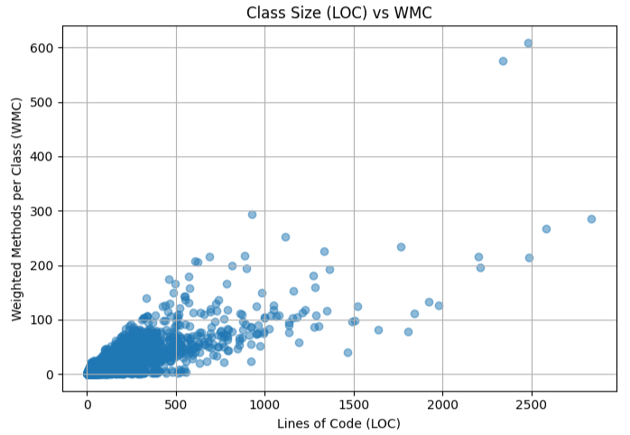
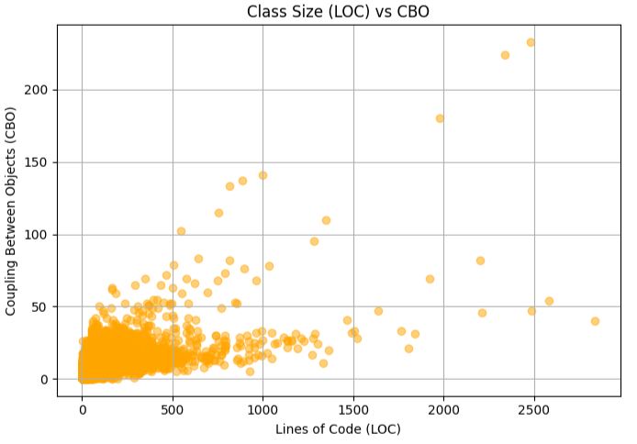
- Bar chart
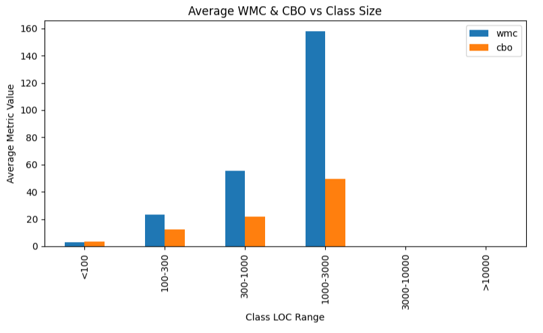
- The correlation values (from analysis_summary.csv)
LOC-WMC Correlation | LOC-CBO Correlation | Total Classes | Projects Analyzed
0.838295 | 0.643635 | 33614 | 5

Explanation:
The results show a strong positive correlation between class size (LOC) and WMC, and a moderate correlation with CBO. Larger classes tend to have more methods and higher coupling, indicating reduced maintainability.
Interpretation of Results:
There is a strong positive correlation (0.838) between LOC and WMC, suggesting that with the increase in class size, the number and complexity of methods also tend to rise. In practice, this means that larger classes are generally more complex and require greater maintenance effort.
The moderate correlation of 0.644 between LOC and CBO indicates that larger classes are also more coupled to other classes. High coupling reduces modularity and increases the risk of introducing bugs when changes are made.
These findings were supported by the scatter plots and bar charts, which showed distinct upward trends between LOC and the other two metrics. Taken together, this suggests that large classes not only have more internal logic but also are dependent on a greater number of external components, in each case possibly making maintenance more difficult.
Section 5 – Conclusions
This empirical study provides clear evidence that class size is a strong indicator of software maintainability in Java projects. The statistical and visual analysis have shown that larger classes exhibit:
Greater internal complexity, or higher WMC.
Greater coupling with other classes as determined by CBO.
Both factors are well-known contributors to poor maintainability, since they make the code more difficult to understand, modify, and test.
Key Takeaways:
Developers should periodically check on class size and refactor oversized classes into smaller, more cohesive units.
Automated tools, such as CK, enable teams to continuously measure and track maintainability-related metrics during the development process.
Projects that apply modular design and class size limitations tend to possess much better long-term maintainability, with less technical debt. This, therefore, supports the conclusion that the best practice in object-oriented software engineering involves having classes that are small in size, cohesive, and loosely coupled, since they directly support higher maintainability and code quality.

References
Chen, J. C., & Huang, S. J. (2009). An empirical analysis of the impact of software development problem factors on software maintainability. Journal of Systems and Software, 82(6), 981-992.
El Emam, K., Benlarbi, S., Goel, N., Melo, W., Lounis, H., & Rai, S. N. (2002). The optimal class size for object-oriented software. IEEE Transactions on software engineering, 28(5), 494-509.
Kemerer, C. F. (1995). Software complexity and software maintenance: A survey of empirical research. Annals of Software Engineering, 1(1), 1-22.
Github Link:
https://github.com/geetanjalikandi-gif/Group-Assignment-1.git

