STAGE-I- PROJECT REPORT

on

“Autonomous drone for disaster surveillance and alert system”

By

Abhilash Nayak 117A3001

Sujay Suresh Kadam 117A3019

Geeta Seshapalli 117A3049

UNDER THE GUIDANCE OF

**Prof. Bushra Shaikh**

SUBMITTED IN PARTIAL FULFILLMENT FOR THE DEGREE OF

BACHELOR OF ENGINEERING

In

Information Technology

**DEPARTMENT OF INFORMATION TECHNOLOGY**

**SIES GRADUATE SCHOOL OF TECHNOLOGY**

**NERUL, NAVI MUMBAI – 400706**

ACADEMIC YEAR

2020-2021

**CERTIFICATE**

This is to certify that this is a bonafide record of Project Stage-I of the project titled **“Autonomous drone for disaster surveillance and alert system”** carried out by the following students of final year in Information Technology.

Sr. No. Name Roll No.

1 Abhilash Nayak 117A3001

2 Sujay Suresh Kadam 117A3019

3 Geeta Seshapalli 117A3049

The report is submitted in partial fulfillment of the degree course of Bachelor of Engineering in Information Technology, of University of Mumbai during the academic year 2020-21.

**Internal Guide Head of Department Principal**

We have examined this report as per University requirements at SIES Graduate School of Technology, Nerul (E), Navi Mumbai on ____________.

**Name of External Examiner: ___________________________________________**

**Signature with Date: _____________________________**

**Name of Internal Examiner: ___________________________________________**

**Signature with Date: _____________________________**

**I: ABSTRACT**

Drones being capable of doing things that are not even remotely possible for a human have a major role to play in society. These unmanned aerial vehicles have endless applications in various fields such as photography, surveillance, farming and communication systems. These drones due to such extraordinary capabilities pose a serious threat to privacy of the general population. However in dire situations privacy is overtaken by safety and security in terms of priority. In this project the applications of unmanned aerial vehicles in the surveillance field are explored while walking the thin line between invasion of privacy and safety concerns. An autonomous drone with a camera module with an intelligent scene analysis model is used to automate the surveillance of vast areas in a single go while keeping maintenance cheap and operability easy. The primary focus would be to surveil the overall population for honoring the “social distancing protocols” and then supported on the results with a wider application in human behavior analysis is to be developed.

**II: ACKNOWLEDGEMENT**

We wish to express our deep sense of gratitude to thank our project guide Prof. Bushra Shaikh for providing timely assistance to our query and guidance. We take this opportunity to thank our HOD Dr. K. Lakshmisudha and Principal Dr. Atul Kemkar for their valuable guidance and immense support in providing all the necessary facilities.

We would also like to thank the entire faculty of the IT Department for their valuable ideas and timely assistance in this project. Last but not the least, we would also like to thank teaching and nonteaching staff members of our college for their support, in facilitating timely completion of this project.

**Project Team**

Abhilash Nayak 117A3001

Sujay Suresh Kadam 117A3019

Geeta Seshapalli 117A3049

**III: LIST OF FIGURES**

|  |  |  |
| --- | --- | --- |
| Fig No. | Description | Page No. |
| 1.0 | System Architecture | 14 |
| 2.0 | Scene Analysis Flowchart | 15 |
| 3.0 | Ground Station Control Application | 17 |
| 4.0 | Schematic Diagram | 18 |

**CONTENTS**

|  |  |  |
| --- | --- | --- |
| Sr.No. | Topic | Page No. |
| I | Abstract | I |
| II | Acknowledgement | II |
| III | List of Tables or Figures if any | III |
| Chapter 1 | Introduction | 7 |
| Chapter 2 | Need of Project | 8 |
| Chapter 3 | Literature Survey | 9 |
| Chapter 4 | Objective/Objectives | 13 |
| Chapter 5 | Methodology | 14 |
| Chapter 6 | Experimental/Modeling/Designing/ work breakdown structure/Gantt chart/ data collection etc. till date (up to end of Sem-VII) | 16 |
| Chapter 7 | Coding Results and Discussions | 17 |
| Chapter 8 | Conclusion | 20 |
|  | References (in chronological order) | 21 |

**CHAPTER NO. 1: INTRODUCTION**

The COVID-19, a global pandemic that caused more than 164,000 deaths and infected more than 2 million people worldwide, makes us rethink how governments, organizations, and societies around the world can work with minimum or without physical contact. These kinds of situations call for interception of various authorities, ultimately increasing the risk of spreading the virus i.e. by sending officials to analyze the situation. In some emergency situations this might not be possible (places of protest, mob gathering, lining at shops etc.) In these situations a portable and inexpensive solution is required to help maintain social distancing norms. This is where a fully autonomous drone with video transmission capabilities is required. Solutions available in the market are not inexpensive and are not modular at all.

Hence there is a need for a cheaper solution with necessary features Disaster Management is in a dire need of an Advanced System of Alert System that can solve problems quickly and efficiently. Advancement can be induced by engaging a synchronized & a distributed system of easy-to-use Drones specialized to detect the affected area. Using a range of sensors, we can bring efficiency to this process by Increasing Detection Accuracy significantly with digital and positioning back-up. These Drones are compact, consume low power and easy to use. These Drones are a moderate one-time investment and are meant to last 4-5 years.

**CHAPTER NO.2: NEED OF PROJECT**

An important policy for authorities across the globe right now is to prevent the spread of the virus. To ensure they are taking unprecedented measures to reduce people-to-people contact. Most countries took measures like the closure of non-essential public places, ban of mass gatherings and ensuring a social distancing to limit physical contact. Alternative is to develop a portable alternative to the manned aerial vehicle model with the ability to move autonomously through an unhindered landscape. To provide a cheap and flexible alternative compared to humans who are prone to the virus. Reduce human error using sophisticated artificial intelligence models and computer vision algorithms. Equip drone with HD Camera, RFI Antenna to perform diagnostic surveys of topology. Perform autonomous flight using maps of the system.

**CHAPTER NO.3: LITERATURE SURVEY**

The presented system helps to detect the affected area. A GPS module interacts with Server-side software and provides real-time location as well as receives the destination location.

Yuan Yuan [1], proposed Scene Recognition by Manifold Regularized Deep Learning Architecture, which is an improved multilayer learning model, which limits the model of the structure to single-layer learning. A deep architecture as a way of bettering the original deep learning by incorporating the geometrical structure of the data into the kernel space. It discusses next hidden space layers from the previous layer’s activities in this paper, this is defined as a basic unit. In each basic unit, a sparse weighted graph can be adaptively learned in the manifold kernel space. Whereas, the hidden space layer can preserve the clear structure of knowledge, and further improve the embedding. Hence, layer-by-layer deep learning architecture is efficient thanks to progressively reveal low-dimensional, nonlinear structures. Scene recognition, the process of categorizing images into different bins is a challenging problem that is of importance in the field of computer vision. It is helpful to reduce the gap between computers and humans when acquiring an under-standing for a scene.

Ali Al-Naji [2] on Life Signs Detector Using a Drone in Disaster Zones describes the aftermath of a disaster, such as earthquake, flood, or avalanche, ground search for survivors is usually hampered by unstable surfaces and difficult terrain. The aim of this study was to explore the utility of a drone equipped for human life detection with a completely unique computer vision system. The proposed system uses image sequences captured by a drone camera to remotely detect the cardiopulmonary motion caused by the periodic chest movement of survivors. The results of eight human subjects and one mannequin in several poses show that motion detection on the body surface of the survivors is probably going to be useful to detect life signs without any physical contact. The results presented during this study may cause a replacement approach to life detection and remote life sensing assessment of survivors.

Yo-Ping Huang [3] explains the Structure from Motion Technique for Scene Detection Using Autonomous Drone Navigation. A method is presented for scene detection and estimation using high-resolution imagery acquired through autonomous drone navigation aided with landmark detection and recognition. The proposed system comprises a drone platform that facilitates efficient autonomous flight; it can capture images and supply real-time video streaming of the bottom cover employing a camera equipped with a 14-megapixel CMOS sensor and a fish-eye lens. In addition, landmark detection and recognition was performed by applying the histogram of oriented gradients and linear support vector machine methods on each frame of the video stream.

The presented system helps to detect the affected area. A GPS module interacts with Server-side software and provides real-time location as well as receives the destination location. Arne Devos et al. in [4] proposed a method of operating and development of autonomous drones in real time using LiDAR-based obstacle avoidance drone systems. Along with its functionality of moving drones autonomously, they ensured the avoidance of obstacles in a complex environment. This paper is sectioned into two parts. In this methodology, 2 LiDAR sensors are placed on the front side of the drone. Whenever the drone detects any object within a distance of 20cm it produces raw sensory signals which are mapped into 2 parameters 1 and -1, here -1 means no obstacle within a mentioned range and 1 means there is an obstacle within a given specified range. This output is known as yaw value, which tells us about the obstacles which are found in the left or right direction. For instance, positive yaw value means there is an obstacle to its left so the drone steers to the right side and vice-versa. As a result, the drone navigates successfully in complex environments. An open-source flight controller is used, named PIXHAWK. It is an autopilot flight stack, which is used as a vehicle controller in hardware. Also interfacing of PIXHAWK with LiDAR Sensor is not complicated in fact it makes sure the drone doesn't hit with its propellers.

 In paper [5] proposed by Himadri Nath Saha et al. in which designing of low cost fully autonomous GPS based Quadcopter is described. This Quadcopter is designed to be used in disaster management where rescue operators are unable to reach that affected area. Night vision is used to obtain the data of the people who are stuck in those affected areas. Since cameras are used in this system live broadcasting of that area can be obtained and necessary actions can be taken by the rescue operation. This paper, mainly focuses on regions one that is onboard communication using a live broadcasting technique with UAV management and second is the establishment of the wireless drone. Also if there is any network disconnection issue, it can be solved with the help of Delay Tolerant Network using a data sorting mechanism and with the help of autonomous flight wireless nodes in which data deliveries are supported. In general DTN for the disaster system and AFW for acquiring data via wireless medium using charged batteries. In some situations there can be a very high saturation of the network, mounting of LTE femtocell base stations on drones to supply an alternative for the saturated existing wireless infrastructure is used. The only drawback here is, it requires a high battery voltage supply to operate this drone.

In order to overcome these problems Sunggoo Jung et.al [6] introduced the deep learning and Line of Sight (LOS) algorithm concept in this system. . LOS vector is used to obtain the navigation path from the starting point to the target destination. Therefore, this LOS vector is used to handle the decoupled quadrotor dynamics. In this system, the main target is to achieve the best performance in terms of navigation speed. AlexNet is a base network instead of the VGG-16 used in the original SSD mode for high navigation speed. Training data were collected using the rose bag function of the ROS using a fisheye camera mounted on the front of the quadrotor. The LOS guidance algorithm is formulated to lead the drone to fly through the gate center detected by the proposed deep learning network. Therefore, this algorithm can be extended to various scenarios such as search and rescue missions that require flying through windows, or avoiding falling debris, and other dynamic obstacles.

In [7] Parabjot Singh Sandhu discusses the dynamics of a quad motorized unmanned aerial vehicle. He discusses the types of aircraft, their weight with respect to air density, and how it affects the dynamics of the drone. It is further discussed what is the axis of movements in the drone i.e. roll, pitch, yaw, and elevation. Roll and pitch being the lateral and longitudinal rotation respectively while yaw is the rotation in the plane parallel to the ground. To control each of these axis a radio-controlled transmitter and receiver pair is used. By interpreting the PPM (pulse position modulated) signal the microcontroller controls the speed of respective motors and maneuvers the drone.

The fabrication and design process is discussed by Sandeep Khajure, Vaibhav Surwade, Vivek Badak in [8]. The drone is made using an X-Configuration i.e. the motors and frame of the drone are in an X formation, such that the arms of the drone are perpendicular to each-other and the axis of movements are 45° leading to each of the arms with a microcontroller as the origin. It is important to configure the motors to move in opposite directions being next to each other, this means that the consecutive motors should spin in opposite directions. This ensures that the yaw axis movement is counterbalanced and the drone is stable, otherwise the drone will drift in the direction opposite to the movement of the motors. This also allows us to configure the drone to move in the yaw axis by speeding up certain motors.

Andrew Gibiansky in his publicly available paper [9] explains the mathematical functions of the Proportional – Integral – Derivative (PID) feedback loop with the manual input from the radio control signal to control the drone. We know that the energy the motor expends during a given period of time is adequate to the force generated on the propeller times the space that the air it displaces moves (P · d t = F · d x). Equivalently, the facility is adequate to the thrust times the air velocity (P = F d x d t). P = Tvh we assume vehicle speeds are low, so vh is that the air velocity when hovering. We also assume that the free stream velocity, v∞, is zero (the air within the surrounding environment is stationary relative to the quadcopter). Momentum theory gives us the equation for hover velocity as a function of thrust, vh = s T 2ρA where ρ is the density of the surrounding air and A is that the area swept out by the rotor. Using our simplified equation for power, we can then write P = Kv Kt τω = KvKτ Kt Tω = T 3 2 p 2ρA. Note that within the general case, τ =~r × ~F; during this case, the torque is proportional to the thrust T by some constant ratio Kτ determined by the blade configuration and parameters. Solving for the thrust magnitude T, we obtain that thrust is proportional to the square of the angular velocity of the motor: T = KvKτ p 2ρA Kt ω!2 = kω 2 3 where k is some appropriately dimensioned constant. Summing over all the motors, we find that the total thrust on the quadcopter (in the body frame) is given by TB = 4 ∑ i=1 Ti = k*matrix [0 0 ∑ ωi2 ]. In addition to the thrust force, we’ll model friction as a force proportional to the linear velocity in each direction. This is a highly simplified view of fluid friction but are going to be sufficient for our modeling and simulation. Our global drag forces will be modeled by an additional force term FD = matrix [−kdx˙ −kdy˙ −kdz˙] If additional precision is desired, the constant kd can be separated into three separate friction constants, one for every direction of motion. These functions allow us to control thrusts in all directions to perform the desired maneuvers.

**Literature Summary -**

|  |  |  |  |
| --- | --- | --- | --- |
| **Sr. No** | **Authors** | **Title & Publication** | **Summary of Work** |
| **1** | Yuan Yuan, L. Mou and X. Lu | Scene Recognition by Manifold Regularized Deep Learning Architecture | Neural Networks and Learning Systems. Scene recognitions using regularized learning. |
| **2** | Prabhjot Singh Sandhu | Development of ISR for Quadcopter, International Journal of Research in Engineering Technology (IJRET), vol. 03, Issue 04, pp. 185-186, April 2014. | Physical control of the body of the quad-copter |
| **3** | Sandeeep Khajure, Vaibhav Surwade, Vivek Badak | Quadcopter Design and Fabrication, International Advance Research Journal in Science, Engineering and Technology (IARJSET), vol. 3, Issue 2, February 2016 | Mathematical functions required to control the quad-copter |
| **4** | Andrew Gibiansky | Quadcopter Dynamics, Simulation, and Control, January 26,2010. | Mathematical functions required to control the quad-copter |
| **5** | L. Apvrille, T. Tanzi and J. Dugelay | Autonomous drones for assisting rescue services within the context of natural disasters, 2014 XXXIth URSI General Assembly and Scientific Symposium (URSI GASS), Beijing, 2014 | Need for autonomy of drones in emergency |
| **6** | H. Saha et al. | A low cost fully autonomous GPS (Global Positioning System) based quad copter for disaster management, 2018 IEEE 8th Annual Computing and Communication Workshop and Conference (CCWC), Las Vegas, NV, 2018 | Use of Global Positioning system in  Autonomous drones |
| **7** | S. Jung, S. Hwang, H. Shin and D. H. Shim | Scene Recognition by Manifold Regularized Deep Learning Architecture, in IEEE Transactions on Neural Networks and Learning Systems, vol. 26, no. 10, pp. 2222-2233, Oct. 2015 | Using computer vision to process camera feed and use it to avoid collusion with objects during flight. |
| **8** | Y. Yuan, L. Mou and X. Lu | Scene Recognition by Manifold Regularized Deep Learning Architecture, in IEEE Transactions on Neural Networks and Learning Systems, vol. 26, no. 10, pp. 2222-2233, Oct. 2015 | Scene recognitions using regularized learning. |
| **9** | Andrew Gibiansky | Quadcopter Dynamics, Simulation, and Control andrew.gibiansky.com | PID contro’s mathematical functions. |

**CHAPTER NO.4: OBJECTIVES**

The main objectives of the project are mentioned below:

* To develop a fully functional Quad copter with the ability to move autonomously through an unhindered landscape.
* To provide a cheap and flexible alternative to manned aerial vehicles that cannot reach the cramped area due to size constraints.
* Reduce human error using sophisticated artificial intelligence models and computer vision algorithms.
* Equip drones with HD Camera, RFI Antenna to perform diagnostic surveys of disaster struck areas or places with uncontrolled crowds. Perform autonomous flight using maps of the system.
* Train the neural network to detect humans in a close range violating social distancing and alert them and the authority. If the pattern is continued by the tagged person to ensure safety.
* Design an application which records and analyses the footage sent by the drone and carries out alert operations intelligently.

**CHAPTER NO.5: METHODOLOGY**

There are two independent systems working in cohesion to provide a smooth operational experience and accurate predictions at the same time. These systems are discussed below:

1. Autonomous Drone System (Hardware) –

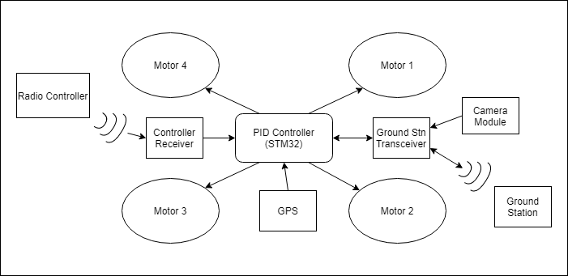

Fig.1.0 Hardware Architecture.

Process Flow:

* The Controller transmits a PPM signal through radio waves and is received at the receiver.
* This loop continues till the user inputs into the remote controller.
* The GPS module provides coordinates to the microcontroller and another set of coordinates i.e. the destination is provided by the ground station transceiver.
* The camera module sends serial data to the ground station through the same transceiver.
* All the inputs are processed in the microcontroller and produces an output in the form of motor speed control such that the drone reaches the desired location.

1. The Real-time scene analysis model (Software) -

Flowchart for real-time analysis:

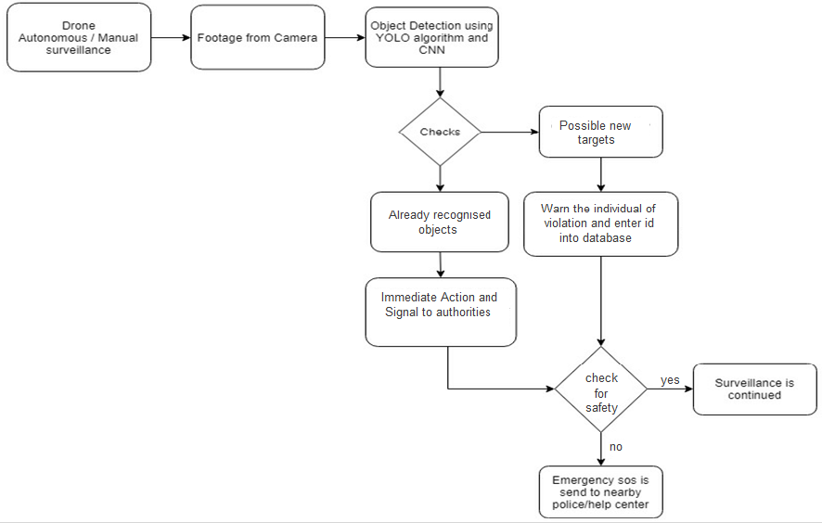

Fig 2.0 Scene Analysis Flowchart

Process Flow:

* The drone is set for surveillance which can be done manually or set to autonomous mode.
* All the footage captured from drone cameras are being monitored on a station computer which uses object detection mechanism and YOLO framework for scene recognition to calculate distance between subjects using Euclidean distance formula.
* If the situation is resolved ensuring safety of individuals the surveillance is continued to another location else it captures the image of the individual and reports it to the base station.

**CHAPTER NO.6: MODELING**

* The ground station desktop application is ready with the front end. It displays a map of the current coordinates and all the telemetric data related to drone
* This application also acts as a remote control and monitoring application using radio transmitters to transmit signals. It also acts as a command station to pass various safety features.
* The application is designed in C# as it has identical modules used in Embedded C for programming the microcontroller.
* C# the environment is object oriented hence it helps in processing the data related to multiple objects parallelly providing seamless experience.
* The prototype model of the drone is complete with partial hardware implementation. The design is made up of four arms with a central plate which holds everything together.
* The drone is configured in ‘X’ orientation such that the front face of the drone is the two motor holding arms.

**CHAPTER NO.7: CODING RESULTS AND DISCUSSIONS**

* Software implementation is completed for the ground station application. It provides essential information related to the drone and acts as a command station.
* The front end is as shown below:

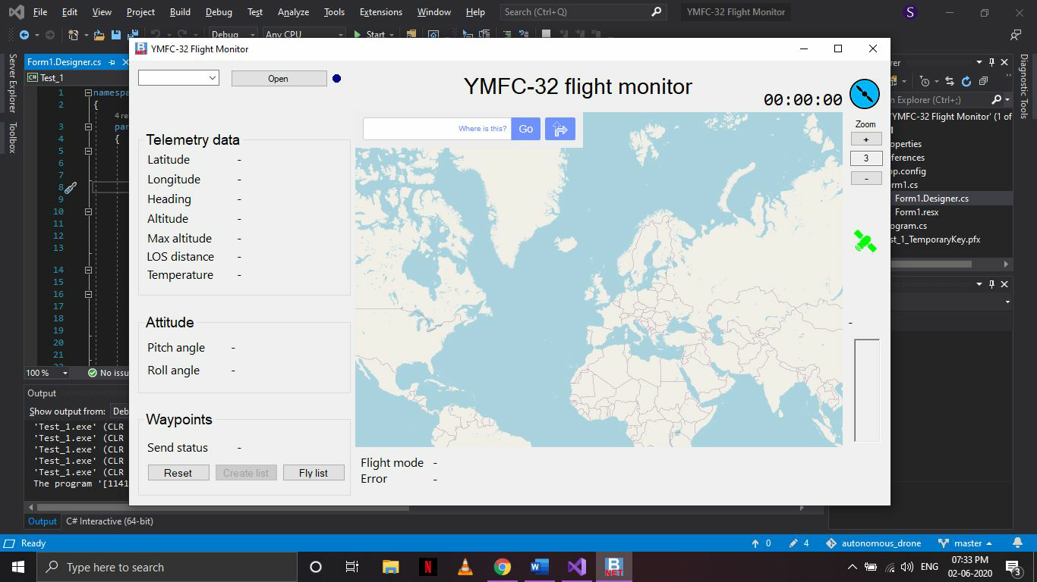

Fig. 3.0 Ground Station Control Application.

* This is a single frame application with a partially implemented backend.
* This application controls the drone from a remote location within a given range. Using radio frequency it communicates with the drone to send commands and receive telemetry data.
* This application also shows the information of the drone ie, its GPS coordinates and position on a map, distance travelled, total time of flight, waypoints to travel and other vital information like battery voltage and satellites in view are also displayed.
* The application acts as a guidance system for the drone to pass the waypoint coordinates and real time location of the drone.
* The application also implements failsafe functions such as return to home location if the signal is lost for a certain amount of time.
* Source code can be found at this repository <https://github.com/sujaykadam/autonomous_drone>
* Hardware implementation is completely done and the schematic diagram is shown below:

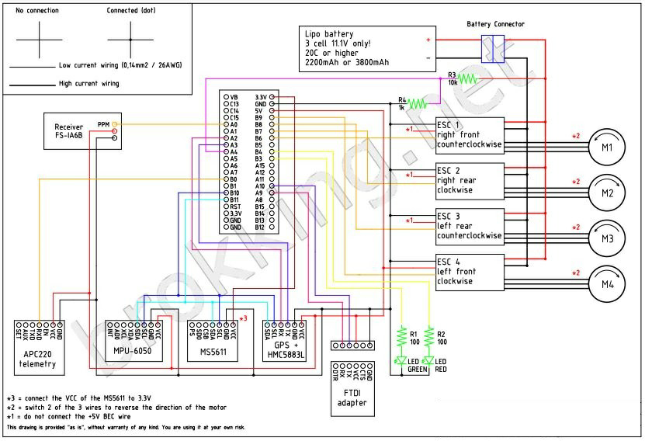

Fig 4.0 Schematic Diagram[10]

* Real hardware implementation is also complete according to the above shown schematic diagram.
* Datasets for training the machine learning models were collected for aerial scene analytics.
* YOLO framework was used to implement a Darknet model (a neural network) to perform specific video analysis.
* The model detects the number of people in a given frame of the video. To achieve this a RCNN network is used to detect all the possible objects in the frame and then a CNN is fed all the objects and it decides whether the fed object is a human subject or not.
* OpenCV is used to draw a bounding box around the human subjects and distance between each of the humans is measured using a Euclidean distance between the centroids of the bounding boxes.
* The program performs thousands of calculations in each given frame in order to generate a usable output. To keep the output video smooth to the human eye it has to happen at least 24 times per second.
* In order to achieve the target frame processing time, the algorithm makes use of a parallel processing paradigm using the systems GPU which provides better performance.
* However, this alone does not solve the frame time problem. The amount of processing done per frame was also reduced at the cost of some accuracy.
* This resulted in 30 FPS for a HD (720p) feed and 21 FPS for a Full HD (1080p) video feed

**CHAPTER NO.8: CONCLUSION**

The architecture of the drone is completed. We researched about the Autonomous feature and Scene recognition techniques through various IEEE papers. Complete hardware implementation was achieved along with software implementation as discussed in the report. The drone successfully achieved a controlled flight with manual control and basic functions through ground station application. Work on a basic object detection neural network using YOLO and Darknet framework and parallel processing utilizing the system GPU in python is completed with a smooth video output. Goals set for the phase in 7th semester were achieved and related research is completed.

**REFERENCES**

 [1] Y. Yuan, L. Mou and X. Lu, "Scene Recognition by Manifold Regularized Deep Learning Architecture," in *IEEE Transactions on Neural Networks and Learning Systems*, vol. 26, no. 10, pp. 2222-2233, Oct. 2015, doi: 10.1109/TNNLS.2014.2359471.

[2] Al-Naji, A.; Perera, A.G.; Mohammed, S.L.; Chahl, J. Life Signs Detector Using a Drone in Disaster Zones. *Remote Sens.* **2019**, *11*, 2441.

[3] Y. Huang, L. Sithole and T. Lee, "Structure From Motion Technique for Scene Detection Using Autonomous Drone Navigation," in *IEEE Transactions on Systems, Man, and Cybernetics: Systems*, vol. 49, no. 12, pp. 2559-2570, Dec. 2019, doi: 10.1109/TSMC.2017.2745419.

[4] A. Devos, E. Ebeid and P. Manoonpong, "Development of Autonomous Drones for Adaptive Obstacle Avoidance in Real World Environments," *2018 21st Euromicro Conference on Digital System Design (DSD)*, Prague, 2018, pp. 707-710, doi: 10.1109/DSD.2018.00009.

[5] H. Saha *et al*., "A low cost fully autonomous GPS (Global Positioning System) based quad copter for disaster management," *2018 IEEE 8th Annual Computing and Communication Workshop and Conference (CCWC)*, Las Vegas, NV, 2018, pp. 654-660, doi: 10.1109/CCWC.2018.8301782.

[6] S. Jung, S. Hwang, H. Shin and D. H. Shim, "Perception, Guidance, and Navigation for Indoor Autonomous Drone Racing Using Deep Learning," in *IEEE Robotics and Automation Letters*, vol. 3, no. 3, pp. 2539-2544, July 2018, doi: 10.1109/LRA.2018.2808368.

[7] Sandhu, Prabhjot. (2014). DEVELOPMENT OF ISR FOR QUADCOPTER. International Journal of Research in Engineering and Technology. 03. 181-189. 10.15623/ijret.2014.0304033.

[8] Sandeeep Khajure; Vaibhav Surwade; Vivek Badak Quadcopter Design and Fabrication International Advanced Research Journal in Science, Engineering and Technology Vol. 3, Issue 2, February 2016

[9] Andrew Gibiansky Quadcopter Dynamics, Simulation, and Control andrew.gibiansky.com

[10] <http://www.brokking.net/YMFC-32/YMFC-32_schematic.pdf>