After building the image for a credit_score_predictor dataset-

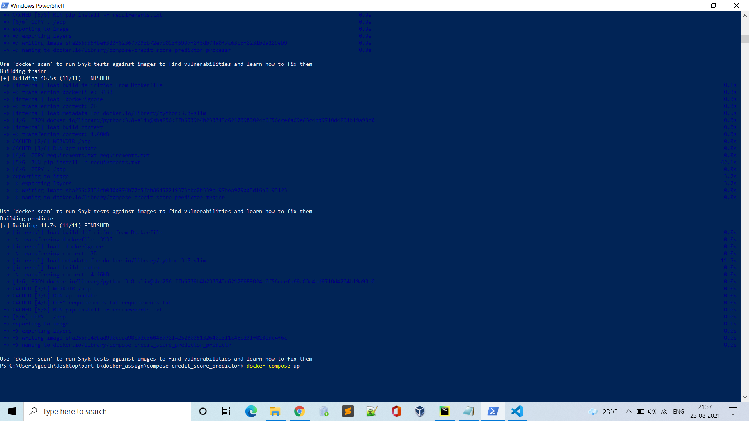

Tested all API’s responses are working-

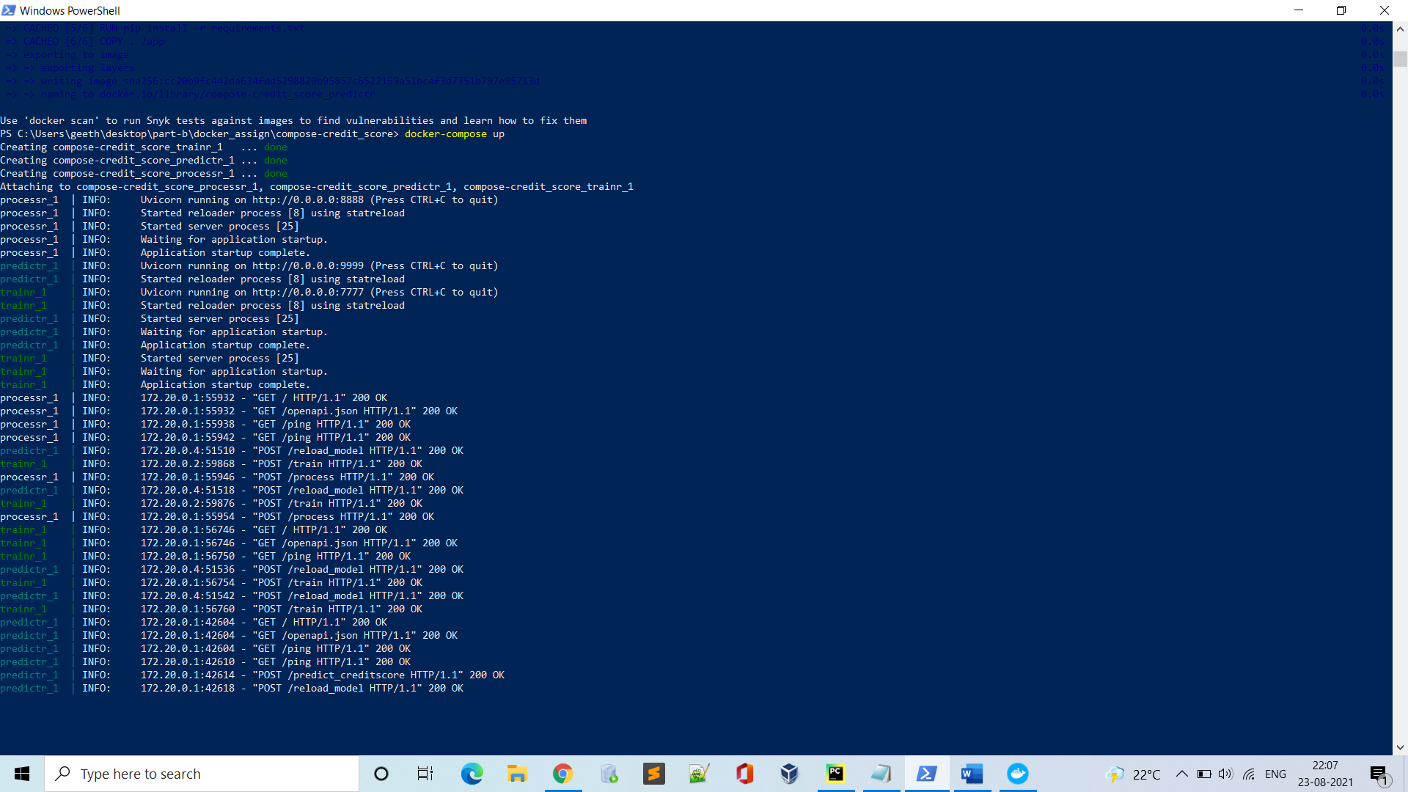

Created the 3 images successfully for credit_score data set-

