Employee

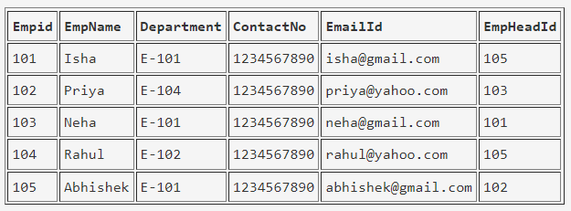

EmployeeDept

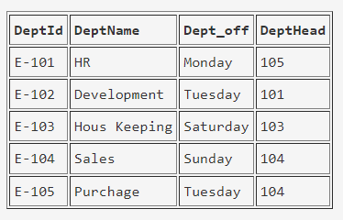

EmployeeSalary

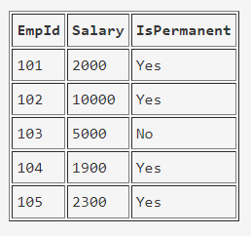

Project

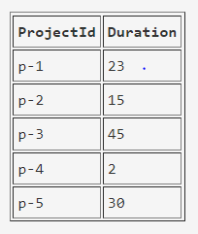

County

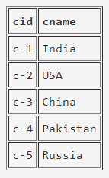

ClientTable

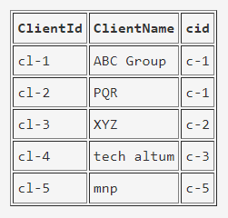

EmployeeProject

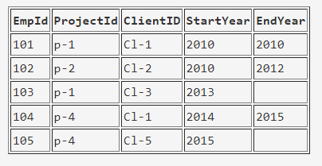

Select the detail of the employee whose name start with P.

### How many permanent candidate take salary more than 5000.

### Select the detail of employee whose emailId is in gmail.

### Select the details of the employee who work either for department E-104 or E-102.

### List name of all employees whose name ends with a.

### Select the department name of the company which is assigned to the employee whose employee id is grater 103.

### Select the name of the employee who is working under Abhishek.

### Select the employee whose department off is Monday