Error 404

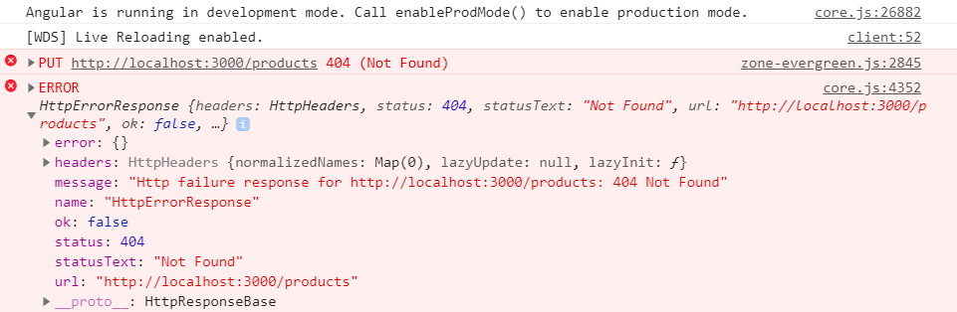

1)The url what you mentioned Is not working as you are using your own JSON server for practice for the Put call.

https://airbrake.io/blog/http-errors/404-not-found-error