We know karma test runner by using the jasmine frame work and the results we can see in chrome as we set chrome as the browser and we can see the same results in cmd also.

There is one mocha report and is looking nice to see the karma test runner results so that we can use this mocha reporter to see the report are good looking.

Install the mocha reporter in your project first

🡪1)npm install karma-mocha-reporter –save-dev

2) go to the karma.config.js file

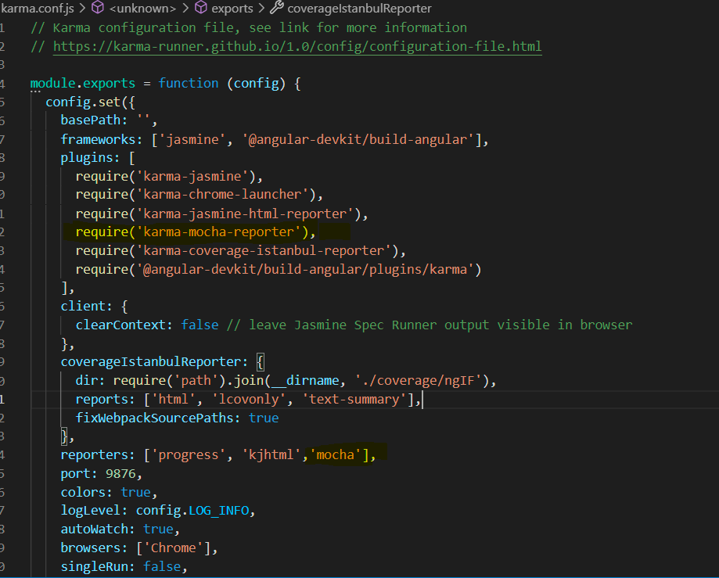

From the above figure at he plugns I added the require( karma-mocha-reporter)

Under reporters[ ‘mocha’] added successfully

3)open CMd

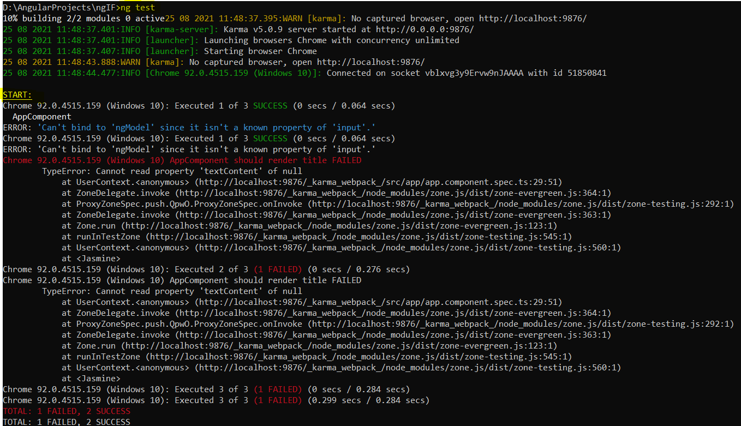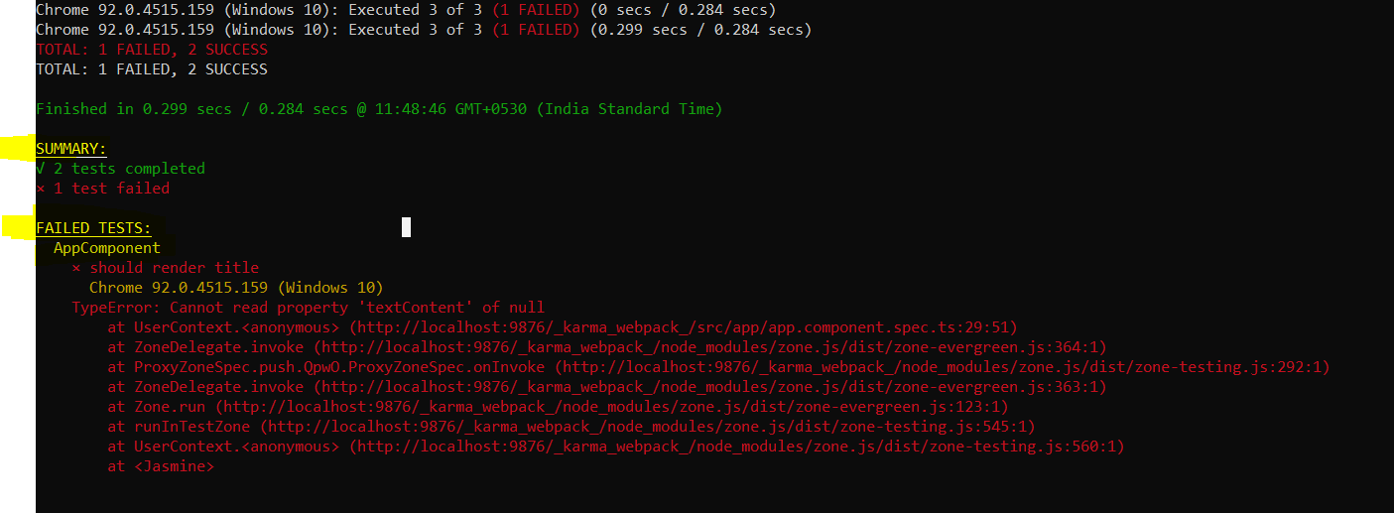

From the above report we can see the START, SUMMERY, FAILED TESTS clearly and looks good fore this kind of clear and more understandable report we installed the MOCHA reporter in angular projects.