**Project: Covid Vaccines Analysis**

**Empathize and Understand the Problem:**

- Understanding the significance of analyzing COVID-19 vaccine data in a specific region.

- Identify the key challenges and concerns related to vaccine distribution, effectiveness, and public perception.

- Gather insights from healthcare experts, public health authorities, and individuals receiving or hesitant about vaccines.

**Defining Clear Objectives:**

Objective 1: Analyze historical COVID-19 vaccination data to identify vaccination trends and patterns.

Objective 2: Identify regions or vaccination centers with consistently high or low vaccination rates.

Objective 3: Develop a predictive model to estimate vaccine coverage based on demographics and vaccine type.

**Ideation and Analysis Approach:**

- Data Collection: Identify sources of COVID-19 vaccine data, which may include government health agencies, vaccination centers, and research institutions.

- Data Pre-processing: Clean and preprocess the data, addressing missing values, outliers, and data quality issues.

- Data Analysis: Utilize statistical analysis and visualization techniques to uncover trends and patterns in vaccination data.

- Vaccination Rate Hotspot Detection: Develop criteria or algorithms to identify areas with consistently high or low vaccination rates.

- Predictive Modeling: Select suitable machine learning algorithms to build predictive models for vaccine coverage.

- Evaluation: Define evaluation metrics to assess the performance of predictive models.

**Prototype and Visualization Selection:**

- Utilize data visualization libraries like Matplotlib, Seaborn, or Plotly for visualizations.

- Use line charts to illustrate vaccination trends over time.

- Heatmaps or geographical maps to pinpoint regions with varying vaccination rates.

- Scatter plots or regression plots to visualize relationships between demographics and vaccine coverage.

**Build and Implement:**

- Develop the full data analysis and visualization pipeline based on the refined approach.

**Test and Iterate:**

- Continuously test and refine the analysis and visualization based on feedback and new insights.

**Deliver Insights:**

- Present findings and insights in a clear and understandable manner.

- Use visualizations to communicate vaccination trends, hotspot areas, and the predictive model's performance.

- Address public concerns and contribute to informed decision-making regarding COVID-19 vaccination strategies.

This adapted approach will enable you to analyze COVID-19 vaccine data effectively and provide valuable insights for public health efforts.

**INNOVATION:**

Designing an innovation for COVID vaccine analysis is a multi-step process that involves careful planning, development, testing, and implementation. Here's a detailed overview of the steps to transform your design into a practical solution for COVID vaccine analysis:

1. **Clarify Objectives:** Clearly define the objectives of your innovation. What problem does it aim to solve in COVID vaccine analysis? Is it improving efficacy, safety monitoring, or distribution?
2. **Concept Development:** Begin by brainstorming and refining your design concept. Consider all aspects, including the technology, data analysis, and tools involved.
3. **Feasibility Study:** Assess the feasibility of your innovation. What resources will be required, and do they align with your available budget and time frame? Investigate any legal or regulatory requirements.
4. **Prototype Creation:** Develop a prototype of your innovation. Depending on your design, this could be software, hardware, or a combination of both. The prototype should demonstrate how your solution works.
5. **Data and Technology Integration:** Identify the data sources and technology components required for your innovation. Consider how data will be collected, stored, and analyzed.
6. **Testing and Validation:** Conduct rigorous testing to ensure your innovation works as intended. Test for accuracy, efficiency, and reliability. Validate your results against existing methods or data.
7. **Iterative Improvement:** Based on the test results, make necessary improvements to your innovation. This might involve refining algorithms, improving user interfaces, or enhancing data collection methods.
8. **Regulatory Compliance:** If your innovation is intended for use in clinical settings or for regulatory purposes, ensure it complies with relevant standards and regulations. Seek approvals or certifications if necessary.
9. **Data Security and Privacy:** Implement robust data security and privacy measures to protect sensitive information. Encryption, access controls, and anonymization of data may be necessary.
10. **Scalability Planning**: Consider how your innovation will scale as the demand for COVID vaccine analysis grows. This might involve optimizing software for large datasets or manufacturing more hardware components.
11. **User Training and Documentation:** Develop user manuals and provide training for individuals who will operate or interact with your innovation. Ensure it is user-friendly and accessible to a wide range of users.
12. **Deployment Strategy:** Plan the deployment of your innovation. Will it be a web-based platform, a mobile app, or integrated into existing systems? Develop a rollout strategy that minimizes disruptions.
13. **Monitoring and Maintenance:** Establish a system for ongoing monitoring and maintenance. Regularly update and maintain your innovation to ensure it remains effective and secure.
14. **Data Analysis and Reporting:** Develop comprehensive data analysis tools and reporting features within your innovation to help users interpret the results of COVID vaccine analysis.
15. **User Feedback and Improvement:** Continuously gather feedback from users to identify areas of improvement. Use this feedback to enhance the performance and usability of your innovation.
16. **Documentation and Knowledge Sharing:** Create detailed documentation that outlines the design, development, and implementation of your innovation. This knowledge can be crucial for future updates or troubleshooting.
17. **Communication and Public Awareness:** Promote your innovation and its benefits through appropriate channels, including scientific publications, conferences, and collaborations with relevant organizations.
18. **Sustainability and Future Developments:** Plan for the sustainability of your innovation, considering future developments and advancements in COVID vaccine analysis.

**Loading and Pre-processing of data:**

from google.colab import drive

drive.mount('/content/drive/')

**Loading data:**

import numpy as np

import pandas as pd

import matplotlib.pyplot as plt

import seaborn as sns

from sklearn.preprocessing import LabelEncoder

from sklearn.preprocessing import StandardScaler

from sklearn.model_selection import train_test_split

from sklearn.linear_model import LinearRegression

from sklearn.preprocessing import PolynomialFeatures

from sklearn import metrics

from sklearn.metrics import mean_squared_error

from sklearn.metrics import r2_score

from sklearn.tree import DecisionTreeRegressor

import xgboost as xgb

from sklearn.cluster import KMeans

from sklearn.model_selection import cross_val_score, KFold

cov19=pd.read_csv('/content/drive/MyDrive/dataset/country_vaccinations.csv')

cov19

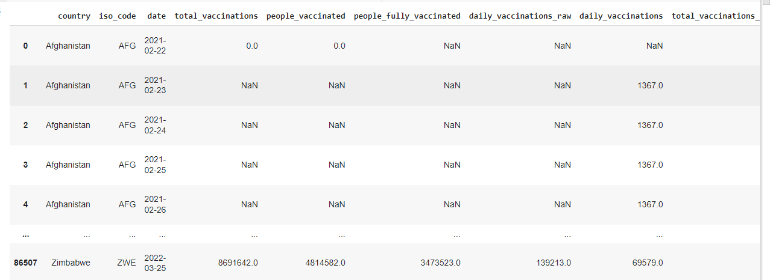

cov19.describe()

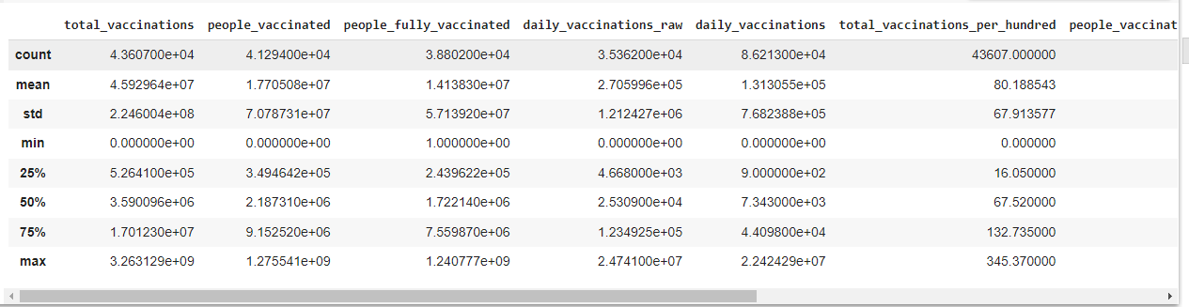

This command is used to view the brief summary of the dataset. We can see the mathematical parameters such as percentiles, standard deviation , mean, minimum and maximum values and count of each column.

cov19.info()

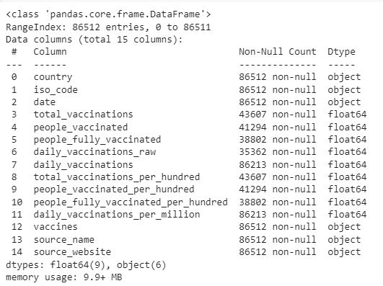

Info command is used check the datatype of every column and the count of each column. The difference between the describe() and info() is that describe command will give the mathematical parameters but info command will not give the mathematical parameters such as mean and standard deviation

**Data Preprocessing:**

cov19.isnull().sum()

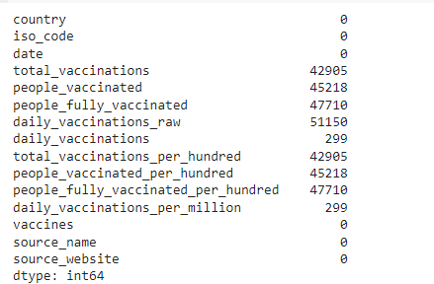

cov19_fillna = cov19

cov19_fillna

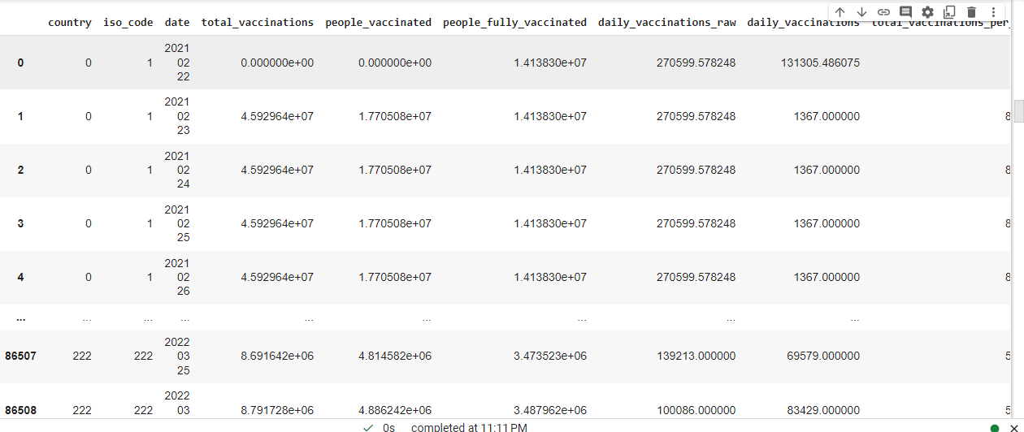

cov19_fillna.fillna(cov19_fillna.mean(), inplace=True)

# count the number of NaN values in each column

print(cov19_fillna.isnull().sum())

cov19_fillna

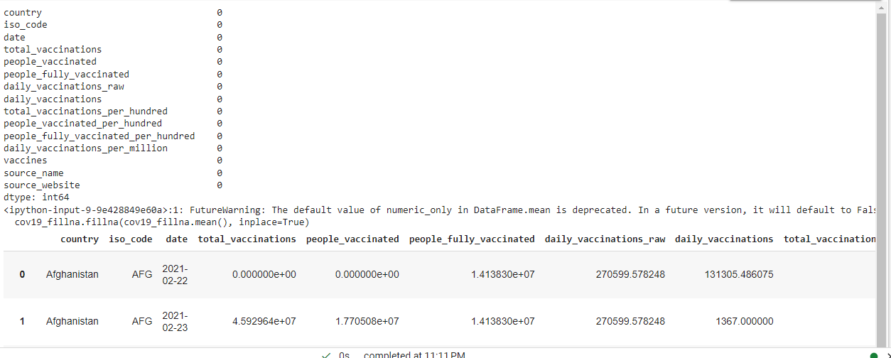

le=LabelEncoder()

cov19['country']=le.fit_transform(cov19['country'])

cov19

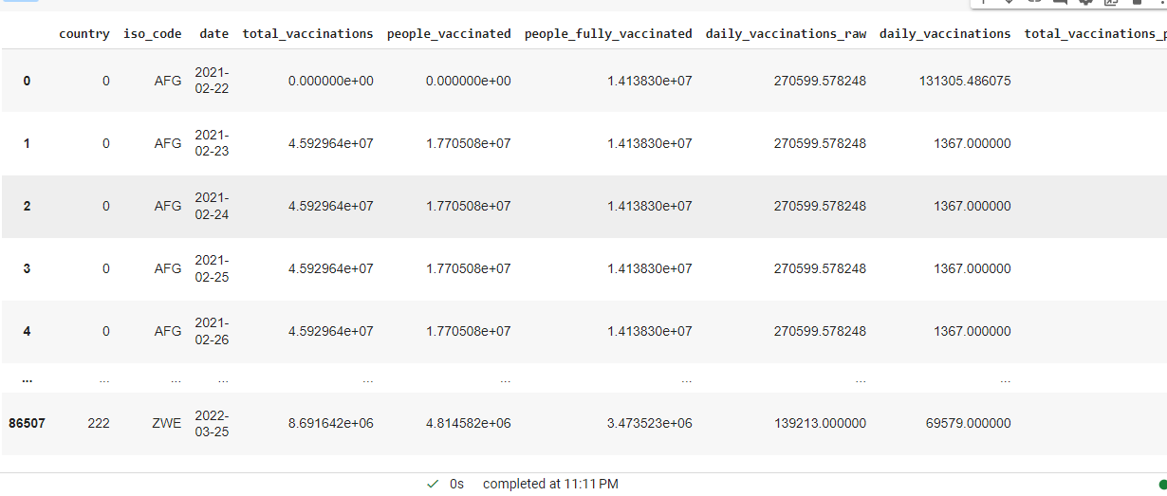

le=LabelEncoder()

cov19['iso_code']=le.fit_transform(cov19['iso_code'])

cov19

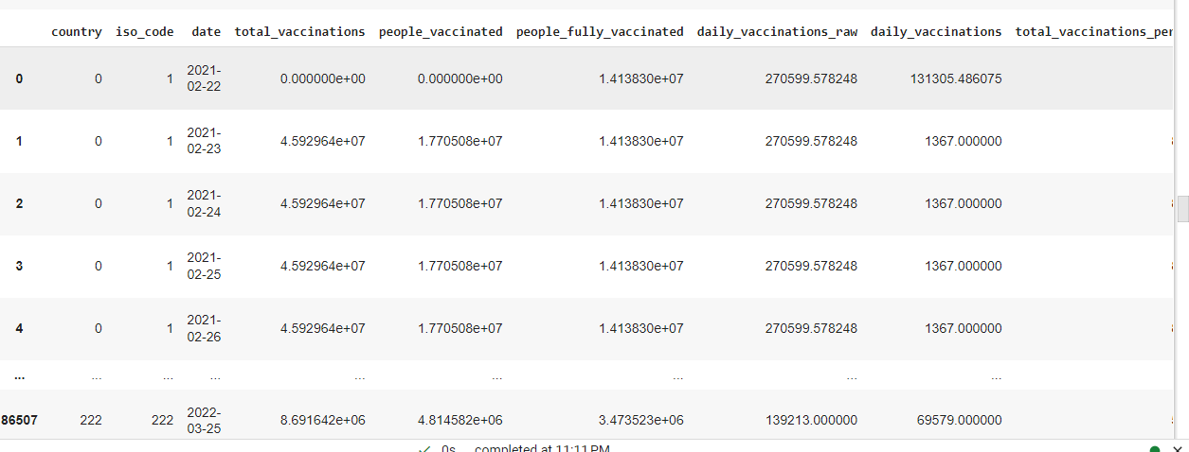

cov19.columns

Index(['country', 'iso_code', 'date', 'total_vaccinations', 'people_vaccinated', 'people_fully_vaccinated', 'daily_vaccinations_raw', 'daily_vaccinations', 'total_vaccinations_per_hundred', 'people_vaccinated_per_hundred', 'people_fully_vaccinated_per_hundred', 'daily_vaccinations_per_million', 'vaccines', 'source_name', 'source_website'], dtype='object')

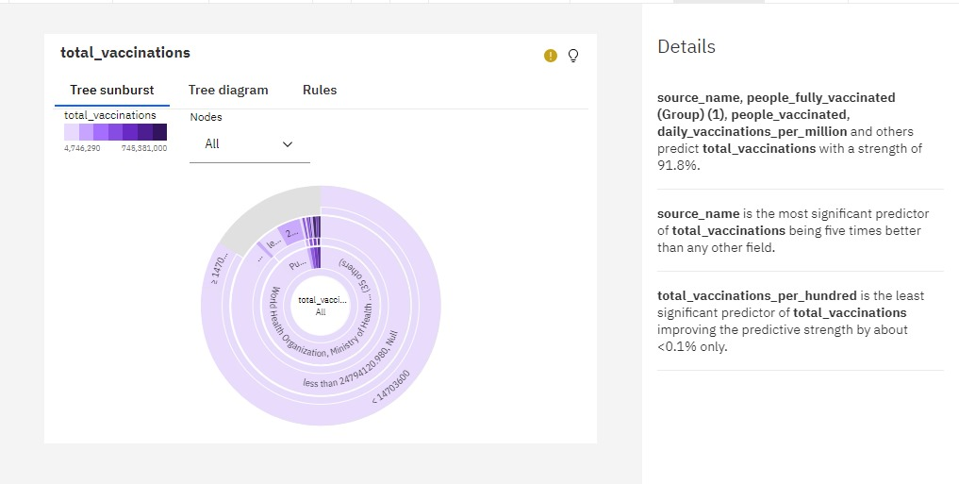

**source_name**, **people_fully_vaccinated (Group) (1)**, **people_vaccinated**, **daily_vaccinations_per_million** and others predict **total_vaccinations** with a strength of 91.8%.

**source_name** is the most significant predictor of **total_vaccinations** being five times better than any other field.

**total_vaccinations_per_hundred** is the least significant predictor of **total_vaccinations** improving the predictive strength by about <0.1% only.

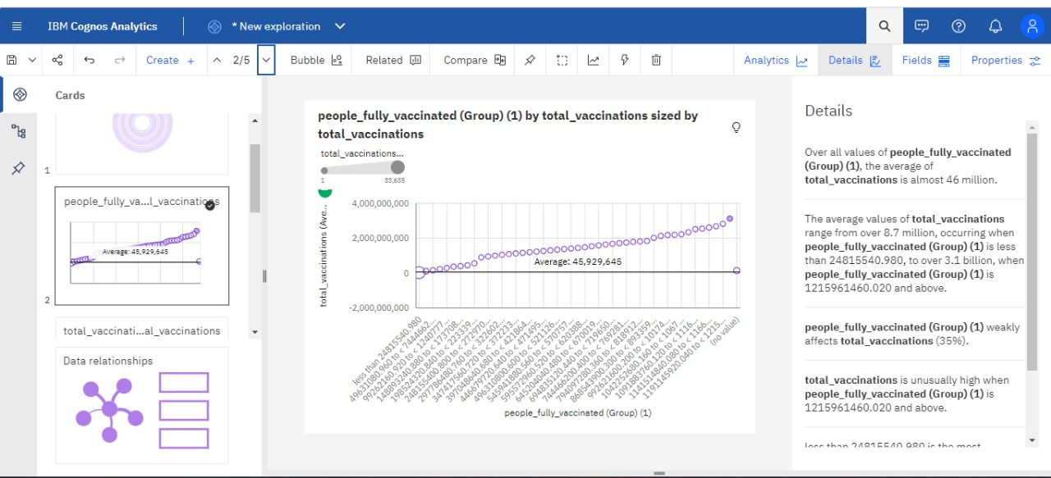

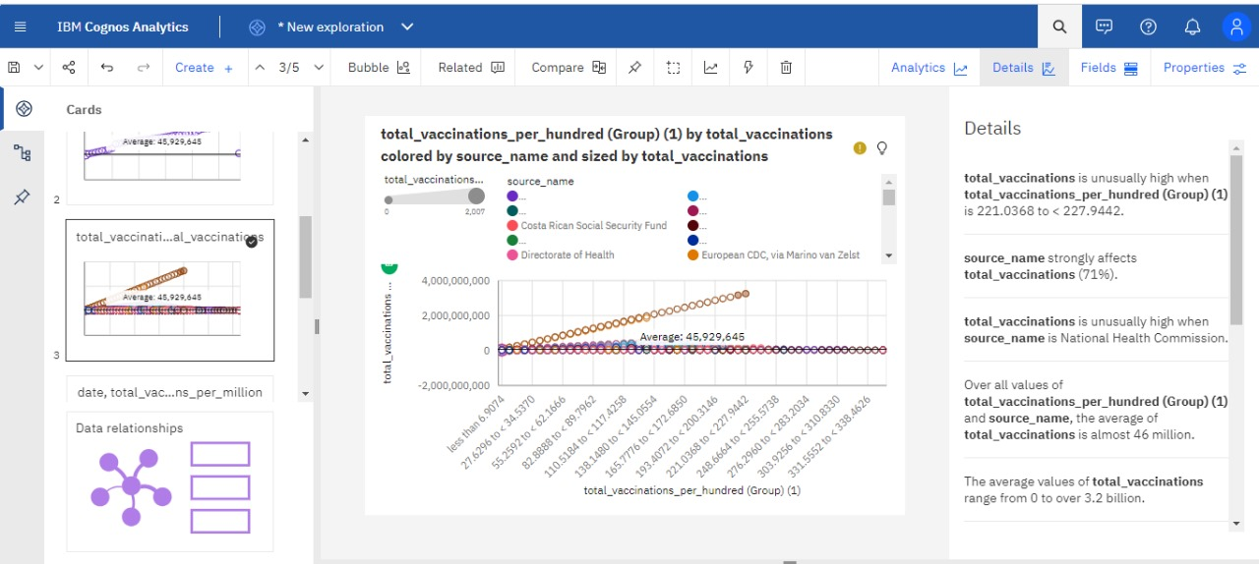

**total_vaccinations** is unusually high when **total_vaccinations_per_hundred (Group) (1)** is 221.0368 to < 227.9442.

**source_name** strongly affects **total_vaccinations** (71%).

**total_vaccinations** is unusually high when **source_name** is National Health Commission.

Over all values of **total_vaccinations_per_hundred (Group) (1)** and **source_name**, the average of **total_vaccinations** is almost 46 million.

The average values of **total_vaccinations** range from 0 to over 3.2 billion.

**total_vaccinations_per_hundred (Group) (1)** and **source_name** strongly affect **total_vaccinations** (100%).

**total_vaccinations** is unusually high when the combinations of **total_vaccinations_per_hundred (Group) (1)** and **source_name** are 221.0368 to < 227.9442 and National Health Commission and 214.1294 to < 221.0368 and National Health Commission.

less than 6.9074 is the most frequently occurring category of **total_vaccinations_per_hundred (Group) (1)** with a count of 7505 items with **total_vaccinations** values (17.2 % of the total).

Ministry of Health is the most frequently occurring category of **source_name** with a count of 9981 items with **total_vaccinations** values (22.9 % of the total).

**Chart A**

date - Top 10 by daily_vaccinations_per_million

**date, total_vaccinations and daily_vaccinations_per_million**

5

date

total_vaccinations

daily_vaccinations_per_million

6/22/2021

2,699,790,526

965,713

6/23/2021

2,788,620,339

954,815

6/26/2021

2,877,147,766

954,034

6/28/2021

2,996,944,602

951,522

**Chart B**

**daily_vaccinations and total_vaccinations by country colored by country**

10,562,357

2 of 200 items

| **Summary** | Select  Chart A : total_vaccinationsChart A : daily_vaccinations_per_million | Select  Chart B : daily_vaccinationsChart B : total_vaccinations | **Combined** |
| --- | --- | --- | --- |
| Chart percent of data set | 1.72% | 100% | - |
| Average | 3,434,983,805.7 | 50,763,407.49 | - |
| Chart total | 34,349,838,057 | 11,320,239,871 | - |

**people_fully_vaccinated (Group) (1) by total_vaccinations sized by total_vaccinations**

less than 24815540.98049631080.960 to < 7444662...99262160.920 to < 1240777...148893240.880 to < 173708...198524320.840 to < 223339...248155400.800 to < 272970...297786480.760 to < 322602...347417560.720 to < 372233...397048640.680 to < 421864...446679720.640 to < 471495...496310800.600 to < 521126...545941880.560 to < 570757...595572960.520 to < 620388...645204040.480 to < 670019...694835120.440 to < 719650...744466200.400 to < 769281...794097280.360 to < 818912...868543900.300 to < 893359...992621600.200 to < 10174...1042252680.160 to < 1067...1091883760.120 to < 1116...1141514840.080 to < 1166...1191145920.040 to < 1215...(no value)people_fully_vaccinated (Group) (1)-2,000,000,00002,000,000,0004,000,000,000total_vaccinations (Ave…5Average: 45,929,645

total_vaccinations (Count)

133,635

**daily_vaccinations_per_million by country colored by date**

United Arab...South KoreaSingaporeNiueMaltaGibraltarCubaChileBruneiBhutancountry010,00020,00030,00040,00050,000daily_vaccinations_per_million (Sum)

date

* 12/22/2021
* 7/2/2021
* 7/1/2021
* 6/30/2021
* 6/29/2021
* 6/28/2021
* 6/27/2021
* 6/26/2021
* 6/23/2021
* 6/22/2021

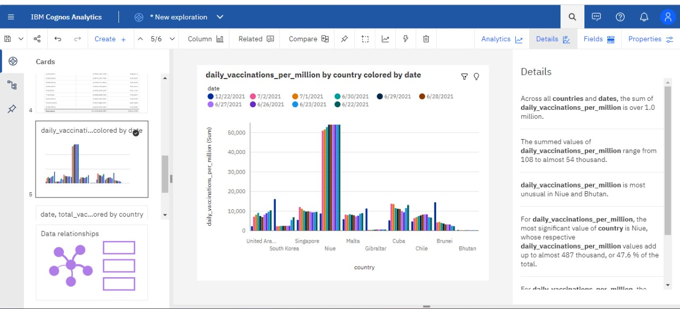

Across all **countries** and **dates**, the sum of **daily_vaccinations_per_million** is over 1.0 million.

The summed values of **daily_vaccinations_per_million** range from 108 to almost 54 thousand.

**daily_vaccinations_per_million** is most unusual in Niue and Bhutan.

For **daily_vaccinations_per_million**, the most significant value of **country** is Niue, whose respective **daily_vaccinations_per_million** values add up to almost 487 thousand, or 47.6 % of the total.

For **daily_vaccinations_per_million**, the most significant values of **date** are 2021-06-22, 2021-06-23, 2021-07-01, 2021-06-30, and 2021-07-02, whose respective **daily_vaccinations_per_million** values add up to over 535 thousand, or 52.3 % of the total.

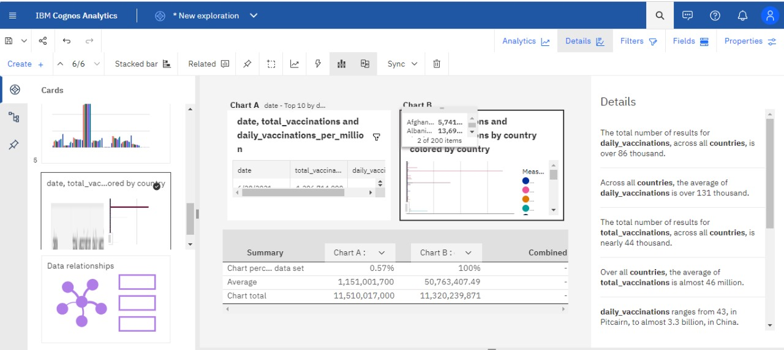

The total number of results for **daily_vaccinations**, across all **countries**, is over 86 thousand.

Across all **countries**, the average of **daily_vaccinations** is over 131 thousand.

The total number of results for **total_vaccinations**, across all **countries**, is nearly 44 thousand.

Over all **countries**, the average of **total_vaccinations** is almost 46 million.

**daily_vaccinations** ranges from 43, in Pitcairn, to almost 3.3 billion, in China.

**total_vaccinations** ranges from 348, in Pitcairn, to approximately 709 billion, in China.

Norway (0.6 %), Latvia (0.6 %), and Denmark (0.6 %) are the most frequently occurring categories of **country** with a combined count of 1435 items with **daily_vaccinations** values (1.7 % of the total).

Norway is the most frequently occurring category of **country** with a count of 482 items with **total_vaccinations** values (1.1 % of the total).

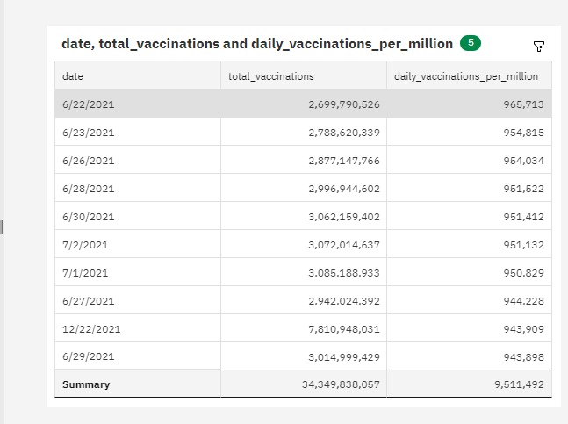

**VISUALIZATION:**

from google.colab import drive  
drive.mount('/content/drive/')

Mounted at /content/drive/

import pandas as pd  
import numpy as np  
import matplotlib.pyplot as plt  
import seaborn as sns  
import warnings  
warnings.filterwarnings("ignore")

df= pd.read_csv("/content/drive/MyDrive/country_vaccinations.csv")

df.head()

country iso_code date total_vaccinations people_vaccinated \  
0 Afghanistan AFG 2021-02-22 0.0 0.0   
1 Afghanistan AFG 2021-02-23 NaN NaN   
2 Afghanistan AFG 2021-02-24 NaN NaN   
3 Afghanistan AFG 2021-02-25 NaN NaN   
4 Afghanistan AFG 2021-02-26 NaN NaN   
  
 people_fully_vaccinated daily_vaccinations_raw daily_vaccinations \  
0 NaN NaN NaN   
1 NaN NaN 1367.0   
2 NaN NaN 1367.0   
3 NaN NaN 1367.0   
4 NaN NaN 1367.0   
  
 total_vaccinations_per_hundred people_vaccinated_per_hundred \  
0 0.0 0.0   
1 NaN NaN   
2 NaN NaN   
3 NaN NaN   
4 NaN NaN   
  
 people_fully_vaccinated_per_hundred daily_vaccinations_per_million \  
0 NaN NaN   
1 NaN 34.0   
2 NaN 34.0   
3 NaN 34.0   
4 NaN 34.0   
  
 vaccines \  
0 Johnson&Johnson, Oxford/AstraZeneca, Pfizer/Bi...   
1 Johnson&Johnson, Oxford/AstraZeneca, Pfizer/Bi...   
2 Johnson&Johnson, Oxford/AstraZeneca, Pfizer/Bi...   
3 Johnson&Johnson, Oxford/AstraZeneca, Pfizer/Bi...   
4 Johnson&Johnson, Oxford/AstraZeneca, Pfizer/Bi...   
  
 source_name source_website   
0 World Health Organization https://covid19.who.int/   
1 World Health Organization https://covid19.who.int/   
2 World Health Organization https://covid19.who.int/   
3 World Health Organization https://covid19.who.int/   
4 World Health Organization https://covid19.who.int/

df.describe()

total_vaccinations people_vaccinated people_fully_vaccinated \  
count 4.360700e+04 4.129400e+04 3.880200e+04   
mean 4.592964e+07 1.770508e+07 1.413830e+07   
std 2.246004e+08 7.078731e+07 5.713920e+07   
min 0.000000e+00 0.000000e+00 1.000000e+00   
25% 5.264100e+05 3.494642e+05 2.439622e+05   
50% 3.590096e+06 2.187310e+06 1.722140e+06   
75% 1.701230e+07 9.152520e+06 7.559870e+06   
max 3.263129e+09 1.275541e+09 1.240777e+09   
  
 daily_vaccinations_raw daily_vaccinations \  
count 3.536200e+04 8.621300e+04   
mean 2.705996e+05 1.313055e+05   
std 1.212427e+06 7.682388e+05   
min 0.000000e+00 0.000000e+00   
25% 4.668000e+03 9.000000e+02   
50% 2.530900e+04 7.343000e+03   
75% 1.234925e+05 4.409800e+04   
max 2.474100e+07 2.242429e+07   
  
 total_vaccinations_per_hundred people_vaccinated_per_hundred \  
count 43607.000000 41294.000000   
mean 80.188543 40.927317   
std 67.913577 29.290759   
min 0.000000 0.000000   
25% 16.050000 11.370000   
50% 67.520000 41.435000   
75% 132.735000 67.910000   
max 345.370000 124.760000   
  
 people_fully_vaccinated_per_hundred daily_vaccinations_per_million   
count 38802.000000 86213.000000   
mean 35.523243 3257.049157   
std 28.376252 3934.312440   
min 0.000000 0.000000   
25% 7.020000 636.000000   
50% 31.750000 2050.000000   
75% 62.080000 4682.000000   
max 122.370000 117497.000000

df.dtypes

country object  
iso_code object  
date object  
total_vaccinations float64  
people_vaccinated float64  
people_fully_vaccinated float64  
daily_vaccinations_raw float64  
daily_vaccinations float64  
total_vaccinations_per_hundred float64  
people_vaccinated_per_hundred float64  
people_fully_vaccinated_per_hundred float64  
daily_vaccinations_per_million float64  
vaccines object  
source_name object  
source_website object  
dtype: object

df["date"]= pd.to_datetime(df.date)

df["Total_vaccinations(count)"]= df.groupby("country").total_vaccinations.tail(1)

df.groupby("country")["Total_vaccinations(count)"].mean().sort_values(ascending= False).head(20)

country  
China 3.263129e+09  
India 1.834501e+09  
United States 5.601818e+08  
Brazil 4.135596e+08  
Indonesia 3.771089e+08  
Japan 2.543456e+08  
Bangladesh 2.436427e+08  
Pakistan 2.193686e+08  
Vietnam 2.031444e+08  
Mexico 1.919079e+08  
Germany 1.719400e+08  
Russia 1.636012e+08  
Philippines 1.487991e+08  
Turkey 1.468819e+08  
Iran 1.467926e+08  
France 1.416662e+08  
United Kingdom 1.409683e+08  
Italy 1.358709e+08  
Thailand 1.288824e+08  
South Korea 1.206045e+08  
Name: Total_vaccinations(count), dtype: float64

x= df.groupby("country")["Total_vaccinations(count)"].mean().sort_values(ascending= False).head(20)  
sns.set_style("whitegrid")  
plt.figure(figsize= (8,8))  
ax = sns.barplot(x=x.values, y=x.index)  
  
ax.set_xlabel("Total vaccinations(count)")  
plt.show()

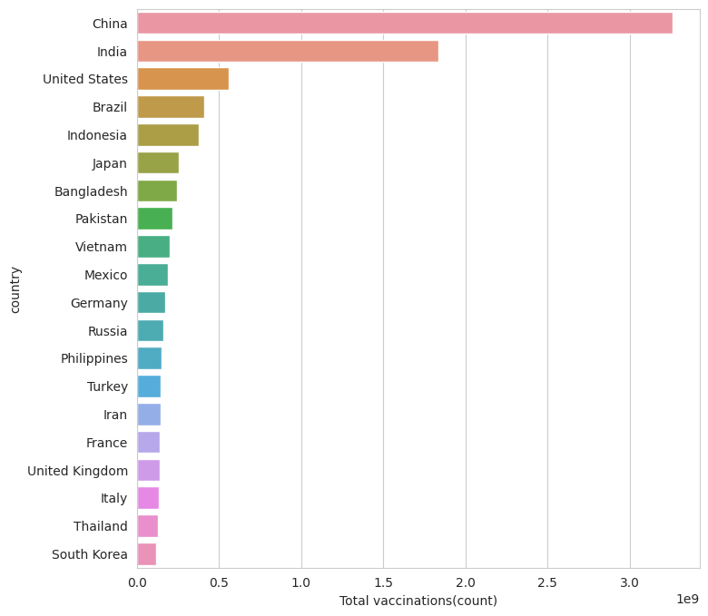

df["Full_vaccinations(count)"]= df.groupby("country").people_fully_vaccinated.tail(1)  
  
df.groupby("country")["Full_vaccinations(count)"].mean().sort_values(ascending= False).head(20)

country  
India 828229455.0  
United States 217498967.0  
Brazil 160272858.0  
Indonesia 158830466.0  
Bangladesh 107712737.0  
Pakistan 101881176.0  
Japan 100633737.0  
Mexico 79711762.0  
Vietnam 77754108.0  
Russia 72841232.0  
Philippines 65804988.0  
Germany 63142649.0  
Iran 56810058.0  
Turkey 52968985.0  
France 52438706.0  
Thailand 50159803.0  
United Kingdom 49404026.0  
Italy 47817555.0  
South Korea 44482876.0  
England 41501690.0  
Name: Full_vaccinations(count), dtype: float64

#barplot visualization of top countries with most full vaccinations  
  
sns.set_style("whitegrid")  
plt.figure(figsize= (8,8))  
ax = sns.barplot(x=x.values, y=x.index)  
ax.set_xlabel("Fully vaccinated(count)")  
plt.show()

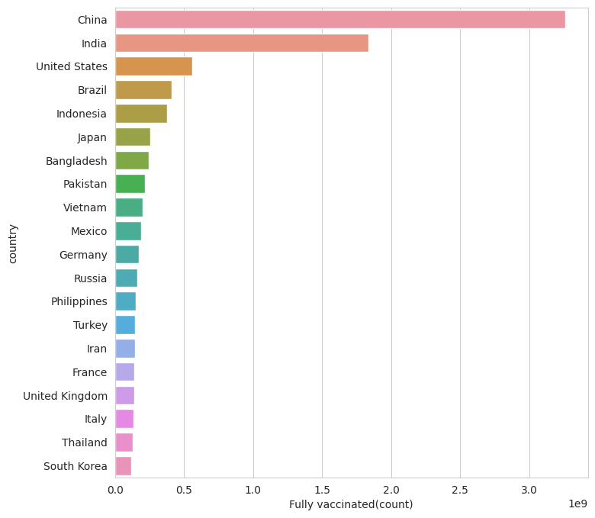

df["Full_vaccinations(count)"]= df.groupby("country").people_fully_vaccinated.tail(1)  
  
df.groupby("country")["Full_vaccinations(count)"].mean().sort_values(ascending= False).head(20)

country  
India 828229455.0  
United States 217498967.0  
Brazil 160272858.0  
Indonesia 158830466.0  
Bangladesh 107712737.0  
Pakistan 101881176.0  
Japan 100633737.0  
Mexico 79711762.0  
Vietnam 77754108.0  
Russia 72841232.0  
Philippines 65804988.0  
Germany 63142649.0  
Iran 56810058.0  
Turkey 52968985.0  
France 52438706.0  
Thailand 50159803.0  
United Kingdom 49404026.0  
Italy 47817555.0  
South Korea 44482876.0  
England 41501690.0  
Name: Full_vaccinations(count), dtype: float64

#Vaccine types  
x=df.vaccines.unique()  
y= list(x)  
for i in y: print(i)

Johnson&Johnson, Oxford/AstraZeneca, Pfizer/BioNTech, Sinopharm/Beijing  
Oxford/AstraZeneca, Pfizer/BioNTech, Sinovac, Sputnik V  
Oxford/AstraZeneca, Sinopharm/Beijing, Sinovac, Sputnik V  
Moderna, Oxford/AstraZeneca, Pfizer/BioNTech  
Oxford/AstraZeneca  
Oxford/AstraZeneca, Pfizer/BioNTech  
Oxford/AstraZeneca, Pfizer/BioNTech, Sputnik V  
CanSino, Moderna, Oxford/AstraZeneca, Pfizer/BioNTech, Sinopharm/Beijing, Sputnik V  
Moderna, Oxford/AstraZeneca, Sinopharm/Beijing, Sinovac, Sputnik V  
Pfizer/BioNTech  
Johnson&Johnson, Moderna, Novavax, Oxford/AstraZeneca, Pfizer/BioNTech  
Johnson&Johnson, Oxford/AstraZeneca, Pfizer/BioNTech  
Johnson&Johnson, Moderna, Oxford/AstraZeneca, Pfizer/BioNTech, Sinopharm/Beijing, Sputnik Light, Sputnik V  
Johnson&Johnson, Moderna, Oxford/AstraZeneca, Pfizer/BioNTech, Sinopharm/Beijing, Sinovac  
Oxford/AstraZeneca, Pfizer/BioNTech, Sinopharm/Beijing  
Sinopharm/Beijing, Sputnik V  
Johnson&Johnson, Moderna, Oxford/AstraZeneca, Pfizer/BioNTech  
Johnson&Johnson, Oxford/AstraZeneca, Pfizer/BioNTech, Sinovac  
Moderna, Oxford/AstraZeneca, Pfizer/BioNTech, Sinopharm/Beijing  
Johnson&Johnson, Oxford/AstraZeneca, Pfizer/BioNTech, Sinopharm/Beijing, Sputnik V  
Moderna, Pfizer/BioNTech  
Covaxin, Johnson&Johnson, Moderna, Oxford/AstraZeneca, Pfizer/BioNTech, Sinovac  
Johnson&Johnson, Oxford/AstraZeneca  
Johnson&Johnson, Moderna, Oxford/AstraZeneca, Pfizer/BioNTech, Sinopharm/Beijing  
Johnson&Johnson, Oxford/AstraZeneca, Sinopharm/Beijing  
Sinopharm/Beijing  
Johnson&Johnson, Oxford/AstraZeneca, Sinopharm/Beijing, Sinovac  
Covaxin, Oxford/AstraZeneca  
CanSino, Oxford/AstraZeneca, Pfizer/BioNTech, Sinovac  
CanSino, Sinopharm/Beijing, Sinopharm/Wuhan, Sinovac, ZF2001  
Johnson&Johnson, Moderna, Oxford/AstraZeneca, Pfizer/BioNTech, Sinovac  
Covaxin, Oxford/AstraZeneca, Sinopharm/Beijing  
Moderna, Oxford/AstraZeneca, Sinopharm/Beijing, Sputnik V  
Abdala, Soberana Plus, Soberana02  
Johnson&Johnson, Moderna, Pfizer/BioNTech  
Johnson&Johnson, Oxford/AstraZeneca, Pfizer/BioNTech, Sinopharm/Beijing, Sinovac, Sputnik V  
Oxford/AstraZeneca, Pfizer/BioNTech, Sinopharm/Beijing, Sinovac  
Covaxin, Johnson&Johnson, Oxford/AstraZeneca, Sinopharm/Beijing, Sinovac  
Johnson&Johnson, Pfizer/BioNTech  
Pfizer/BioNTech, Sinopharm/Beijing, Sputnik V  
Oxford/AstraZeneca, Sputnik V  
Moderna  
Moderna, Oxford/AstraZeneca, Pfizer/BioNTech, Sputnik V  
Oxford/AstraZeneca, Sinopharm/Beijing  
Moderna, Oxford/AstraZeneca, Pfizer/BioNTech, Sinopharm/Beijing, Sputnik V  
Johnson&Johnson, Moderna  
Johnson&Johnson, Moderna, Oxford/AstraZeneca, Pfizer/BioNTech, Sputnik V  
Pfizer/BioNTech, Sinovac  
Johnson&Johnson, Moderna, Oxford/AstraZeneca, Pfizer/BioNTech, Sinopharm/Beijing, Sputnik V  
Covaxin, Oxford/AstraZeneca, Sputnik V  
Johnson&Johnson, Moderna, Novavax, Oxford/AstraZeneca, Pfizer/BioNTech, Sinopharm/Beijing, Sinovac  
COVIran Barekat, Covaxin, FAKHRAVAC, Oxford/AstraZeneca, Razi Cov Pars, Sinopharm/Beijing, Soberana02, SpikoGen, Sputnik V  
Oxford/AstraZeneca, Pfizer/BioNTech, Sinopharm/Beijing, Sputnik V  
QazVac, Sinopharm/Beijing, Sputnik V  
Johnson&Johnson, Oxford/AstraZeneca, Pfizer/BioNTech, Sinopharm/Beijing, Sinovac, Sputnik Light, Sputnik V  
Johnson&Johnson, Moderna, Novavax, Pfizer/BioNTech  
Oxford/AstraZeneca, Pfizer/BioNTech, Sinopharm/Beijing, Sinovac, Sputnik V  
Pfizer/BioNTech, Sinopharm/Beijing  
CanSino, Oxford/AstraZeneca, Pfizer/BioNTech, Sinopharm/Beijing, Sinovac  
CanSino, Johnson&Johnson, Moderna, Oxford/AstraZeneca, Pfizer/BioNTech, Sinovac, Sputnik V  
Abdala, Johnson&Johnson, Oxford/AstraZeneca, Pfizer/BioNTech, Soberana02, Sputnik Light, Sputnik V  
Oxford/AstraZeneca, Pfizer/BioNTech, Sinovac  
CanSino, Covaxin, Moderna, Oxford/AstraZeneca, Pfizer/BioNTech, Sinopharm/Beijing, Sinovac, Sputnik V  
Johnson&Johnson, Moderna, Oxford/AstraZeneca, Pfizer/BioNTech, Sinopharm/Beijing, Sinovac, Sputnik Light, Sputnik V  
Covaxin, Moderna, Oxford/AstraZeneca, Pfizer/BioNTech, Sinopharm/Beijing, Sinovac, Sputnik V  
EpiVacCorona, Sputnik V  
Johnson&Johnson, Moderna, Oxford/AstraZeneca, Pfizer/BioNTech, Sinopharm/Beijing, Sinovac, Sputnik V  
Pfizer/BioNTech, Sputnik V  
Oxford/AstraZeneca, Sinopharm/Beijing, Sputnik V  
Moderna, Pfizer/BioNTech, Sinopharm/Beijing, Sinovac  
Johnson&Johnson, Moderna, Novavax, Oxford/AstraZeneca, Pfizer/BioNTech, Sputnik V  
Johnson&Johnson, Oxford/AstraZeneca, Pfizer/BioNTech, Sinopharm/Beijing, Sinovac  
Johnson&Johnson, Oxford/AstraZeneca, Sinopharm/Beijing, Sinovac, Sputnik Light, Sputnik V  
Medigen, Moderna, Oxford/AstraZeneca, Pfizer/BioNTech  
Moderna, Oxford/AstraZeneca, Pfizer/BioNTech, Sinovac, Sputnik V  
Johnson&Johnson, Pfizer/BioNTech, Sinopharm/Beijing  
Moderna, Oxford/AstraZeneca, Pfizer/BioNTech, Sinopharm/Beijing, Sinovac  
Pfizer/BioNTech, Sinovac, Turkovac  
EpiVacCorona, Oxford/AstraZeneca, QazVac, Sinopharm/Beijing, Sputnik V, ZF2001  
Oxford/AstraZeneca, Pfizer/BioNTech, Sinopharm/Beijing, Sinopharm/Wuhan, Sputnik V  
Moderna, Oxford/AstraZeneca, Pfizer/BioNTech, Sinovac, Sputnik Light, Sputnik V, ZF2001  
Abdala, Sinopharm/Beijing, Sinovac, Soberana02, Sputnik Light, Sputnik V  
Abdala, Moderna, Oxford/AstraZeneca, Pfizer/BioNTech, Sinopharm/Beijing, Sputnik V  
Johnson&Johnson, Oxford/AstraZeneca, Sinovac

df.vaccines.value_counts()

Johnson&Johnson, Moderna, Oxford/AstraZeneca, Pfizer/BioNTech 7608  
Moderna, Oxford/AstraZeneca, Pfizer/BioNTech 6263  
Oxford/AstraZeneca 6022  
Oxford/AstraZeneca, Pfizer/BioNTech 4629  
Johnson&Johnson, Moderna, Novavax, Oxford/AstraZeneca, Pfizer/BioNTech 3564  
 ...   
Johnson&Johnson, Oxford/AstraZeneca, Sinovac 312  
Moderna, Oxford/AstraZeneca, Pfizer/BioNTech, Sinovac, Sputnik V 311  
Johnson&Johnson, Moderna 251  
Johnson&Johnson, Pfizer/BioNTech, Sinopharm/Beijing 228  
EpiVacCorona, Oxford/AstraZeneca, QazVac, Sinopharm/Beijing, Sputnik V, ZF2001 190  
Name: vaccines, Length: 84, dtype: int64

from wordcloud import WordCloud, STOPWORDS  
plt.figure(figsize= (20,20))  
words= "".join(df["vaccines"])  
final = WordCloud(width = 2000, height = 800, background_color ="black",min_font_size = 10).generate(words)  
plt.imshow(final)  
plt.axis("off")  
plt.show()

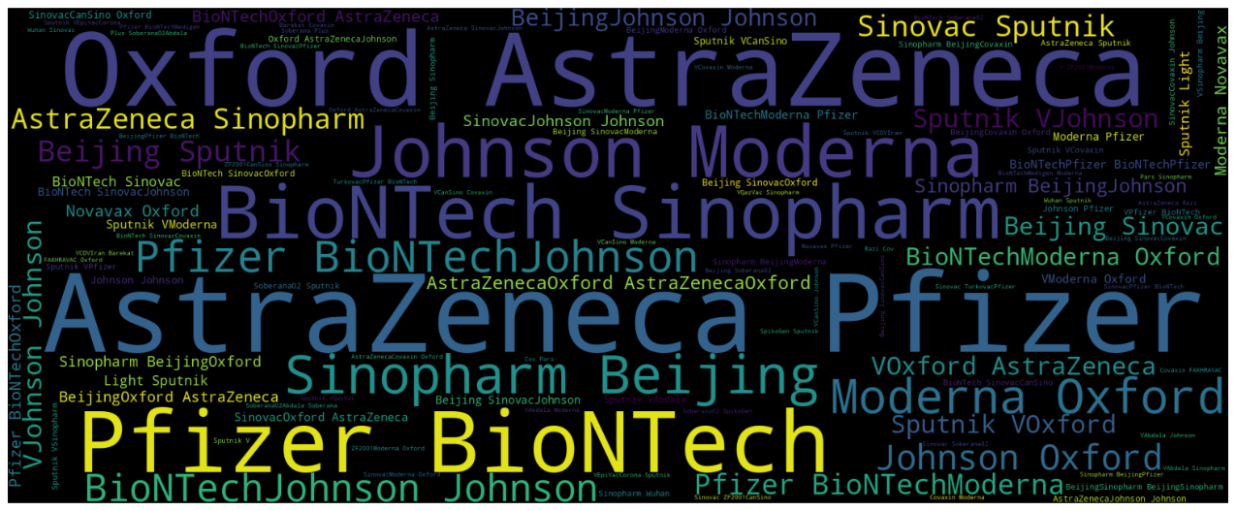

plt.figure(figsize=(15,15))  
sns.countplot(y= "vaccines",data= df)  
plt.show()

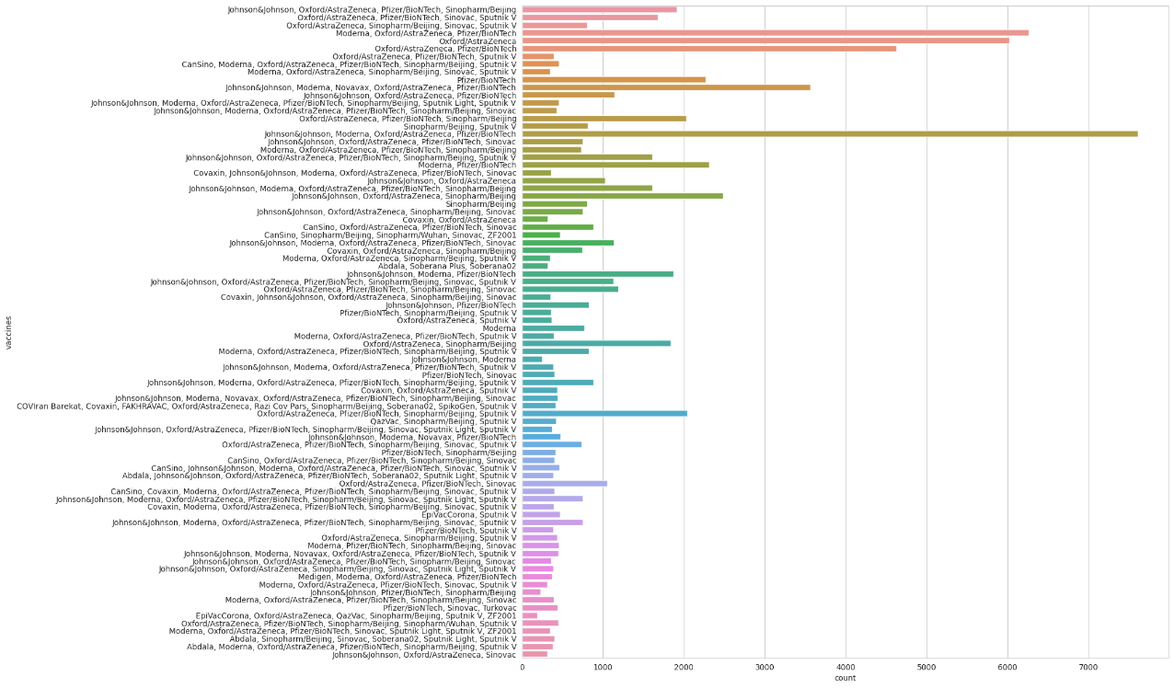

#daily vaccinations  
x= df.groupby("date").daily_vaccinations.sum()  
plt.figure(figsize= (15,5))  
sns.lineplot(x=x.index, y=x.values)  
plt.show()

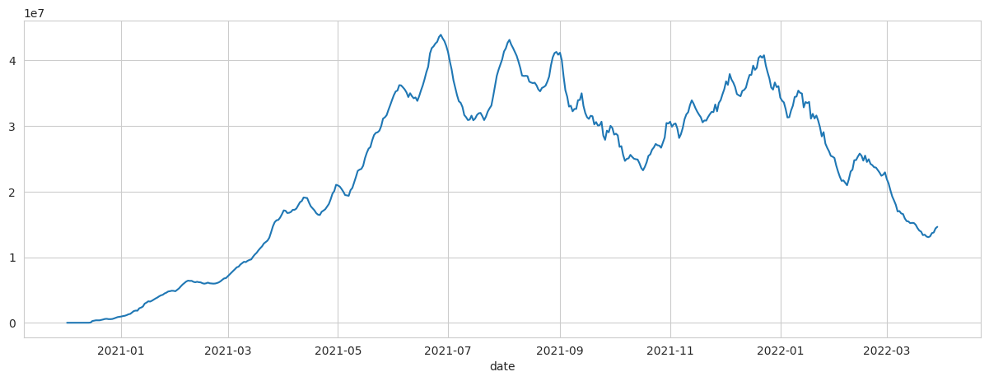

#total vaccinations  
plt.figure(figsize= (15,5))  
sns.lineplot(x= "date",y= "total_vaccinations",data= df)  
plt.show()

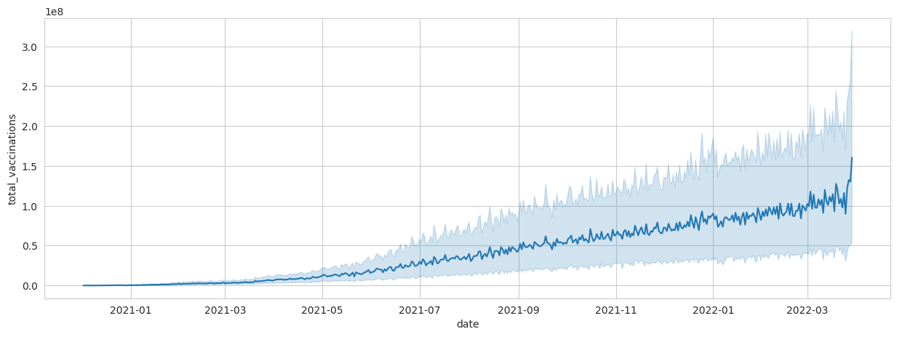

x= df.groupby("country").daily_vaccinations.mean().sort_values(ascending= False).head(20)  
x

country  
China 6.930368e+06  
India 4.175994e+06  
United States 1.191727e+06  
Brazil 9.435287e+05  
Indonesia 8.462893e+05  
Japan 6.215795e+05  
Bangladesh 5.453055e+05  
Pakistan 5.430051e+05  
Vietnam 5.310949e+05  
Mexico 4.134253e+05  
Germany 3.761575e+05  
Philippines 3.665658e+05  
Iran 3.535194e+05  
Russia 3.480843e+05  
Turkey 3.351917e+05  
Thailand 3.251471e+05  
United Kingdom 3.140841e+05  
France 3.104963e+05  
South Korea 3.042512e+05  
Italy 2.970580e+05  
Name: daily_vaccinations, dtype: float64

#daily vaccinations barplot  
plt.figure(figsize= (8,8))  
ax = sns.barplot(x=x.index, y=x.values)  
ax.set_xlabel("daily vaccinations(avg)")  
plt.show()

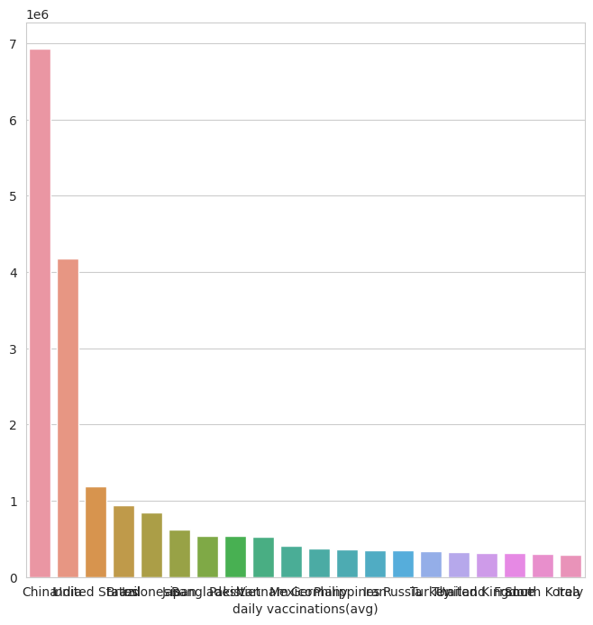

df["Total_vaccinations_per_hundred"]= df.groupby("country").total_vaccinations_per_hundred.tail(1)

x= df.groupby("country")["Total_vaccinations_per_hundred"].mean().sort_values(ascending= False).head(10)  
plt.figure(figsize= (8,8))  
ax= sns.barplot(x=x.values,y=x.index)  
ax.set_xlabel("vaccinations per hundred")  
plt.show()

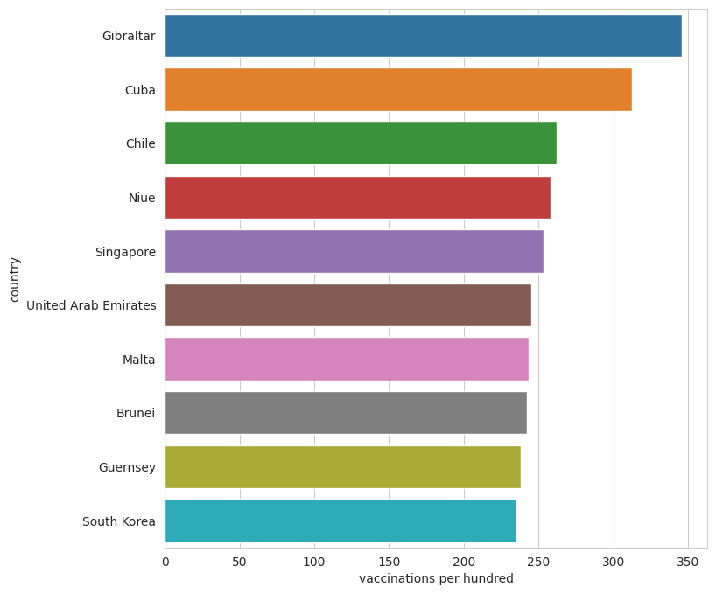

df.groupby("country")["daily_vaccinations_per_million"].mean().sort_values(ascending= False).head(20)

country  
Falkland Islands 21185.393939  
Saint Helena 13915.164835  
Tokelau 12718.106195  
Pitcairn 10891.797619  
Niue 10109.509434  
Cuba 9955.943333  
Gibraltar 8000.463470  
Bonaire Sint Eustatius and Saba 7412.000000  
Bhutan 7241.676880  
Brunei 6906.782857  
Turkmenistan 6618.888889  
South Korea 5930.227273  
Uruguay 5829.491139  
Chile 5764.154525  
Singapore 5585.536424  
Malta 5553.986207  
Taiwan 5545.517426  
Guernsey 5437.624113  
Australia 5422.241895  
Vietnam 5410.000000  
Name: daily_vaccinations_per_million, dtype: float64

#daily vaccination per million  
plt.figure(figsize= (15,5))  
sns.lineplot(x= "date",y= "daily_vaccinations_per_million",data= df)  
plt.show()

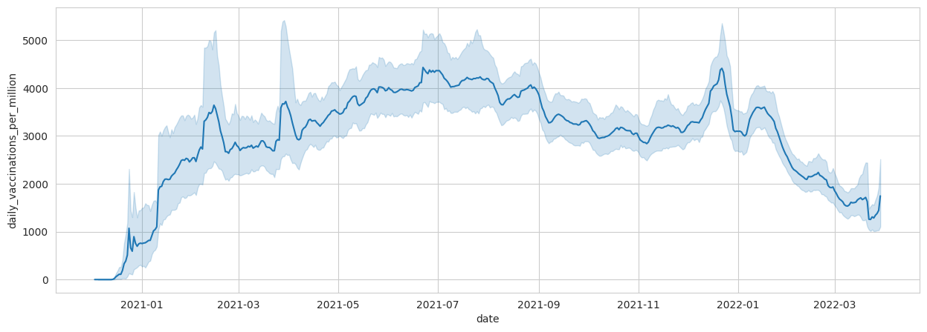

#people fully vaccinated  
plt.figure(figsize= (15,5))  
sns.lineplot(x= "date",y= "people_fully_vaccinated",data= df)  
plt.show()

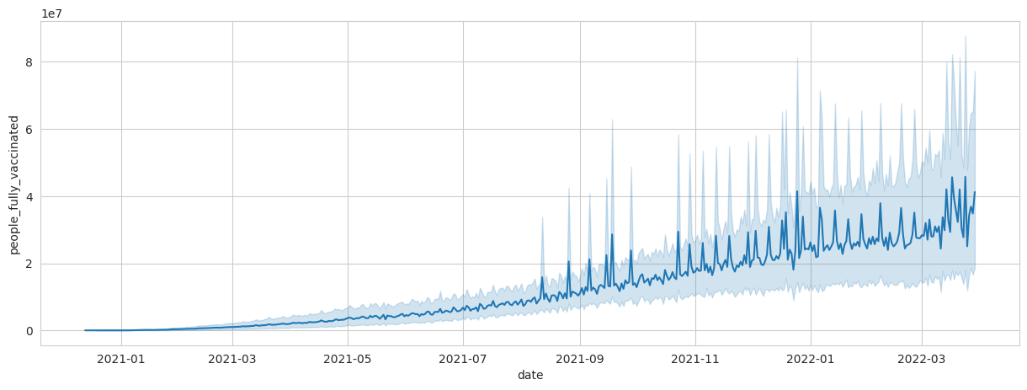

#Total vaccinations in India  
plt.figure(figsize= (15,5))  
sns.lineplot(x= "date",y= "total_vaccinations",data= df[df["country"]=="India"])  
plt.show()

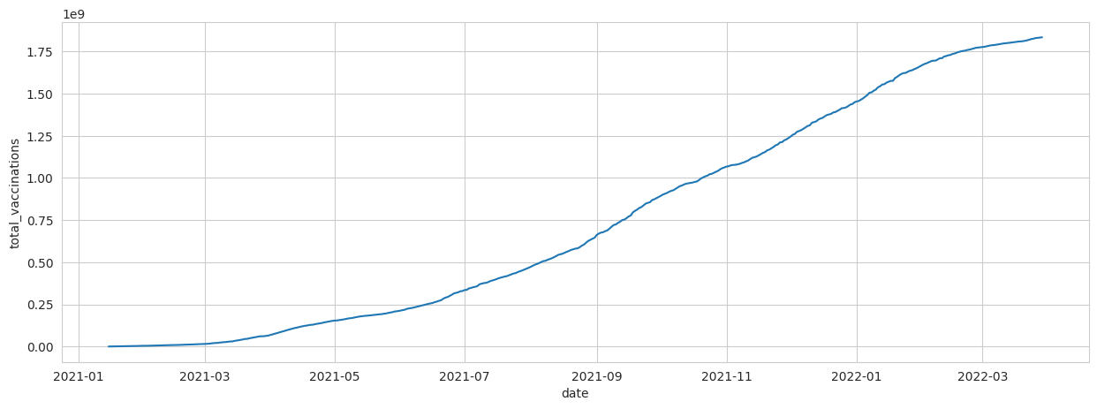

#full vaccinations in India  
plt.figure(figsize= (15,5))  
sns.lineplot(x= "date",y= "people_fully_vaccinated",data= df[df["country"]=="India"])  
plt.show()

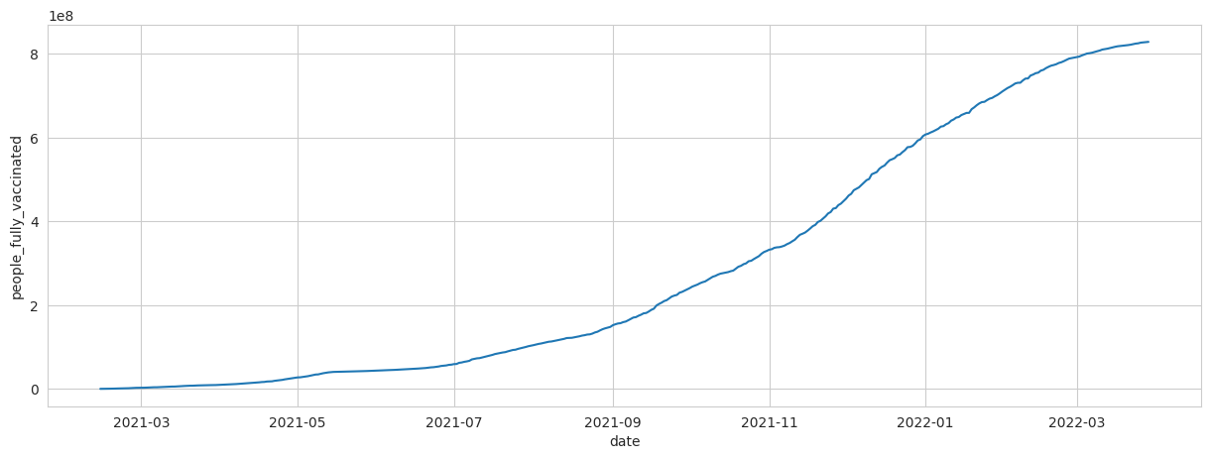

#people_vaccinated per hundred in India  
plt.figure(figsize= (15,5))  
sns.lineplot(x= "date",y= "people_vaccinated_per_hundred",data= df[df["country"]=="India"])  
plt.show()

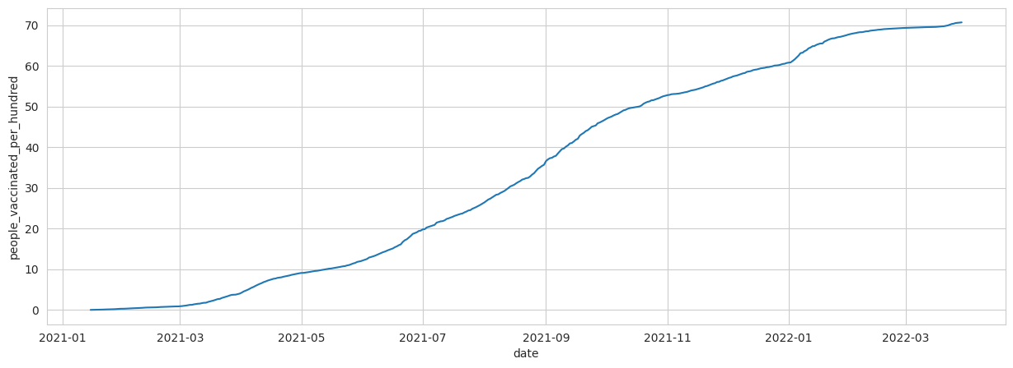

x= df[df["country"]=="India"]  
z= x.vaccines.value_counts()  
c= list(z.index)  
c

['Covaxin, Oxford/AstraZeneca, Sputnik V']

df.groupby("country")["Total_vaccinations(count)"].mean().sort_values(ascending= False).head()

country  
China 3.263129e+09  
India 1.834501e+09  
United States 5.601818e+08  
Brazil 4.135596e+08  
Indonesia 3.771089e+08  
Name: Total_vaccinations(count), dtype: float64

#creating dataframe for top 5 vaccinated countries  
x= df.loc[(df.country== "United States") | (df.country== "China")| (df.country== "India")| (df.country== "Unted Kingdom")|(df.country== "England")]

#total vaccination comparison  
plt.figure(figsize= (15,5))  
sns.lineplot(x= "date",y= "total_vaccinations" ,data= x,hue= "country")  
plt.show()

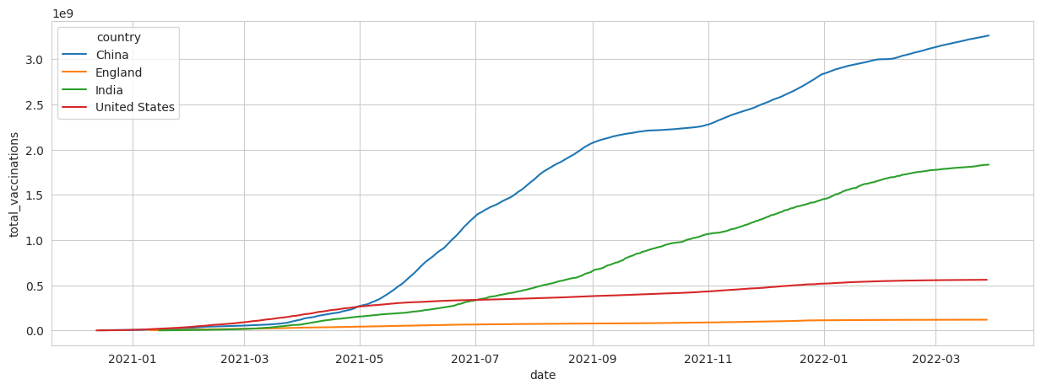

#daily vaccination comparison  
plt.figure(figsize= (15,5))  
sns.lineplot(x= "date",y= "daily_vaccinations" ,data= x,hue= "country")  
plt.show()

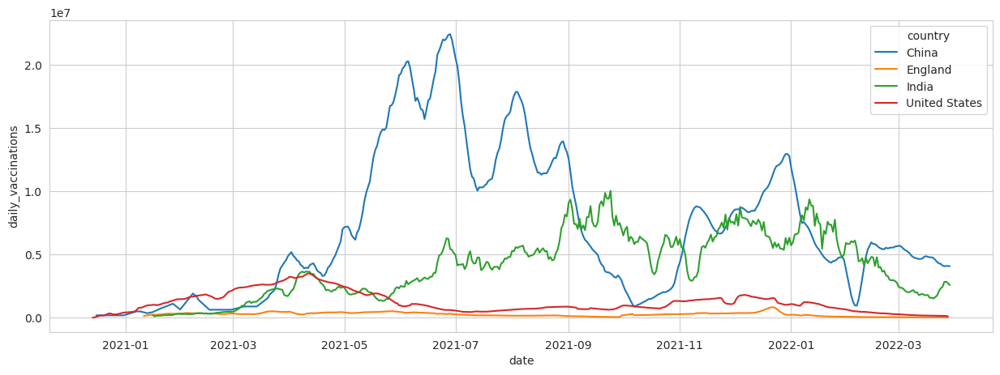

#full vaccinations comparison  
plt.figure(figsize= (15,5))  
sns.lineplot(x= "date",y= "people_fully_vaccinated" ,data= x,hue= "country")  
plt.show()

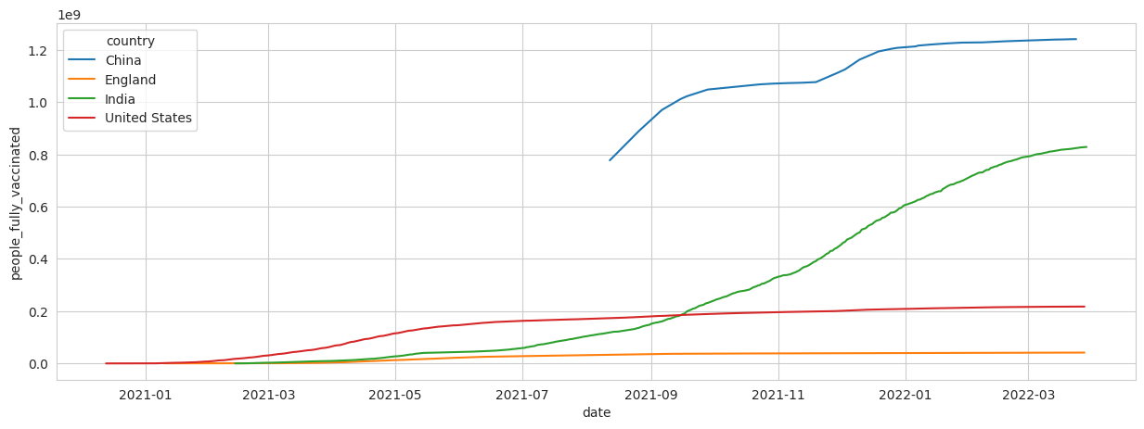

#daily vaccination per million comparison  
plt.figure(figsize= (15,5))  
sns.lineplot(x= "date",y= "daily_vaccinations_per_million" ,data= x,hue= "country")  
plt.show()

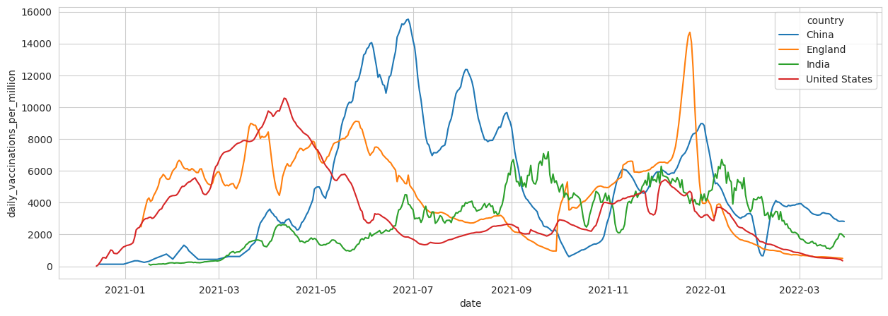

import pandas as pd  
  
# Assuming your DataFrame is named df  
summary_stats = df['daily_vaccinations'].describe()  
  
print(summary_stats)

count 8.621300e+04  
mean 1.313055e+05  
std 7.682388e+05  
min 0.000000e+00  
25% 9.000000e+02  
50% 7.343000e+03  
75% 4.409800e+04  
max 2.242429e+07  
Name: daily_vaccinations, dtype: float64