**Summary for "Gesture Controlled Virtual Mouse"**

**Project Overview**

This project involves controlling a computer mouse using hand gestures detected through a webcam, offering a touchless interface for interacting with devices.

**Key Components**

1. **Workflow:**
   * **Video Capture:** Real-time video input through OpenCV.
   * **Hand Detection:** Using MediaPipe to track hand landmarks.
   * **Gesture Recognition:** Identifying gestures based on hand positions.
   * **Mouse Control:** Executing actions like clicks, scrolling, and screenshots.

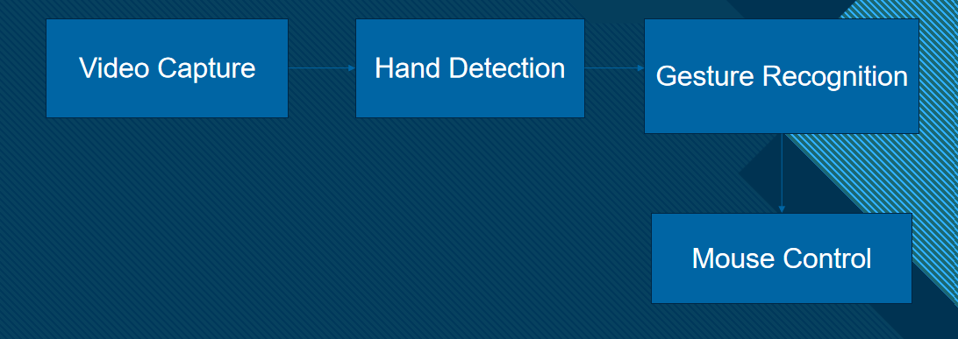

1. **Tools and Libraries Used:**
   * **OpenCV:** Video frame capture and display.
   * **MediaPipe:** Hand landmark tracking with 21 key points.
   * **PyAutoGUI:** Automating mouse actions.
   * **Pynput:** Low-level mouse control.
   * **Random:** Generating random numbers for auxiliary features.

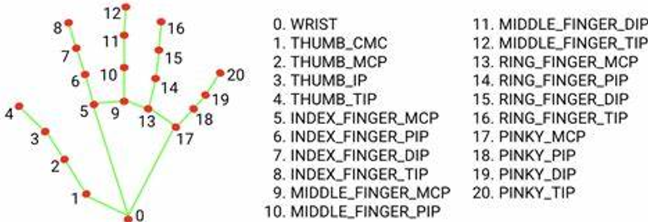

1. **Gesture Detection:**
   * **Left Click:** Thumb (Landmark 4) and Index (Landmark 8) close together.

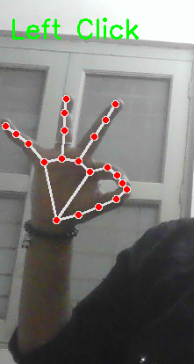

* + **Right Click:** Thumb (Landmark 4) and Middle Finger (Landmark 12) close together.

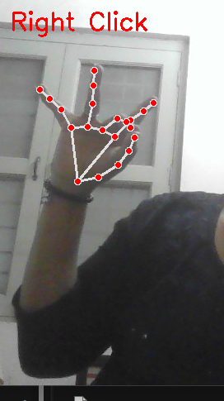

* + **Scroll Up/Down:** Middle Finger (Landmark 12) moves up or down.

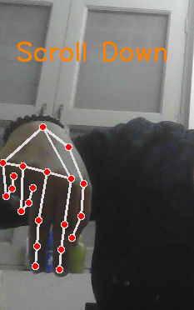

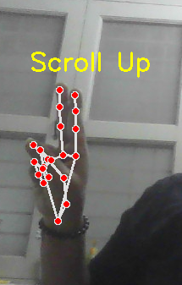

* + **Screenshot:** Thumb (Landmark 4) and Little Finger (Landmark 20) close together.

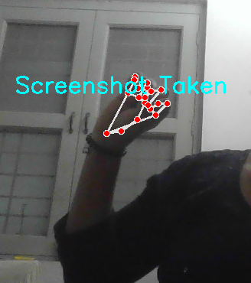

1. **Challenges Encountered:**
   * Variable lighting affecting detection accuracy.
   * Limited gesture library.
   * High CPU usage for real-time processing.
2. **Improvement Opportunities:**
   * Adding support for multiple hands.
   * Customizable gestures for more actions.
   * Integration with AR/VR systems.

**Applications**

* Touchless control for presentations.
* Gaming and virtual reality interfaces.
* Smart home control systems.