**Summary for "Gesture Controlled Virtual Mouse"**

**Project Overview**

This project involves controlling a computer mouse using hand gestures detected through a webcam, offering a touchless interface for interacting with devices.

**Key Components**

1. **Workflow:**
   * **Video Capture:** Real-time video input through OpenCV.
   * **Hand Detection:** Using MediaPipe to track hand landmarks.
   * **Gesture Recognition:** Identifying gestures based on hand positions.
   * **Mouse Control:** Executing actions like clicks, scrolling, and screenshots.

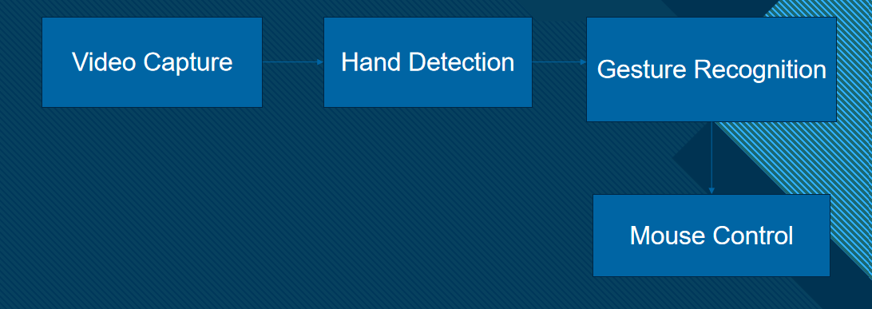

1. **Tools and Libraries Used:**
   * **OpenCV:** Video frame capture and display.
   * **MediaPipe:** Hand landmark tracking with 21 key points.
   * **PyAutoGUI:** Automating mouse actions.
   * **Pynput:** Low-level mouse control.
   * **Random:** Generating random numbers for auxiliary features.

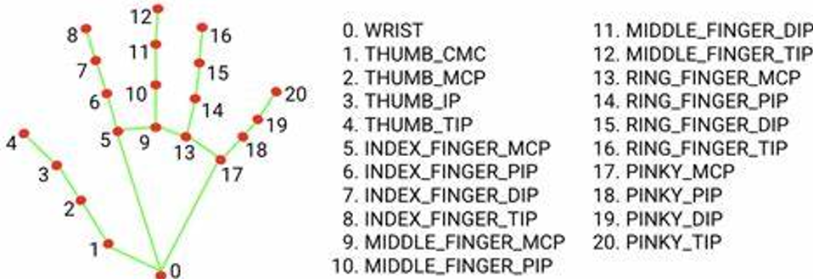

1. **Gesture Detection:**
   * **Left Click:** Thumb (Landmark 4) and Index (Landmark 8) close together.

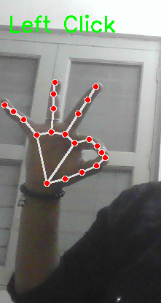

* + **Right Click:** Thumb (Landmark 4) and Middle Finger (Landmark 12) close together.

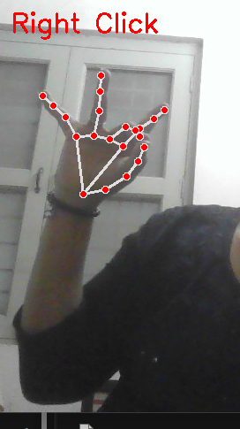

* + **Scroll Up/Down:** Middle Finger (Landmark 12) moves up or down.

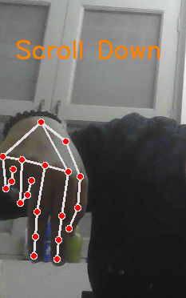

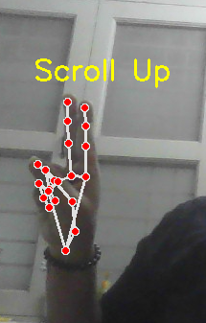

* + **Screenshot:** Thumb (Landmark 4) and Little Finger (Landmark 20) close together.

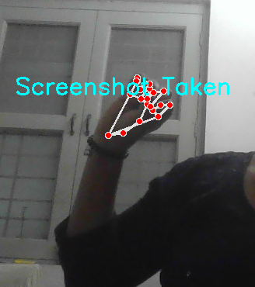

**Challenges Encountered:**

* + Variable lighting affecting detection accuracy.
  + Limited gesture library.
  + High CPU usage for real-time processing.

**Improvement Opportunities:**

* + Adding support for multiple hands.
  + Customizable gestures for more actions.
  + Integration with AR/VR systems.

**Applications**

* Touchless control for presentations.
* Gaming and virtual reality interfaces.
* Smart home control systems.

**ChatBot:**

A Chatbot is a vital tool for enhancing user experience by providing **instant support** and **24/7 availability**. It simplifies communication by answering frequently asked questions, guiding users, and automating repetitive tasks. Chat bots save time, reduce human effort, and improve efficiency in customer service and business processes. They are highly scalable and can handle multiple queries simultaneously, ensuring quick and accurate responses.

**Dialogflow:**

Dialogflow is a powerful tool for creating chatbots that leverage **Natural Language Processing (NLP)** to understand and respond to user queries effectively.

Its key uses include:

1. **Intent Recognition**: Dialog flow identifies user intents and maps them to appropriate responses, enabling seamless communication.
2. **Multi-Channel Integration**: It allows chat bots to be deployed across platforms like websites, mobile apps, and social media (e.g., Messenger,Telegram).
3. **Context Handling**: Maintains the context of conversations, making interactions more personalized and relevant.
4. **Customizable Responses**: Developers can design dynamic and tailored responses using Dialog flow’s rich set of tools.
5. **Scalability**: Handles multiple languages and large volumes of interactions efficiently, perfect for businesses of all sizes.

Integrating Dialogflow with a Virtual Mouse Project: Step-by-Step

1. **Set Up Dialog flow Account**: Create a Dialog flow account and a new agent for the Virtual Mouse project.
2. **Define Intents**: Create intents like "Mouse Movement," "Click," and "Scroll" with sample user input to trigger actions.
3. **Create Entities**: Define entities such as "Direction" (e.g., "up," "down") to capture specific information from user queries.
4. **Configure Fulfillment**: Enable web hook in Dialog flow and integrate it with your Virtual Mouse code to trigger actions based on intents.
5. **Test and Debug**: Test the chatbot to ensure it recognizes and processes commands correctly, adjusting parameters as needed.
6. **Integrate with Virtual Mouse**: Use the web hook to trigger mouse actions in your app using libraries like **PyAutoGUI** .
7. **Deploy and Improve**: Deploy the integrated solution and refine intents/entities based on user interactions for continuous improvement.

Intents:

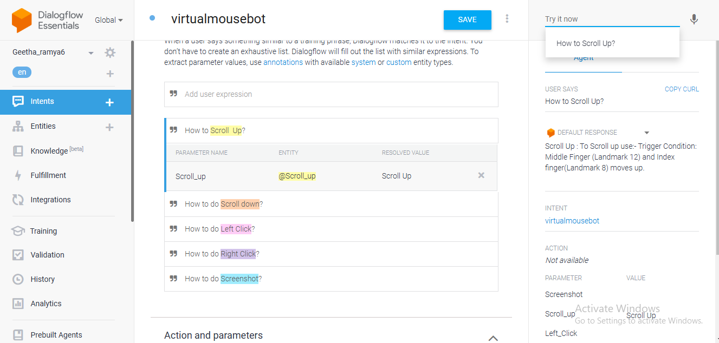

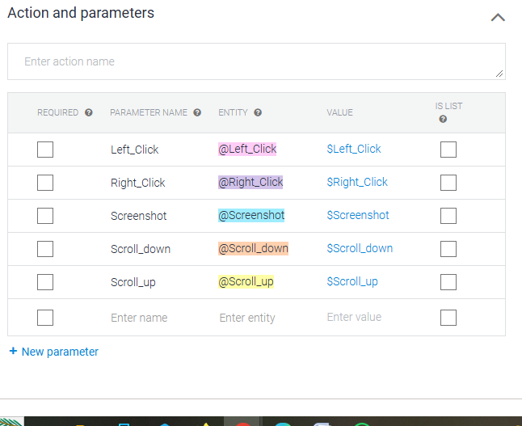

Entities:

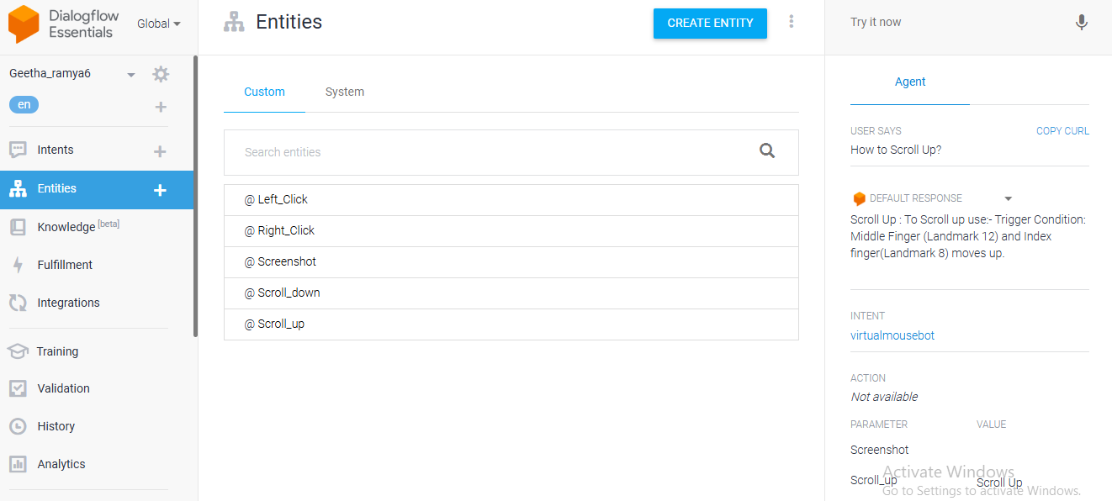

**ChatBot:**

