Angular (v20.0) – Hands-On 1

Aim: To set up an Angular application using Angular CLI, understand the Angular project structure, create reusable components, and build the basic Student Course Portal interface

Theory: Angular is a TypeScript-based framework used to build Single Page Applications (SPAs). Angular CLI simplifies project creation, component generation, building, and serving applications. Angular applications are built using standalone components, each consisting of a TypeScript file, HTML template, CSS stylesheet, and test file. The Angular project structure organizes application code, configuration files, assets, and dependencies efficiently, making development and maintenance easier.

Procedure:
- Installed Angular CLI.
- Created a new Angular project named student-course-portal.
- Explored the generated project structure.
- Created notes.txt explaining important Angular files.
- Executed ng serve and verified the Angular application.
- Executed ng build and verified the generated dist folder.
- Generated the following components:
  - HeaderComponent
  - HomeComponent
  - CourseListComponent
  - StudentProfileComponent
- Updated HeaderComponent with navigation links.
- Updated HomeComponent with welcome message and statistics.
- Modified the root component to display the Header and Home components.
- Verified the application in the browser.

Outputs:
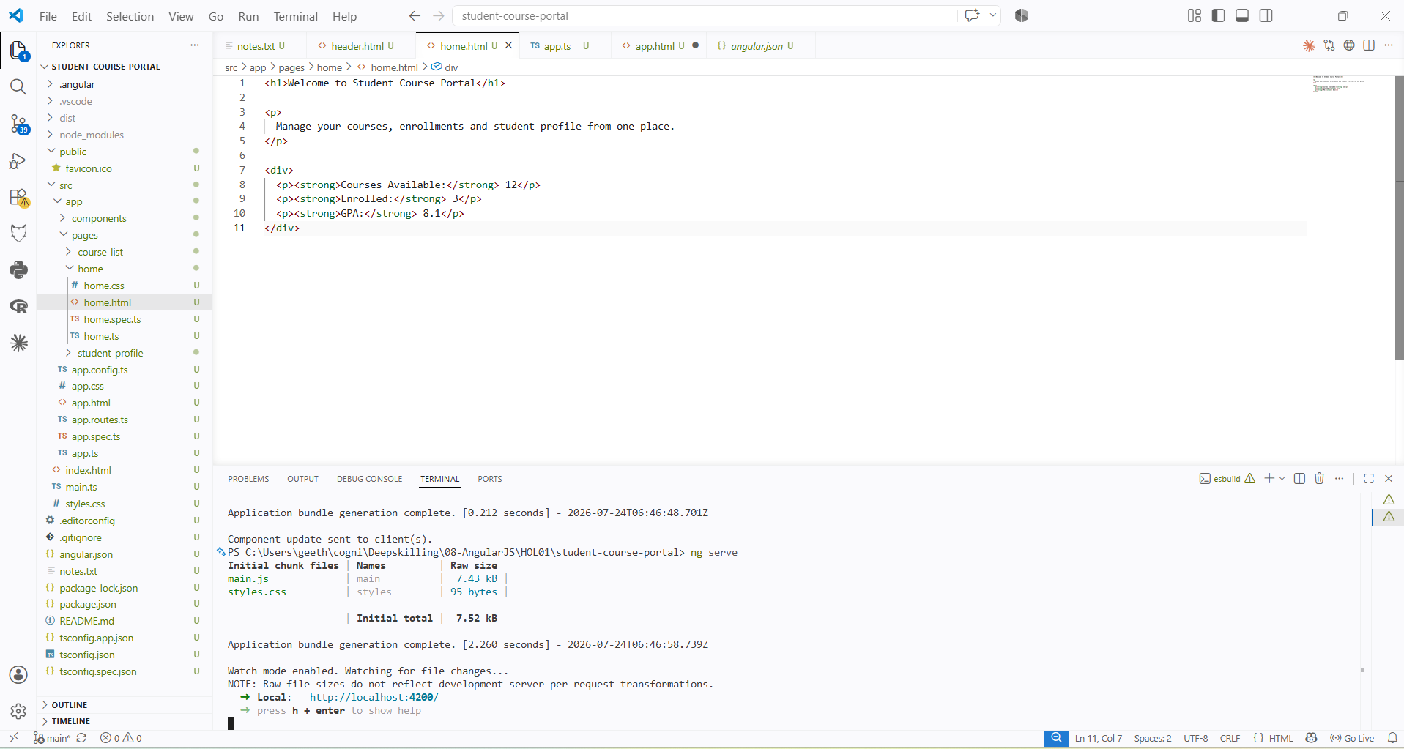
Header.html
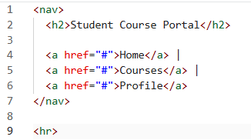
app.html
