HANDS-ON 2: Data Binding, Lifecycle Hooks & Component Communication
Objective: To implement Angular data binding techniques, lifecycle hooks, and parent-child component communication using @Input and @Output decorators in the Student Course Portal application.
Output-1
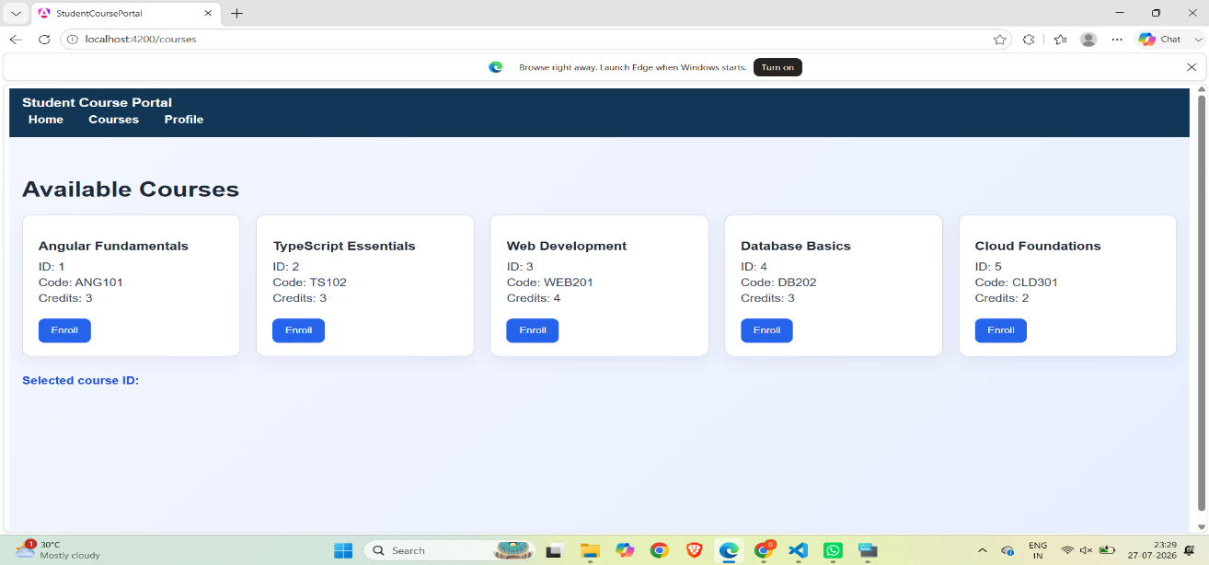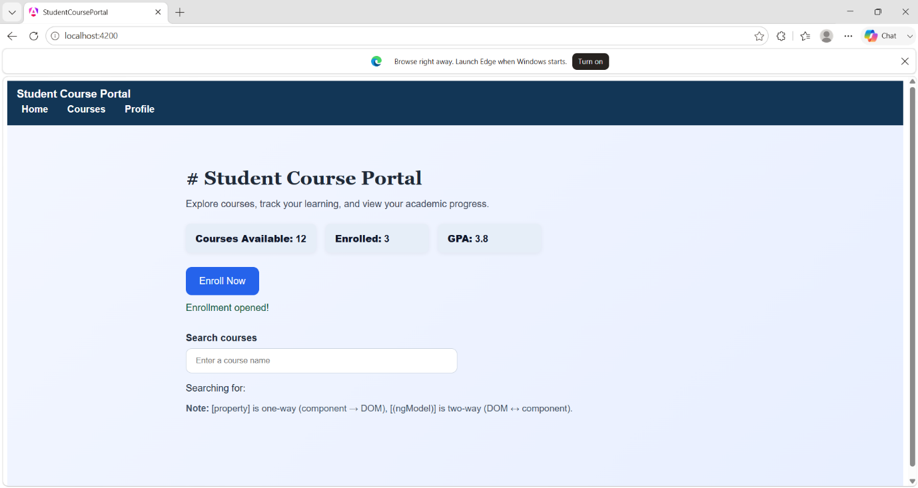

Output-3
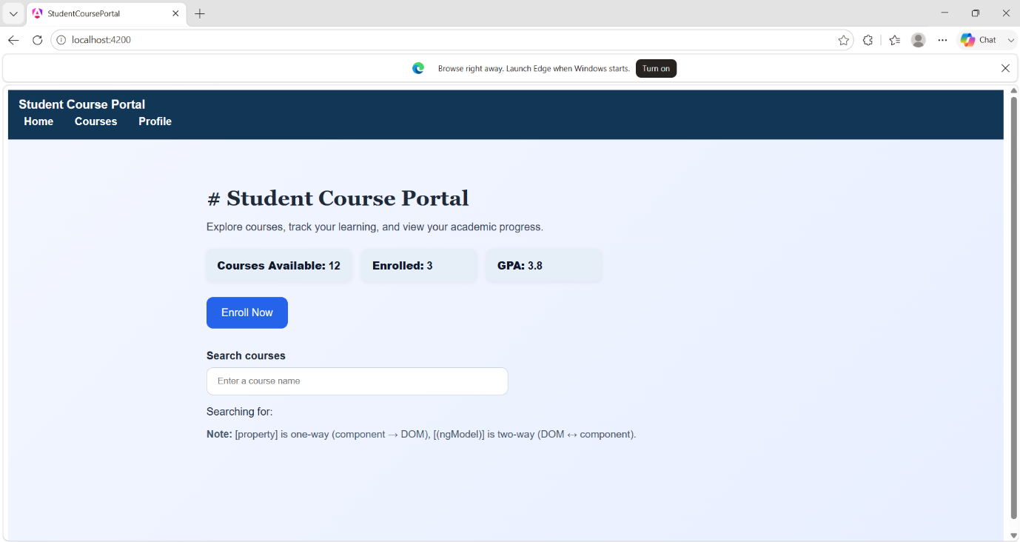
Output-4
