HANDS-ON 4: Template-Driven Forms & Validation
Objective: To build a template-driven student enrolment form using Angular Forms, implement built-in validations, display validation messages, and handle form submission successfully.
Student Registration Form
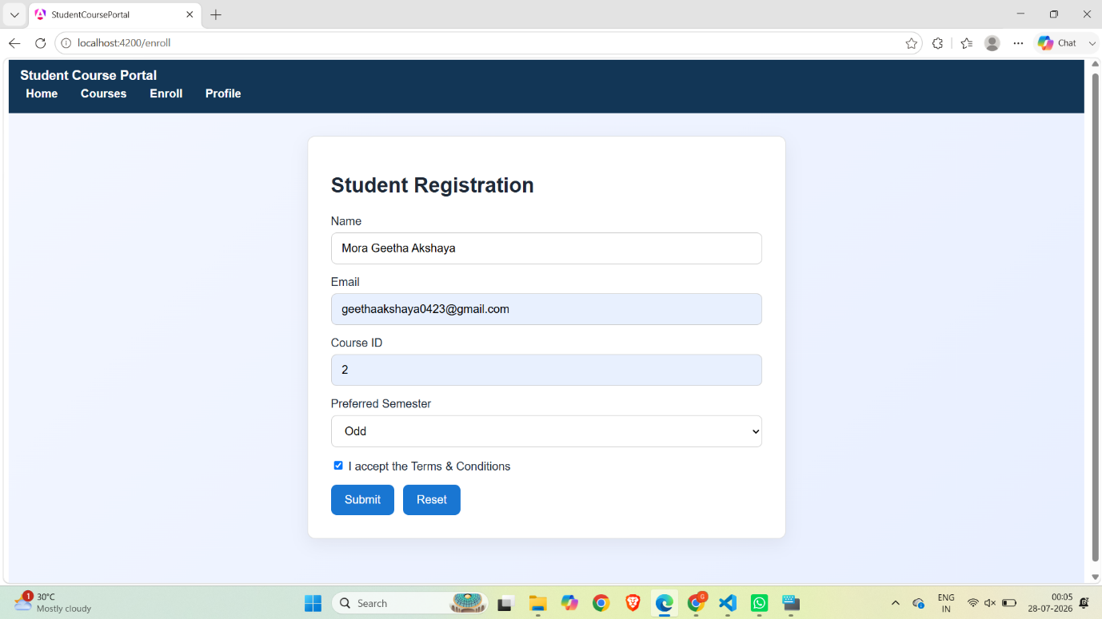
Form Validation with Valid Inputs
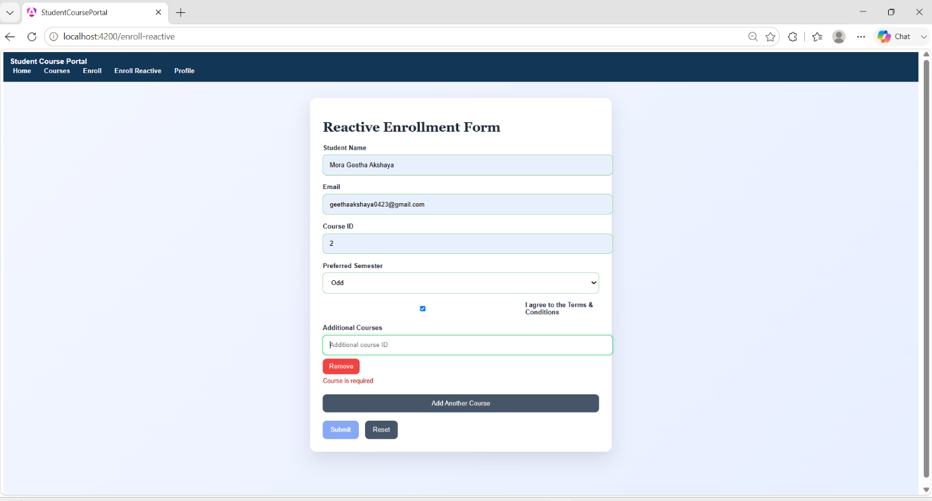

Successful Enrolment Submission
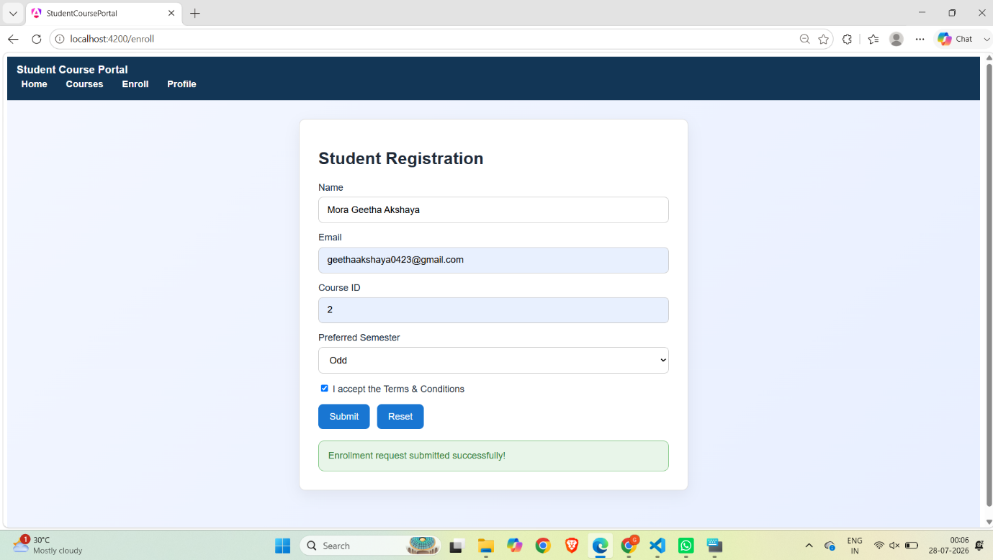
Reset Enrolment Form


