HANDS-ON 5: Reactive Forms – FormBuilder, FormGroup, FormArray & Custom Validators

Objective: To develop a reactive enrollment form using Angular Reactive Forms, implement built-in and custom validators, use asynchronous validation, and manage dynamic form controls using FormArray.

Reactive Enrolment Form
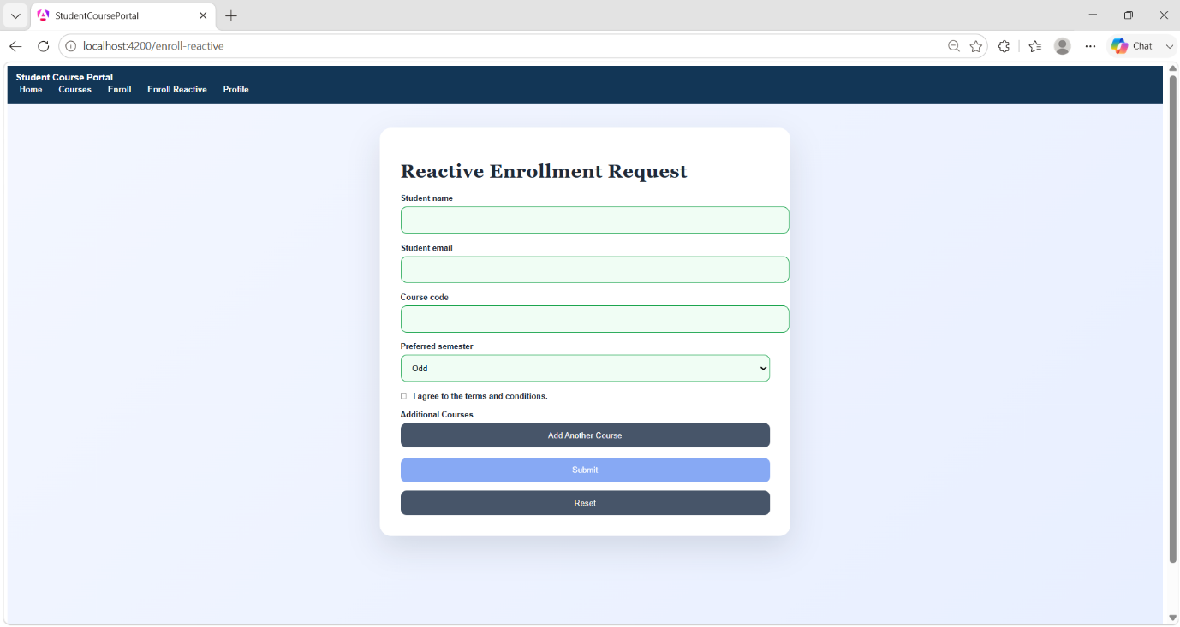
Valid Reactive Form
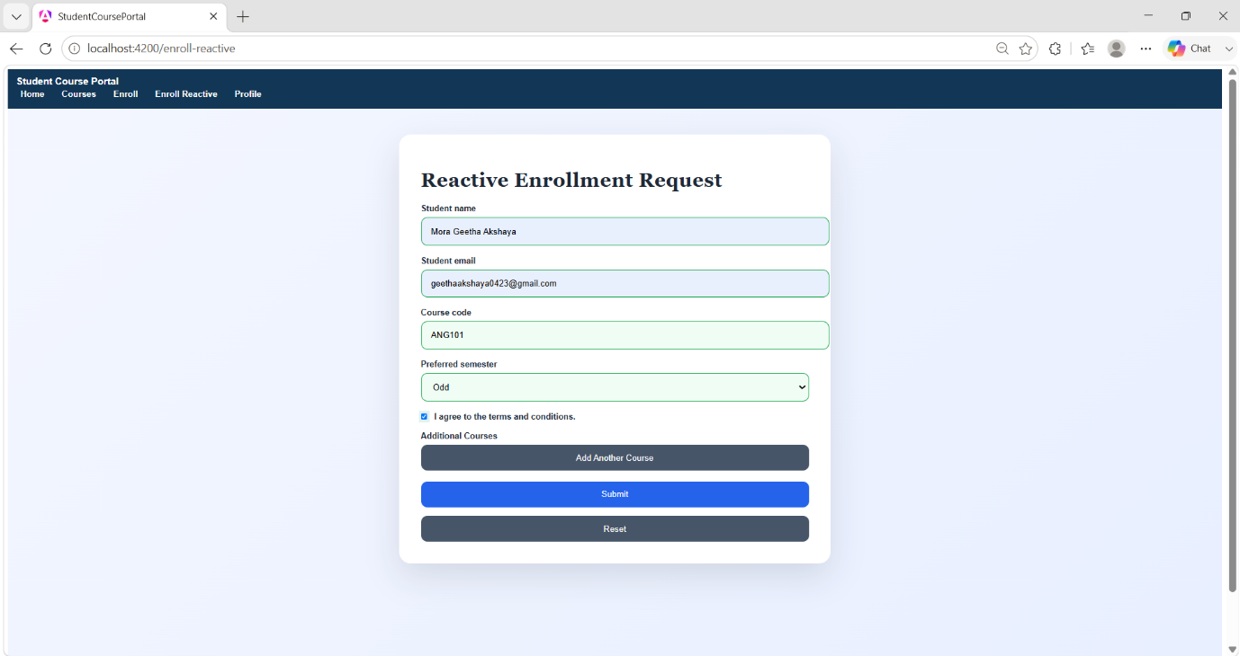

Custom Validation Errors
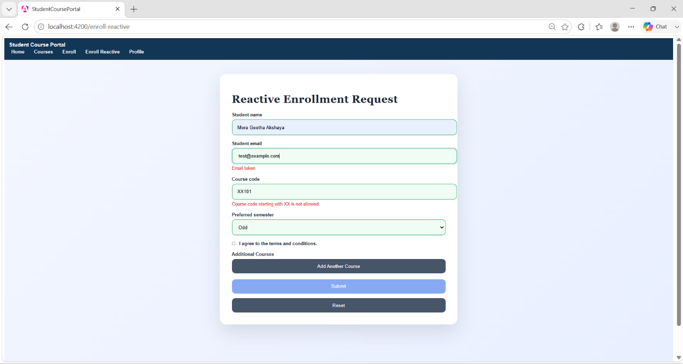

Dynamic Additional Courses
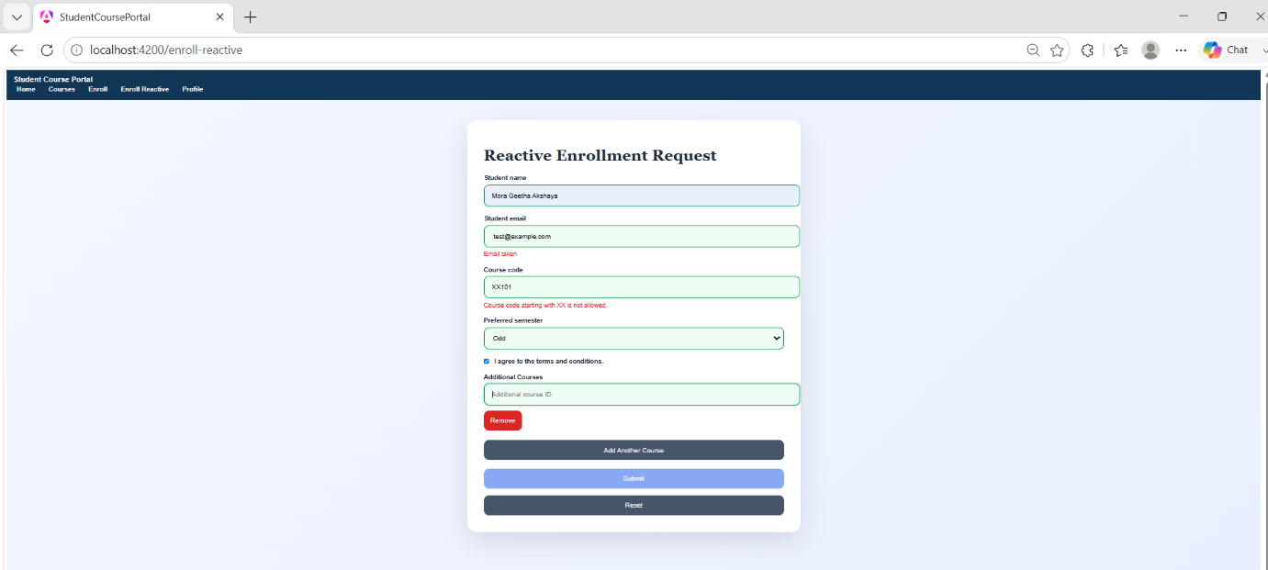

Successful Reactive Form Submission
