HANDS-ON 7: Angular Routing – Guards, Lazy Loading & Route Data

Objective: To implement Angular Routing in the Student Course Portal by configuring application routes, using route parameters and query parameters, implementing nested routes, enabling lazy loading, and protecting routes using CanActivate and CanDeactivate guards.

Course List with Query Parameter Search
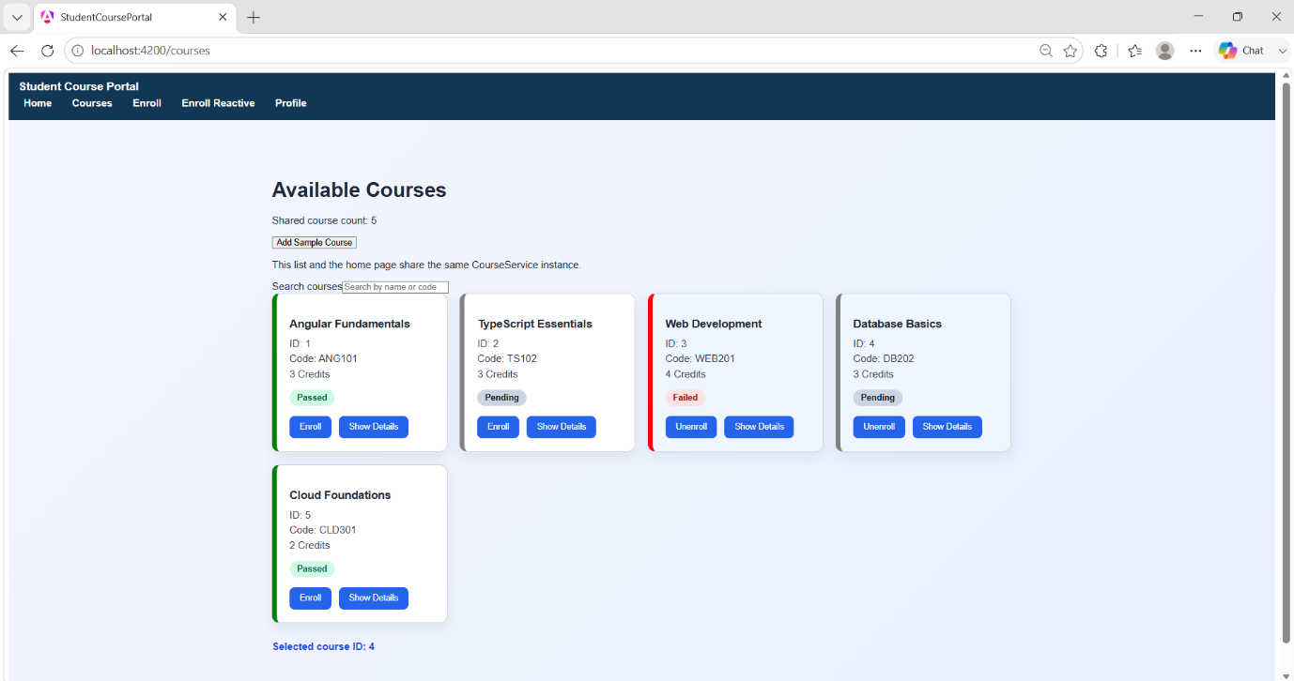
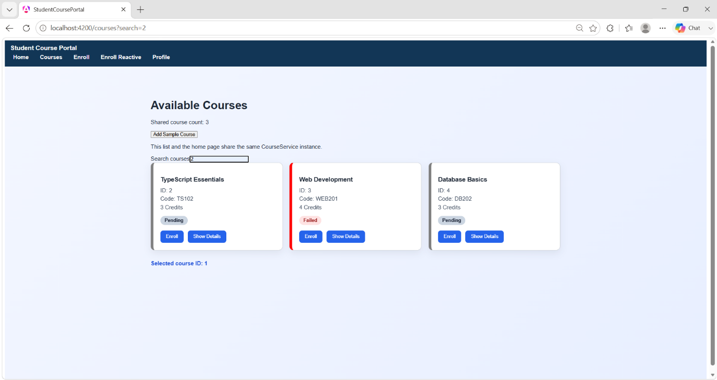

Course Search Showing No Matching Results
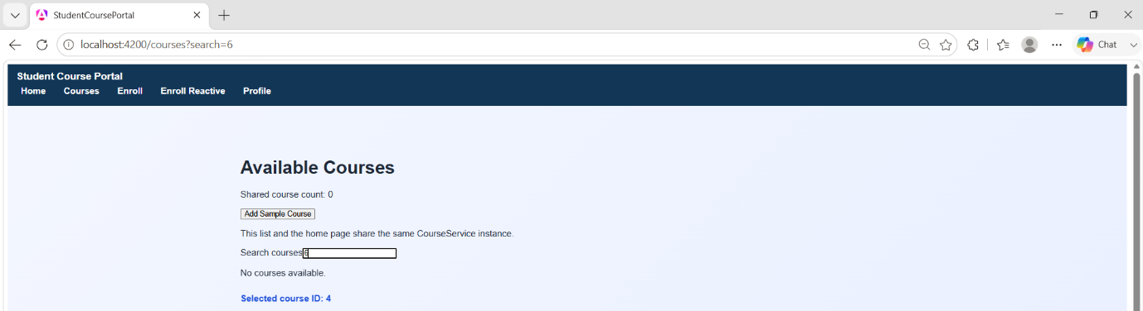

Unsaved Changes Confirmation Dialog
