HANDS-ON 9: State Management – NgRx Store, Actions, Reducers, Effects & Selectors

Objective: To implement centralized state management in the Student Course Portal using NgRx Store. The application was enhanced with Actions, Reducers, Effects, Selectors, and Redux DevTools to efficiently manage course and enrollment state while keeping the application scalable and maintainable.

Redux DevTools Showing Course Load State
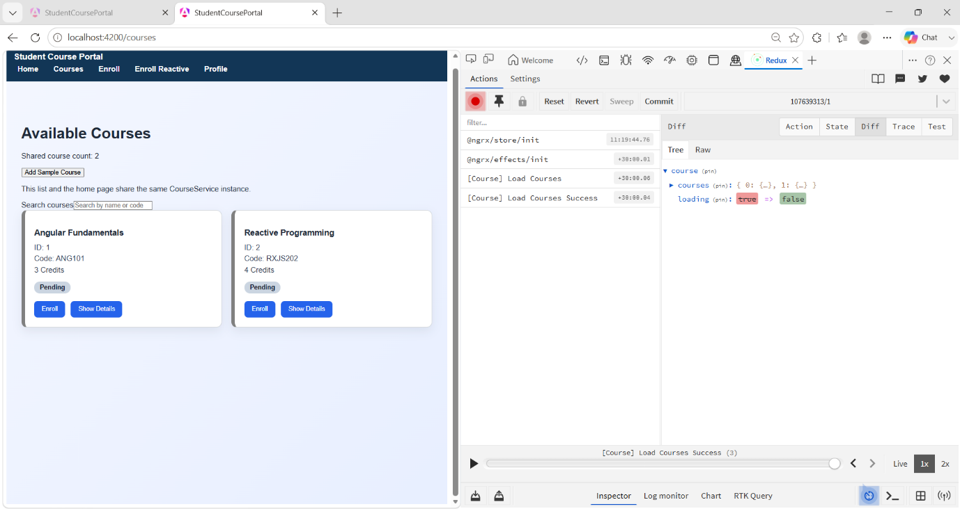
Enrolment State Updated in Redux DevTools
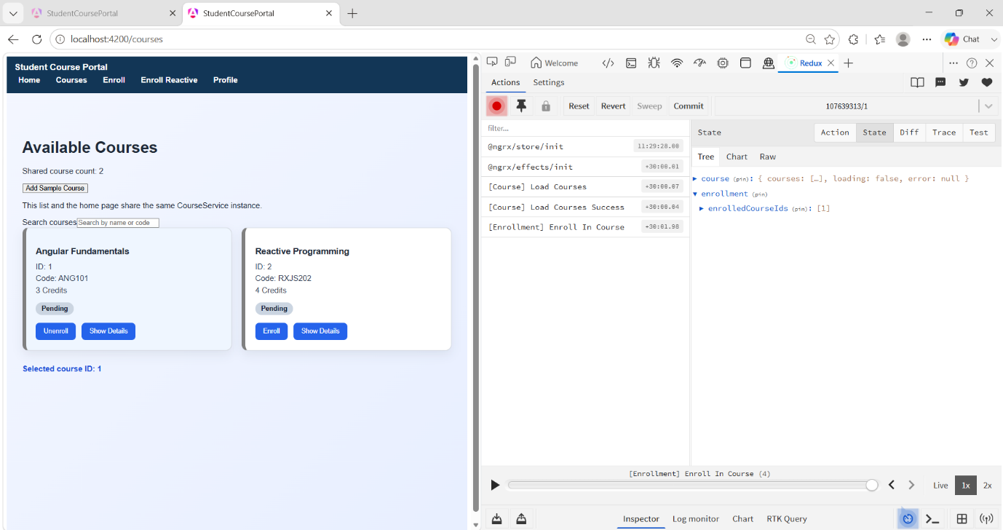
Unenroll From Course
