Exercise 1:Ranking and Window Functions

Create a Database
CREATE DATABASE CognizantDB;
GO
USE CognizantDB;
GO
Create the Employee Table
CREATE TABLE Employee
(
EmployeeID INT PRIMARY KEY,
EmployeeName VARCHAR(50),
Department VARCHAR(50),
Salary DECIMAL(10,2)
);
INSERT INTO Employee VALUES
(101,'Rahul','IT',60000),
(102,'Sneha','HR',45000),
(103,'Arjun','IT',70000),
(104,'Priya','Finance',55000),
(105,'Kiran','IT',80000),
(106,'Anjali','HR',50000),
(107,'Vikas','Finance',65000),
(108,'Neha','IT',75000);
SELECT * FROM Employee;
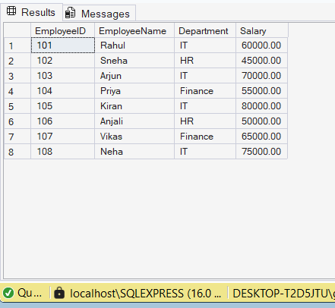
ROW_NUMBER()
SELECT
EmployeeID,
EmployeeName,
Department,
Salary,
ROW_NUMBER() OVER(ORDER BY Salary DESC) AS RowNum
FROM Employee;
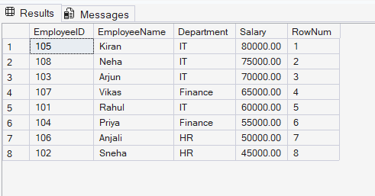
RANK()
SELECT
EmployeeName,
Salary,
RANK() OVER(ORDER BY Salary DESC) AS RankNo
FROM Employee;
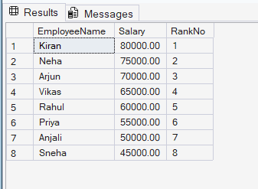
DENSE_RANK()
SELECT
EmployeeName,
Salary,
DENSE_RANK() OVER(ORDER BY Salary DESC) AS DenseRankNo
FROM Employee;
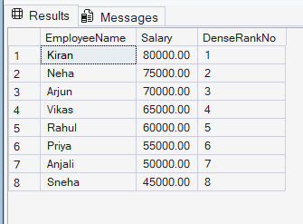

Partition By Department
SELECT
EmployeeName,
Department,
Salary,
ROW_NUMBER() OVER(PARTITION BY Department ORDER BY Salary DESC) AS DeptRank
FROM Employee;
