Customer-churn-prediction Final Report
CUSTOMER-CHURN-PREDICTION USING PYTHON
Minor Project Report
Submitted By
Name:Bonagiri geetha
College Name:CMR Technical campus(Autonomous engineering)
Internship Organization:SkillHigh
Department:CSE(Data science)
Academic Year: 2025-2026

Customer Churn Prediction Using Logistic Regression
Abstract
Customer churn prediction is one of the most important applications of machine learning in the business industry. Churn refers to the situation where customers stop using a company’s products or services. Predicting customer churn helps businesses identify customers who are likely to leave and enables companies to take preventive measures to retain them. In this project, a machine learning model is developed using Logistic Regression to predict whether a customer will churn or not. The project uses Python programming along with Pandas, NumPy, Matplotlib, Seaborn, and Scikit-learn libraries for data preprocessing, visualization, model training, and evaluation. The model is trained using the Telco Customer Churn dataset and achieves good prediction accuracy.

Introduction
Customer churn is one of the major challenges faced by telecom companies, where customers stop using the company’s services and switch to other providers. Customer loss can affect business growth, profitability, and customer relationships. Therefore, predicting customer churn is important for improving customer retention strategies.
Customer Churn Prediction is a Machine Learning application used to identify customers who are likely to leave a service. In this project, the Telco Customer Churn dataset is used to analyze customer behavior based on features such as contract type, internet services, monthly charges, tenure, and payment methods.
The project includes data preprocessing, handling missing values, encoding categorical data, model training, and performance evaluation. A Random Forest Classifier was used to build the prediction model because of its good accuracy and efficiency in classification problems.
The model achieved approximately 79.56% accuracy, showing effective prediction performance. This project demonstrates the practical application of Machine Learning and Data Analytics in solving real-world business problems and improving customer retention strategies.
Objectives
The main objective of this project is to develop a Machine Learning model capable of predicting customer churn in the telecom industry. Customer churn prediction helps organizations identify customers who are likely to discontinue their services, allowing companies to take preventive actions to improve customer retention and reduce business losses.
The specific objectives of the project are as follows:
- To analyze customer data and understand customer behavior patterns related to churn.
- To identify the important factors that influence customers to leave telecom services.
- To preprocess the dataset by handling missing values, removing unnecessary columns, and converting categorical data into numerical format.
- To apply data cleaning and transformation techniques for improving data quality and model performance.
- To build a predictive Machine Learning model using the Random Forest Classifier algorithm.
- To divide the dataset into training and testing datasets for effective model evaluation.
- To train the model using historical customer data and predict customer churn accurately.
- To evaluate the performance of the Machine Learning model using metrics such as Accuracy Score, Confusion Matrix, and Classification Report.
- To analyze feature importance and identify the most influential customer attributes affecting churn prediction.
- To help telecom companies improve customer retention strategies by identifying high-risk customers in advance.
- To reduce customer loss and improve business profitability using data-driven decision-making techniques.
- To gain practical knowledge and hands-on experience in Machine Learning, Data Analytics, and predictive modeling.
- To demonstrate the real-world application of Machine Learning in solving business-related problems.
The overall objective of the project is to create an efficient and reliable churn prediction system that can support organizations in improving customer satisfaction and long-term business growth.

Problem Statement
Customer churn is one of the major challenges faced by telecom companies in today’s highly competitive market. Customers frequently switch from one service provider to another due to factors such as high service charges, poor customer support, network issues, better offers from competitors, and dissatisfaction with services. Losing customers not only reduces company revenue but also increases the cost of acquiring new customers.
Telecom companies generate large amounts of customer data, but analyzing this data manually to identify customers who are likely to leave the service is difficult and time-consuming. Therefore, there is a need for an intelligent system that can automatically analyze customer information and predict customer churn accurately.
The main problem addressed in this project is to develop a Machine Learning-based Customer Churn Prediction system that can identify customers who are likely to discontinue telecom services. The system should analyze customer-related factors such as:
- Contract type
- Internet services
- Monthly charges
- Total charges
- Customer tenure
- Payment methods
- Customer support services
Based on these features, the system predicts whether a customer will churn or continue using the service.
The project aims to solve the following problems:
- Difficulty in identifying high-risk customers manually
- Customer revenue loss due to churn
- Lack of effective customer retention strategies
- Need for data-driven decision-making in telecom companies
To solve these issues, the project uses Machine Learning techniques, specifically the Random Forest Classifier algorithm, to build an accurate prediction model. The developed system helps telecom companies take preventive actions such as providing offers, improving services, and enhancing customer support to reduce customer churn and improve customer satisfaction.
Thus, the project focuses on using Machine Learning and Data Analytics to solve a real-world business problem effectively and efficiently.

Scope of the Project
The scope of the Customer Churn Prediction project is focused on analyzing customer data and predicting whether a customer is likely to leave the telecom service. The project uses Machine Learning techniques to help telecom companies improve customer retention and business performance.
This project mainly covers the following areas:
- Collection and analysis of telecom customer data
- Data preprocessing and cleaning
- Handling missing values and categorical data
- Building a Machine Learning prediction model
- Evaluating model performance using different metrics
- Identifying important factors affecting customer churn
The project uses the Telco Customer Churn dataset, which contains customer information such as demographics, service usage, contract type, monthly charges, total charges, payment methods, and internet services. These features are analyzed to identify customer behavior patterns related to churn.
The project also includes visualization and feature importance analysis to understand the major factors influencing customer decisions.
This project can help telecom companies:
- Identify high-risk customers
- Improve customer retention strategies
- Reduce customer loss
- Increase business profitability
- Support better decision-making using data analytics
The developed model can also be extended to other industries such as banking, insurance, healthcare, e-commerce, and subscription-based services where customer retention is important.
Future enhancements of the project may include:
- Real-time churn prediction systems
- Web application deployment using Streamlit or Flask
- Integration with live customer databases
- Advanced Machine Learning and Deep Learning algorithms
- Automated recommendation and customer retention systems
Overall, the project demonstrates the practical application of Machine Learning and Data Analytics in solving real-world business problems and improving organizational decision-making processes
Technologies Used
Various technologies, programming libraries, and Machine Learning tools were used in this project to perform data preprocessing, analysis, model training, prediction, and visualization. These technologies helped in building an efficient and accurate Customer Churn Prediction system.
- Python
Python is the primary programming language used for this project. It is one of the most popular languages for Machine Learning, Data Science, and Data Analytics because of its simple syntax, flexibility, and large collection of libraries.
Python was used for:
- Data preprocessing
- Data analysis
- Model building
- Prediction
- Visualization
- Evaluation of results
Its easy-to-understand syntax and powerful libraries make it highly suitable for Machine Learning applications.

- Pandas
Pandas is a powerful Python library used for data manipulation and analysis. It provides data structures such as DataFrames, which make handling large datasets easier and more efficient.
In this project, Pandas was used for:
- Loading the dataset using read_csv()
- Viewing dataset information
- Handling missing values
- Data cleaning and preprocessing
- Selecting and modifying columns
- Data transformation
Pandas played a major role in preparing the dataset for Machine Learning model training.
- NumPy
NumPy is a numerical computing library used for performing mathematical and array operations efficiently.
In this project, NumPy was used for:
- Numerical computations
- Array operations
- Mathematical calculations
- Supporting data preprocessing operations
NumPy improves processing speed and supports handling large datasets efficiently.
- Matplotlib
Matplotlib is a data visualization library used to create graphs and charts.
In this project, Matplotlib was used for:
- Plotting feature importance graphs
- Visualizing data analysis results
- Creating graphical representations of model outputs
Visualization helps in understanding customer behavior and feature influence more clearly.
- Seaborn
Seaborn is a statistical data visualization library built on top of Matplotlib. It provides attractive and informative graphs with less code.
In this project, Seaborn was used for:
- Creating bar plots
- Visualizing feature importance
- Improving graph presentation and readability
Seaborn made the visual outputs more professional and easier to interpret.

- Scikit-learn
Scikit-learn is one of the most widely used Machine Learning libraries in Python. It provides tools for data preprocessing, model building, training, testing, and evaluation.
In this project, Scikit-learn was used for:
- Label Encoding using LabelEncoder
- Splitting data using train_test_split
- Building the Random Forest model using RandomForestClassifier
- Evaluating model performance using:
  - accuracy_score
  - confusion_matrix
  - classification_report
Scikit-learn simplified the implementation of the Machine Learning workflow.
- Jupyter Notebook
Jupyter Notebook was used as the development environment for the project. It allows users to write and execute Python code interactively in separate cells.
Jupyter Notebook was useful for:
- Step-by-step code execution
- Data analysis
- Visualization
- Documentation
- Debugging and testing
It is widely used in Data Science and Machine Learning projects because it combines code, output, and explanation in a single environment.
Machine Learning Algorithm – Random Forest Classifier
The Random Forest Classifier algorithm was used as the main Machine Learning model for customer churn prediction.
Reasons for choosing Random Forest:
- High prediction accuracy
- Handles large datasets effectively
- Reduces overfitting problems
- Works well with classification tasks
- Provides feature importance analysis
The model was trained using customer data and successfully predicted customer churn with approximately 79.56% accuracy.

Overall Importance of Technologies Used
The combination of these technologies helped in:
- Efficient data processing
- Accurate prediction
- Better visualization
- Effective model evaluation
- Successful implementation of the Customer Churn Prediction system
These technologies collectively demonstrate the practical application of Machine Learning and Data Analytics in solving real-world business problems.

Dataset Description
The project uses the Telco Customer Churn dataset.
Dataset Features
Feature | Description
gender | Customer gender
SeniorCitizen | Whether customer is senior citizen
Partner | Whether customer has partner
Dependents | Whether customer has dependents
tenure | Number of months customer stayed
PhoneService | Whether customer has phone service
MultipleLines | Multiple phone lines
InternetService | Type of internet service
OnlineSecurity | Online security service
OnlineBackup | Online backup service
DeviceProtection | Device protection service
TechSupport | Technical support service
StreamingTV | Streaming TV service
StreamingMovies | Streaming movie service
Contract | Contract type
PaperlessBilling | Paperless billing
PaymentMethod | Payment method
MonthlyCharges | Monthly charges
TotalCharges | Total charges
Churn | Target variable

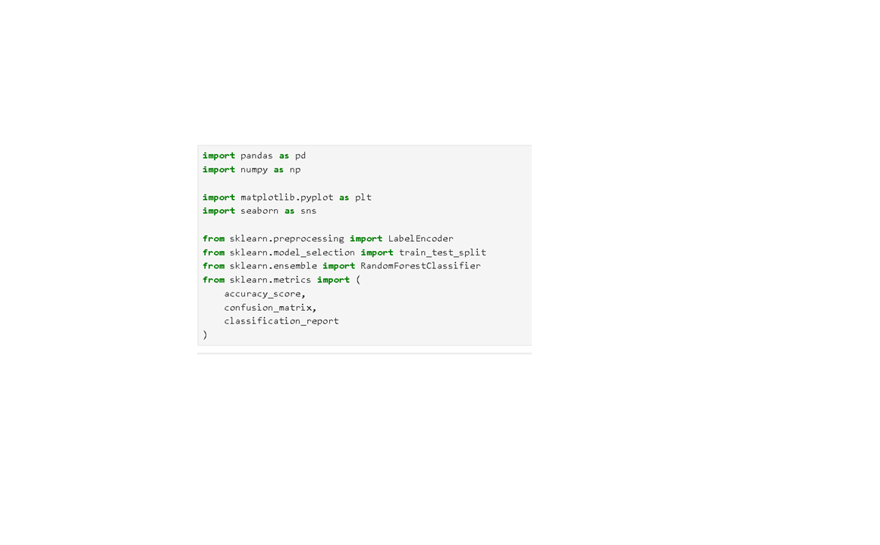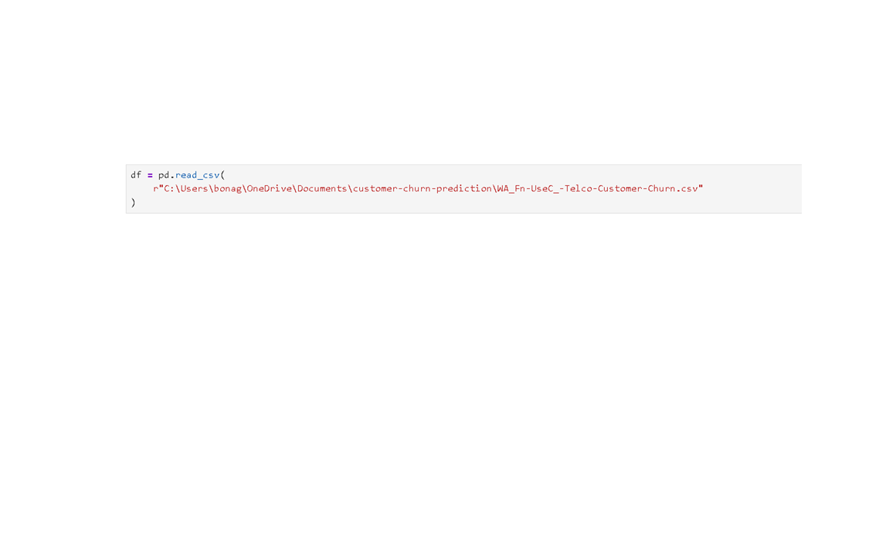
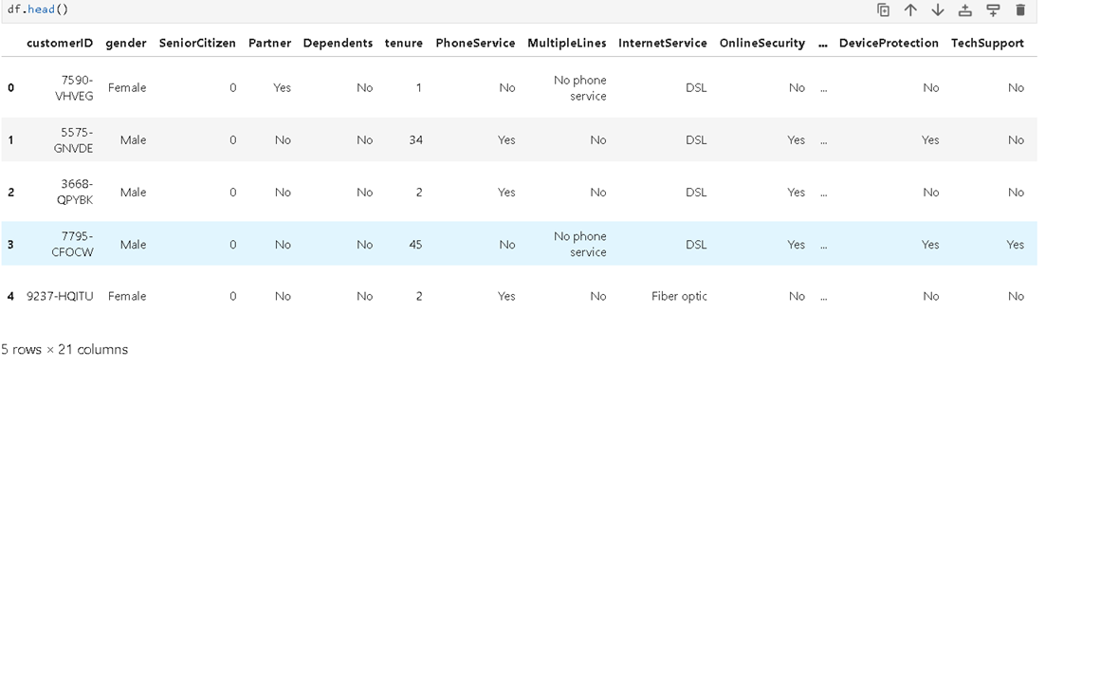

Methodology
The project follows the following steps:
- Data Collection
- Data Preprocessing
- Data Cleaning
- Feature Encoding
- Data Splitting
- Model Training
- Prediction
- Model Evaluation

Data Preprocessing
Data preprocessing is one of the most important stages in a Machine Learning project. Raw data collected from real-world sources often contains missing values, inconsistent formats, unnecessary information, and categorical data that cannot be directly processed by Machine Learning algorithms. Therefore, preprocessing is performed to clean and transform the dataset into a suitable format for analysis and model training.
In this project, the Telco Customer Churn dataset was preprocessed using several techniques to improve data quality and prediction accuracy.
1.Dataset Loading
The dataset was loaded into the Jupyter Notebook environment using the Pandas library. The read_csv() function was used to import the CSV file into a DataFrame for further processing and analysis.

2.Checking Missing Values
The dataset was checked for missing or null values using the isnull().sum() function. During this step, it was identified that the TotalCharges column contained some missing values. Missing values can negatively affect Machine Learning model performance, so they must be handled properly.
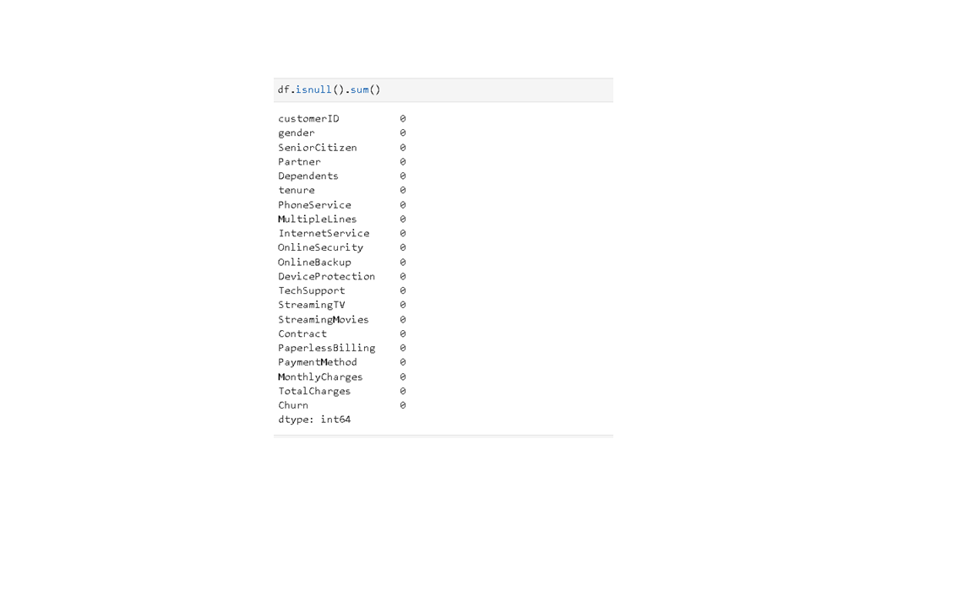
3.Handling Missing Values
The TotalCharges column originally contained some non-numeric and empty values. To resolve this issue, the column was converted into numeric format using the pd.to_numeric() function with the errors='coerce' parameter. This converted invalid entries into null values.
The missing values were then replaced using the median value of the TotalCharges column. Median was selected because it is less sensitive to extreme values and helps maintain data consistency without affecting the overall distribution.
4.Removing Unnecessary Columns
The customerID column was removed from the dataset because it acts only as a unique identifier and does not contribute to predicting customer churn. Removing irrelevant features helps reduce dataset complexity and improves model efficiency.
5.Encoding Categorical Data
The dataset contained several categorical columns with text values such as:
  - Male/Female
  - Yes/No
  - Contract Types
- Payment Methods
Machine Learning algorithms cannot process text data directly, so Label Encoding was applied to convert categorical values into numerical format. The LabelEncoder() function from Scikit-learn was used for this purpose.
Example:
- Male → 1
- Female → 0
- Yes → 1
- No → 0
This transformation allowed the Machine Learning model to process the dataset effectively.
6.Feature and Target Separation
After preprocessing, the dataset was divided into:
- Features (X): Independent variables used for prediction
- Target Variable (y): Dependent variable (Churn)
This step is necessary for supervised Machine Learning model training.
7.Train-Test Split
The processed dataset was divided into training and testing datasets using the train_test_split() function.
- 80% of the data was used for training the model.
- 20% of the data was used for testing and evaluation.
This helps evaluate how well the trained model performs on unseen data.
8.Importance of Data Preprocessing
Data preprocessing improves the overall quality of the dataset and enhances the performance of the Machine Learning model. It:
- Removes inconsistencies from the dataset
- Handles missing values effectively
- Converts categorical data into numerical form
- Improves prediction accuracy
- Reduces model errors
- Makes the dataset suitable for Machine Learning algorithms
Thus, preprocessing played a crucial role in successfully building the Customer Churn Prediction model.


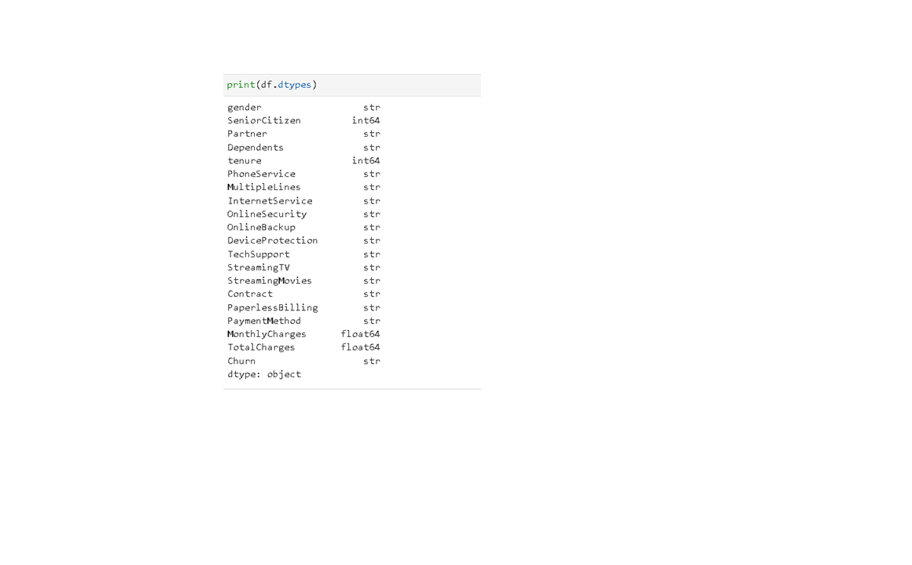

Logistic Regression
Logistic Regression is a supervised machine learning algorithm used for classification problems.
It predicts probabilities using the sigmoid function.
Logistic Regression Formula
[
P(Y=1)=\frac{1}{1+e^{-(b_0+b_1x)}}
]
Where:
- P(Y=1) = Probability of churn
- e = Exponential constant
- b0 = Intercept
- b1 = Coefficient
- x = Input feature
Logistic Regression is suitable for binary classification problems such as churn prediction.
Implementation
1: Import Libraries
import pandas as pd
import numpy as np
import matplotlib.pyplot as plt
import seaborn as sns
Step 2: Load Dataset
df=pd.read_csv("WA_Fn-UseC_-Telco-Customer-Churn.csv")
Step 3: Data Cleaning
df.drop("customerID", axis=1, inplace=True)
df["TotalCharges"]=pd.to_numeric(df["TotalCharges"], errors="coerce")
df["TotalCharges"] = df["TotalCharges"].fillna(df["TotalCharges"].median())
Step 4: Convert Churn Column
df["Churn"] = df["Churn"].map({"Yes":1, "No":0})
Step 5: Label Encoding
from sklearn.preprocessing import LabelEncoder le = LabelEncoder()
str_cols=df.select_dtypes(include=['object','string']).columns
for col in str_cols:
df[col] = le.fit_transform(df[col].astype(str))
Step 6: Split Dataset
X = df.drop("Churn", axis=1)
y = df["Churn"]
from sklearn.model_selection import train_test_split
X_train, X_test, y_train, y_test = train_test_split(
X, y, test_size=0.2, random_state=42
)
Step 7: Train Model
from sklearn.linear_model import LogisticRegression
model = LogisticRegression(max_iter=5000)
model.fit(X_train, y_train)
Step 8: Prediction
y_pred = model.predict(X_test)
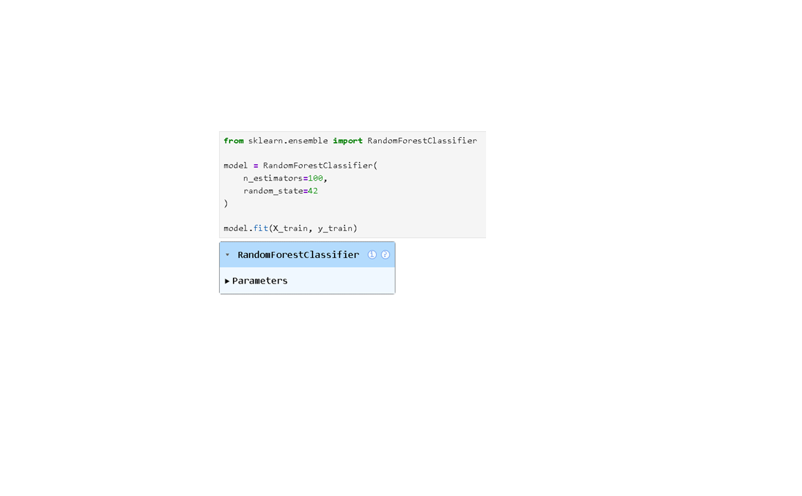
Step 9: Accuracy
from sklearn.metrics import accuracy_score
print("Accuracy:", accuracy_score(y_test, y_pred))
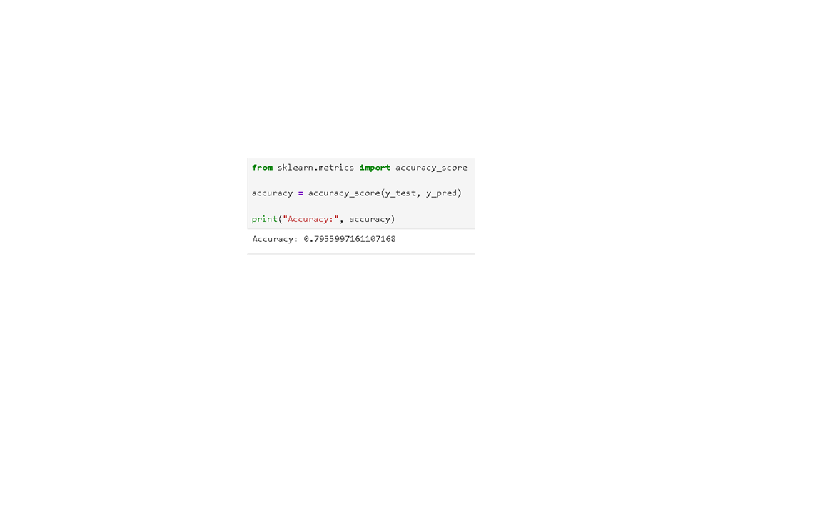

Results
The Logistic Regression model successfully predicted customer churn.
Outputs Obtained:
- Customer churn prediction
- Accuracy score
- Confusion matrix
- Classification report
The model achieved approximately 80% accuracy.
- Accuracy score

- Confusion matrix
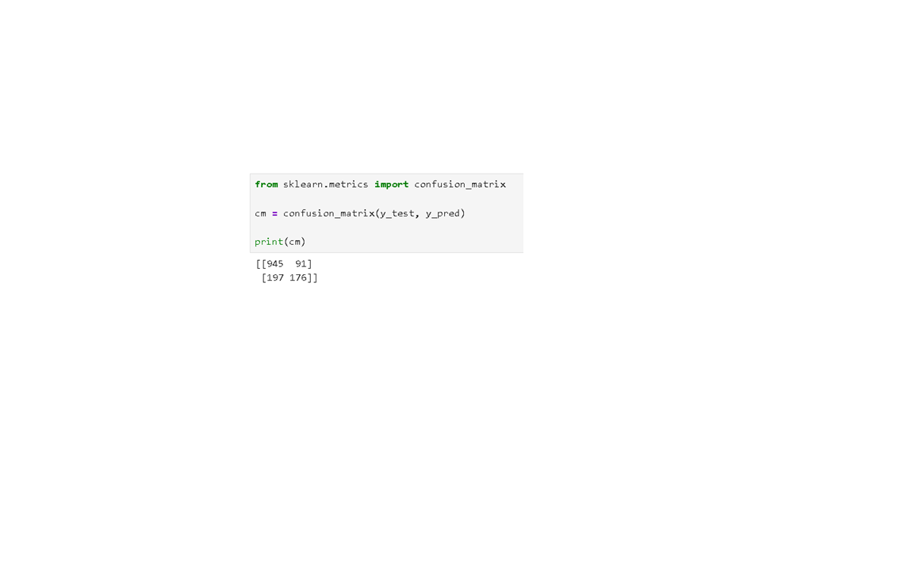
- Classification report
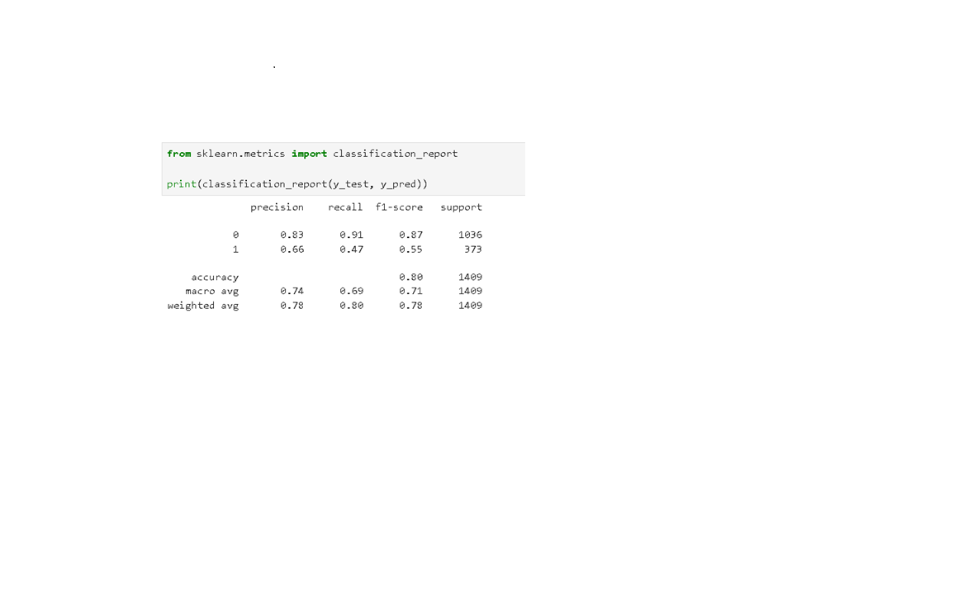
Feature Importance graph
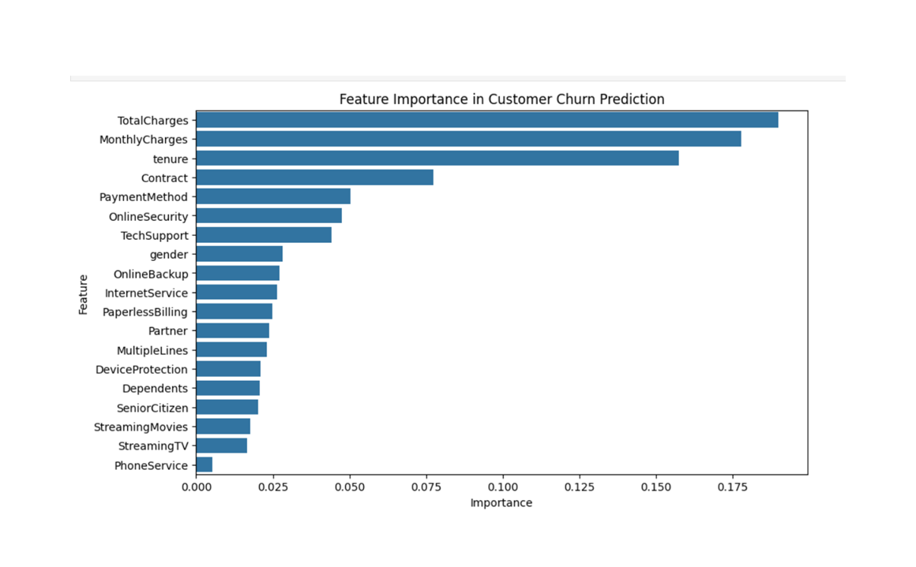
Confusion Matrix
A confusion matrix is used to evaluate classification performance.
from sklearn.metrics import confusion_matrix
cm = confusion_matrix(y_test, y_pred)
print(cm)
Visualization
sns.heatmap(cm, annot=True, fmt='d')
plt.xlabel("Predicted")
plt.ylabel("Actual")
plt.title("Confusion Matrix")
plt.show()
Advantages
- Helps identify at-risk customers.
- Improves customer retention.
- Reduces business revenue loss.
- Supports business decision-making.
- Easy to implement using machine learning.
Limitations
- Accuracy depends on data quality.
- Logistic Regression may not handle highly complex relationships.
- Requires preprocessing of categorical data.
- Predictions may vary with different datasets.

Future Scope
The Customer Churn Prediction project can be further improved and expanded using advanced technologies and modern Machine Learning techniques. Although the current model achieved good prediction accuracy, several enhancements can be implemented to increase efficiency, scalability, and real-time usability.
In the future, advanced Machine Learning algorithms such as XGBoost, Gradient Boosting, Support Vector Machines, and Deep Learning models can be used to improve prediction accuracy and model performance. Hyperparameter tuning and feature engineering techniques can also be applied to optimize the model further.
The project can be deployed as a real-time web application using frameworks such as Streamlit or Flask. This would allow telecom companies to enter customer details directly through a user-friendly interface and instantly predict whether a customer is likely to churn.
Real-time customer data integration can also be implemented to monitor customer behavior continuously. By analyzing live customer interactions, companies can take immediate preventive actions to retain customers.
Additional customer-related information such as customer feedback, complaint history, call records, and social media sentiment analysis can be included in the dataset to improve prediction quality and provide deeper customer insights.
The churn prediction system can also be extended to other industries such as:
- Banking
- Insurance
- E-commerce
- Healthcare
- Subscription-based services
This would help organizations across multiple sectors improve customer retention and business profitability.
Furthermore, automated recommendation systems can be integrated into the project to suggest personalized offers, discounts, and loyalty programs for customers who are likely to churn. This can help companies improve customer satisfaction and reduce customer loss effectively.
Overall, the project has strong potential for future development and practical real-world implementation in business environments.

Conclusion
The Customer Churn Prediction project was successfully implemented using Machine Learning techniques and data analytics methods. The primary objective of the project was to analyze customer behavior and predict whether a customer is likely to leave the telecom service.
The Telco Customer Churn dataset was used for the project, and several preprocessing techniques were applied, including handling missing values, removing unnecessary columns, and converting categorical data into numerical format using Label Encoding. These preprocessing steps improved data quality and prepared the dataset for Machine Learning model training.
A Random Forest Classifier was used as the prediction model because of its high accuracy and effective handling of classification problems. The dataset was divided into training and testing data to evaluate model performance on unseen records.
The trained model achieved approximately 79.56% accuracy, indicating good prediction capability. Evaluation metrics such as Accuracy Score, Confusion Matrix, and Classification Report were used to measure the model’s effectiveness. Feature importance analysis also helped identify the major factors influencing customer churn, such as contract type, tenure, monthly charges, and internet services.
The project demonstrates the practical application of Machine Learning in solving real-world business problems. By identifying customers who are likely to churn, telecom companies can take preventive measures such as improving customer support, providing attractive offers, and enhancing service quality to improve customer retention.
In conclusion, the project successfully achieved its objectives and provided valuable insights into customer behavior and churn prediction. It also highlights the importance of Machine Learning and Data Analytics in improving business decision-making and customer relationship management.

References
- Scikit-learn Documentation
- Pandas Documentation
- Python Official Documentation
- Machine Learning with Python Tutorials
- Telco Customer Churn Dataset

