WEEK 3 TASK REPORT
Advanced Data Analysis and Visualization in Logistics
Academic Year: 2026–2027
Internship Project: Logistics Data Analysis Internship
Institution: CMR Technical Campus, Hyderabad, Telangana
Programme: B.Tech – Computer Science and Data Science
Prepared by: Geetha Bonagiri

Acknowledgement
I would like to thank the internship team for providing an opportunity to practise data analysis in a logistics context. This report documents the data preparation, statistical summaries, visual exploration, interpretation, and recommendations completed for the Week 3 task.

Abstract
This report applies exploratory data analysis (EDA) and visualization to 250 simulated logistics shipments. It summarizes delivery time, transport cost, transport-mode performance, regional on-time delivery, and numeric relationships. The analysis identifies patterns that can guide monitoring and planning, while recognizing that simulated data cannot establish real-world performance or causality.

Contents
Executive Summary
Introduction and Objectives
Dataset Design and Methodology
Data Preparation and Exploratory Data Analysis
Descriptive Statistics and Visualizations
Key Findings
Recommendations
How Visualizations Support Decisions
Python Tools and Code
Limitations
Conclusion
Appendix: Reproducibility

Executive Summary
This report analyzes 250 simulated shipments to understand delivery speed, transportation costs, regional service levels, and relationships between shipment characteristics. The overall on-time delivery rate is 64.8%. Average delivery time is 2.45 days (median 2.21 days), and average transportation cost is ₹179.75 (median ₹173.31). The analysis uses descriptive statistics, grouped comparisons, histograms, scatter plots, a regional bar chart, and a correlation matrix. Since the data are hypothetical, results demonstrate a method and should not be treated as actual company performance.

Objectives
- Create a realistic, reproducible hypothetical logistics dataset.
- Explore data structure, quality, central tendency, spread, distributions, and correlations.
- Visualize delivery performance, cost patterns, transport-mode differences, and regional service levels.
- Translate patterns into practical recommendations for logistics planning and monitoring.

Dataset Design and Methodology
The dataset contains 250 shipment records across five regions and three transport modes. Each row represents one shipment. The data were generated with a fixed random seed so the analysis can be reproduced. Delivery time and cost are simulated from distance, weight, volume, transport mode, and random variation; a small proportion of shipments receive additional delay.
Variable | Meaning | Type
Shipment_ID | Unique shipment identifier | Categorical ID
Shipment_Date | Simulated shipment date | Date
Region | North, South, East, West, Central | Categorical
Transport_Mode | Road, Rail, or Air | Categorical
Distance_km | Shipment distance in kilometres | Numeric
Weight_kg | Shipment weight in kilograms | Numeric
Shipment_Volume_units | Number of units in shipment | Integer
Delivery_Time_days | Elapsed delivery time in days | Numeric
Transport_Cost_INR | Simulated transportation cost in rupees | Numeric
On_Time_Delivery | Whether the shipment met a mode-specific target | Categorical

Data Preparation and Exploratory Data Analysis
The dataset has 250 rows and 10 columns. The generated file contains 0 missing values. Shipment_ID is used as an identifier rather than a measurement. Numeric variables were summarized using count, mean, standard deviation, minimum, quartiles, and maximum. Pearson correlation was used to describe linear relationships among numeric variables. Correlation does not prove causation.

Descriptive statistics
Metric | Mean | Median | Std. dev. | Minimum | Maximum
Distance km | 434.46 | 378.90 | 261.19 | 72.80 | 1400.00
Weight kg | 33.64 | 28.00 | 23.79 | 3.30 | 143.90
Shipment Volume units | 30.29 | 30.00 | 17.10 | 1.00 | 60.00
Delivery Time days | 2.45 | 2.21 | 1.11 | 0.30 | 5.85
Transport Cost INR | 179.75 | 173.31 | 60.28 | 60.00 | 409.36
Interpretation: The mean and median provide complementary summaries. A mean higher than the median can indicate a right-skewed distribution, where a smaller number of long or expensive shipments pull the average upward. Standard deviation describes spread, while the minimum and maximum show the range and can help identify values for further checking.

Delivery time distribution
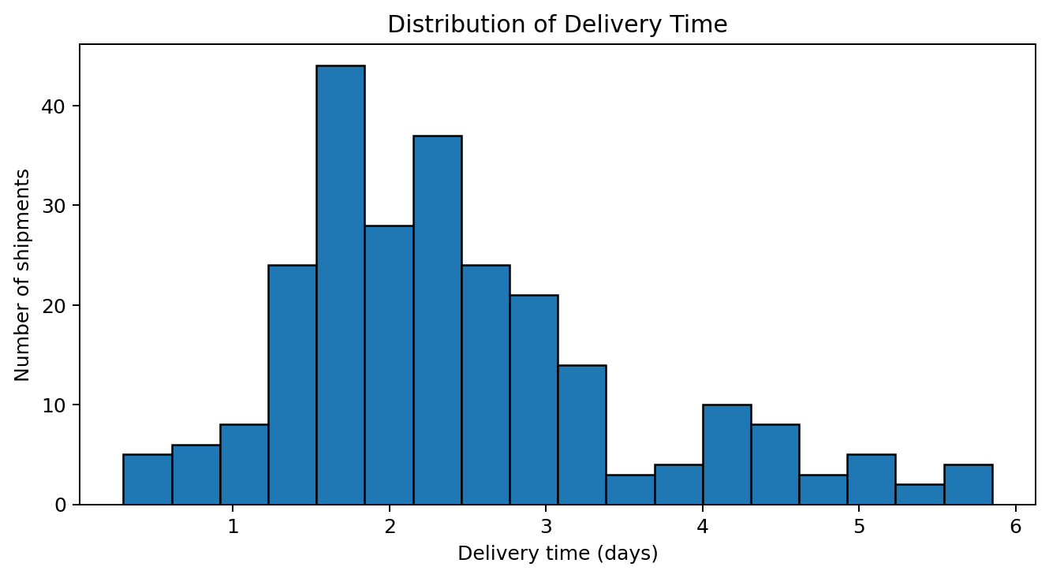
The average delivery time is 2.45 days and the median is 2.21 days. The histogram shows how frequently shipments fall within different delivery-time intervals. A longer right tail represents relatively slow deliveries and may indicate exceptions, congestion, handoff delays, or long-distance routes that deserve investigation. Histogram bins are useful for spotting the typical range and unusually long delivery times.

Transportation cost distribution
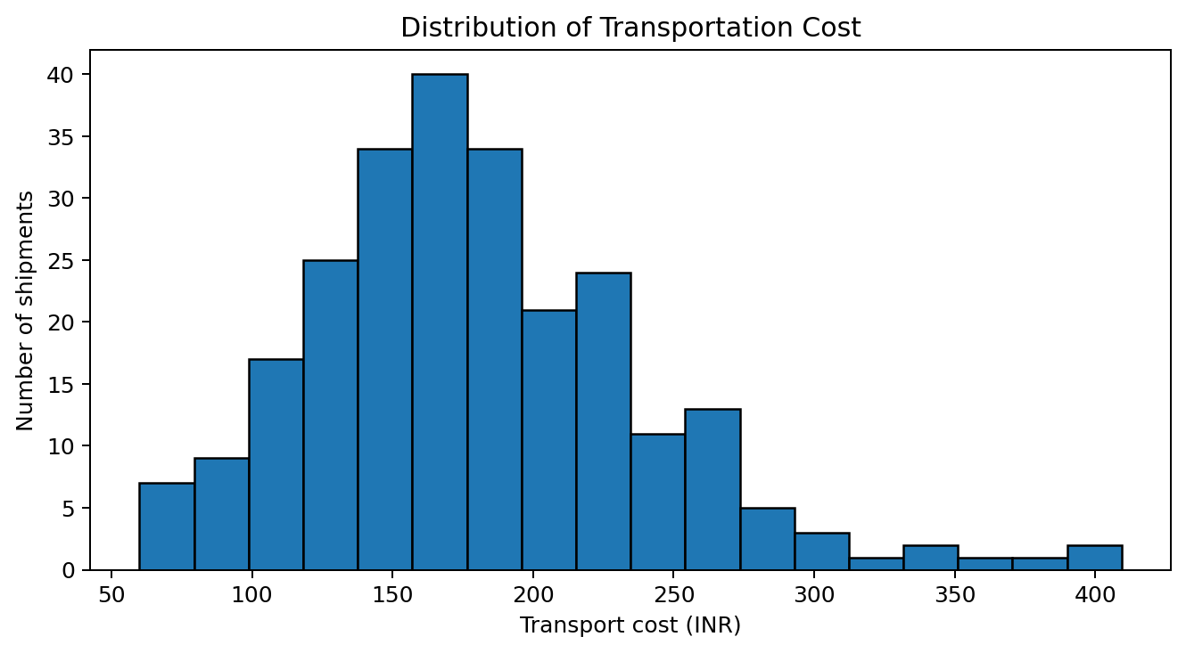
Average cost is ₹179.75 and median cost is ₹173.31. The histogram reveals the concentration and spread of shipment costs. A right tail suggests that a subset of shipments is substantially more expensive than typical shipments. Such cases should be reviewed alongside distance, weight, volume, and mode before deciding whether they represent avoidable cost or legitimate service needs.

Distance and transportation cost
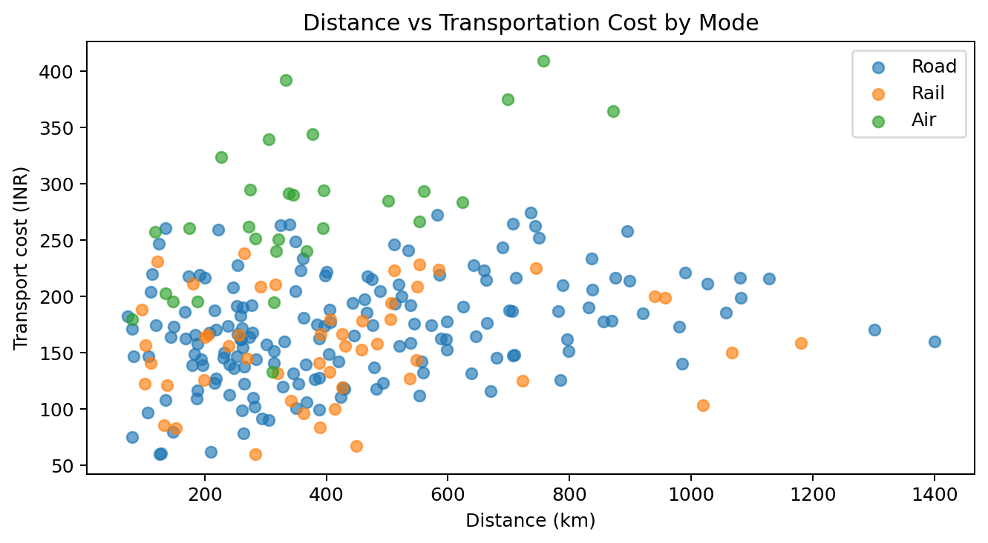
The correlation between distance and cost is 0.20. The scatter plot is appropriate because it shows the relationship between two numeric variables and reveals spread, clusters, and potential outliers. Costs generally tend to rise with distance, but transport mode and shipment weight/volume also affect cost. Comparing modes helps avoid treating all shipments as if they have the same cost structure.

Delivery time by transport mode
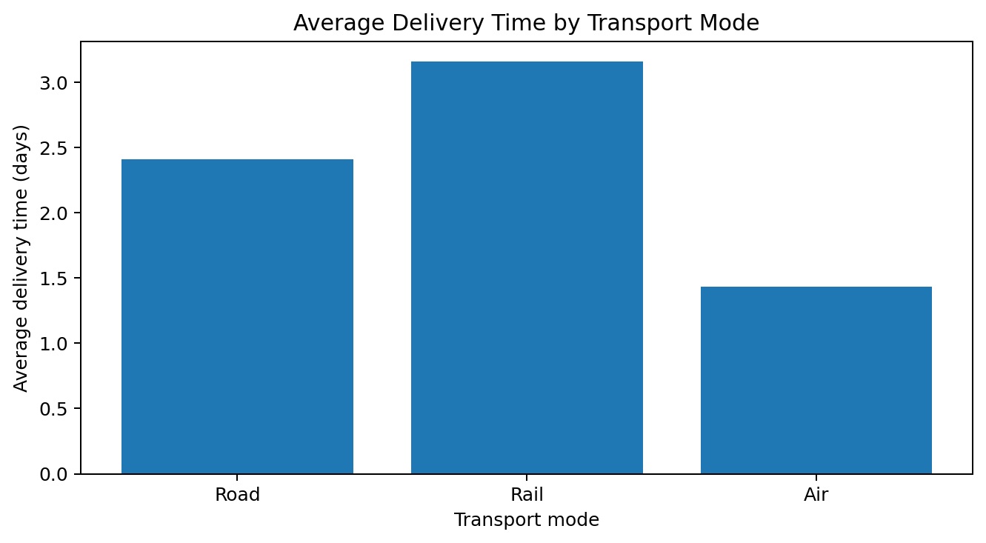
A bar chart compares mean delivery time across Road, Rail, and Air. It is easy to compare categories at a glance. The mode with the shortest average time may suit urgent shipments, while slower modes may remain appropriate for lower-cost or bulk movement. Mode selection should consider both time and cost, not speed alone.
Mode | Shipments | Avg days | Avg cost (₹) | On-time (%)
Air | 29 | 1.43 | 274.99 | 65.5%
Rail | 50 | 3.16 | 156.19 | 64.0%
Road | 171 | 2.41 | 170.49 | 64.9%

On-time delivery by region
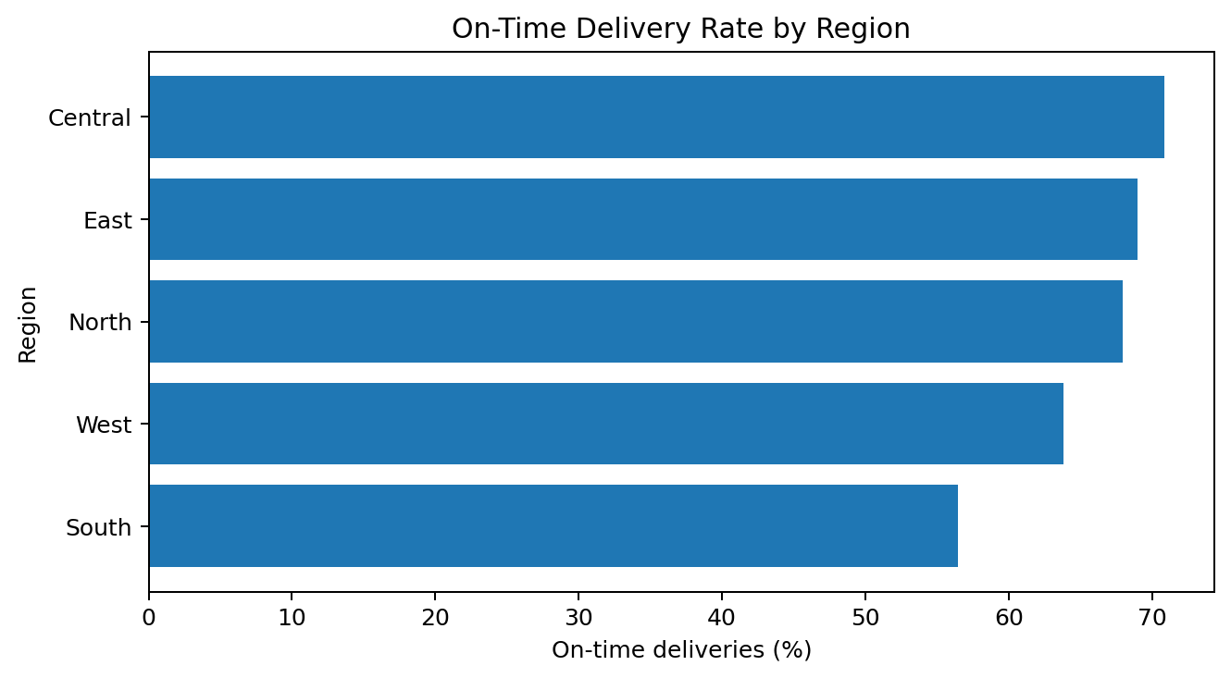
The horizontal bar chart ranks regions by on-time delivery rate. Horizontal bars make region labels readable and help locate comparatively strong or weak service areas. Regional differences should be investigated alongside route distance, transport-mode mix, shipment volume, and sample size. A lower rate is a signal for investigation rather than proof that a region is poorly managed.

Correlation matrix
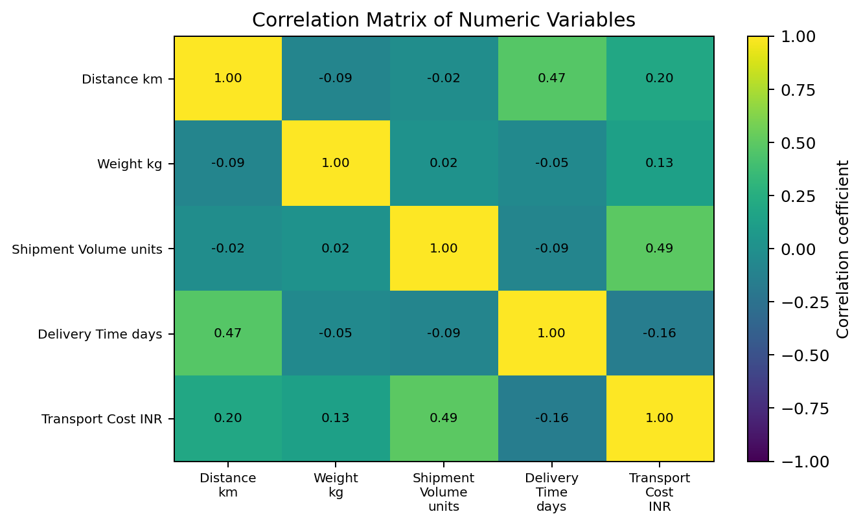
Distance and delivery time have a correlation of 0.47; cost and delivery time have a correlation of -0.16. The matrix summarizes pairwise linear relationships: values near +1 indicate positive association, values near −1 indicate negative association, and values near 0 indicate weak linear association. The matrix is a screening tool, not a causal model. Operational decisions should be validated with additional data and, where appropriate, regression or controlled comparisons.

Key Findings
- Overall on-time delivery rate: 64.8% of simulated shipments.
- Average delivery time: 2.45 days; median: 2.21 days.
- Average transportation cost: ₹179.75; median: ₹173.31.
- Distance-cost correlation: 0.20; distance-delivery-time correlation: 0.47.
- Fastest mode by average delivery time in this sample: Air (1.43 days); slowest: Rail (3.16 days).
- Highest regional on-time rate: Central (70.8%); lowest: South (56.5%).

Recommendations
- Monitor delivery exceptions: Track late shipments weekly and segment by route, carrier, mode, and reason code. Investigate the longest delivery-time tail first.
- Use mode-specific service rules: Choose transport mode by urgency, shipment size, and total landed cost. Compare on-time rate and cost together instead of optimizing only one metric.
- Review high-cost shipments: Flag costs that are unusually high for their distance, weight, and mode. Confirm whether they are due to urgent service, special handling, poor load utilization, or pricing differences.
- Improve regional visibility: Create a dashboard for on-time delivery, average delivery time, shipment count, and average cost by region. Investigate low-performing areas after adjusting for route mix.
- Improve data collection: Capture promised delivery date, actual delivery date, carrier, route, fuel surcharge, failed delivery reason, warehouse processing time, and customer priority.
- Validate with real data: Repeat the analysis on actual historical records and compare periods. Use adequate sample sizes and avoid making causal claims from correlations alone.

How the Visualizations Support Decisions
Visualization | Why this method? | Decision supported
Delivery-time histogram | Shows frequency distribution, skew, and tail behaviour | Find typical delivery window and long-delay cases
Cost histogram | Shows spread and unusually expensive shipments | Prioritize cost exception reviews
Distance-cost scatter plot | Shows relationship and variation between two numeric variables | Understand distance-related cost and compare modes
Mode average bar chart | Makes categorical means easy to compare | Balance speed against transport cost
Regional on-time bar chart | Ranks regions clearly | Identify areas for operational investigation
Correlation matrix | Summarizes pairwise linear relationships | Select variables for deeper analysis

Python Tools and Code Excerpt
pandas loads and groups the data, NumPy supports reproducible simulation, and Matplotlib creates the visualizations. The complete runnable script is supplied separately as week3_logistics_analysis.py.
import pandas as pd
import matplotlib.pyplot as plt
df = pd.read_csv("week3_logistics_hypothetical_dataset.csv")
metrics = ["Distance_km", "Weight_kg", "Shipment_Volume_units",
"Delivery_Time_days", "Transport_Cost_INR"]
print(df[metrics].describe().round(2))
print(df[metrics].corr().round(2))
plt.hist(df["Delivery_Time_days"], bins=18, edgecolor="black")
plt.title("Distribution of Delivery Time")
plt.xlabel("Delivery time (days)")
plt.ylabel("Number of shipments")
plt.tight_layout()
plt.show()

Limitations
- All records are simulated for learning purposes and do not represent a real logistics company.
- The on-time flag is based on simplified mode-specific thresholds; real service-level agreements may differ.
- The analysis is descriptive. It does not control for all confounding factors or establish causality.
- Costs are simulated in INR and do not include a detailed breakdown of fuel, labour, warehousing, tolls, or surcharges.

Conclusion
This exercise demonstrates how a structured EDA workflow can convert shipment records into operationally useful evidence. Descriptive statistics summarize typical performance, histograms reveal variation and long tails, scatter plots explore cost drivers, grouped bar charts compare modes and regions, and correlation analysis highlights relationships for further study. The recommended next step is to apply the same reproducible workflow to validated real shipment data, then build a recurring KPI dashboard and investigate late or high-cost exceptions.

Appendix A: Reproducibility
Files supplied: (1) week3_logistics_hypothetical_dataset.csv — 250-row simulated dataset; (2) week3_logistics_analysis.py — script for summary statistics and plots; (3) week3_logistics_analysis_report.docx — this report with embedded visualization outputs.
To run: install pandas, numpy, and matplotlib; place the CSV and Python script in the same folder; run `python week3_logistics_analysis.py`.

