>npm install -g create-react-app

create-react-app TweetAPP

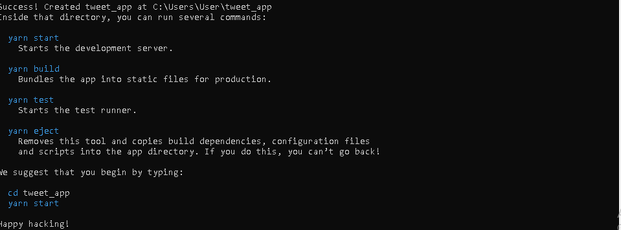

zookeeper-server-start.bat ../../config/zookeeper.properties

kafka-server-start.bat ../../config/server.properties

Docker

Dockerfile.txt: FROM java:8

EXPOSE 8083

ADD /target/tweetapp-0.0.1-SNAPSHOT.jar tweetapp.jar

ENTRYPOINT ["java","-jar","tweetapp.jar"]

For creating docker images based on docker file: docker build -t tweetapp --file ./Dockerfile .txt .

For checking docker images: docker images

For pushing docker image to docker :docker run -p 8080:8080 –t tweetapp

docker stop

docker ps --help

docker run --help

docker system prune

docker ps -a

docker tag tweetapp geetha27/tweetapp

docker.io/geetha27/tweetapp

EWzXFYQ2

C:\Users\User>docker push geetha27/tweetapp