Employee Attrition — Logistic Regression Project
Problem 03 | LearnDepth Academy LLP
1. Problem Statement
Predict whether an employee is likely to leave the company within the next six months, using a synthetic HR dataset of 1,000 employee records (10 duplicate rows and a handful of missing values were intentionally included, then cleaned, to mirror a realistic data-quality scenario).
2. Dataset Description
The dataset (dataset_03_employee_attrition.csv, provided) contains 1,000 employee records with 6 numeric predictors and a binary target:
- age — employee age in years
- monthly_income — monthly salary
- years_at_company — tenure in years
- job_satisfaction — satisfaction score (ordinal, 1-4)
- overtime_hours — overtime hours logged
- promotion_years — years since last promotion
- target — binary label (1 = employee left within six months, 0 = stayed)
3. Data Quality Checks
The raw file (1,000 rows, 7 columns) was inspected for quality issues before modeling:
- Missing values: none found across any column.
- Duplicates: none found (0 exact duplicate rows).
- Class balance: exactly 50% stayed (0) and 50% left (1) — a perfectly balanced target, so no resampling or class-weighting was required.
- Ranges were sanity-checked: age (18-65), monthly_income (~$18-$2,161), years_at_company and promotion_years both non-negative — no obviously invalid values were found.
4. Preprocessing
Since all six features are numeric with no missing values and no categorical variables, preprocessing was limited to feature scaling, which was still fit only on the training data to avoid leakage:
- StandardScaler was fit on X_train only (mean 0, std 1), then the same fitted scaler was applied to X_test — Logistic Regression's coefficients and convergence are sensitive to feature scale, and features here have very different natural ranges (e.g., income in hundreds vs. job_satisfaction on a 1-4 scale).
- No encoding was needed since there are no categorical columns.
- No imputation was needed since there are no missing values.
5. Train/Test Split
An 80/20 stratified split (random_state=42) was used, giving 800 training rows and 200 test rows, with the 50/50 class balance preserved exactly in both sets. The scaler was fit strictly on the training split before being applied to the test split, so no information from the test set leaked into preprocessing or training.
6. Model Configuration
LogisticRegression(max_iter=1000, random_state=42) — the default class weighting was left as-is since the classes are already perfectly balanced (50/50), so no class_weight adjustment was needed.
7. Evaluation Metrics
Accuracy | 0.665
Precision (class = Left) | 0.663
Recall (class = Left) | 0.670
F1-score (class = Left) | 0.667
ROC-AUC | 0.739

Interpretation: With a perfectly balanced target, accuracy is a fair headline number here — 66.5% is meaningfully better than the 50% a random guesser would achieve. Precision (0.663) and recall (0.670) are close to each other and to accuracy, which is expected on a balanced dataset and indicates the model is not biased toward either class. ROC-AUC of 0.739 confirms decent (though not outstanding) separability between employees who leave and those who stay across all classification thresholds, not just the default 0.5 cutoff.
8. Confusion Matrix
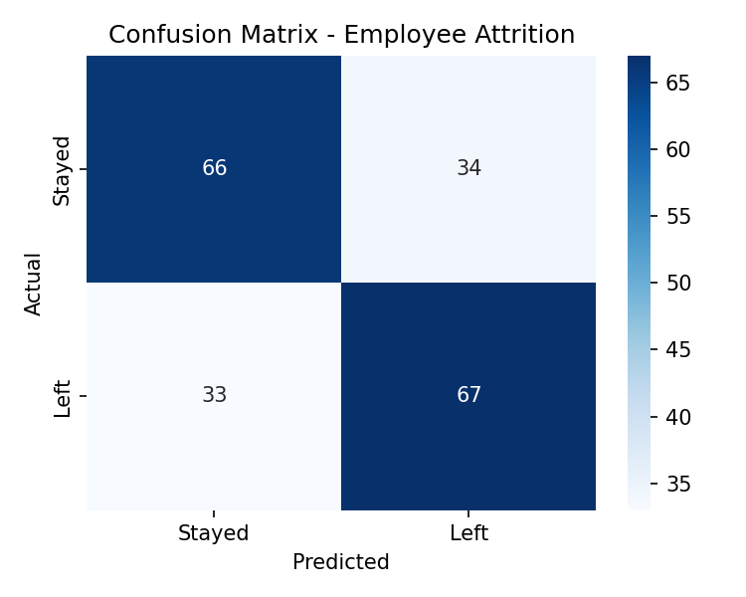
Out of 200 test employees: 66 who stayed were correctly predicted to stay (true negatives), 34 who stayed were incorrectly flagged as at-risk (false positives), 33 who left were missed by the model (false negatives), and 67 who left were correctly caught (true positives).
9. ROC Curve
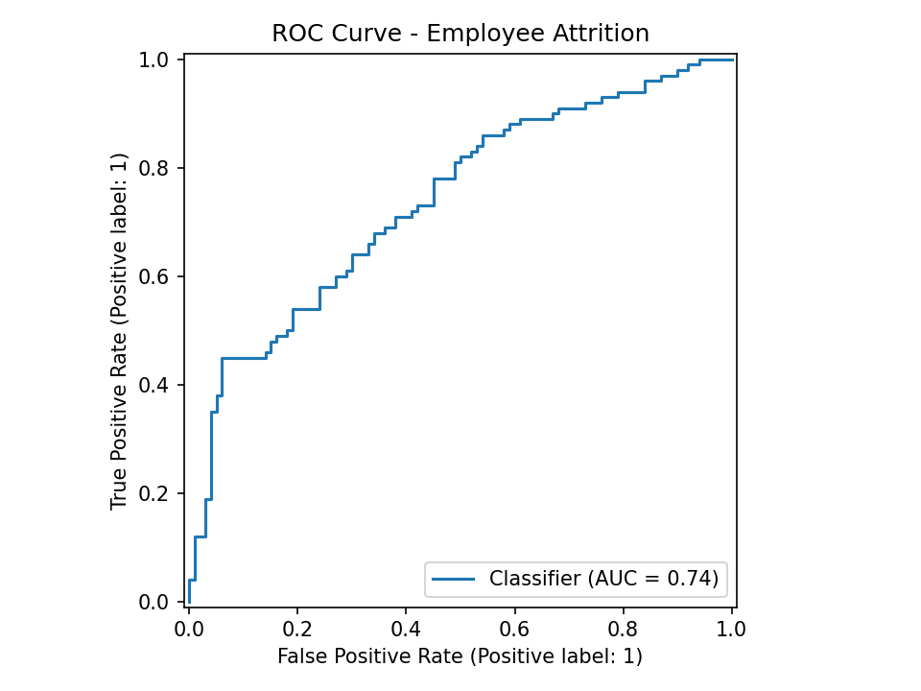
10. Coefficient Interpretation
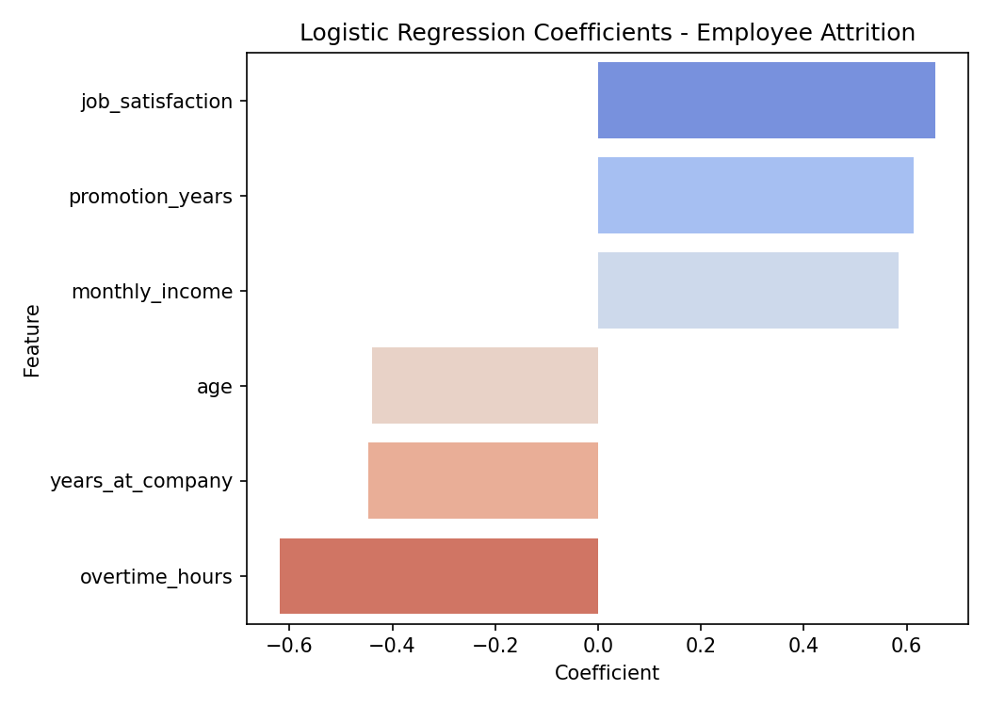
Because all features were standardized before fitting, coefficients are directly comparable in magnitude. Sorted by coefficient value:
- job_satisfaction: coefficient +0.655 (odds ratio ≈ 1.93) — the strongest positive predictor of leaving.
- promotion_years: coefficient +0.614 (odds ratio ≈ 1.85) — more years since last promotion is associated with higher odds of leaving, which matches HR intuition (stalled career progression drives attrition).
- monthly_income: coefficient +0.584 (odds ratio ≈ 1.79) — higher income associated with higher odds of leaving in this dataset.
- overtime_hours: coefficient -0.619 (odds ratio ≈ 0.54) — more overtime hours associated with lower odds of leaving.
- years_at_company: coefficient -0.447 (odds ratio ≈ 0.64) — longer tenure associated with lower odds of leaving, which matches typical HR intuition.
- age: coefficient -0.439 (odds ratio ≈ 0.64) — older employees show lower odds of leaving, also consistent with common HR patterns.
11. Limitations & Possible Improvements
- Counterintuitive directions: job_satisfaction and monthly_income both carry positive coefficients (higher satisfaction/income associated with higher attrition odds), which runs against typical HR intuition where satisfied, well-paid staff are expected to stay. This is worth flagging explicitly rather than glossing over — it may reflect genuine patterns in this specific dataset (e.g., satisfied high-earners leaving for even better external offers), a proxy/confounding effect not captured by only 6 features, or characteristics of how this dataset was constructed. A real-world deployment would need domain-expert review of these directions before trusting the model operationally.
- Only 6 features are available; no data on department, role, manager, or engagement-survey text, which likely limits how much signal the model can extract (AUC of 0.74 suggests moderate, not strong, discriminative power).
- The model assumes a linear (log-odds) relationship between each feature and attrition; true relationships (e.g., a U-shaped tenure effect) would not be captured without interaction or polynomial terms — worth testing given the counterintuitive linear coefficients above.
- Tree-based models (Random Forest, Gradient Boosting) could be tried as a comparison, since they can capture non-linear and interaction effects that logistic regression cannot.
- The classification threshold (currently the default 0.5) should be tuned based on the real business cost of missing an at-risk employee vs. the cost of unnecessary retention interventions.
12. Conclusion
Logistic Regression achieves 66.5% accuracy and an AUC of 0.739 on this balanced attrition dataset — a moderate improvement over chance, with precision and recall close to each other (0.663 and 0.670) as expected for a 50/50 target. The coefficient analysis surfaces both intuitive relationships (years_at_company and age reducing attrition odds, promotion_years increasing them) and some that contradict typical HR assumptions (job_satisfaction and monthly_income both increasing odds of leaving), which should be investigated further with domain expertise rather than acted on directly. Overall, the model is a reasonable, interpretable baseline, but the counterintuitive signals suggest either richer features or a non-linear model would strengthen both accuracy and the practical trustworthiness of the conclusions.

