Experiment 7

Create a Virtual Machine with 1 CPU, 2GB RAM and 15GB storage disk using a Type 2 Virtualization Software.

1.click on create a new virtual michine

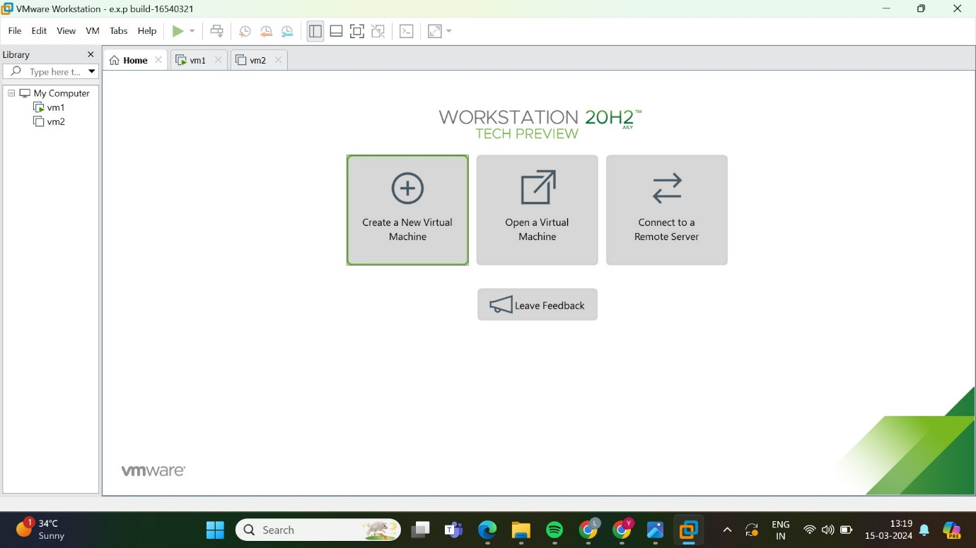

2. shows the type of configuration then select typical

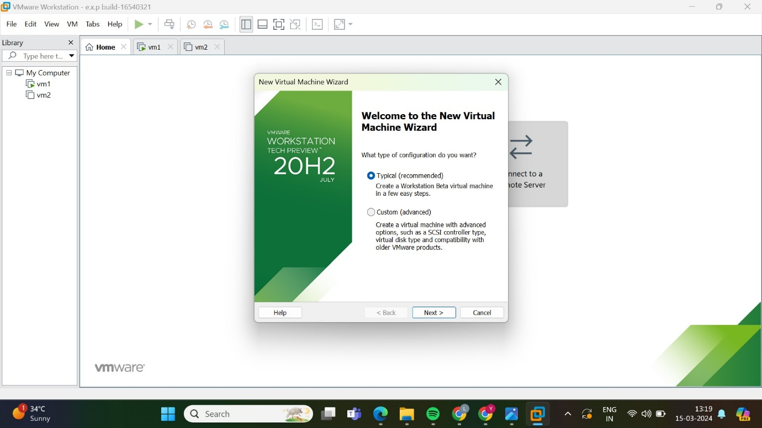

3.select the guest operating system installation

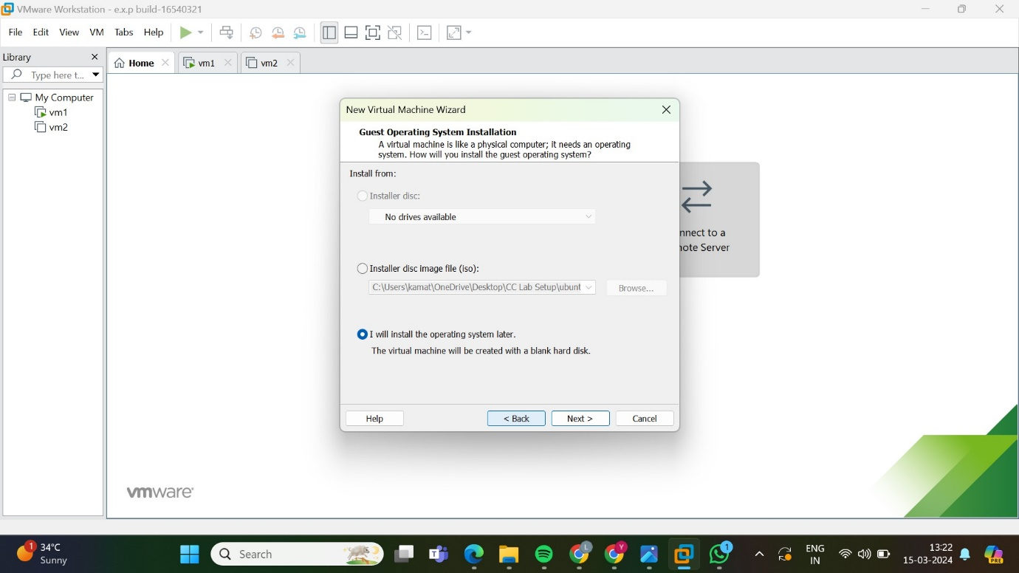

4.now select the guest operating system

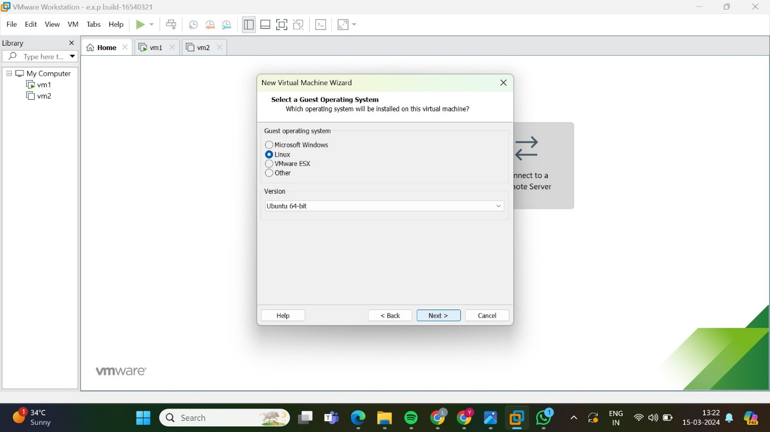

5.name the virtual machine

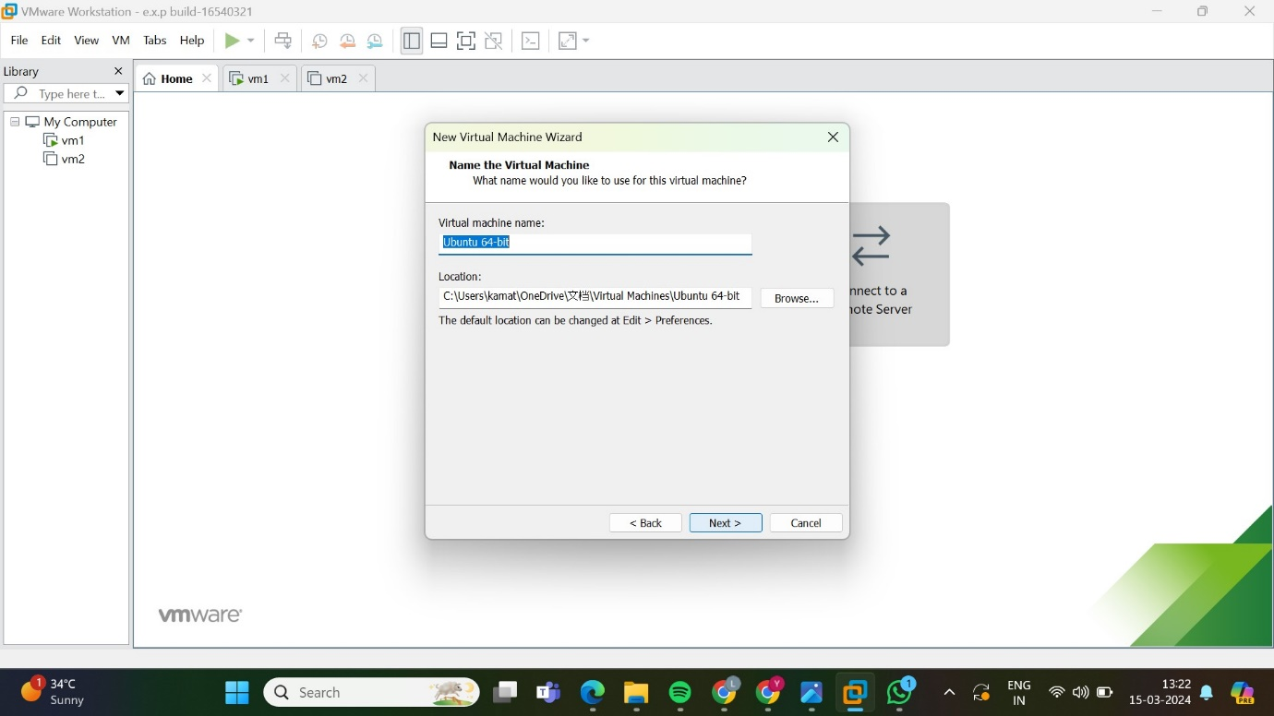

6. specify the disk capacity

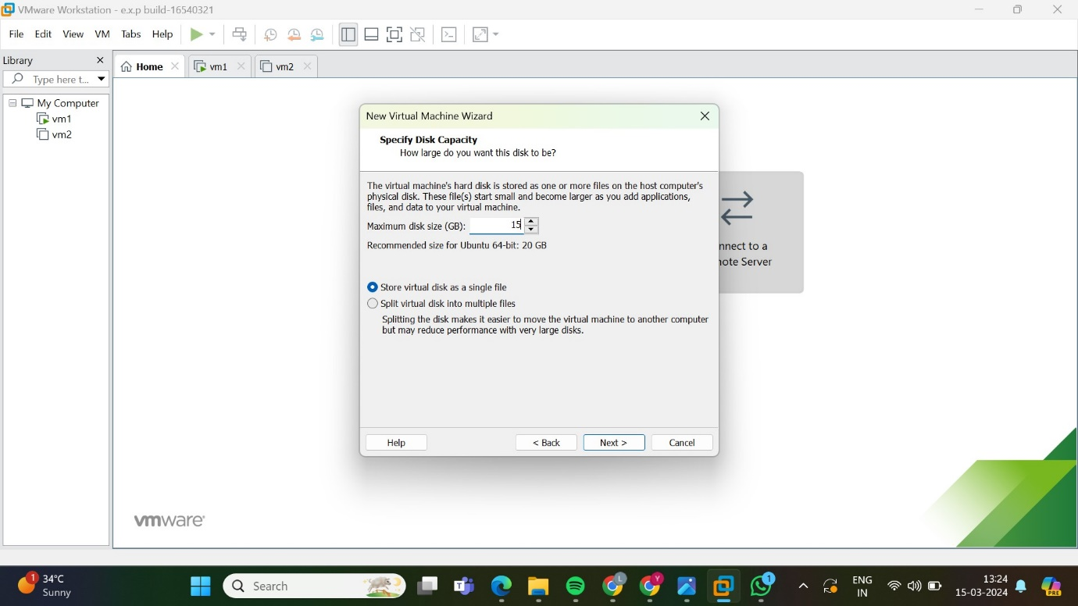

7.shows the description

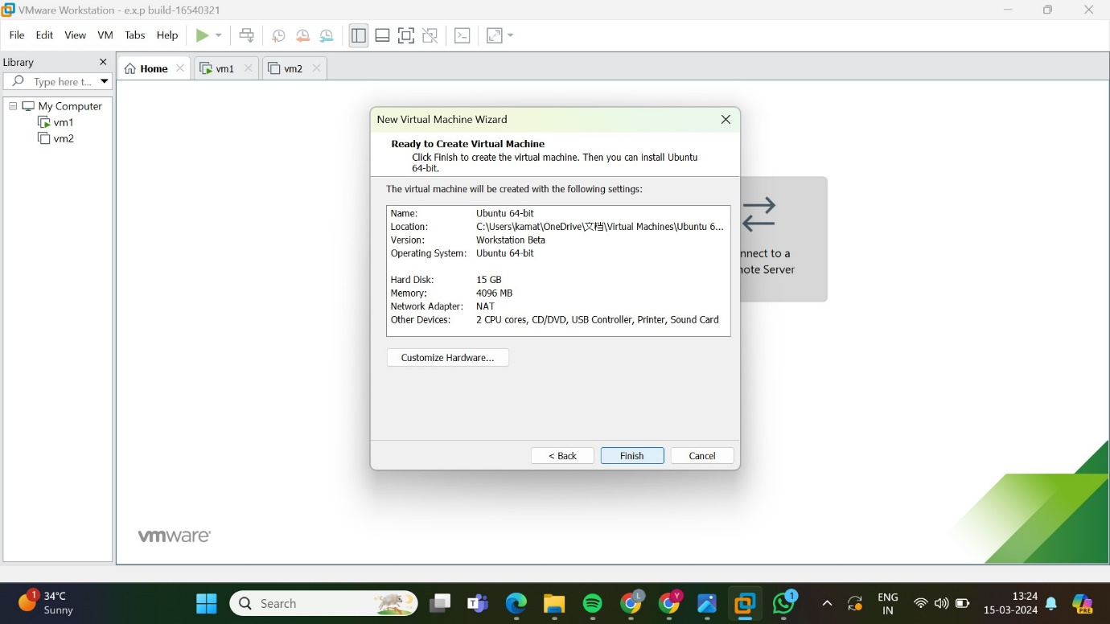

8.shows the required virtual machine

