Experiment 8

Create a Virtual Hard Disk and allocate the storage using VM ware Workstation

1.selcet create a new virtual machine

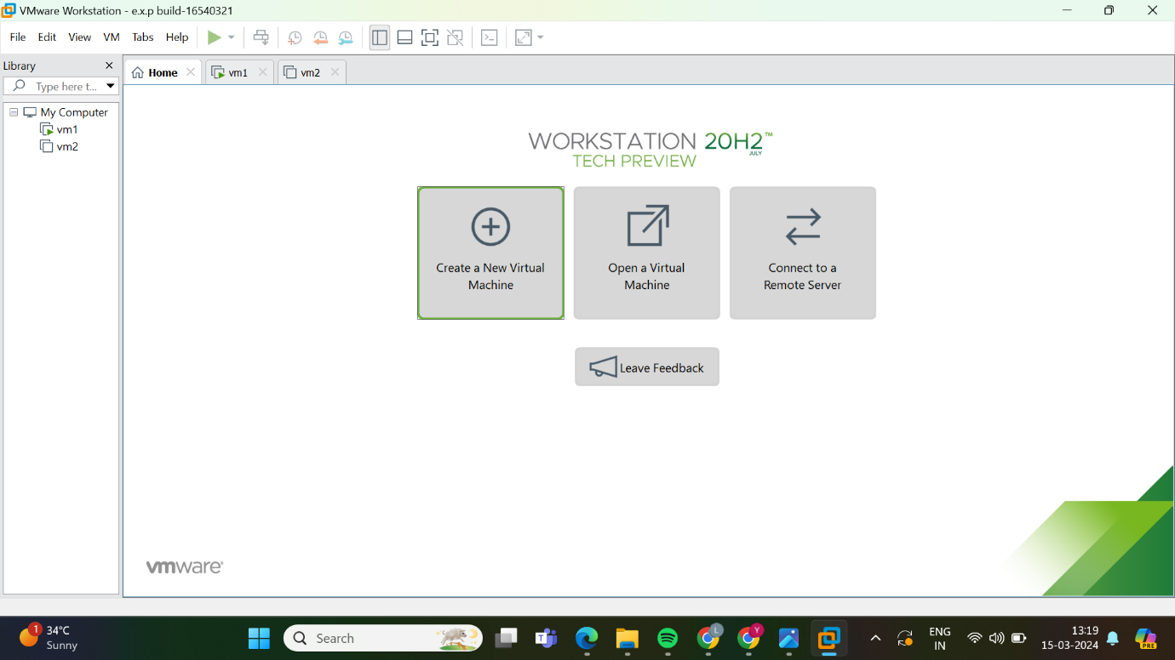

2.select type of configuration set it as typicall

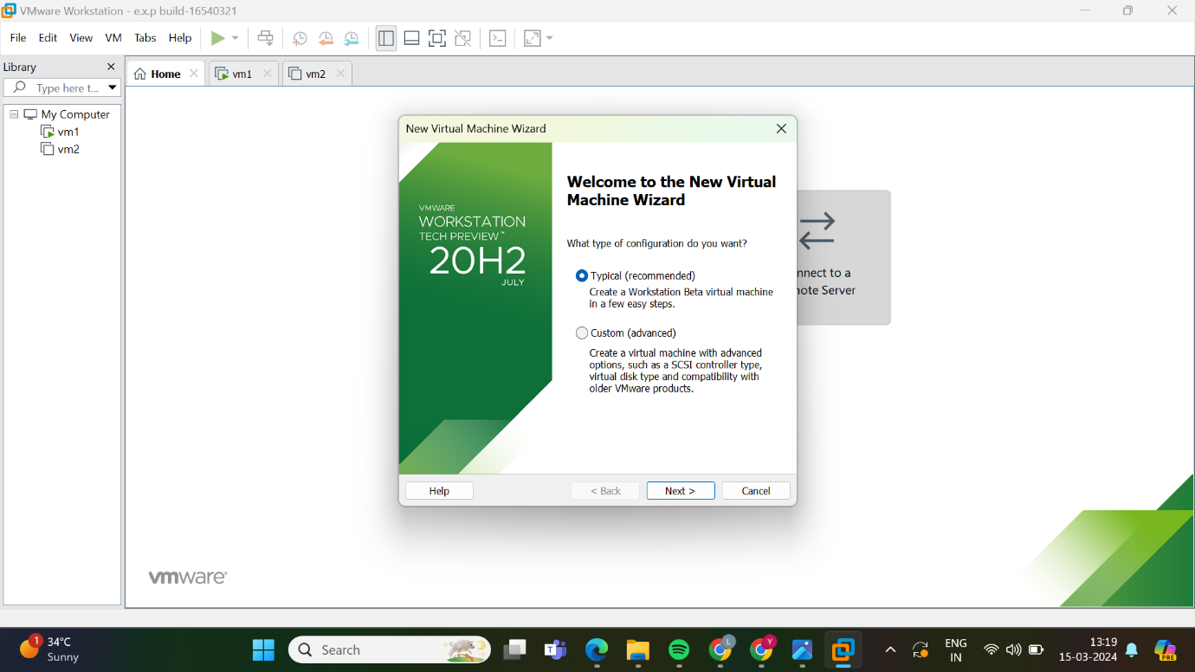

3.sellect the guest OS installation

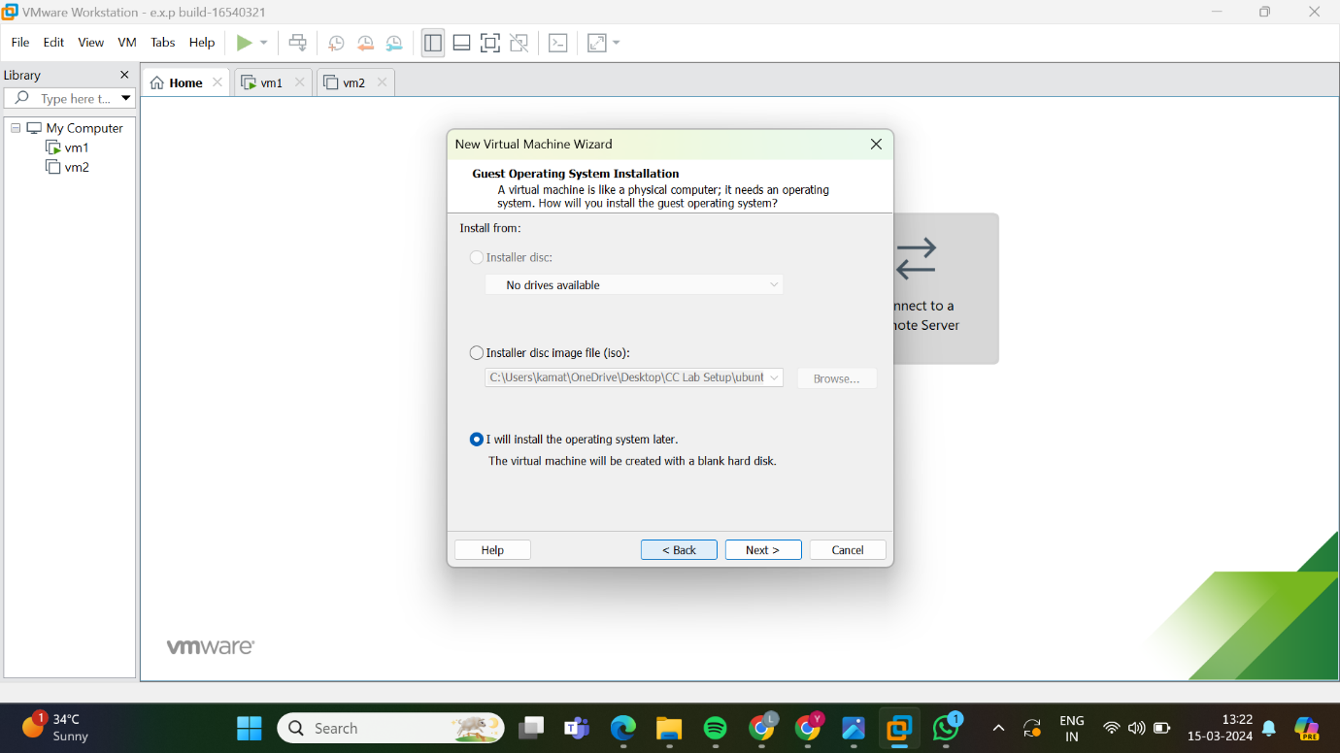

4.select a guest OS

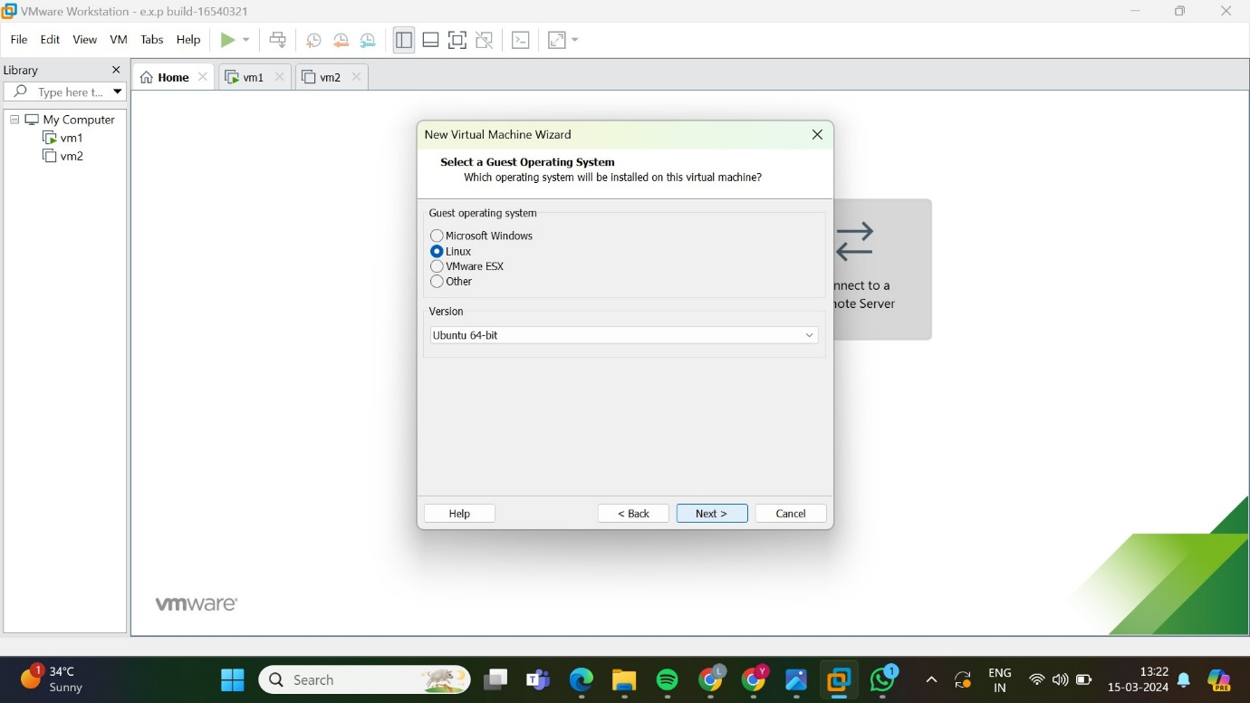

5.name the virtual machine

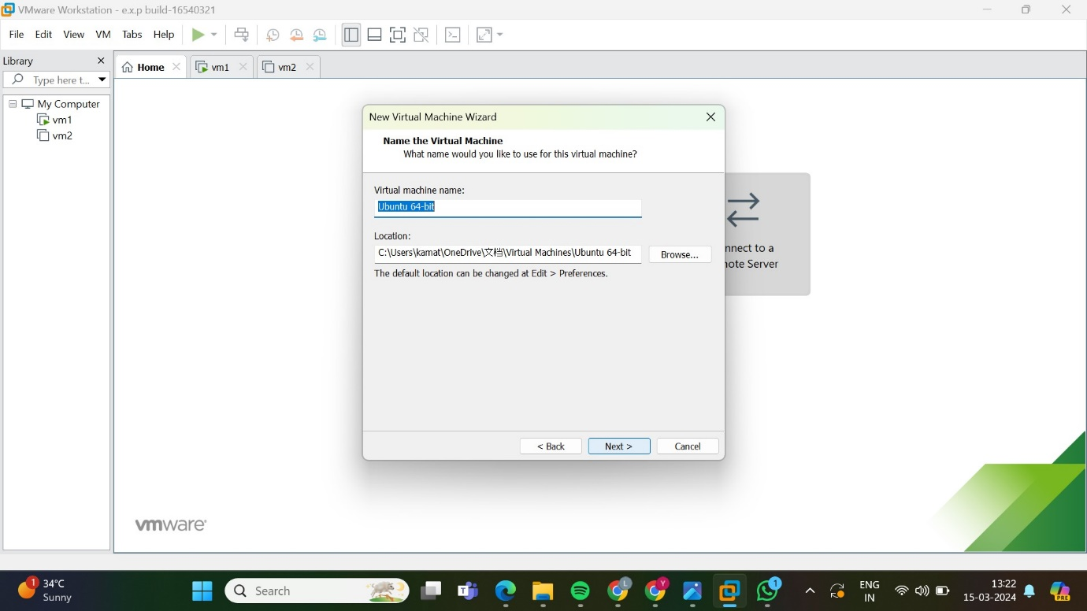

6.specify disk capacity

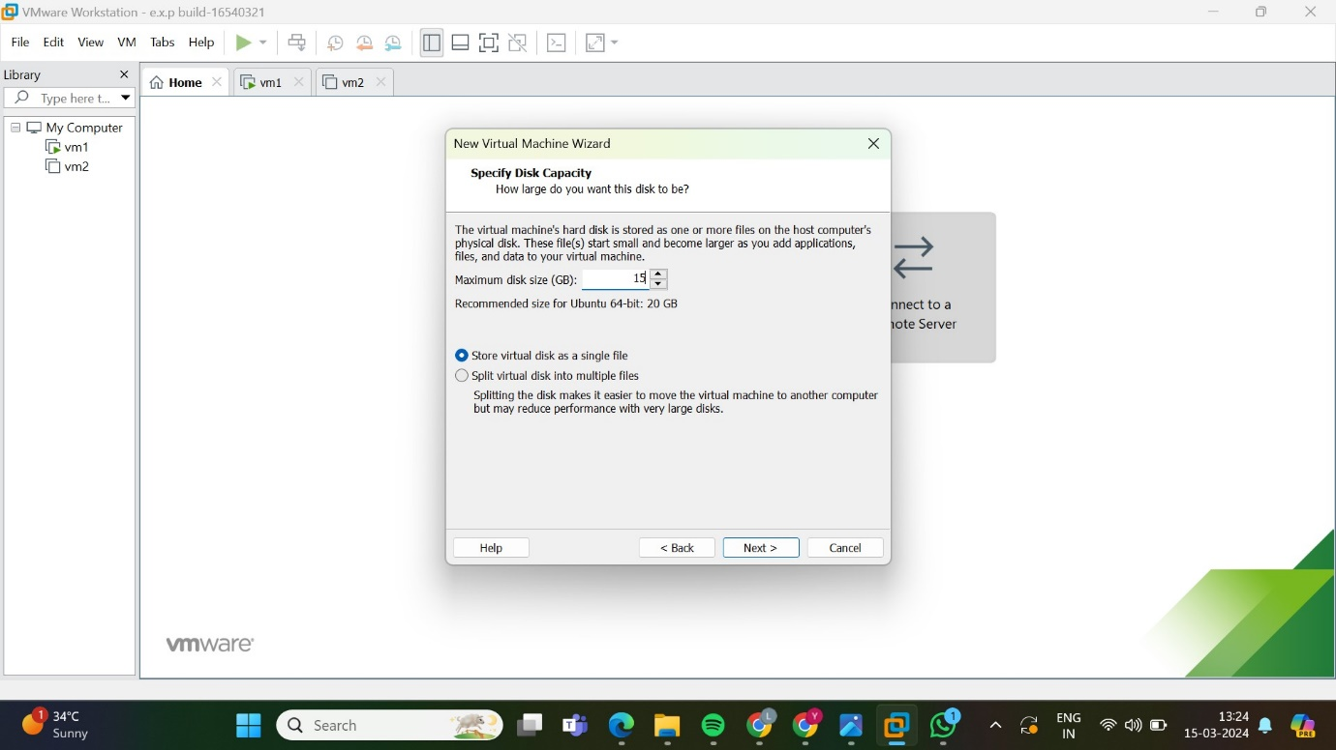

7.shows the description

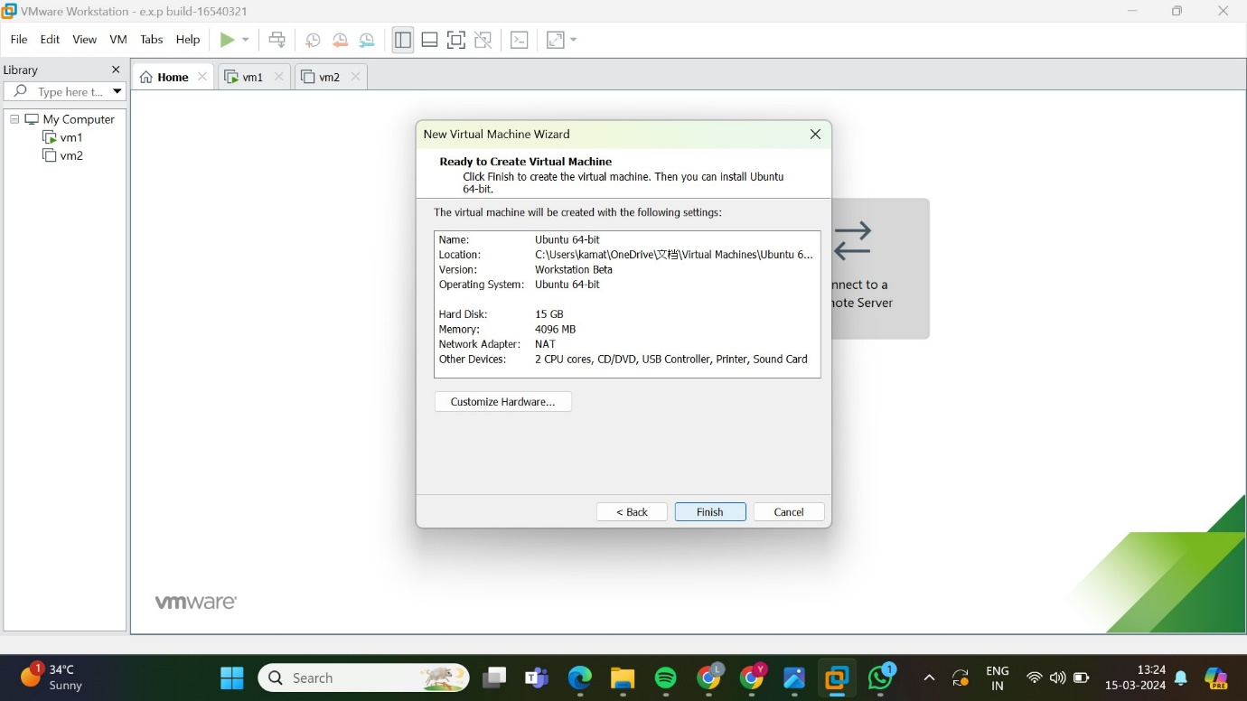

8.displays the vm now click on harddisk

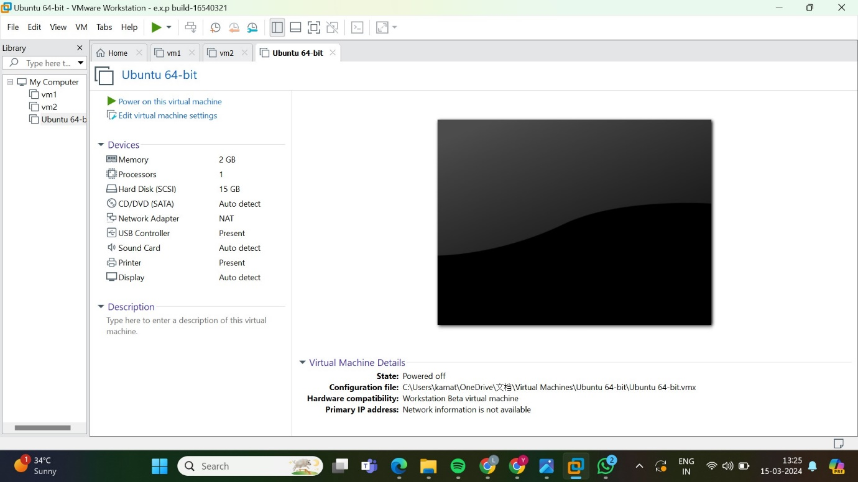

9.click on hard disk

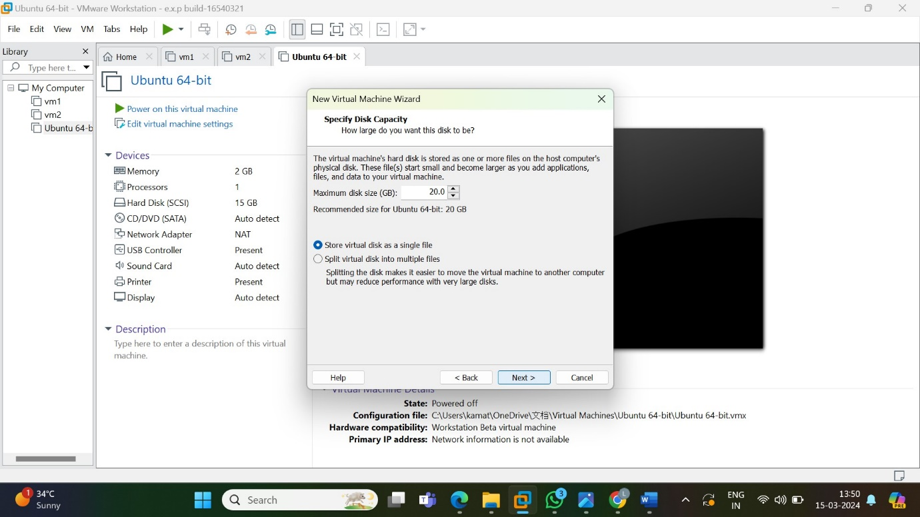

10.select hard disk to add new hard disk click on add

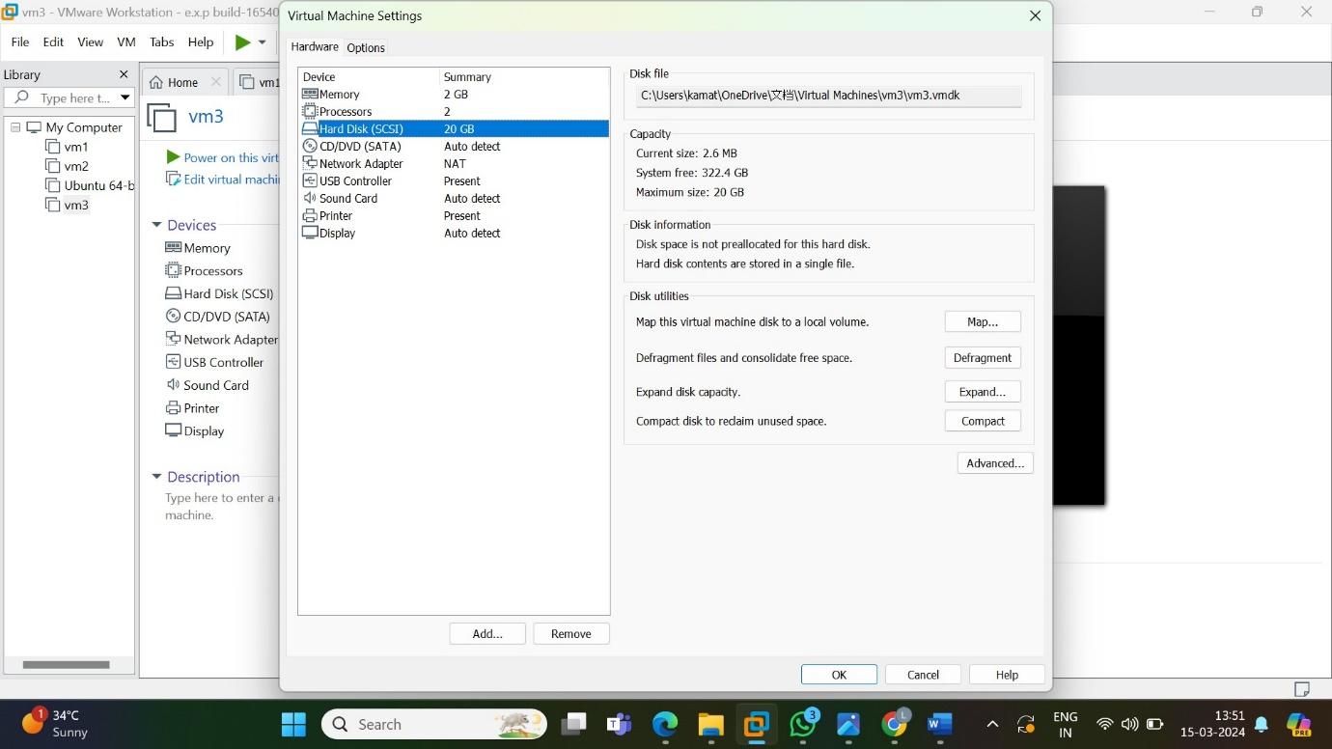

11.click on hard disk then click on next

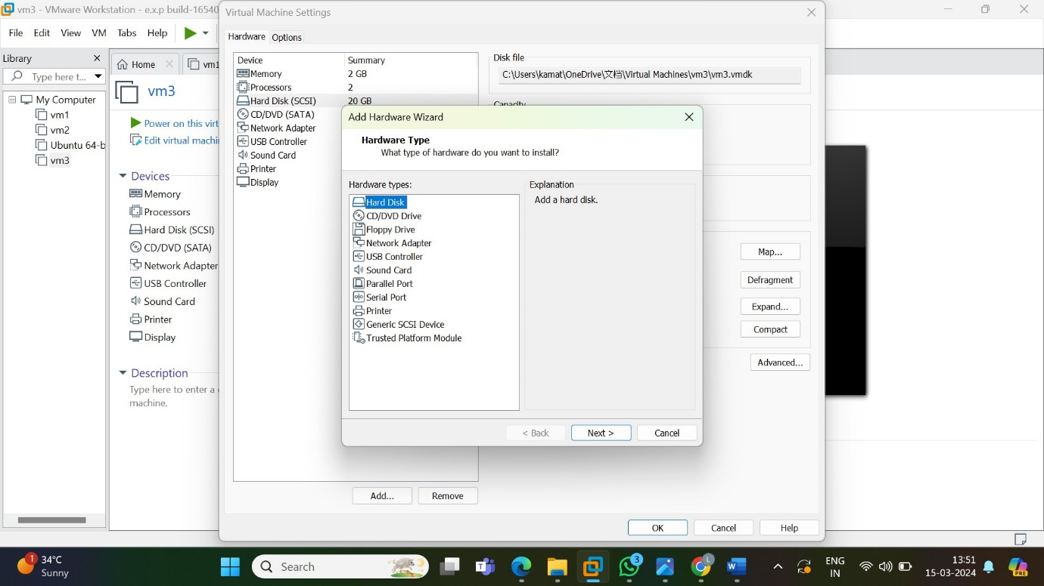

12.select type of disk as scsi

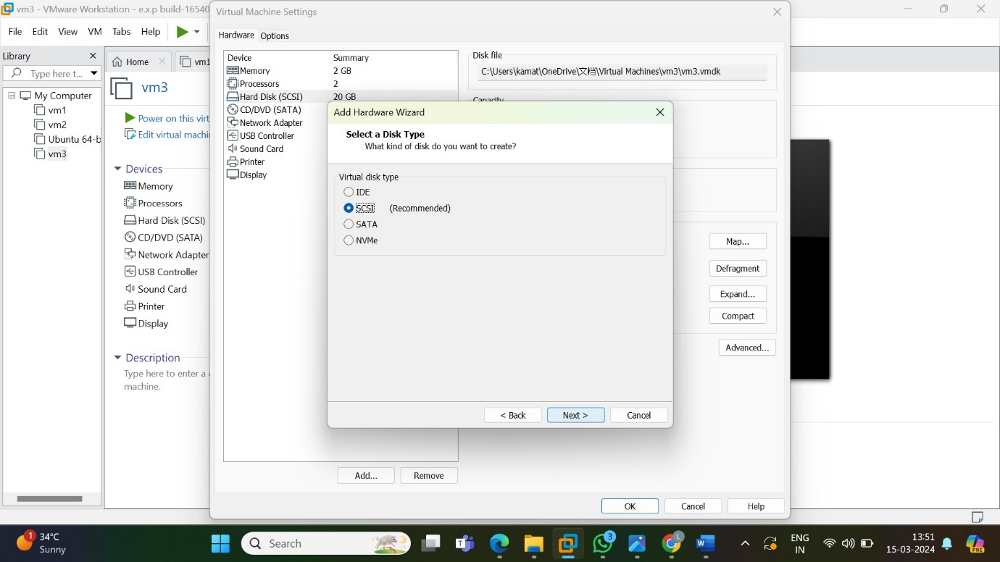

13.select the disk as create a new virtual disk

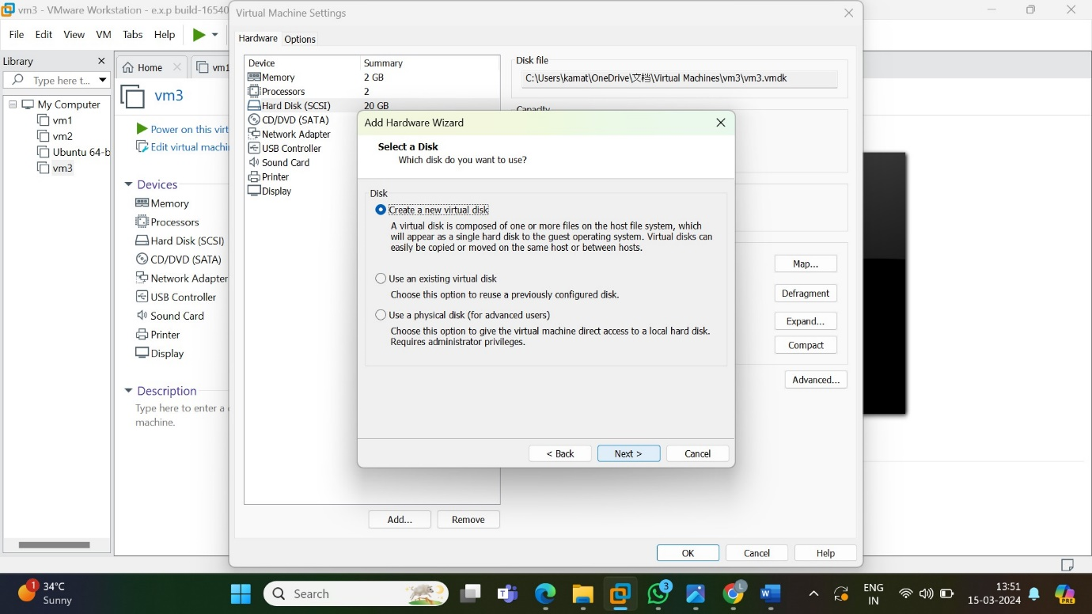

14.specify the disk capacity and select store virtual disk as a single file

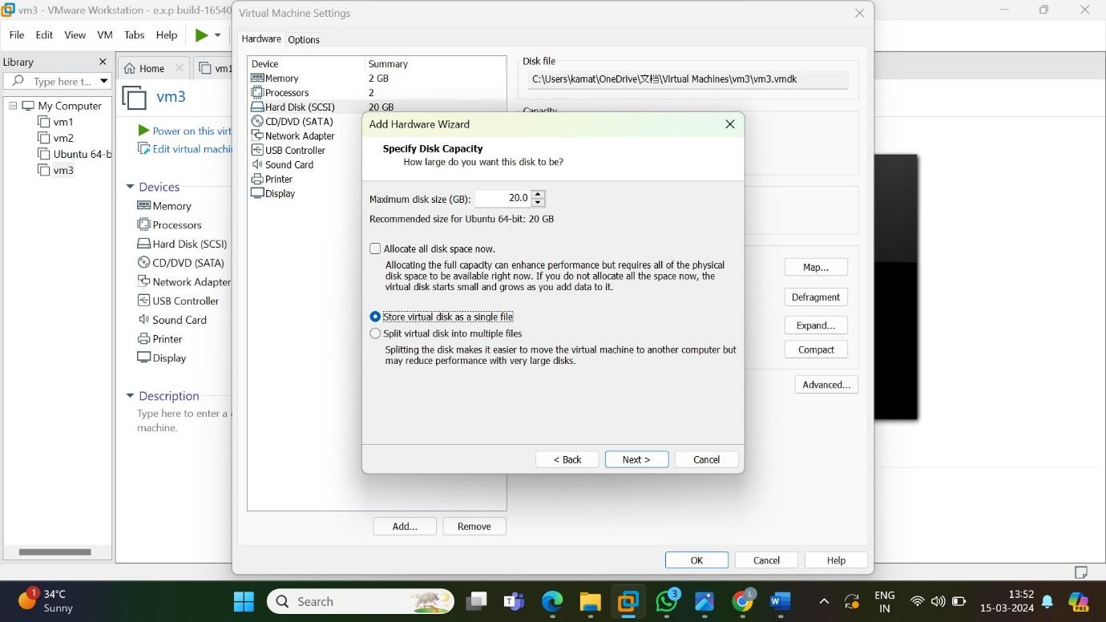

15.specify the disk name

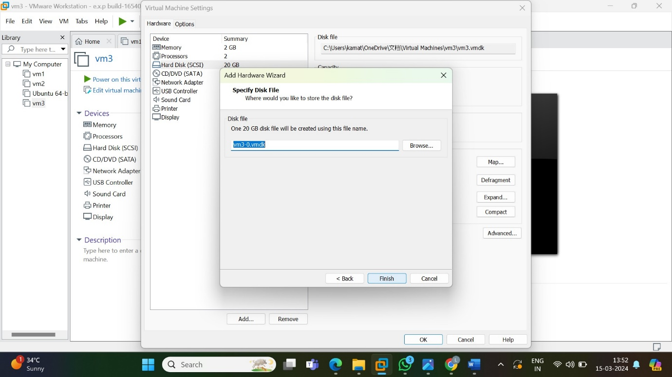

16. specify the disk capacity as store virtual as a single file

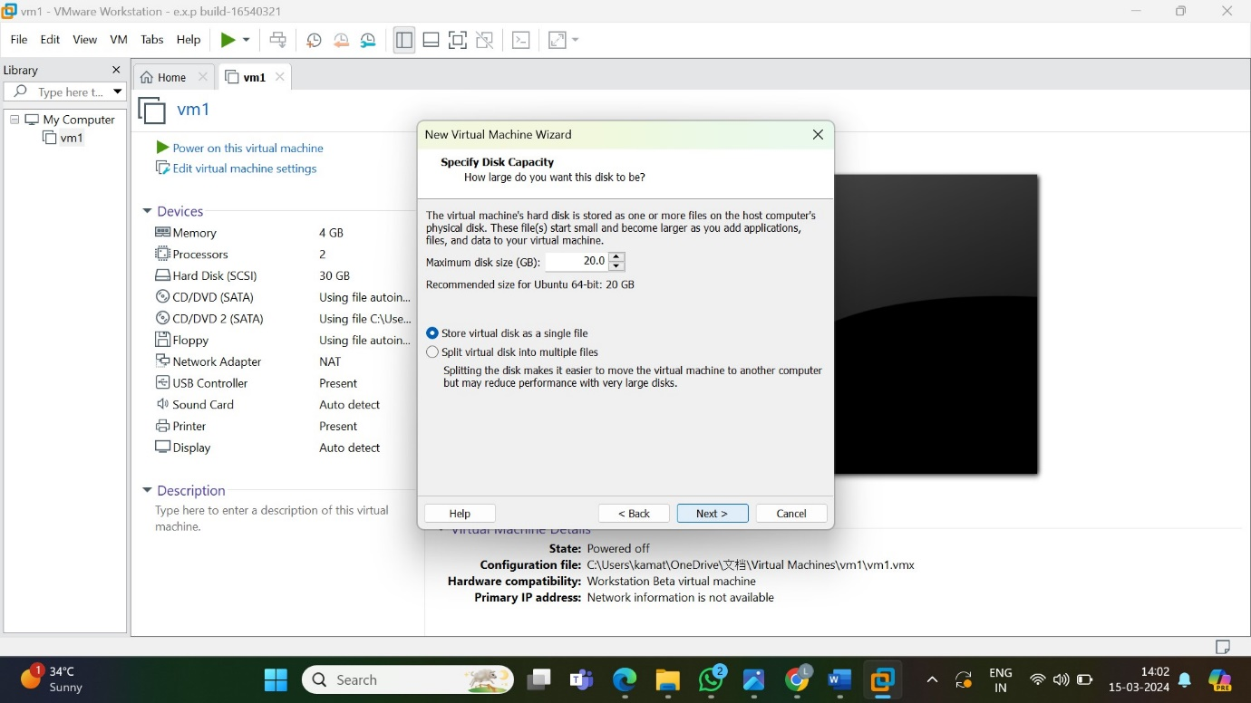

17.extra hard disk has been added

