Exp 11

1.click on create a new virtual machine

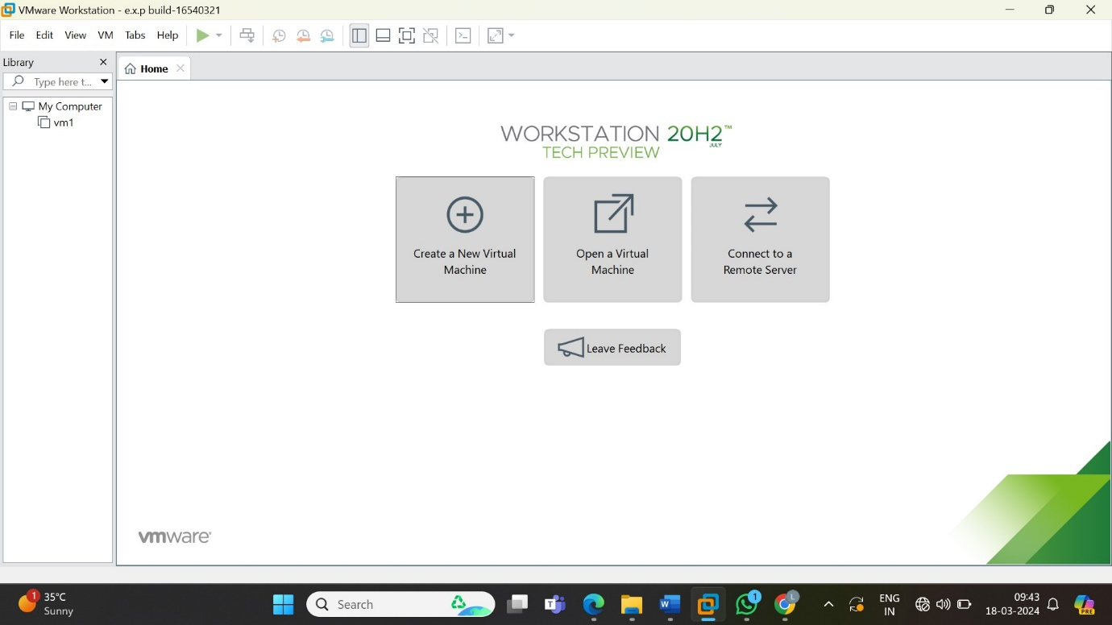

2.choose type of configuration as typical then click on next

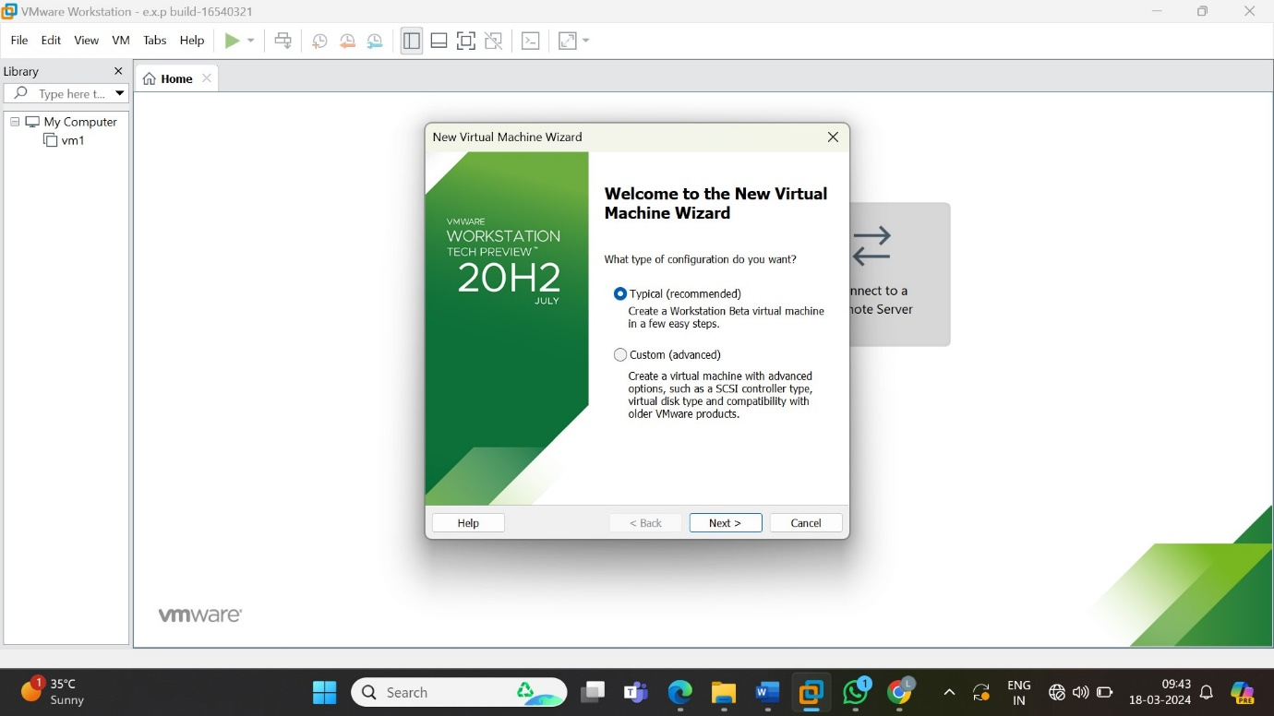

3.guset operation system select install later option

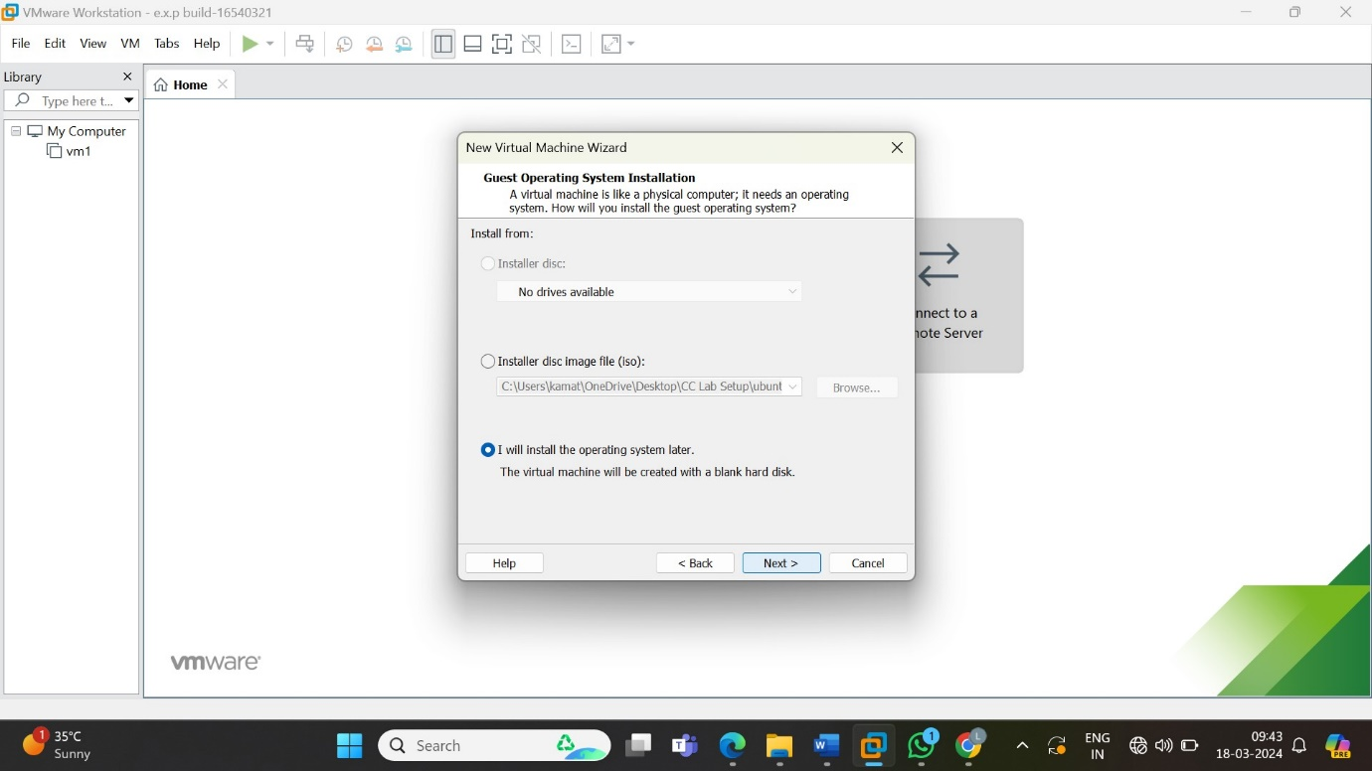

4.select guest operating system as Linux

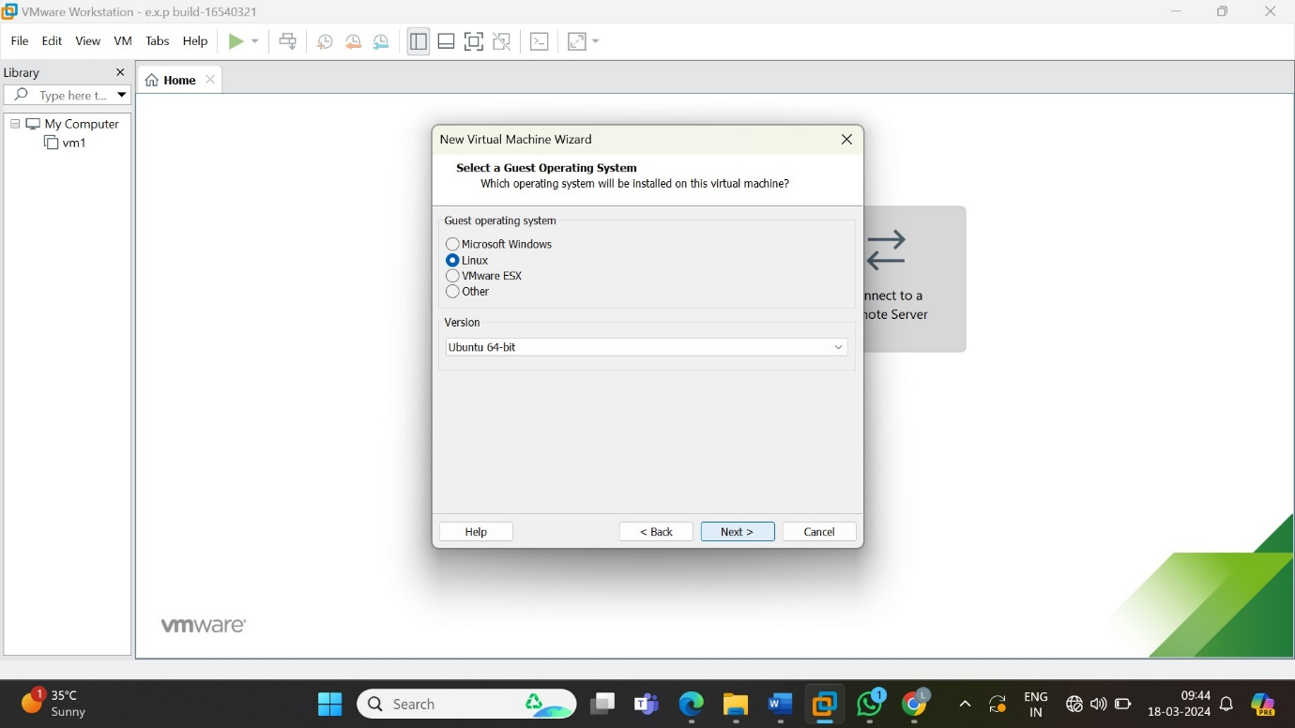

5.name the virtual machine as vm5

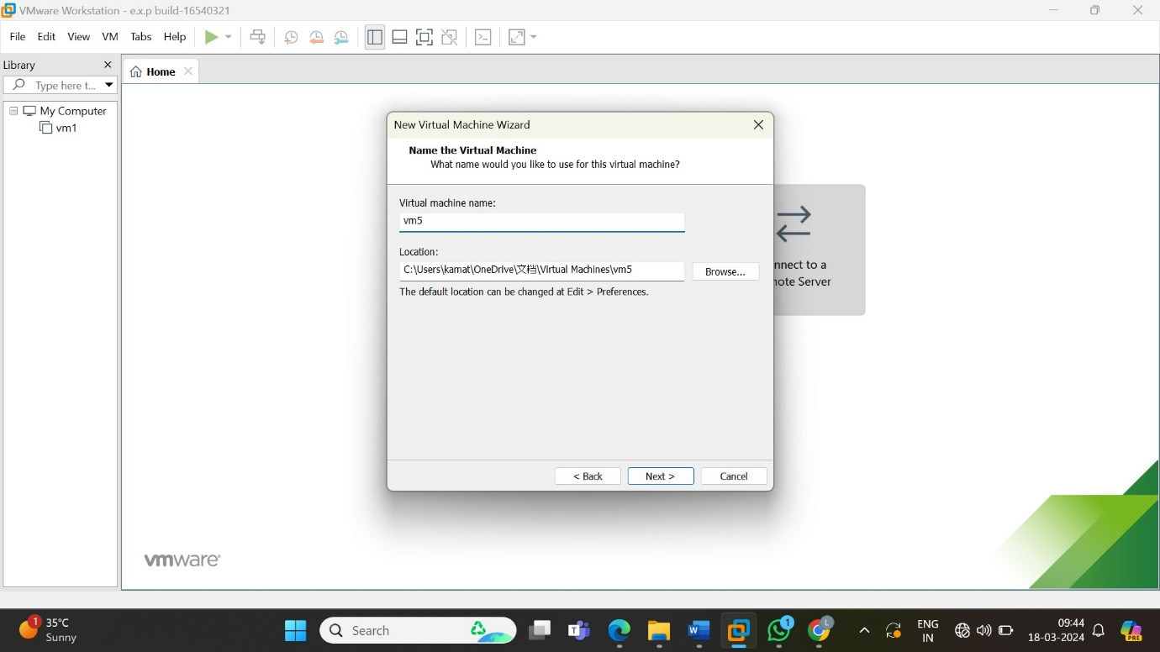

6.specify the idk capacity and select disk as a single file then click on next

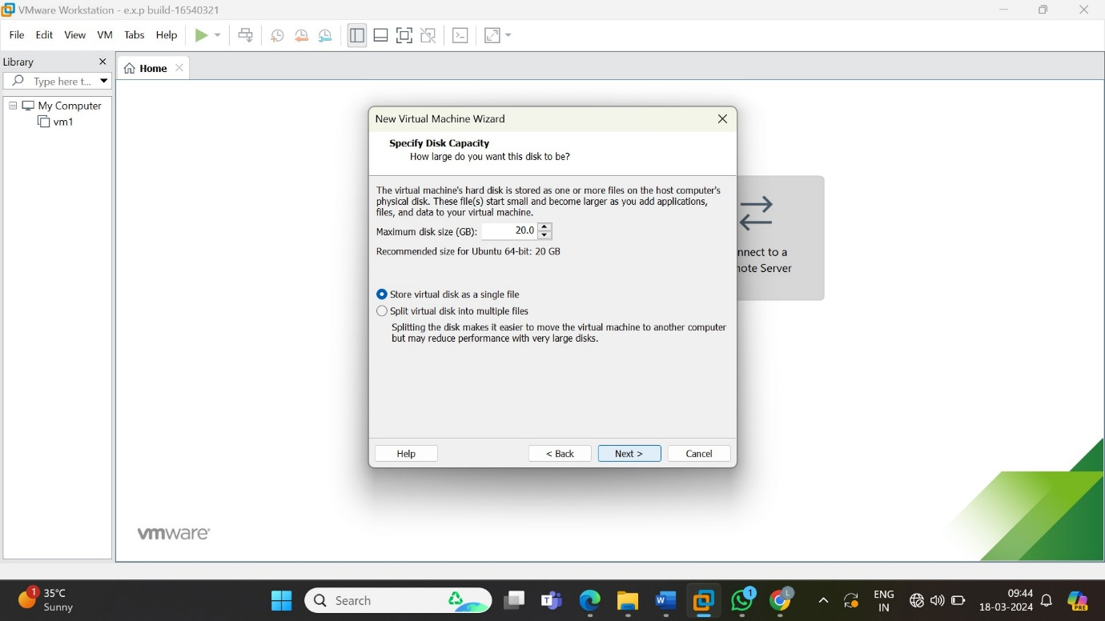

7.shows the virtualization

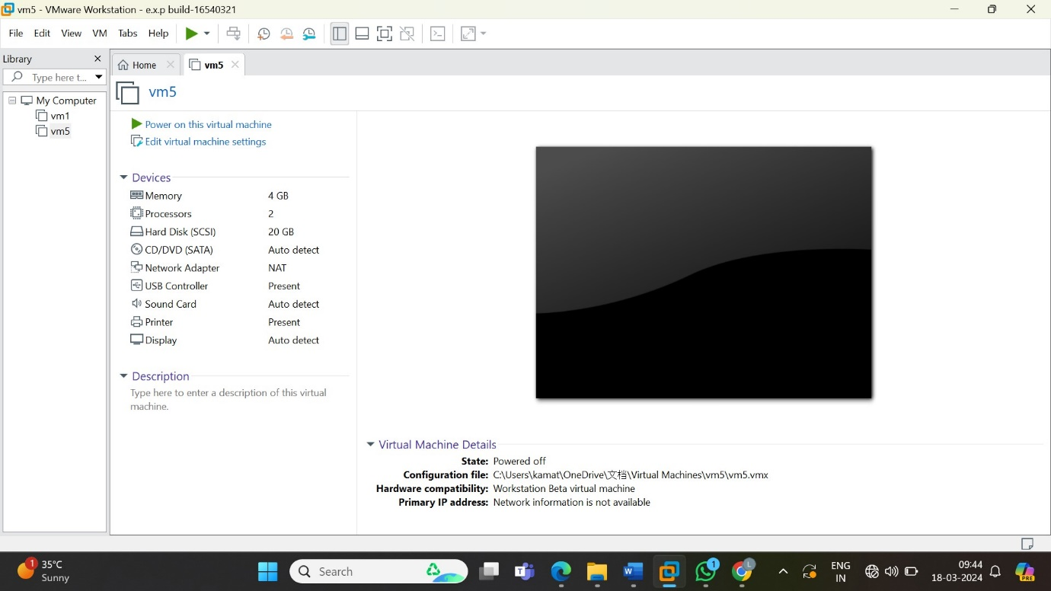

8.click on memory and choose the memory space then click ok

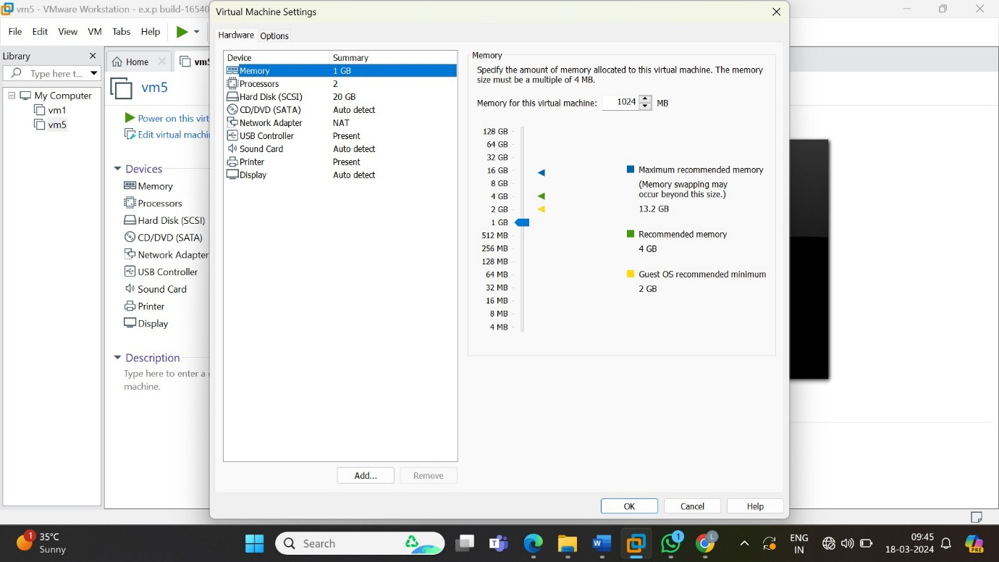

9.this is the final result after changing the hardware of the given virtualization

