EXPERIEMENT:10: Create a Cloning of a VM and Test it by loading the Previous Version/Cloned VM.

STEP:1: AFTER CREATING A NEW VIRTUAL MACHINE.

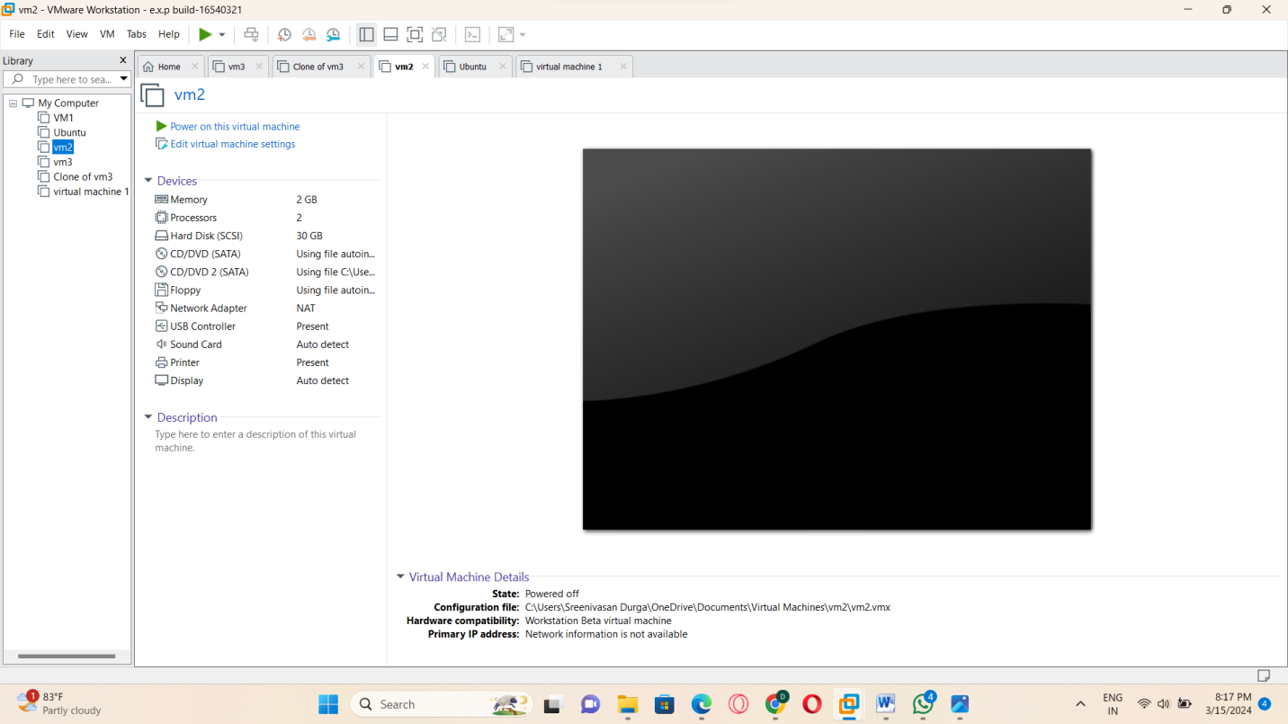

STEP:2: THE CURRENT STATE IN THE VIRTUAL MACHINE.

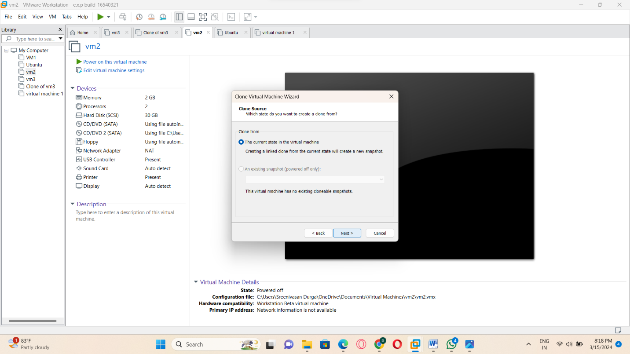

STEP:3: and then create a new clone.

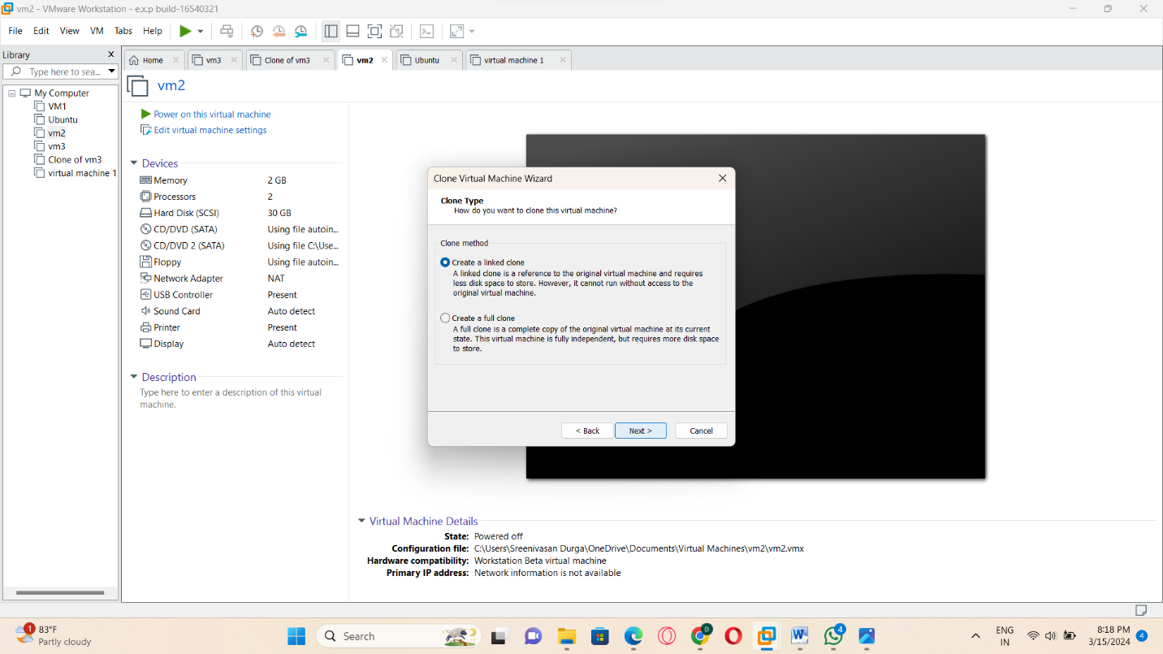

STEP:4: and create a new clone and next.

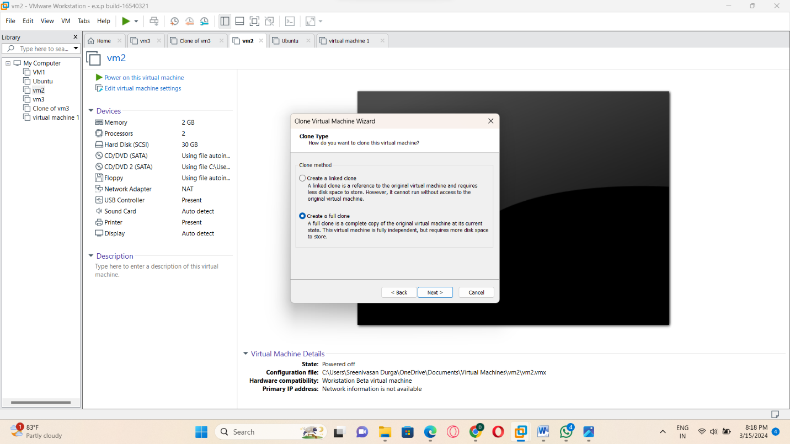

STEP:5: create a new virtual machine name.

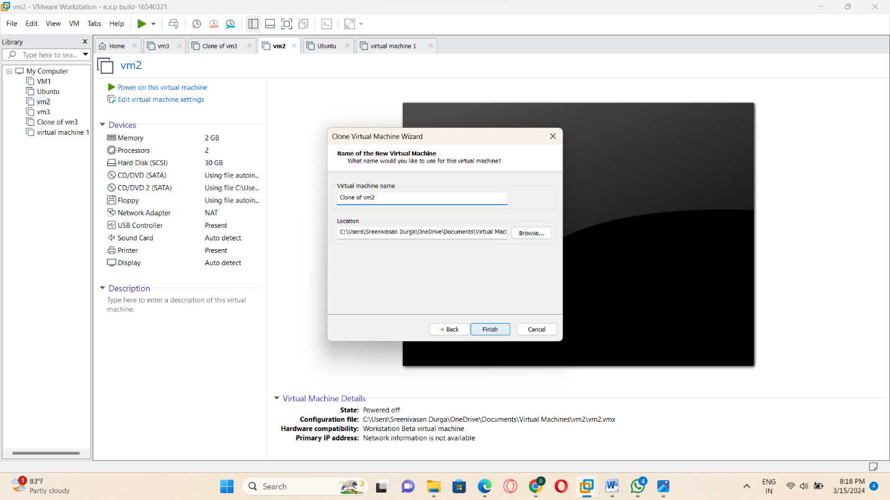

STEP:6: and then cloning the virtual machine now close.

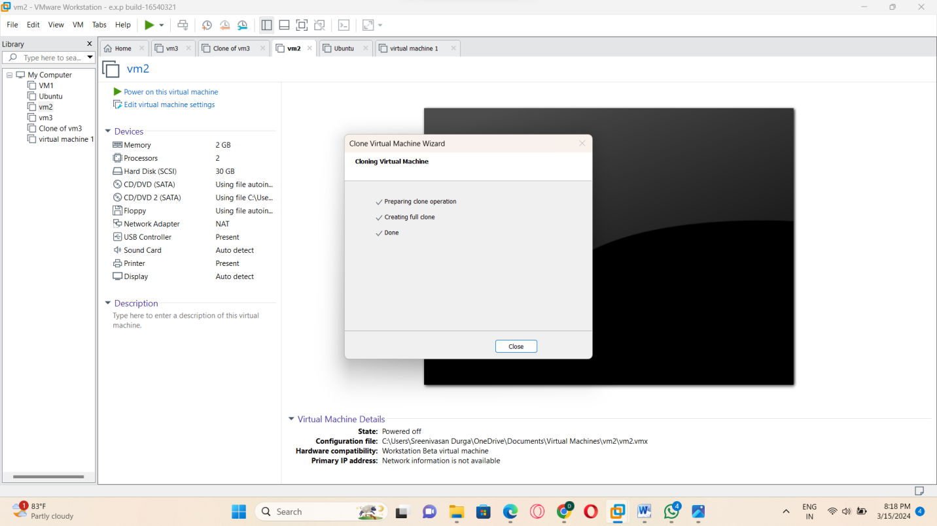

STEP:7: and then the clone of vm2 is ready clone(duplicative).

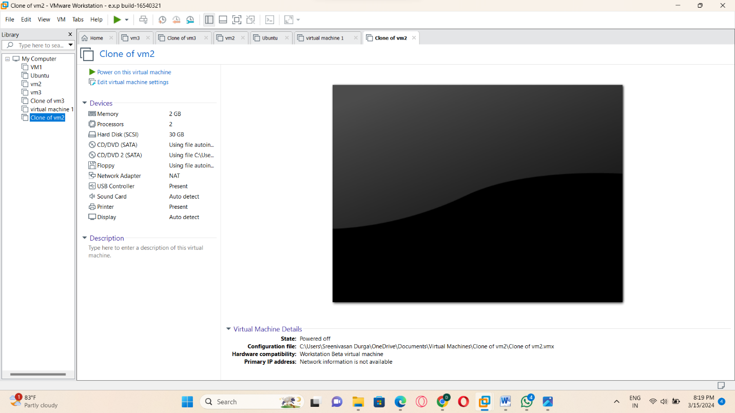

RESULT: THUS,THE PROGRAM FOR VM-WARE IN CLONE HAS BEEN EXCEUTED SUCCESSFULLY.