IoT Home Automation System

Abhishek Balaji Rao
Geethan Rajkumar
Shuchi Shailesh Kumar Patel
Swayam Jaiminkumar Shah
Department of Industrial and Systems Engineering, San José State University
ISE222: Advanced Systems Engineering
Dr. Ramesh Srinivasan
October 18, 2023

Table of Contents
INTRODUCTION 3
PROBLEM IDENTIFICATION 3
CUSTOMER NEEDS / WANTS 4
Anticipated Customer Needs 4
Anticipated Customer Wants 4
Validation process overview 5
Customer requirements and Relative importance rating: 11
SCOPE OF SYSTEM UNDER CONSIDERATION 15
Physical boundaries 15
Business boundaries 15
Process and Information boundaries 15
Temporal boundaries 16
Outside Interfaces Boundaries: Connectivity and Networking 16
OPERATIONAL REQUIREMENTS AND TECHNICAL PERFORMANCE MEASURES 17
HOUSE OF QUALITY 18
Maintenance flow diagram 19
FUNCTIONAL ANALYSIS AND REQUIREMENT ALLOCATION 20
LIFE CYCLE COSTING 22
REFERENCES 24
APPENDIX 1 25

INTRODUCTION
Smart homes have been on the radar as something futuristic for many years now but the smart home market of sensors, actuators, hubs or gateways, and the apps in the smart home ecosystem have been fragmented and there has not been one system or device that has catered to the wide areas of application in the home. We propose a hub/gateway device with multiple wireless protocols and an app for the hub with a great user interface to integrate cameras, doors, smart garden irrigation, intrusion detection, smart electricity meter, thermostat/HVAC, lighting and smoke detectors.

PROBLEM IDENTIFICATION
When we were searching for a product that seamlessly integrates different devices and controls all aspects of a smart home, we found that there are not a lot of good systems that have seamless integration and a convenient interface. Not all protocols are appropriate for IoT devices, which forces businesses to deal with those protocols in a very complex way in order to make a product that can be widely used in the smart home (Li et al., 2021). There is estimated to be more than 43 billion devices connected to the internet in 2023 according to Forbes (Marr, 2022) and the number of IoT devices in the home is growing.
Our suggested hub/gateway device and companion app seek to provide a comprehensive, user-centric solution that meets the changing requirements of the smart home industry by attending to the customer's needs.

CUSTOMER NEEDS / WANTS

Anticipated Customer Needs
- Seamless Integration in between devices: Customers would desire a solution that integrates several smart home protocols and devices in an intuitive way, doing away with the need for numerous, unrelated apps and systems.
- Convenient interface: Customers would need a mobile app experience for their smart home devices that is easy to use, intuitive, and easy to monitor.
- Robust security: Customers will place a high importance on security in their smart homes.

Anticipated Customer Wants
- Compatibility: Customers would look for a hub/gateway device that supports a wide range of wireless protocols that are often used in smart home devices to ensure interoperability with their present or future IoT products.
- Energy Efficiency: Customers could be interested in a system that reduces utility costs and saves energy.
- Reliability: Customers would desire a system that minimizes downtime and delivers consistent performance for their smart home appliances.
- Cost Effectiveness: Customers might seek a solution that is reasonably priced and provides good value.
- Customization: Some consumers might want the option to alter automation and control parameters.
- Scalability: Customers might pick a solution that allows them to progressively add new components and services to their smart home ecosystem as needed without adding a lot of complexity.
- Remote Access: Customers could desire the mobile app to provide remote access and monitoring features so they can operate their smart home even while they are away.
- Integration with voice access: For hands-free operation, some users may choose to combine their smart gadgets with well-known voice assistants like Amazon Alexa or Google Assistant.
- Data privacy: Customers who respect their privacy can request guarantees about the security of their data and the usage of that data (Buil-Gil et al., 2023).

Validation process overview
We followed the Voice of Customer(VOC) technique to validate our anticipated customer wants and needs. For this, we created a survey in Google Forms and asked our potential customers to validate our assumptions. We also informally spoke to several engineers in leading electronic design companies like NXP Semiconductors and e-info chips (an Arrow company) to validate our customer wants and needs.
Graphical analysis of the survey is represented as follows:

Figure 1:
Graphical analysis for question 1
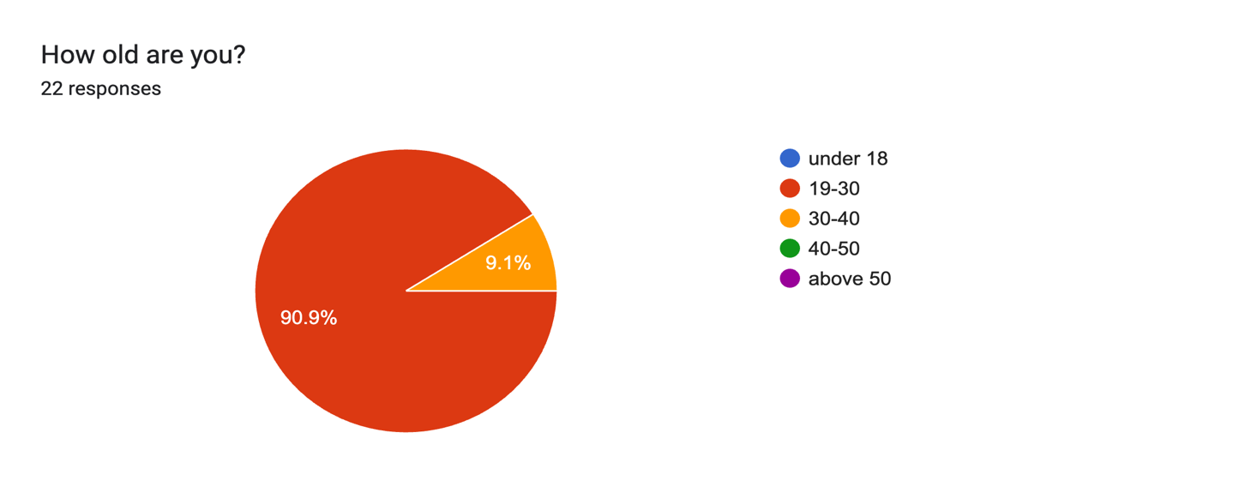
Figure 2:
Graphical analysis for question 2
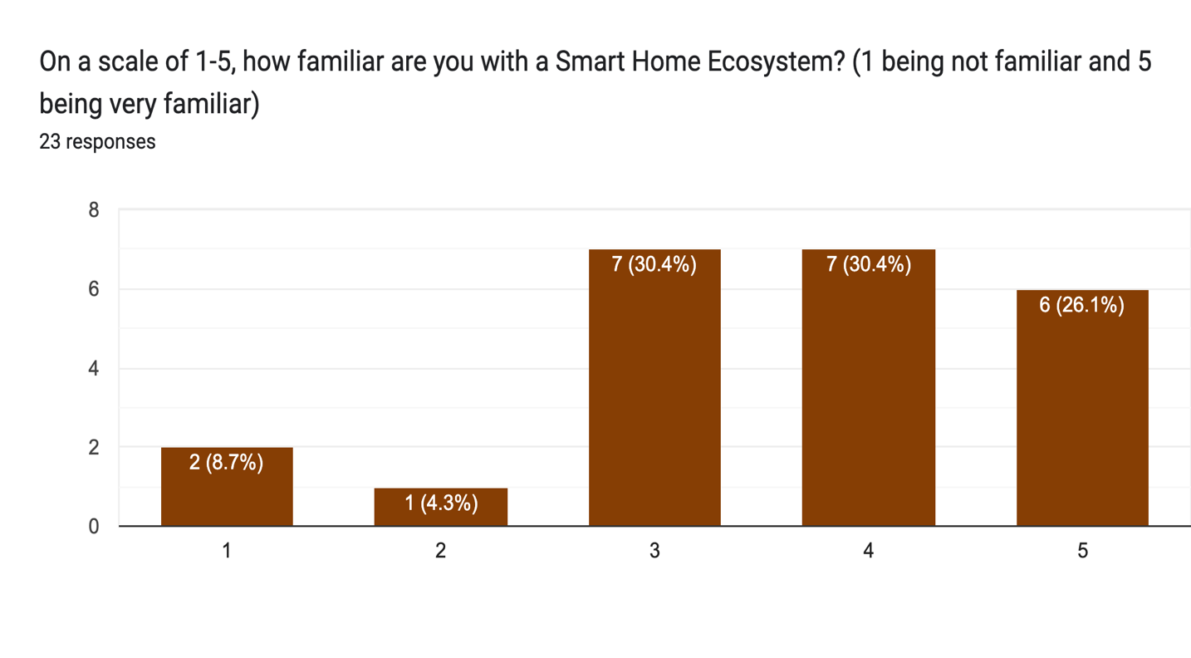

Figure 3:
Graphical analysis for question 3
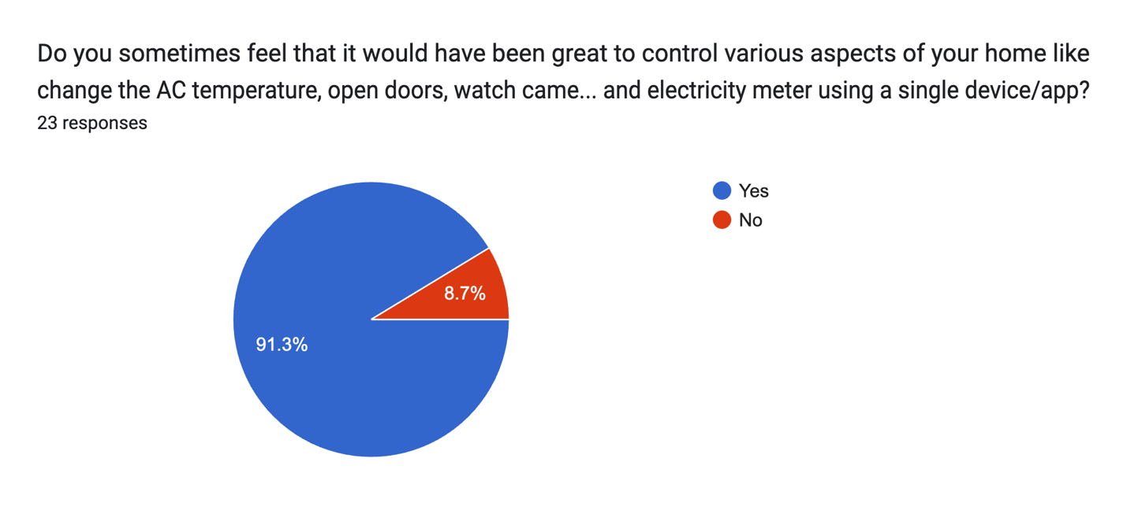

Figure 4:
Graphical analysis for question 4
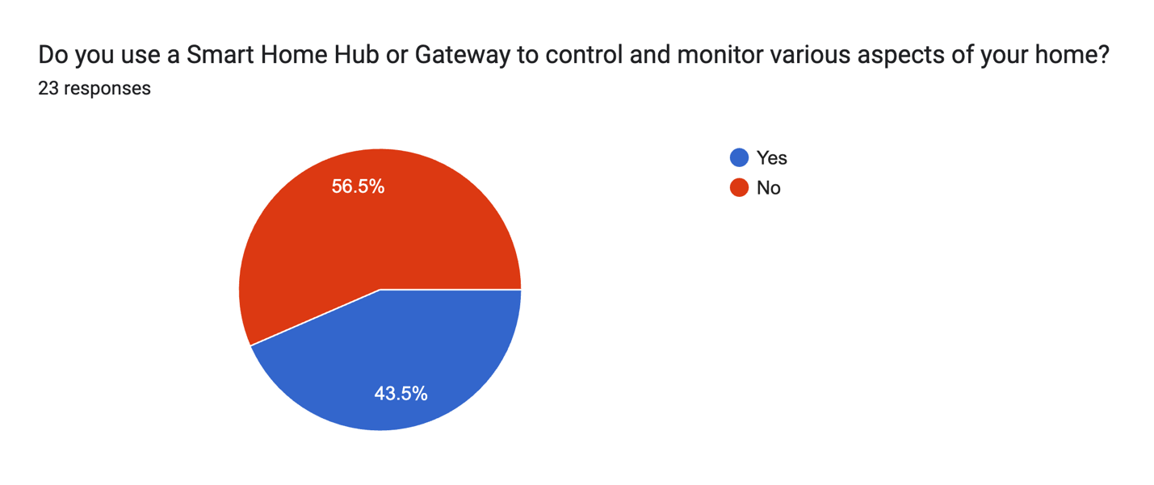

Figure 5:
Graphical analysis for question 5
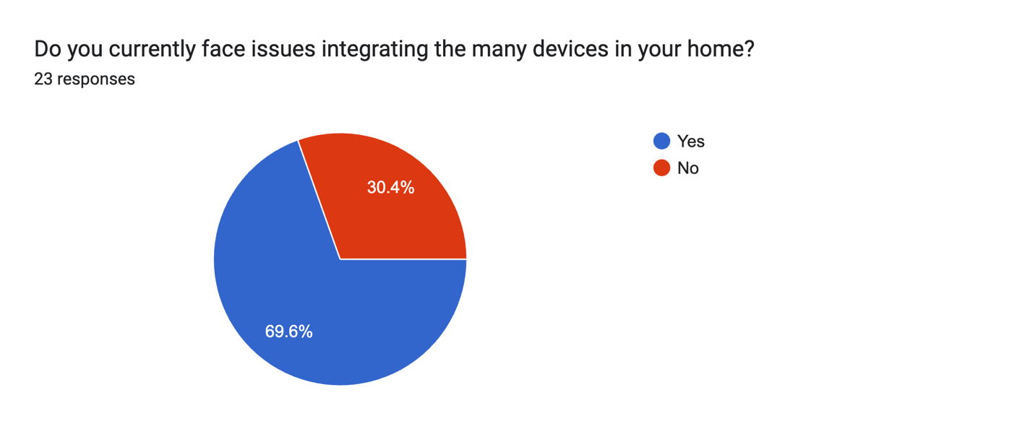

Figure 6:
Graphical analysis for question 6
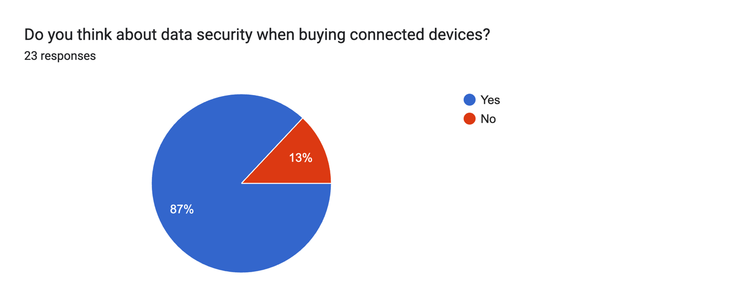

Figure 7:
Graphical analysis for question 7
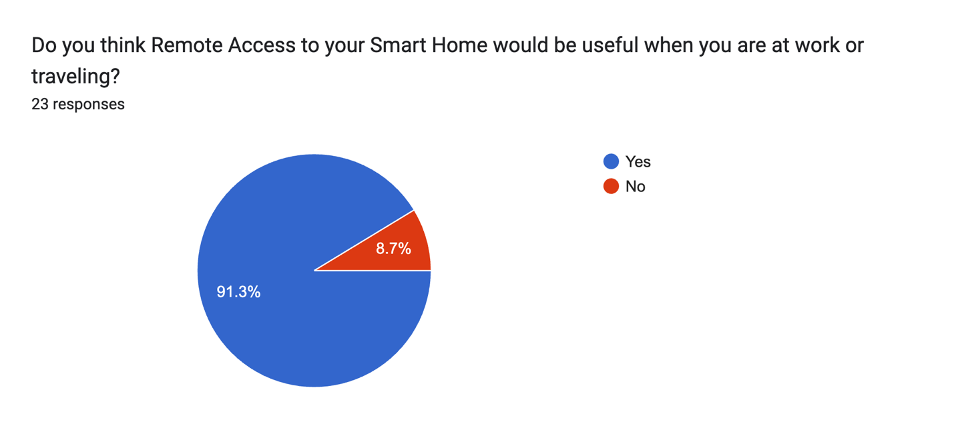

Figure 8:
Graphical analysis for question 8
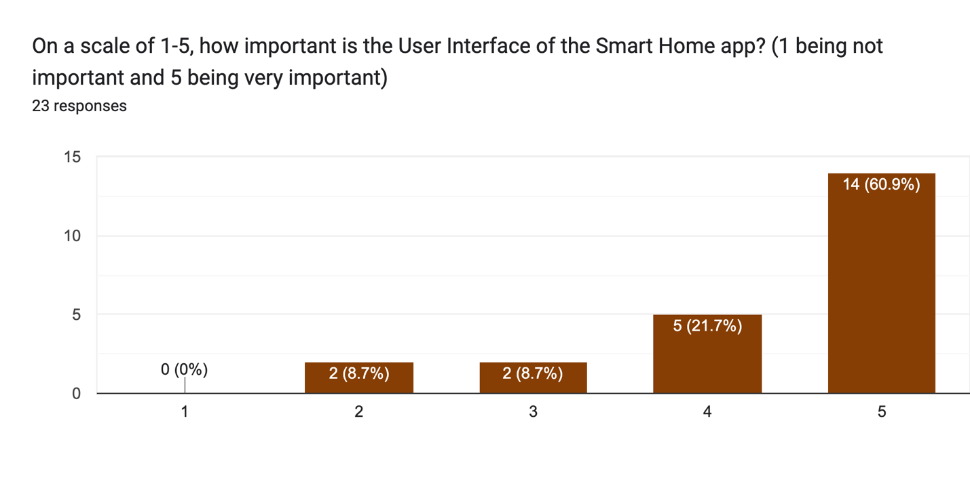

Figure 9:
Graphical analysis for question 9
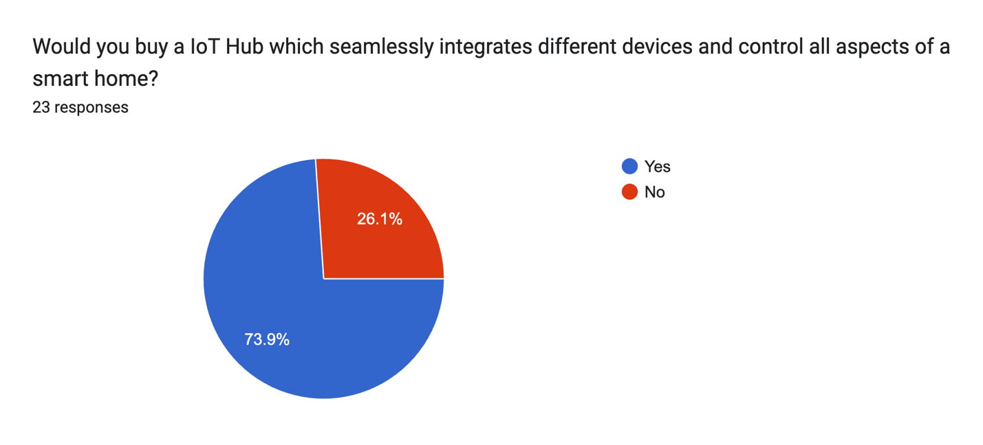

Figure 10:
Graphical analysis for question 10
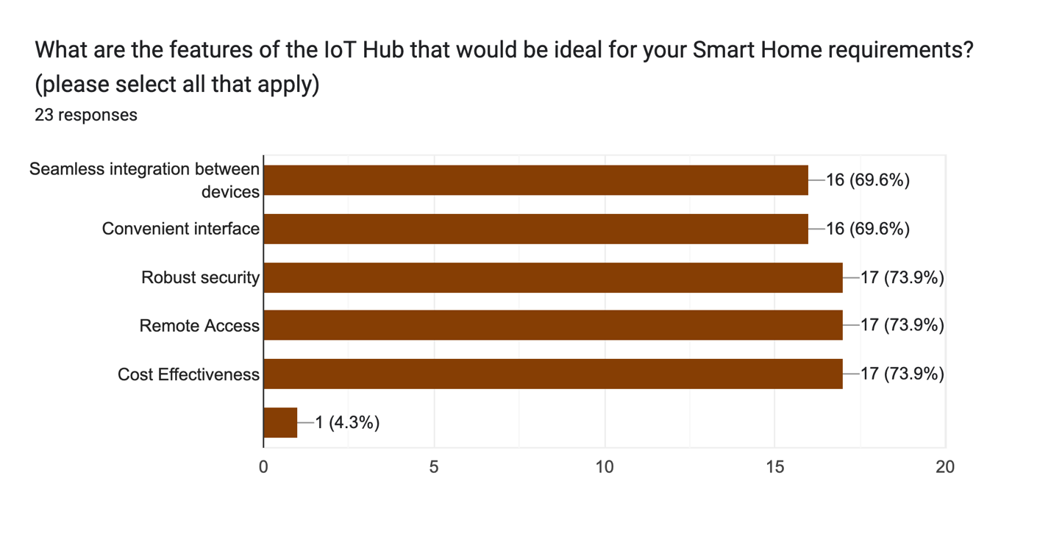
Figure 11:
Graphical analysis for question 11
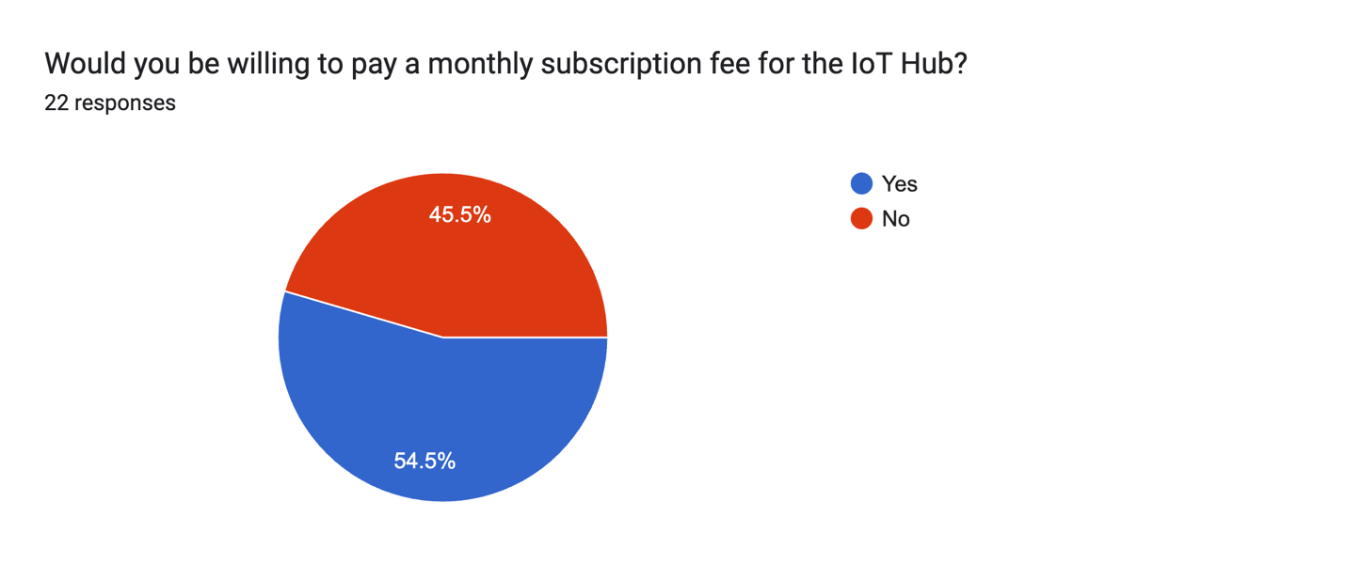

Customer requirements and Relative importance rating:
Table 1:
Customer needs and wants | Need or want | Weightage | Importance rating
Seamless Integration between devices | Need | 69.6% | 4
Convenient interface | Need | 91.3% | 5
Robust security | Need | 87% | 5
Reliability | Want | 43.5% | 3
Cost Effectiveness | Want | 73.9% | 4
Data security | Want | 87% | 5
Remote access | Want | 91.3% | 5

Based on the customer survey below are the customer requirements with their importance ratings:

Table 2:
Customer requirements with their importance rating based on customer survey:
Customer requirements | Importance rating
User friendly | 5
Cost effective | 4
Convenient interface | 5
Single device app | 5
Remote access | 4

CONTEXT DIAGRAM (Please zoom in for clarity of image)
Figure 12
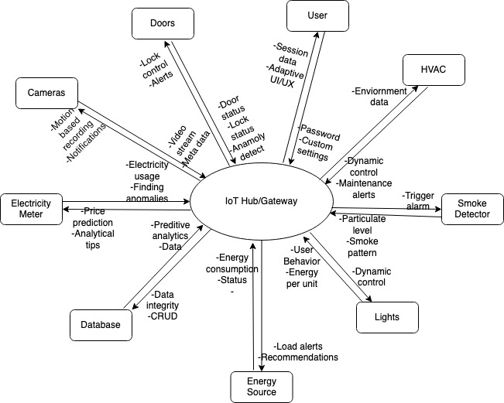

INTERFACES
Table 3
Interfaces of the IoT Hub/Gateway
Name | Input(I)/ Output (O) | Interface type | Description
Doors/ input | I | Physical and digital | Door status using sensors (locked/unlocked)
Doors/ output | O | Physical and digital | Lock/Unlock command
User/ input | I | Physical and digital | Multifactor verification in terms of biometrics (fingerprint/face scan)
User/output | O | Physical and digital | Secure session deployment
HVAC/ Input | I | Physical and digital | Microenvironment data (temp, humidity)
HVAC/ output | O | Physical and digital | Dynamic environment control
Smoke detectors/ input | I | Physical and digital | Smoke behaviour patterns (kitchen fumes, personal habits)
Smoke detectors/output | O | Physical and digital | Advance alert system based on smoke trends
Light/ input | I | Physical and digital | Ambient light data
Light/ output | O | Physical and digital | dynamic light control based on room condition and occupancy
Energy consumption/input | I | Physical and digital | Real-time data on energy output and consumption.
Energy consumption/ output | O | Physical and digital | Analytics for utilizing renewable energy
Database/input | I | Physical and digital | Timestamp-based CRUD operations on data.
Database/output | O | Physical and digital | Data backup schedules and version control.
Electric meter/input | I | Physical and digital | High-resolution statistics on electricity usage.
Electric meter/output | O | Physical and digital | Predictions of dynamic price.
Camera/input | I | Physical and digital | Video streams in high definition.
Camera/output | O | Physical and digital | Motion based recordings

SCOPE OF SYSTEM UNDER CONSIDERATION

Physical boundaries
- Hub/gateway equipment: Modules for connectivity - The hub should support a variety of wireless protocols since "Seamless integration between devices" is required.
- Devices for User Interaction: Due to the demand for "convenient interfaces," these gadgets make sure that interactions have user-friendly interfaces.
- Device sensors: Sensors in HVAC systems, cameras, and other prioritized devices that communicate data to provide a "single location" for handling numerous functionalities.
- Actuators: Reliable performance in accordance with client demands, ensuring that devices react quickly.

Business boundaries
- Price Structures: Appropriate pricing techniques should be used, with "cost-effectiveness" as a primary consideration.
- Vendor connections: Decreasing downtime by ensuring smooth connection with manufacturers for a strong and dependable system.
- Premium Options: Permit personalized elements based on customers' need for "customization" for a personalized experience.
- Customer support system: Provide efficient troubleshooting.

Process and Information boundaries
- Check for Compatibility: "Compatibility" was a key client need, thus it's critical to make sure a variety of devices may be added.
- Data Mapping: Ensure that data is represented in a comprehensible and natural way, echoing the need for a "convenient interface".
- The ability to "alter automation and control parameters" may be something that customers demand.
- Feedback Cycle: This procedure is essential to guarantee user confidence and trust, particularly with reference to "robust security".
- Data security procedures: In order to secure user data and assure transparency, it is critical to building robust methods for handling "data privacy".
- Dependable defence mechanisms such as strong security measures are required because clients value "robust security".

Temporal boundaries
- Latency Controls: Actions should be almost instantaneous in order to maintain "reliability" and a "convenient interface".
- Regarding "reliability," users should receive prompt feedback on their commands.
- System upkeep: Consistent security audits, upgrades, and other measures to guarantee "robust security" and reduce system vulnerabilities.

Outside Interfaces Boundaries: Connectivity and Networking
- Remote Access: The system should prioritize reliable connectivity mechanisms because "remote access" is a top priority for customers.
- Integration with Notable Voice Assistants: For "hands-free operation," customers may desire integration with services like Amazon Alexa or Google Assistant.
- External APIs: formats for exchanging data Standard formats guarantee flawless interactions with various devices, thus satisfying the need for "seamless integration".

OPERATIONAL REQUIREMENTS AND TECHNICAL PERFORMANCE MEASURES
Table 4
Operational requirements | TPM | TPM Units | TPM Target value/ Range
Protocol Compatibility | Number of Supported Wireless Protocols | Number of wireless protocols | Range: 5- 10
Device Connectivity | Max devices connected | Devices | Range: 10-150
Cost Effectiveness | Maximum Features at competitive price | $/unit | Range: 50 - 100
User Interface Responsiveness | Response Time | Seconds | 0.1 - 2
Cloud Connectivity Latency | Time to connect to the cloud | Seconds | 0.1 - 3
Data Security | Encryption standard | Bit strength | ≥ 256 bits
Reliability | Consistent performance with minimal downtime | System Uptime | Range: 98-99.9%
Device Integration Time | Time to add new device | Seconds | < 10

HOUSE OF QUALITY
Figure 13
House of quality
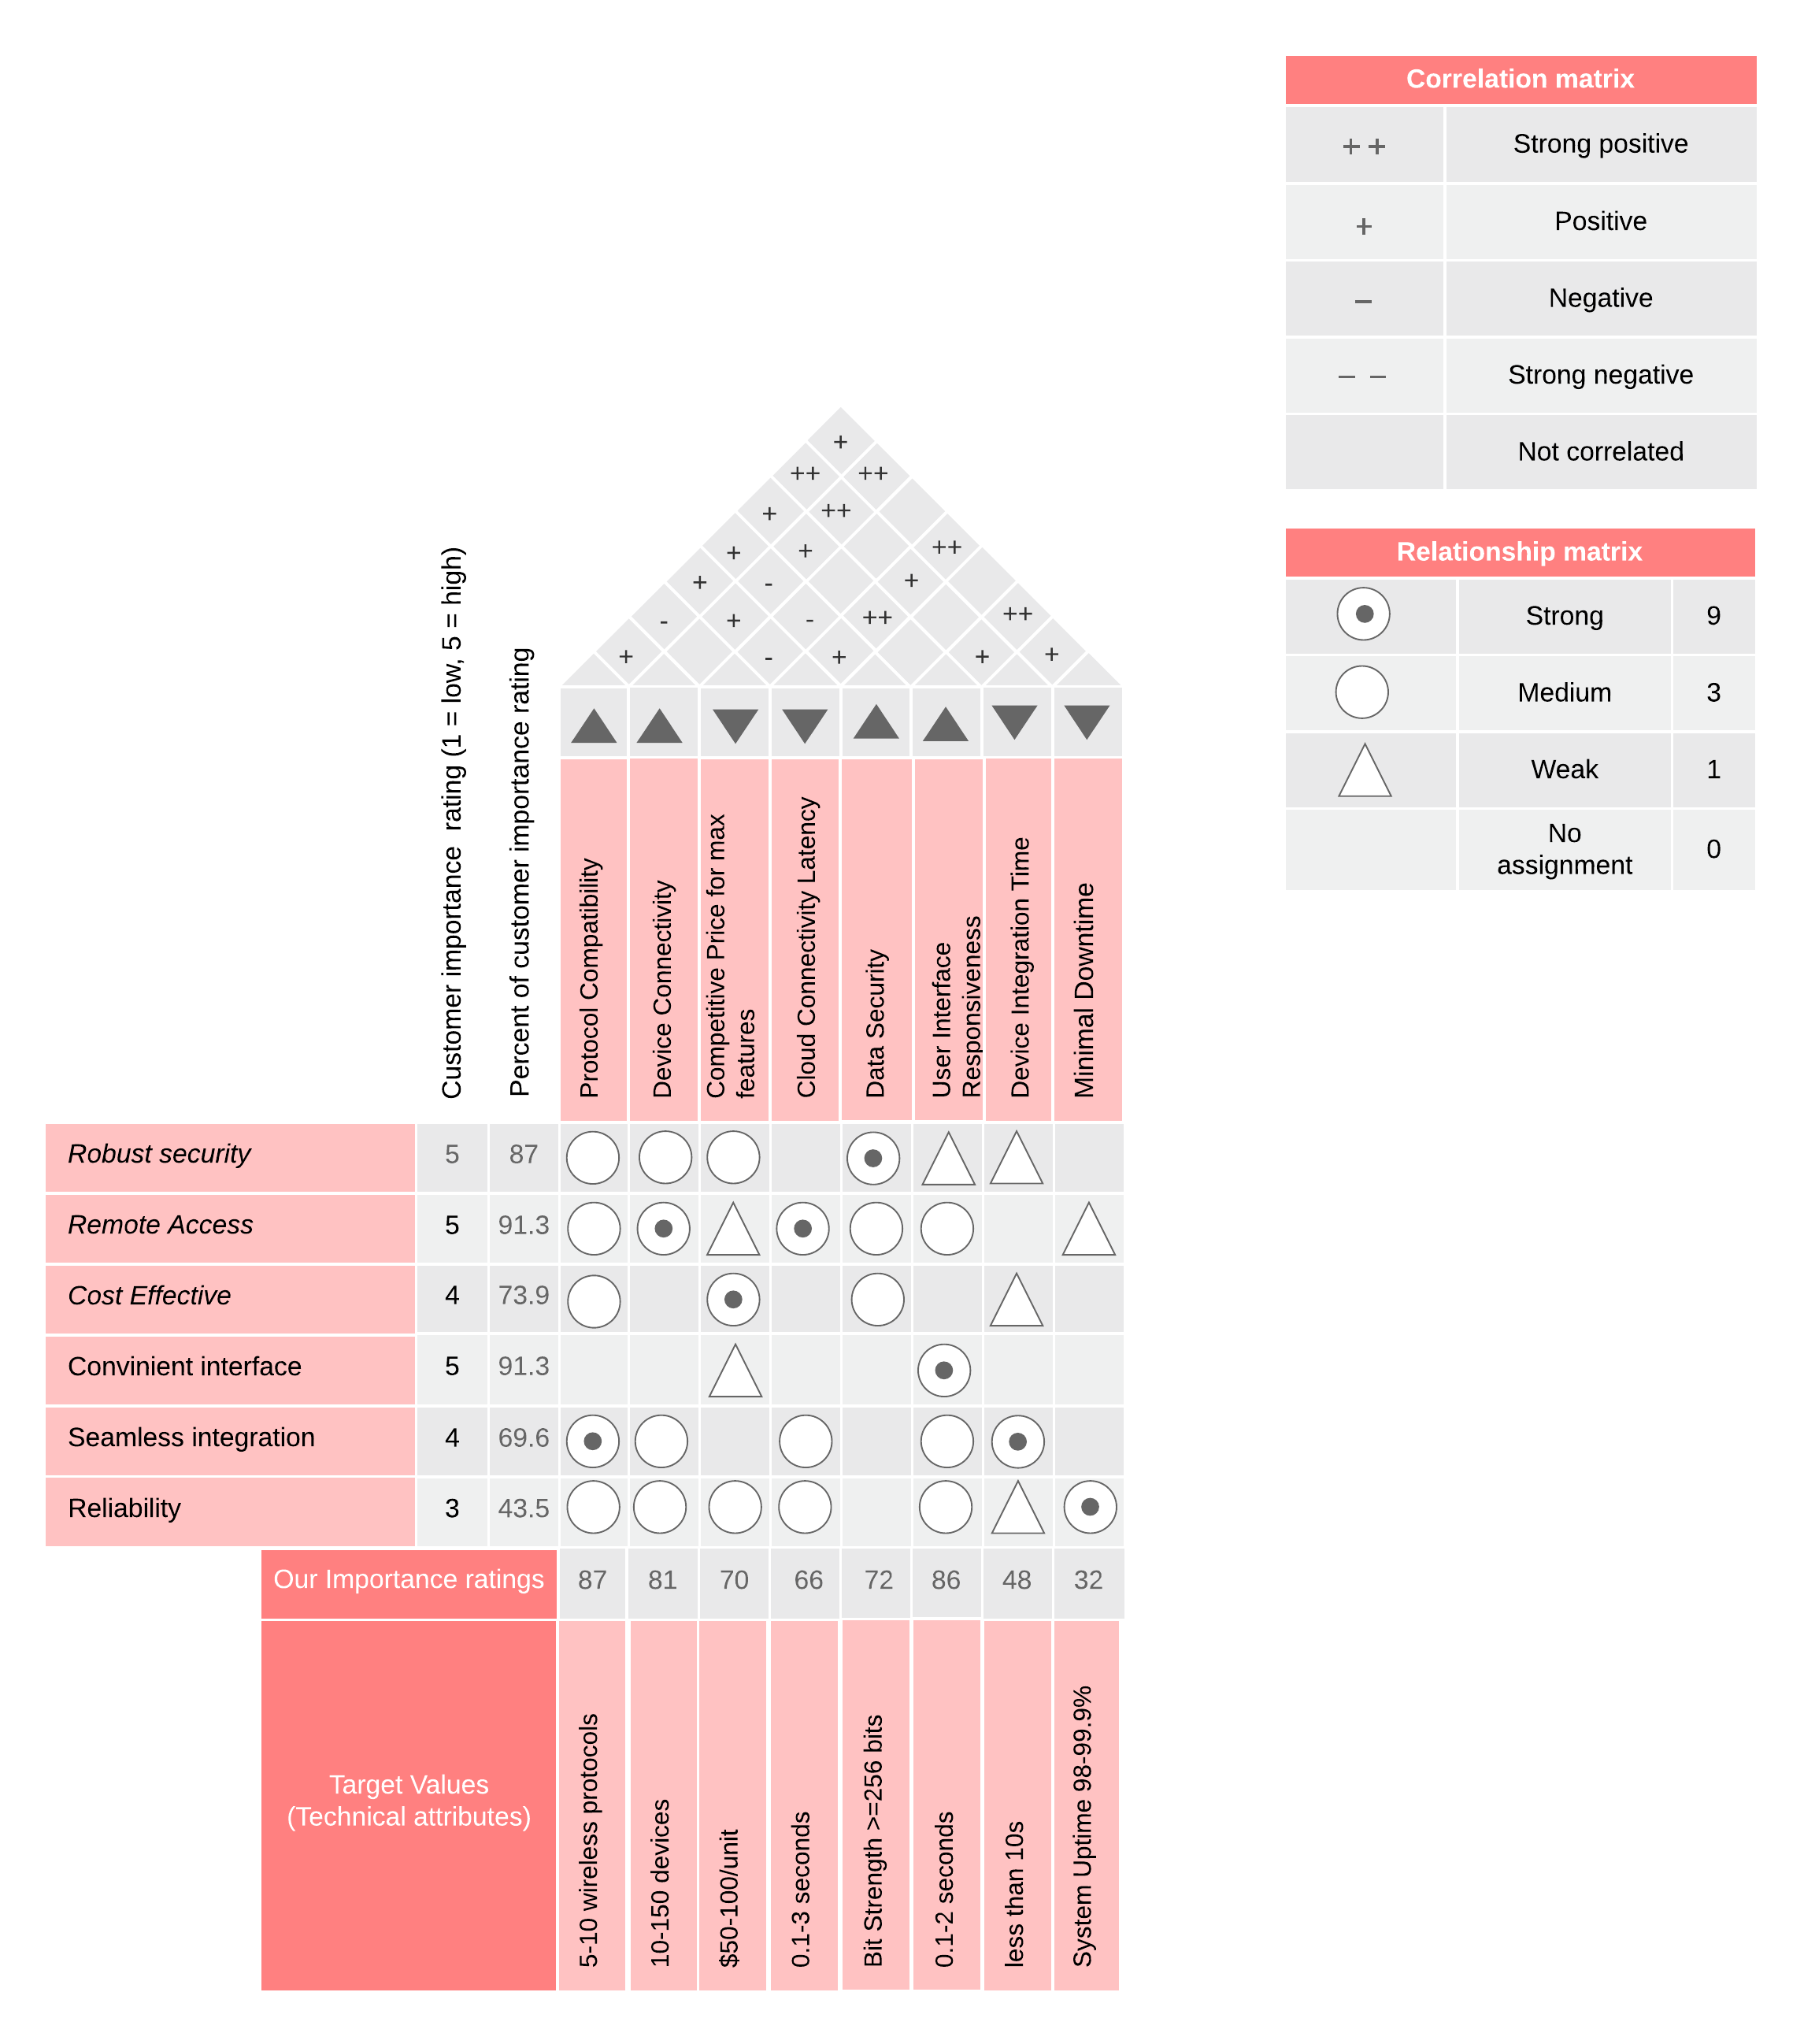

MAINTENANCE CONCEPT
IoT Hub/Gateway maintenance involves software updates, system backup, troubleshooting issues in IoT device installation, and providing user with technical support.

Maintenance flow diagram
Figure 14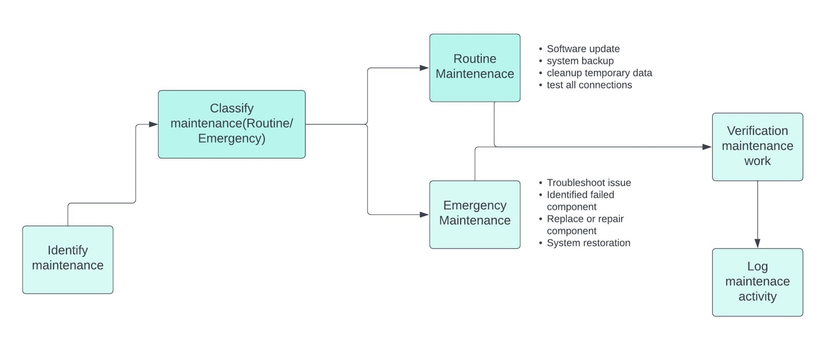Table 5: Maintenance details
What | Where | Who | Type of Work Accomplished
Software Update | IoT Hub/Gateway | IT Technician | Routine
System Backup | IoT Hub/Gateway | System Administrator | Routine
Clean up Temporary Data | IoT Hub/Gateway | IT Technician | Routine
Test All Connections | IoT Hub/Gateway | IT Technician | Routine
Troubleshoot Issue | IoT Hub/Gateway | IT Technician | Emergency
Identify Failed Component | IoT Hub/Gateway | IT Technician | Emergency
Replace/Repair Component | IoT Hub/Gateway | Hardware Technician | Emergency
System Restoration | IoT Hub/Gateway | System Administrator | Emergency

FUNCTIONAL ANALYSIS AND REQUIREMENT ALLOCATION
Figure 15
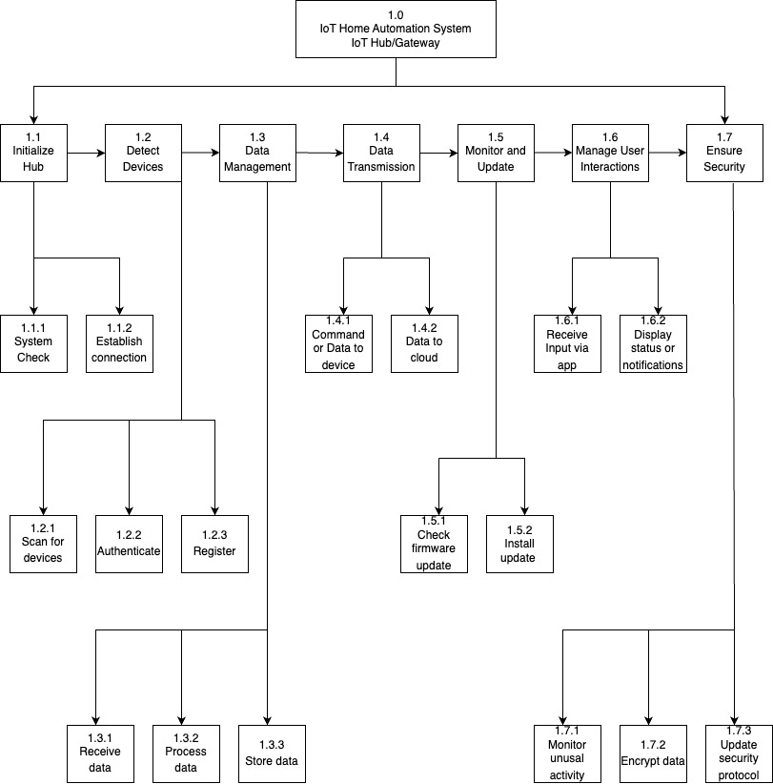

Requirement Allocation
Table 6:
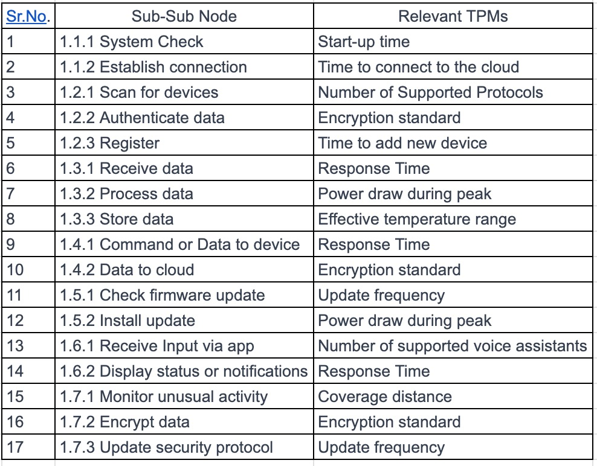

LIFE CYCLE COSTING

Life Cycle Cost Breakdown for IoT Hub/Gateway

Program Activity | Cost by Program Year | Cost by Program Year (Inflated Dollars@10% inflation) | Cost by Program Year (Inflated Dollars@10% inflation) | Cost by Program Year (Inflated Dollars@10% inflation | Cost by Program Year (Inflated Dollars@10% inflation | Total Actual Cost (Dollars)
 | Year 1 | Year 2 | Year 3 | Year 4 | Year 5
Total R&D cost for IoT Hub/Gateway | $550,000 | $352,000 | $387,200 | $425,920 | $468,512 | $2,183,632
Total Production & Construction cost for IoT Hub/Gateway | $395,000 | $434,500 | $477,050 | $525,745 | $578,319 | $2,410,614
Disposal Cost |  |  |  |  |  | $125,000
Total Estimated Life Cycle Cost for IoT Hub/Gateway | $945,000 | $786,500 | $864,250 | $951,665 | $1,046,831 | $4,719,246

Research and Development Cost for IoT Hub/Gateway

Program Activity | Cost by Program Year | Cost by Program Year (Inflated Dollars@10% inflation) | Cost by Program Year (Inflated Dollars@10% inflation) | Cost by Program Year (Inflated Dollars@10% inflation | Cost by Program Year (Inflated Dollars@10% inflation | Total Actual Cost (Dollars)
 | Year 1 | Year 2 | Year 3 | Year 4 | Year 5
A. Customer costs: IoT Hub/Gateway
1. Initial Concept Development | $80,000 | - | - | - | - | $80,000
2. Hardware Design & Prototyping | $150,000 | - | - | - | - | $150,000
B. Supplier costs: IoT Hub/Gateway
1. Component Acquisition | $100,000 | $110,000 | $121,000 | $133,100 | $146,410 | $610,510
2. Firmware Development | $60,000 | $66,000 | $72,600 | $79,860 | $87,846 | $366,306
3. Integration & Testing | $70,000 | $77,000 | $84,700 | $93,170 | $102,487 | $427,357
4. Quality Assurance & Certification | $90,000 | $99,000 | $108,900 | $119,790 | $131,769 | $549,459
Total R&D cost for IoT Hub/Gateway | $550,000 | $352,000 | $387,200 | $425,920 | $468,512 | $2,183,632

Production/Construction Costs for IoT Hub/Gateway

Program Activity | Cost by Program Year | Cost by Program Year (Inflated Dollars@10% inflation) | Cost by Program Year (Inflated Dollars@10% inflation) | Cost by Program Year (Inflated Dollars@10% inflation | Cost by Program Year (Inflated Dollars@10% inflation | Total Actual Cost (Dollars)
 | Year 1 | Year 2 | Year 3 | Year 4 | Year 5
1. Cloud Platform Licensing | $80,000 | $88,000 | $96,800 | $106,480 | $117,128 | $488,408
2. Hardware Manufacturing | $125,000 | $137,500 | $151,250 | $166,375 | $183,012 | $763,137
3. Software Development | $100,000 | $110,000 | $121,000 | $133,100 | $146,410 | $610,510
4. Support and Maintenance
a. Hardware Support | $30,000 | $33,000 | $36,000 | $39,930 | $43,923 | $182,853
b. Firmware Updates | $30,000 | $33,000 | $36,000 | $39,930 | $43,923 | $182,853
c. Customer Service | $30,000 | $33,000 | $36,000 | $39,930 | $43,923 | $182,853
Total Production & Construction cost for IoT Hub/Gateway | $395,000 | $434,500 | $477,050 | $525,745 | $578,319 | $2,410,614

REFERENCES
Li, J., & Lin, Y. (2021). IOT home automation – Smart homes and Internet of Things. 2021 3rd International Academic Exchange Conference on Science and Technology Innovation (IAECST). https://doi.org/10.1109/iaecst54258.2021.9695788

Buil‐Gil, D., Kemp, S., Kuenzel, S., Coventry, L., Zakhary, S., Tilley, D. S., & Nicholson, J. W. G. (2023). The digital harms of smart home devices: A systematic literature review. Computers in Human Behavior, 145, 107770. https://doi.org/10.1016/j.chb.2023.107770

Marr, B. (2022, November 7). The Top 4 Internet Of Things Trends In 2023. Forbes. https://www.forbes.com/sites/bernardmarr/2022/11/07/the-top-4-internet-of-things-trends-in-2023/?sh=298f46eb2aea

APPENDIX 1
Customer Survey

