Specifications   
Illumination and sensor board for multispectral cameras system

Author: Gaetano Scebba

Version: V3 (2017-06-02)

1. Motivation

Management and treatment of chronic wounds represent a challenge for both the patients and the medical practitioners. Typically, the wound healing process is slow, so the structural wound changes can be recognized only across several days or weeks. This is why most wound treatments involve weekly visits to the hospital, to document the current wound state. However, in some cases, this low frequency of hospital visits can lead to critical delays in wound interventions in case the wound condition changes more rapidly.

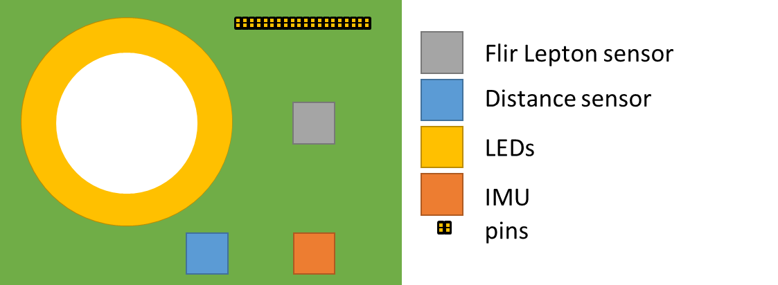Our research group is interested in developing a device that allows patients to take images of wounds at their homes with a higher frequency compared to typical hospital visits. The images would then be made available to their clinicians for continuous wound monitoring.

Figure 1 Main components of the designed PCB

1. Purpose

The purpose of this document is to provide specifications for the design and develop of a printed circuit board (PCB) for enhancing a multispectral cameras system (VIS-IR econ systemse-CAM40_CUMI4682_MOD - 4 MP OV4682[1]) interfaced to a Raspberry PI 3 board. The PCB (Figure 1) will provide following functions:

1. Illumination in infrared, ultraviolet and visible spectrum
2. Thermal (FIR) imaging
3. Distance measurement
4. Spatial orientation measurement
5. PCB specifications

|  |  |  |
| --- | --- | --- |
| Description | Quantity | Wavelength |
| SMD Infrared LED | 20 | 850 nm |
| SMD Ultra-violet LED | 4 | 405 nm |
| SMD White LED | 4 | - |

* The PCB shall integrate the following sets of LEDs:
* The PCB shall integrate all the circuits and mounts for adding and operating the following sensors:
  + Flir Lepton infrared camera sensor;
  + ST’s VL53L0X distance sensor;
  + FIS1100 Inertial Measurement Unit;
* The PCB shall integrate 40 pins (2x20) to be interfaced with the Raspberry PI 3 board.

1. PCB requirements

* The intensity of each set of LEDs shall be individually controllable using continuous current;
* The Flir Lepton sensor shall be fully operational;
* The VL53L0X distance sensor shall be fully operational;

Figure 2 Format and dimensions

* The FIS1100 IMU shall be fully operational.

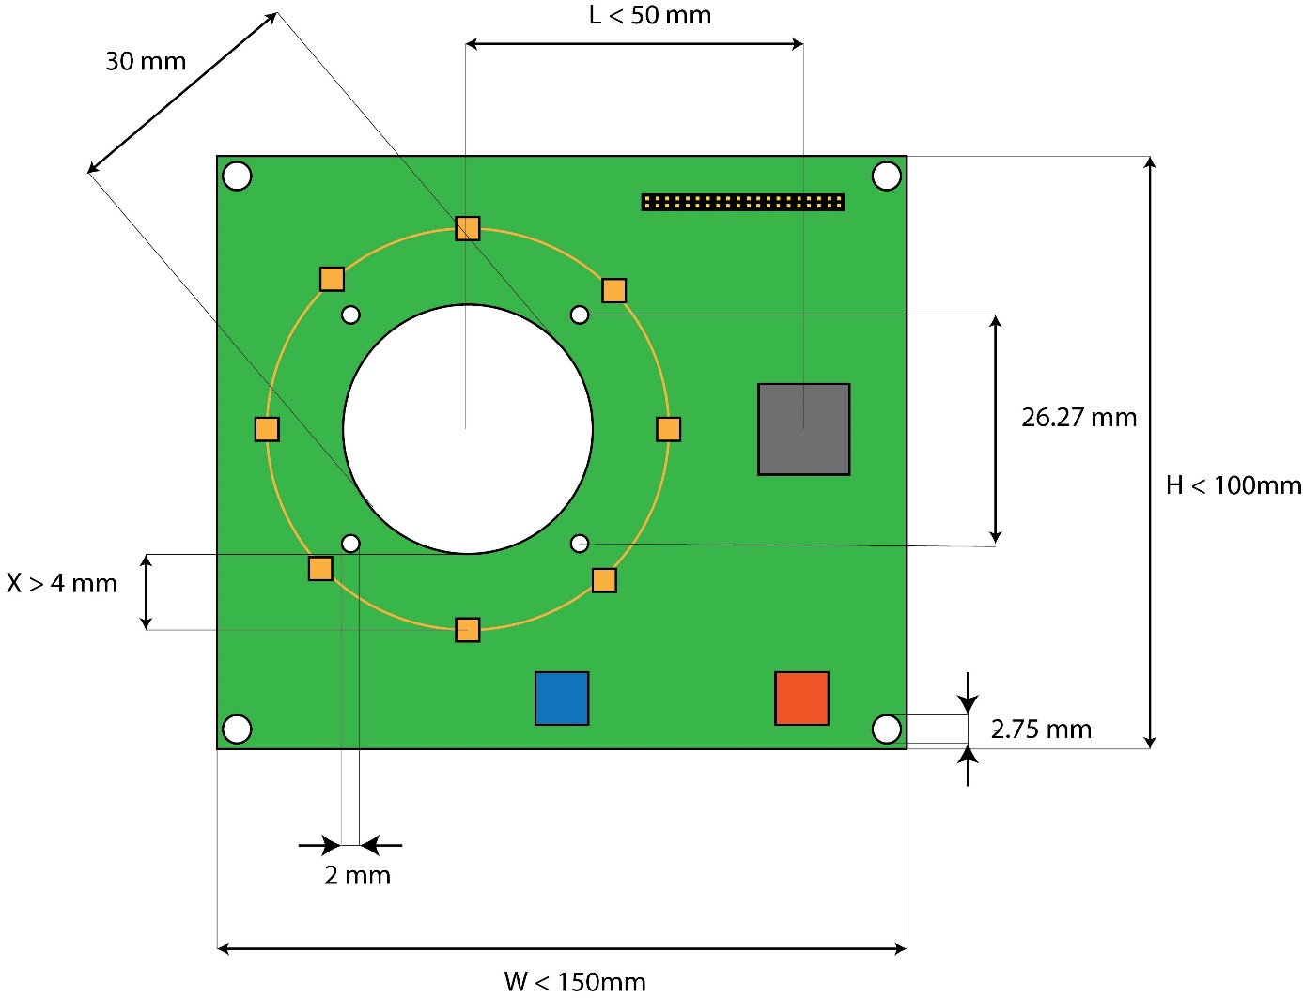

1. Tasks list
   1. Debug the existing PCB prototype;
   2. Design of the revised PCB with the desired specifications and requirements;
   3. Ordering of the components;
   4. PCB manufacturing;
   5. Test of the requirements;
   6. Documentation and getting-started guide.
2. Milestones
   1. Report of the bugs and planned revisions;
   2. Pre-manufacturing report of the PCB;
   3. Demo of the final system.
3. Further duties

Log worked hours and report weekly.

1. Components
   1. Flir Lepton sensor and breakout board

Figure 3 Flir Lepton sensor

Figure 4 Flir Lepton breakout board and Flir Lepton sensor

The Flir Lepton is an infrared camera system that integrates a fixed-focus lens assembly, an 80x60 long-wave infrared microbolometer sensor array, and the signal-processing electronics.

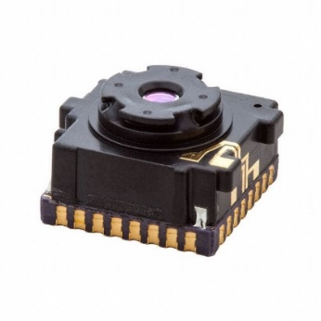The schematic of the operating circuit for the Flir Lepton is in FlirLeptonSensor/LeptonSchematic.pdf

8.2 VL53L0X Time-of Flight distance sensor carrier

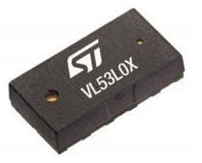The VL53L0X is a time-of-flight laser sensor for distance measurement. It can measure absolute distances up to 2 meters.

Figure 4 VL53L0X distance sensor

The schematic of the operating circuit for the VL53L0X distance sensor is in DistanceSensor/DistSchematic.png

8.3 FIS1100 Inertial Measurement Unit

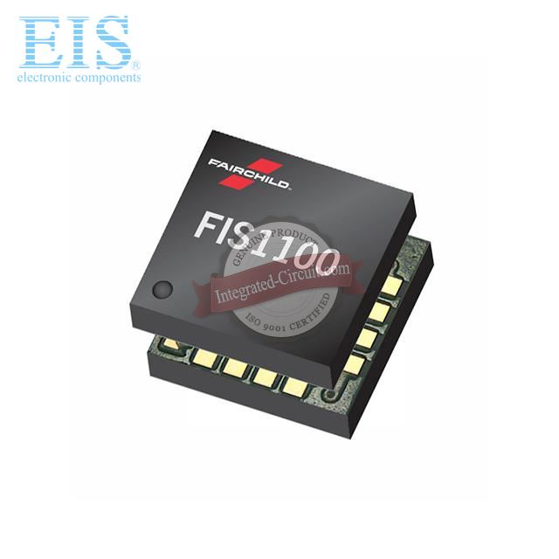The FIS1100 is an integrated 6-axis MEMS sensor that includes a 3D accelerometer, a 3D gyroscope and a custom vector digital signal processor.

Figure 5 FIS1100 IMU

The datasheet of the FIS1100 IMU is in IMU/FIS1100Datasheet.pdf

1. https://www.e-consystems.com/OV4682-RGB-IR-MIPI-CAMERA-Module.asp