"The best way to predict the future is to create it."

BE THE CITIZEN OF INDIA

23-10-2024

Ratan Tata was born in Bombay (now [Mumbai](https://en.wikipedia.org/wiki/Mumbai)), during the [British Raj](https://en.wikipedia.org/wiki/British_Raj), into a [Parsi](https://en.wikipedia.org/wiki/Parsis" \o "Parsis) [Zoroastrian](https://en.wikipedia.org/wiki/Zoroastrianism) family, on 28 December 1937.[[12]](https://en.wikipedia.org/wiki/Ratan_Tata#cite_note-13) He was the son of [Naval Tata](https://en.wikipedia.org/wiki/Naval_Tata) (who was born in [Surat](https://en.wikipedia.org/wiki/Surat) and later adopted into the Tata family), and Soonoo Tata (the niece of Tata group founder

He then continued his studies at the [Cathedral and John Connon School](https://en.wikipedia.org/wiki/Cathedral_and_John_Connon_School) in [Mumbai](https://en.wikipedia.org/wiki/Mumbai), the [Bishop Cotton School](https://en.wikipedia.org/wiki/Bishop_Cotton_School_(Shimla)) in [Shimla](https://en.wikipedia.org/wiki/Shimla), and the [Riverdale Country School](https://en.wikipedia.org/wiki/Riverdale_Country_School) in New York City, from which he graduated in 1955.[[15]](https://en.wikipedia.org/wiki/Ratan_Tata#cite_note-toitataschool-16)[[16]](https://en.wikipedia.org/wiki/Ratan_Tata#cite_note-17)[[17]](https://en.wikipedia.org/wiki/Ratan_Tata#cite_note-18) After high school, Tata enrolled in [Cornell University](https://en.wikipedia.org/wiki/Cornell_University), from which he graduated with a bachelor's degree in architecture in 1962.[[18]](https://en.wikipedia.org/wiki/Ratan_Tata#cite_note-19)[[19]](https://en.wikipedia.org/wiki/Ratan_Tata#cite_note-20) While at Cornell, Tata became a member of the [Alpha Sigma Phi Fraternity](https://en.wikipedia.org/wiki/Alpha_Sigma_Phi). In 1975, Tata enrolled in the Advanced Management Program at [Harvard Business School (HBS)](https://en.wikipedia.org/wiki/Harvard_Business_School).[[20]](https://en.wikipedia.org/wiki/Ratan_Tata#cite_note-21) In 2008, Tata gifted Cornell $50 million, becoming the largest international donor in the university's history.

 He served as the chairman of [Tata Group](https://en.wikipedia.org/wiki/Tata_Group) and [Tata Sons](https://en.wikipedia.org/wiki/Tata_Sons) from 1991 to 2012 and he held the position of interim chairman from October 2016 to February 2017.[[3]](https://en.wikipedia.org/wiki/Ratan_Tata#cite_note-4)[[4]](https://en.wikipedia.org/wiki/Ratan_Tata#cite_note-5) In 2000, he received the [Padma Bhushan](https://en.wikipedia.org/wiki/Padma_Bhushan), the third highest civilian honour in India, followed by the [Padma Vibhushan](https://en.wikipedia.org/wiki/Padma_Vibhushan), the country's second highest civilian honour, in 2008.

Tata was a supporter of education, medicine and [rural development](https://en.wikipedia.org/wiki/Rural_development), and considered a leading philanthropist in India. Ratan Tata was the highest international donor to the Cornell University

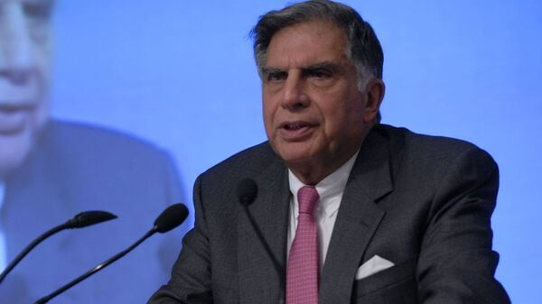

ABOUT A GREAT AND POPULAR EMINENT

PERSONALITY IN THE WORLD:RATAN TATA

,l

QOUTE FOR THE DAY:



WE WILL BE AWARE OF ALL THE THINGS THAT ARE HAPPENING IN THE WORLD.

WE CAN GAIN KNOWELEDGE BY READING NEWSPAPER WHICH WILL BE USEFULL IN OUR LIFE

Objective Of NewsPaper

[Sidebar Title]

[Sidebars are great for calling out important points from your text or adding additional info for quick reference, such as a schedule.

They are typically placed on the left, right, top or bottom of the page. But you can easily drag them to any position you prefer.

When you’re ready to add your content, just click here and start typing.]

**News Letter**