**Program No:1 Date:10.08.2022**

**Aim**

Design a login form with username and password using linear layout and toast valid credentials.

**Program Code:**

**activity.xml:**

*<?*xml version="1.0" encoding="utf-8"*?>*<LinearLayout xmlns:android="http://schemas.android.com/apk/res/android"  
 xmlns:app="http://schemas.android.com/apk/res-auto"  
 xmlns:tools="http://schemas.android.com/tools"  
 android:layout_width="match_parent"  
 android:layout_height="match_parent"  
 tools:context=".MainActivity"  
 android:orientation="vertical">  
  
  
 <TextView  
 android:layout_width="wrap_content"  
 android:layout_height="wrap_content"  
 android:text="LOGIN" />  
  
 <EditText  
 android:layout_width="wrap_content"  
 android:layout_height="wrap_content"  
 android:hint="Enter the Username"  
 android:id="@+id/et1" />  
 <EditText  
 android:layout_width="wrap_content"  
 android:layout_height="wrap_content"  
 android:hint="Enter the password"  
 android:id="@+id/et2"

android:inputType="textPassword"  
 android:layout_marginTop="10dp" />  
  
 <Button  
 android:layout_width="wrap_content"  
 android:layout_height="wrap_content"  
 android:text="LOGIN"  
 android:id="@+id/btn"  
 android:layout_marginLeft="10dp" />  
  
</LinearLayout>

**mainactivity.java:**

package com.example.myapplication;  
  
import androidx.appcompat.app.AppCompatActivity;  
import android.os.Bundle;  
import android.view.View;  
import android.widget.Button;  
import android.widget.EditText;  
import android.widget.Toast;  
import javax.xml.validation.Validator;  
  
public class MainActivity extends AppCompatActivity {  
 @Override  
 protected void onCreate(Bundle savedInstanceState) {  
 super.onCreate(savedInstanceState);  
 setContentView(R.layout.*activity_main*);  
 EditText et1=findViewById(R.id.*et1*);  
 EditText et2=findViewById(R.id.*et2*);  
 Button button=findViewById(R.id.*btn*);  
 button.setOnClickListener(new View.OnClickListener() {  
 @Override  
 public void onClick(View view) {  
 Validate(et1.getText().toString(),et2.getText().toString());  
 }  
 private void Validate(String user, String pw)  
 {  
 if (user.equals("Admin") && pw.equals("0987"))  
 {  
 Toast.*makeText*(getApplicationContext(),"Login Successful",Toast.*LENGTH_LONG*).show();  
 }  
 else  
 {  
 Toast.*makeText*(getApplicationContext(),"Login Failed",Toast.*LENGTH_LONG*).show();  
  
 }  
 }  
 });  
 }  
}

**Result**

Program compiled successfully and output verified.

**Output**

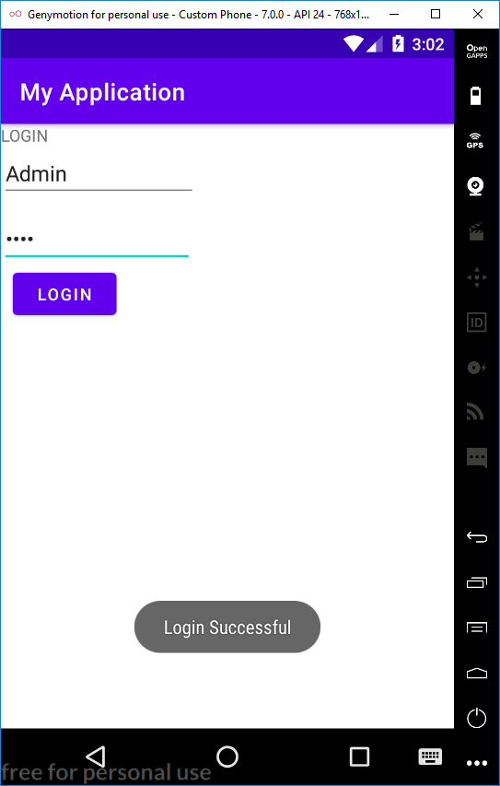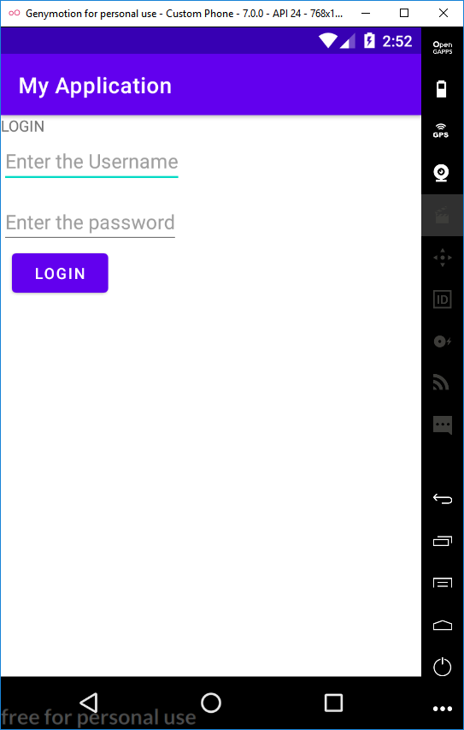

**Program No:2 Date:16.08.2022**

**Aim:**

Write a program to demonstrate activity lifecycle.

**Program Code:**

**activity.xml:**

<?xml version="1.0" encoding="utf-8"?>

<androidx.constraintlayout.widget.ConstraintLayout xmlns:android="http://schemas.android.com/apk/res/android"

xmlns:app="http://schemas.android.com/apk/res-auto"

xmlns:tools="http://schemas.android.com/tools"

android:layout_width="match_parent"

android:layout_height="match_parent"

tools:context=".MainActivity">

<TextView

android:layout_width="wrap_content"

android:layout_height="wrap_content"

android:text="Hello World!"

app:layout_constraintBottom_toBottomOf="parent"

app:layout_constraintEnd_toEndOf="parent"

app:layout_constraintStart_toStartOf="parent"

app:layout_constraintTop_toTopOf="parent" />

</androidx.constraintlayout.widget.ConstraintLayout>

**mainactivity.java:**

package com.example.myapplication;

import androidx.appcompat.app.AppCompatActivity;

import android.os.Bundle;

import android.util.Log;

class MainActivity extends AppCompatActivity {

@Override

protected void onCreate(Bundle savedInstanceState) {

super.onCreate(savedInstanceState);

setContentView(R.layout.activity_main);

Log.d("lifecycle","onCreate invoked");

}

@Override

protected void onStart(){

super.onStart();

Log.d("lifecycle","onStart invoked");

}

@Override

protected void onResume(){

super.onResume();

Log.d("Lifecycle","Onresume invoked");

}

@Override

protected void onPause(){

super.onPause();

Log.d("Lifecycle","OnPause invoked");

}

@Override

protected void onStop(){

super.onStop();

Log.d("Lifecycle","OnStop invoked");

}

@Override

protected void onRestart(){

super.onRestart();

Log.d("Lifecycle","Onrestart invoked");

}

@Override

protected void onDestroy(){

super.onDestroy();

Log.d("Lifecycle","OnDestroy invoked");

}

}

**Result**

Program compiled successfully and output verified.

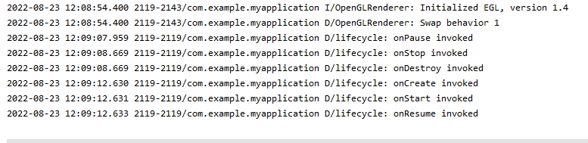**Output**

**Program No:3 Date:19.08.2022**

**Aim:**

Implementing basic arithmetic operation of a simple calculator.

**Program Code:**

**activity.xml:**

<?xml version="1.0" encoding="utf-8"?>

<LinearLayout xmlns:android="http://schemas.android.com/apk/res/android"

xmlns:app="http://schemas.android.com/apk/res-auto"

xmlns:tools="http://schemas.android.com/tools"

android:layout_width="match_parent"

android:layout_height="match_parent"

android:orientation="vertical"

tools:context=".MainActivity">

<TextView

android:layout_width="wrap_content"

android:layout_height="wrap_content"

android:text="Enter the first number" />

<EditText

android:layout_width="wrap_content"

android:layout_height="wrap_content"

android:id="@+id/et1" />

<TextView

android:layout_width="wrap_content"

android:layout_height="wrap_content"

android:text="Enter the second number" />

<EditText

android:layout_width="wrap_content"

android:layout_height="wrap_content"

android:id="@+id/et2" />

<TextView

android:layout_width="wrap_content"

android:layout_height="wrap_content"

android:id="@+id/txt1" />

<Button

android:layout_width="wrap_content"

android:layout_height="wrap_content"

android:id="@+id/b1"

android:text="ADD" />

<Button

android:layout_width="wrap_content"

android:layout_height="wrap_content"

android:id="@+id/b2"

android:text="SUB" />

<Button

android:layout_width="wrap_content"

android:layout_height="wrap_content"

android:id="@+id/b3"

android:text="MUL" />

<Button

android:layout_width="wrap_content"

android:layout_height="wrap_content"

android:id="@+id/b4"

android:text="DIV" />

</LinearLayout>

**mainactivity.java:**

package com.example.myapplication;

import androidx.appcompat.app.AppCompatActivity;

import android.os.Bundle;

import android.view.View;

import android.widget.Button;

import android.widget.EditText;

import android.widget.TextView;

public class MainActivity extends AppCompatActivity {

@Override

protected void onCreate(Bundle savedInstanceState) {

super.onCreate(savedInstanceState);

setContentView(R.layout.activity_main);

Button b1=findViewById(R.id.b1);

Button b2=findViewById(R.id.b2);

Button b3=findViewById(R.id.b3);

Button b4=findViewById(R.id.b4);

EditText et1=findViewById(R.id.et1);

EditText et2=findViewById(R.id.et2);

TextView txt1=findViewById(R.id.txt1);

b1.setOnClickListener(new View.OnClickListener(){

@Override

public void onClick(View view){

Double a1=Double.parseDouble(et1.getText().toString());

Double a2=Double.parseDouble(et2.getText().toString());

Double r=a1+a2;

txt1.setText("Result="+String.valueOf(r));

}

});

b2.setOnClickListener(new View.OnClickListener(){

@Override

public void onClick(View view){

Double a1=Double.parseDouble(et1.getText().toString());

Double a2=Double.parseDouble(et2.getText().toString());

Double r=a1-a2;

txt1.setText("Result="+String.valueOf(r));

}

});

b3.setOnClickListener(new View.OnClickListener(){

@Override

public void onClick(View view){

Double a1=Double.parseDouble(et1.getText().toString());

Double a2=Double.parseDouble(et2.getText().toString());

Double r=a1*a2;

txt1.setText("Result="+String.valueOf(r));

}

});

b4.setOnClickListener(new View.OnClickListener(){

@Override

public void onClick(View view){

Double a1=Double.parseDouble(et1.getText().toString());

Double a2=Double.parseDouble(et2.getText().toString());

Double r=a1/a2;

txt1.setText("Result="+String.valueOf(r));

}

});

}

}

**Result**

Program compiled successfully and output verified.

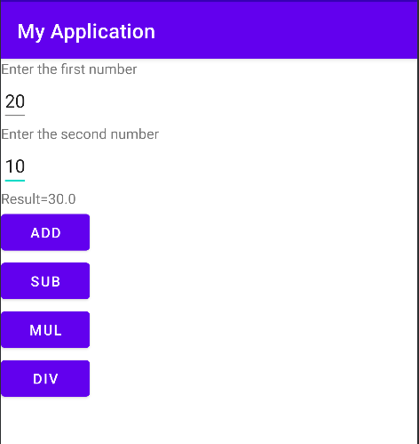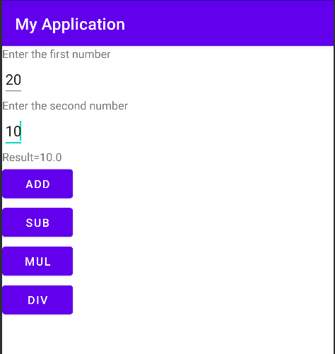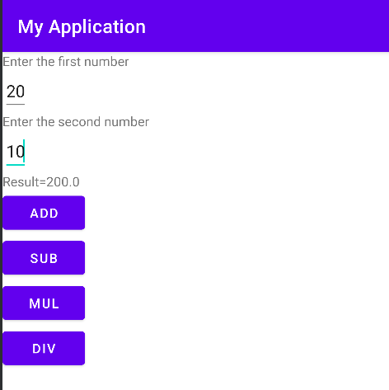**Output**

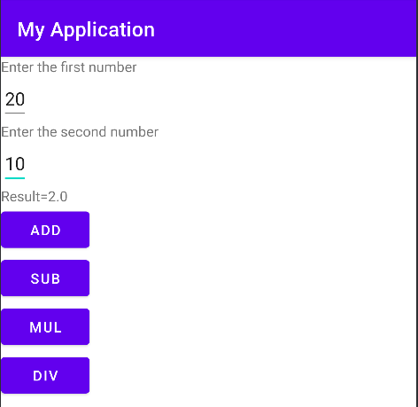

**Program No:4 Date:23.08.2022**

**Aim:**

Program to implement validation on various UI Controls.

**Program Code:**

**activity.xml:**

*<?*xml version="1.0" encoding="utf-8"*?>*<LinearLayout xmlns:android="http://schemas.android.com/apk/res/android"  
 xmlns:app="http://schemas.android.com/apk/res-auto"  
 xmlns:tools="http://schemas.android.com/tools"  
 android:layout_width="match_parent"  
 android:layout_height="match_parent"  
 android:orientation="vertical"  
 tools:context=".MainActivity">  
  
 <TextView  
 android:layout_width="match_parent"  
 android:layout_height="wrap_content"  
 android:text="REGISTRATION"  
 android:textColor="@color/design_default_color_error"  
 android:textSize="30dp" />  
  
 <EditText  
 android:id="@+id/name"  
 android:layout_width="match_parent"  
 android:layout_height="wrap_content"  
 android:hint="Name" />  
  
 <EditText  
 android:layout_width="match_parent"  
 android:layout_height="wrap_content"  
 android:hint="MobileNumber"  
 android:id="@+id/mobile"/>  
  
 <EditText  
 android:layout_width="match_parent"  
 android:layout_height="wrap_content"  
 android:hint="Age"  
 android:id="@+id/age" />  
  
 <TextView  
 android:layout_width="match_parent"  
 android:layout_height="wrap_content"  
 android:hint="Gender"  
 android:id="@+id/gender"  
 android:textSize="20dp"  
 android:textColor="@color/design_default_color_on_primary"/>  
 <RadioGroup  
 android:layout_width="wrap_content"  
 android:layout_height="wrap_content"  
 android:id="@+id/RG" >  
  
 <RadioButton  
 android:layout_width="wrap_content"  
 android:layout_height="wrap_content"  
 android:id="@+id/radiobutton1"  
 android:text="Male" />  
  
 <RadioButton  
 android:layout_width="wrap_content"  
 android:layout_height="wrap_content"  
 android:id="@+id/radiobutton2"  
 android:text="Female" />  
 </RadioGroup>  
  
 <Button  
 android:layout_width="wrap_content"  
 android:layout_height="wrap_content"  
 android:text="Submit"  
 android:id="@+id/button" />  
  
 <CheckBox  
 android:layout_width="wrap_content"  
 android:layout_height="wrap_content"  
 android:text="I agree all terms and conditions"  
 android:id="@+id/checkbox"/>  
  
</LinearLayout>

**mainactivity.java:**

package com.example.myapplication;  
import androidx.appcompat.app.AppCompatActivity;  
import android.content.DialogInterface;  
import android.os.Bundle;  
import android.widget.Button;  
import android.view.View;  
import android.widget.Toast;  
import android.content.Intent;  
import android.widget.CheckBox;  
import android.widget.RadioGroup;  
import android.widget.EditText;  
import android.widget.RadioButton;  
import com.google.android.material.chip.ChipGroup;  
  
public class MainActivity extends AppCompatActivity {  
 EditText name;  
 EditText mobileno;  
 EditText age;  
 RadioGroup radiogroup;  
 RadioButton male;  
 RadioButton female;  
 CheckBox checkbox;  
 Button button;  
  
 @Override  
 protected void onCreate(Bundle savedInstanceState) {  
 super.onCreate(savedInstanceState);  
 setContentView(R.layout.activity_main);  
 name=findViewById(R.id.name);  
 mobileno=findViewById(R.id.mobile);  
 age=findViewById(R.id.age);  
 radiogroup=findViewById(R.id.RG);  
 male=findViewById(R.id.radiobutton1);  
 female=findViewById(R.id.radiobutton2);  
 checkbox=findViewById(R.id.checkbox);  
 button=findViewById(R.id.button);  
 Button b=findViewById(R.id.button);  
 button.setOnClickListener(new View.OnClickListener() {  
 @Override  
 public void onClick(View view) {  
 if(error()) {  
 Intent p = new Intent(MainActivity.this, login.class);  
 startActivity(p);  
 }  
 }  
 });  
 }  
 private boolean error() {  
 if (name.getText().toString().length()==0){  
 Toast.makeText(getApplicationContext(),"Please enter the name",Toast.*LENGTH_LONG*).show();  
 return false;  
 }  
 else if (mobileno.getText().toString().length()==0) {  
 Toast.makeText(getApplicationContext(), "Please enter mobile number", Toast.*LENGTH_LONG*).show();  
 return false;  
 }  
 else if (mobileno.getText().toString().length()!=10) {  
 Toast.makeText(getApplicationContext(), "Please enter 10 numbers", Toast.*LENGTH_LONG*).show();  
 return false;  
 }  
 else if (age.getText().toString().length()==0){  
 Toast.makeText(getApplicationContext(),"Please enter age",Toast.*LENGTH_LONG*).show();  
 return false;  
 }  
 else if (!male.isChecked() && !female.isChecked())  
 {  
 Toast.makeText(getApplicationContext(),"Please choose gender", Toast.*LENGTH_LONG*).show();  
 return false;  
 }  
 else if (!checkbox.isChecked())  
 {  
 Toast.makeText(getApplicationContext(),"Please click on checkbox", Toast.*LENGTH_LONG*).show();  
 return false;  
 }  
 else {  
 return true;  
 }  
 }  
}

**activityLogin.xml:**

*<?*xml version="1.0" encoding="utf-8"*?>*<LinearLayout xmlns:android="http://schemas.android.com/apk/res/android"  
 xmlns:app="http://schemas.android.com/apk/res-auto"  
 xmlns:tools="http://schemas.android.com/tools"  
 android:layout_width="match_parent"  
 android:layout_height="match_parent"  
 android:orientation="vertical"  
 tools:context=".activityLogin">  
  
 <TextView  
 android:id="@+id/text"  
 android:layout_width="312dp"  
 android:layout_height="92dp"  
 android:text="Welcome to my login page"  
 android:textColor="#FFC107" />

</LinearLayout>

**activityLogin.java:**

package com.example.myapplication;  
import android.os.Bundle;  
import android.widget.TextView;  
import androidx.appcompat.app.AppCompatActivity;  
  
public class login extends AppCompatActivity {  
  
  
 @Override  
 protected void onCreate(Bundle savedInstanceState) {  
 super.onCreate(savedInstanceState);  
 setContentView(R.layout.activity_login);  
  
 }  
}

**Result**

Program compiled successfully and output verified.

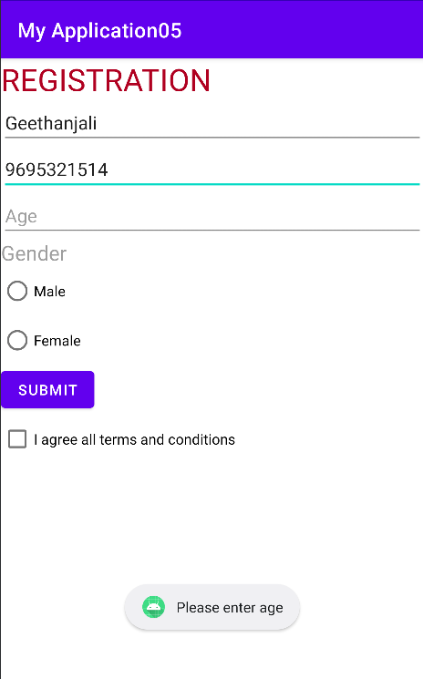**Output**

**Program No:5 Date:26.08.2022**

**Aim:**

Program to design a registration activity and store registration details in local memory of phone using intent and shared preferences.

**Program Code:**

**activity.xml:**

<?xml version="1.0" encoding="utf-8"?>

<LinearLayout xmlns:android="http://schemas.android.com/apk/res/android"

xmlns:app="http://schemas.android.com/apk/res-auto"

xmlns:tools="http://schemas.android.com/tools"

android:layout_width="match_parent"

android:layout_height="match_parent"

android:orientation="vertical"

tools:context=".MainActivity">

<TextView

android:layout_width="match_parent"

android:layout_height="wrap_content"

android:text="REGISTRATION"

android:textColor="@color/purple_500"

android:textSize="30dp" />

<EditText

android:id="@+id/name"

android:layout_width="match_parent"

android:layout_height="wrap_content"

android:hint="Name" />

<EditText

android:layout_width="match_parent"

android:layout_height="wrap_content"

android:hint="Age"

android:id="@+id/age" />

<EditText

android:layout_width="match_parent"

android:layout_height="wrap_content"

android:hint="email"

android:id="@+id/email"/>

<EditText

android:layout_width="match_parent"

android:layout_height="wrap_content"

android:hint="Address"

android:id="@+id/address"/>

<EditText

android:layout_width="match_parent"

android:layout_height="wrap_content"

android:hint="Qualification"

android:id="@+id/quali"/>

<Button

android:layout_width="wrap_content"

android:layout_height="wrap_content"

android:text="Submit"

android:id="@+id/button" />

</LinearLayout>

**mainactivity.java:**

package com.example.myapplication;

import androidx.appcompat.app.AppCompatActivity;

import android.os.Bundle;

import android.widget.Button;

import android.view.View;

import android.widget.Toast;

import android.content.Intent;

import android.widget.EditText;

import android.widget.ScrollView;

import android.content.SharedPreferences;

public class MainActivity extends AppCompatActivity {

EditText name,age,email,quali,address;

Button button;

@Override

protected void onCreate(Bundle savedInstanceState) {

super.onCreate(savedInstanceState);

setContentView(R.layout.activity_main);

name=findViewById(R.id.name);

age=findViewById(R.id.age);

email=findViewById(R.id.email);

address=findViewById(R.id.address);

quali=findViewById(R.id.quali);

button=findViewById(R.id.button);

button.setOnClickListener(new View.OnClickListener() {

@Override

public void onClick(View view) {

Intent i = new Intent(MainActivity.this, MainActivity2.class);

startActivity(i);

}

});

}

@Override

protected void onResume() {

super.onResume();

SharedPreferences sh = getSharedPreferences("mysharedpreference", MODE_PRIVATE);

String s1 = sh.getString("name", "");

int a = sh.getInt("age",0);

String s2 = sh.getString("email", "");

String s3 = sh.getString("address", "");

String s4 = sh.getString("quali", "");

name.setText(s1);

age.setText((String.valueOf(a)));

email.setText(s2);

address.setText(s3);

quali.setText(s4);

}

@Override

protected void onPause() {

super.onPause();

SharedPreferences sh = getSharedPreferences("mysharedpreference", MODE_PRIVATE);

SharedPreferences.Editor myEdit=sh.edit();

myEdit.putString("name",name.getText().toString());

myEdit.putInt("age",Integer.parseInt(age.getText().toString()));

myEdit.putString("email",email.getText().toString());

myEdit.putString("address",address.getText().toString());

myEdit.putString("quali",quali.getText().toString());

myEdit.commit();

}

}

**activity_main2.xml:**

<?xml version="1.0" encoding="utf-8"?>

<LinearLayout xmlns:android="http://schemas.android.com/apk/res/android"

xmlns:app="http://schemas.android.com/apk/res-auto"

xmlns:tools="http://schemas.android.com/tools"

android:layout_width="match_parent"

android:layout_height="match_parent"

tools:context=".MainActivity2">

<TextView

android:layout_width="wrap_content"

android:layout_height="wrap_content"

android:text="Welcome"/>

</LinearLayout>

**MainActivity2.java:**

package com.example.myapplication;

import androidx.appcompat.app.AppCompatActivity;

import android.os.Bundle;

public class MainActivity2 extends AppCompatActivity {

@Override

protected void onCreate(Bundle savedInstanceState) {

super.onCreate(savedInstanceState);

setContentView(R.layout.activity_main2);

}

}

**Result**

Program compiled successfully and output verified.

**Output**

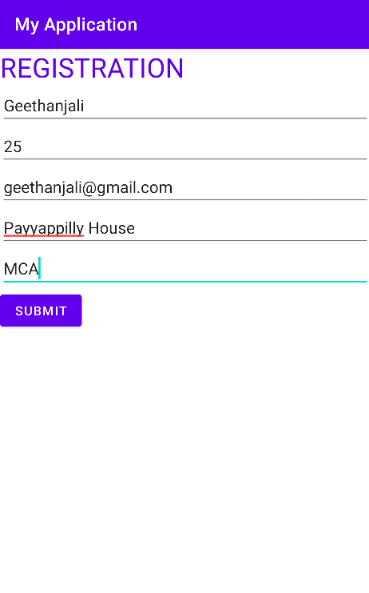

**Program No:6** **Date:30.08.2022**

**Aim:**

Design a simple calculator using GridLayout.

**Program Code:**

**activity.xml:**

<?xml version="1.0" encoding="utf-8"?>

<GridLayout xmlns:android="http://schemas.android.com/apk/res/android"

xmlns:app="http://schemas.android.com/apk/res-auto"

xmlns:tools="http://schemas.android.com/tools"

android:layout_width="match_parent"

android:layout_height="match_parent"

android:orientation="vertical"

tools:context=".MainActivity">

<TextView

android:layout_width="wrap_content"

android:layout_height="wrap_content"

android:text="1st number"

android:layout_row="0"

android:layout_column="0"/>

<EditText

android:layout_width="wrap_content"

android:layout_height="wrap_content"

android:id="@+id/et1"

android:layout_row="1"

android:layout_column="0"/>

<TextView

android:layout_width="wrap_content"

android:layout_height="wrap_content"

android:text="2nd number"

android:layout_row="2"

android:layout_column="0"/>

<EditText

android:layout_width="wrap_content"

android:layout_height="wrap_content"

android:id="@+id/et2"

android:layout_row="3"

android:layout_column="0"/>

<TextView

android:layout_width="wrap_content"

android:layout_height="wrap_content"

android:id="@+id/txt1"

android:layout_row="4"

android:layout_column="0"/>

<Button

android:layout_width="wrap_content"

android:layout_height="wrap_content"

android:id="@+id/b1"

android:text="ADD"

android:layout_row="5"

android:layout_column="0"/>

<Button

android:id="@+id/b2"

android:layout_width="wrap_content"

android:layout_height="wrap_content"

android:layout_row="5"

android:layout_column="1"

android:text="SUB" />

<Button

android:layout_width="wrap_content"

android:layout_height="wrap_content"

android:id="@+id/b3"

android:text="MUL"

android:layout_row="5"

android:layout_column="2"/>

<Button

android:id="@+id/b4"

android:layout_width="wrap_content"

android:layout_height="wrap_content"

android:layout_row="5"

android:layout_column="3"

android:text="DIV" />

</GridLayout>

**mainactivity.java:**

package com.example.myapplication;

import androidx.appcompat.app.AppCompatActivity;

import android.os.Bundle;

import android.view.View;

import android.widget.Button;

import android.widget.EditText;

import android.widget.TextView;

public class MainActivity extends AppCompatActivity {

@Override

protected void onCreate(Bundle savedInstanceState) {

super.onCreate(savedInstanceState);

setContentView(R.layout.activity_main);

Button b1=findViewById(R.id.b1);

Button b2=findViewById(R.id.b2);

Button b3=findViewById(R.id.b3);

Button b4=findViewById(R.id.b4);

EditText et1=findViewById(R.id.et1);

EditText et2=findViewById(R.id.et2);

TextView txt1=findViewById(R.id.txt1);

b1.setOnClickListener(new View.OnClickListener(){

@Override

public void onClick(View view){

Double a1=Double.parseDouble(et1.getText().toString());

Double a2=Double.parseDouble(et2.getText().toString());

Double r=a1+a2;

txt1.setText("Result="+String.valueOf(r));

}

});

b2.setOnClickListener(new View.OnClickListener(){

@Override

public void onClick(View view){

Double a1=Double.parseDouble(et1.getText().toString());

Double a2=Double.parseDouble(et2.getText().toString());

Double r=a1-a2;

txt1.setText("Result="+String.valueOf(r));

}

});

b3.setOnClickListener(new View.OnClickListener(){

@Override

public void onClick(View view){

Double a1=Double.parseDouble(et1.getText().toString());

Double a2=Double.parseDouble(et2.getText().toString());

Double r=a1*a2;

txt1.setText("Result="+String.valueOf(r));

}

});

b4.setOnClickListener(new View.OnClickListener(){

@Override

public void onClick(View view){

Double a1=Double.parseDouble(et1.getText().toString());

Double a2=Double.parseDouble(et2.getText().toString());

Double r=a1/a2;

txt1.setText("Result="+String.valueOf(r));

}

});

}

}

**Result**

Program compiled successfully and output verified.

**Output**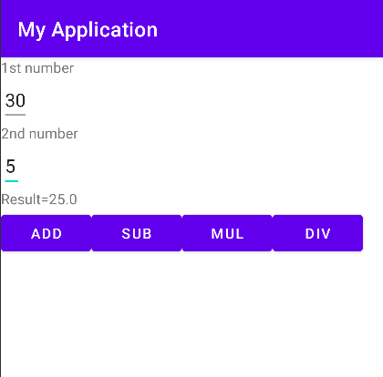

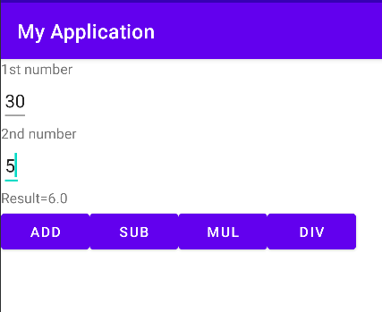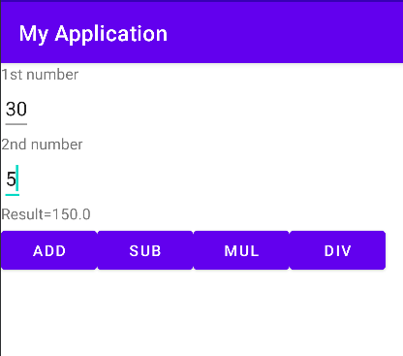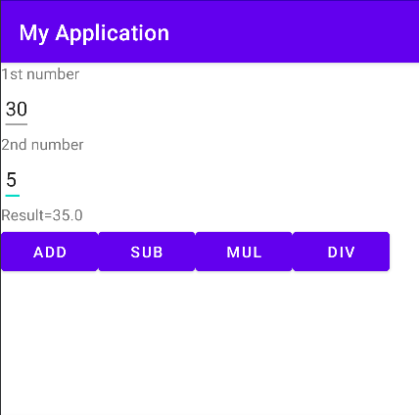

**Program No:7** **Date:2.09.2022**

**Aim**

Create a Facebook page using RelativeLayout, set properties using .xml file.

**Program Code:**

**activity_main.xml:**

<?xml version="1.0" encoding="utf-8"?>

<RelativeLayout

xmlns:android="http://schemas.android.com/apk/res/android"

xmlns:tools="http://schemas.android.com/tools"

android:id="@+id/activity_main"

android:layout_width="match_parent"

android:layout_height="match_parent"

tools:context=".MainActivity">

<RelativeLayout

android:id="@+id/relativeLayout"

android:layout_width="match_parent"

android:layout_height="wrap_content">

<ImageView

android:layout_width="match_parent"

android:layout_height="200dp"

android:id="@+id/img1"

android:src="@drawable/cover"

android:scaleType="centerCrop"/>

<ImageView

android:layout_width="70dp"

android:layout_height="150dp"

android:id="@+id/profilePic"

android:src="@drawable/profpic"

android:layout_alignBottom="@+id/linearLayout"/>

<LinearLayout

android:layout_toRightOf="@+id/profilePic"

android:layout_width="match_parent"

android:layout_height="wrap_content"

android:layout_below="@+id/img1"

android:orientation="horizontal"

android:weightSum="100"

android:id="@+id/linearLayout">

<Button

android:layout_width="70dp"

android:layout_height="40dp"

android:text="Timeline"

android:textSize="7dp"

android:layout_weight="10"/>

<Button

android:layout_width="60dp"

android:layout_height="40dp"

android:layout_weight="10"

android:textSize="7dp"

android:text="About" />

<Button

android:layout_weight="10"

android:textSize="7dp"

android:layout_width="60dp"

android:layout_height="40dp"

android:text="Friends" />

<Button

android:layout_weight="10"

android:textSize="7dp"

android:layout_width="60dp"

android:layout_height="40dp"

android:text="Photos" />

</LinearLayout>

<TextView

android:textColor="@color/white"

android:textStyle="bold"

android:layout_width="wrap_content"

android:layout_height="wrap_content"

android:text="Geethanjali Paul"

android:ems="20"

android:layout_alignParentEnd="true"

android:id="@+id/textName"

android:layout_alignBottom="@+id/img1"/>

</RelativeLayout>

<RelativeLayout

android:paddingRight="15dp"

android:paddingLeft="15dp"

android:paddingTop="15dp"

android:paddingBottom="15dp"

android:layout_below="@+id/relativeLayout"

android:layout_width="match_parent"

android:layout_height="wrap_content">

<LinearLayout

android:layout_width="match_parent"

android:layout_height="wrap_content"

android:orientation="horizontal"

android:id="@+id/linearLayout2">

<ImageView

android:layout_width="25dp"

android:layout_height="25dp"

android:src="@drawable/profpic"/>

<EditText

android:id="@+id/etPost"

android:layout_marginLeft="10dp"

android:textSize="15dp"

android:layout_width="match_parent"

android:layout_height="40dp"

android:hint="What's on your mind?"/>

</LinearLayout>

<Button

android:textSize="10dp"

android:text="Post"

android:layout_width="70dp"

android:layout_height="40dp"

android:layout_alignParentRight="true"

android:layout_below="@+id/linearLayout2"/>

</RelativeLayout>

</RelativeLayout>

**mainactivity.java:**

package com.example.facebook;

import androidx.appcompat.app.AppCompatActivity;

import android.os.Bundle;

public class MainActivity extends AppCompatActivity {

@Override

protected void onCreate(Bundle savedInstanceState) {

super.onCreate(savedInstanceState);

setContentView(R.layout.activity_main);

}

}

**Result**

Program compiled successfully and output verified.

**Output**

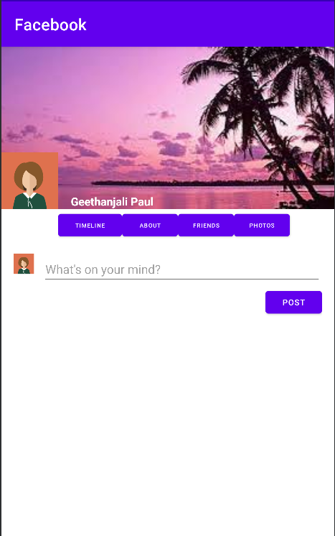

**Program No:8** **Date:14.09.2022**

**Aim**

Develop an application tha toggles image using FrameLayout.

**Program Code:**

**activity_main.xml:**

*<?*xml version="1.0" encoding="utf-8"*?>*

<FrameLayout xmlns:android="http://schemas.android.com/apk/res/android"

xmlns:tools="http://schemas.android.com/tools"

android:layout_width="fill_parent"

android:layout_height="fill_parent"

tools:context=".MainActivity">

<ImageView

android:id="@+id/image1"  
 android:layout_width="410dp"

android:layout_height="200dp"

android:scaleType="centerCrop"

android:src="@drawable/i1" />

<ImageView

android:id="@+id/image2"

android:layout_width="410dp"

android:layout_height="200dp"

android:scaleType="centerCrop"

android:src="@drawable/i2" />

</FrameLayout>

**mainactivity.java:**

package com.example.myapplication11;

import androidx.appcompat.app.AppCompatActivity;

import android.os.Bundle;

import android.view.View;

import android.widget.ImageView;

public class MainActivity extends AppCompatActivity {

ImageView i1,i2;

@Override

protected void onCreate(Bundle savedInstanceState) {

super.onCreate(savedInstanceState);

setContentView(R.layout.*activity_main*);

i1=findViewById(R.id.*image1*);

i2=findViewById(R.id.*image2*);

i2.setOnClickListener(new View.OnClickListener() {

@Override

public void onClick(View view) {

i2.setVisibility(View.*GONE*);

i1.setVisibility(View.*VISIBLE*);

}

});

i1.setOnClickListener(new View.OnClickListener() {

@Override

public void onClick(View view) {

i1.setVisibility(View.*GONE*);

i2.setVisibility(View.*VISIBLE*);

}

});

}

}

**Result**

Program compiled successfully and output verified.

**Output**

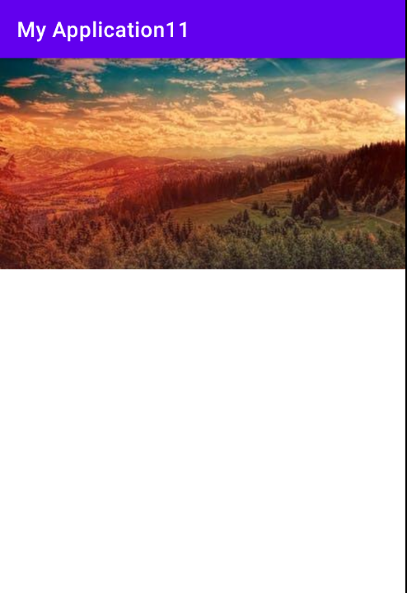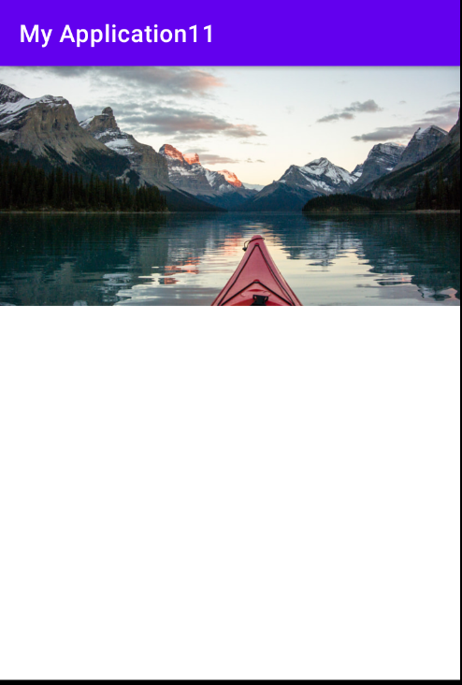

**Program No:9 Date:16.09.2022**

**Aim:**

Web application to implement implicit intent.

**Program Code:**

**activity.xml:**

*<?*xml version="1.0" encoding="utf-8"*?>*<LinearLayout xmlns:android="http://schemas.android.com/apk/res/android"  
 xmlns:app="http://schemas.android.com/apk/res-auto"  
 xmlns:tools="http://schemas.android.com/tools"  
 android:layout_width="match_parent"  
 android:layout_height="match_parent"  
 tools:context=".MainActivity">  
  
 <EditText  
 android:id="@+id/t1"  
 android:layout_width="wrap_content"  
 android:layout_height="wrap_content"  
 android:text="http://www.google.co.in"  
 android:textColor="@color/design_default_color_secondary"/>

<Button  
 android:id="@+id/btn1"  
 android:layout_width="wrap_content"  
 android:layout_height="wrap_content"  
 android:text="click"  
 android:textColor="@color/design_default_color_error"/>  
</LinearLayout>

**mainactivity.java:**

package com.example.myapplication7;  
import androidx.appcompat.app.AppCompatActivity;  
import android.content.Intent;  
import android.net.Uri;  
import android.os.Bundle;  
import android.view.View;  
import android.widget.Button;  
import android.widget.EditText;  
  
public class MainActivity extends AppCompatActivity {  
 EditText et1;  
 Button b1;  
  
 @Override  
 protected void onCreate(Bundle savedInstanceState) {  
 super.onCreate(savedInstanceState);  
 setContentView(R.layout.*activity_main*);  
 et1=findViewById(R.id.*t1*);  
 b1=findViewById(R.id.*btn1*);  
 b1.setOnClickListener(new View.OnClickListener() {  
 @Override  
 public void onClick(View view) {  
 String url=et1.getText().toString();  
 Intent i=new Intent(Intent.*ACTION_VIEW*, Uri.*parse*(url));  
 startActivity(i);  
 }  
 });  
 }  
}

**Result**

Program compiled successfully and output verified

**Output**

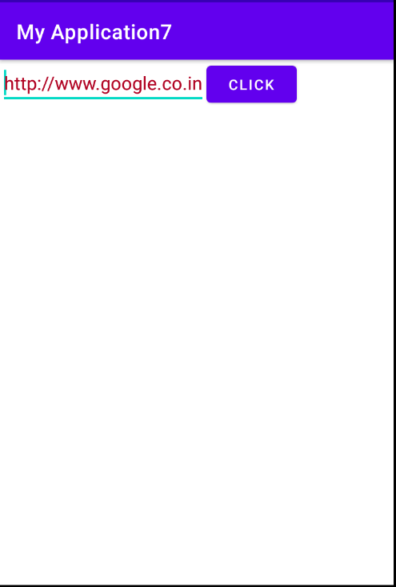

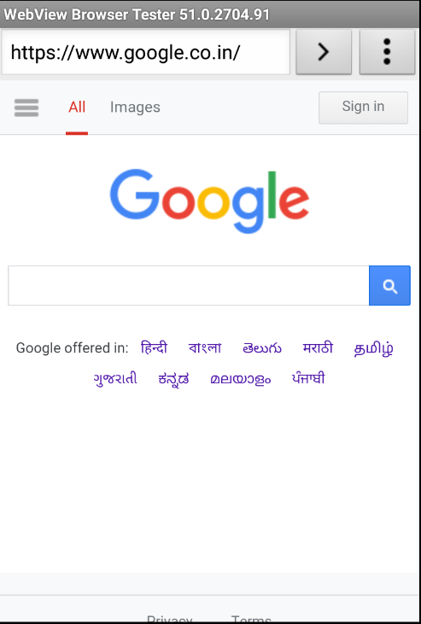

**Program No:10 Date:20.09.2022**

**Aim:**

Implement options menu to navigate two activities.

**Program Code:**

**activity.xml:**

*<?*xml version="1.0" encoding="utf-8"*?>*<androidx.constraintlayout.widget.ConstraintLayout xmlns:android="http://schemas.android.com/apk/res/android"  
 xmlns:app="http://schemas.android.com/apk/res-auto"  
 xmlns:tools="http://schemas.android.com/tools"  
 android:layout_width="match_parent"  
 android:layout_height="match_parent"  
 tools:context=".MainActivity">  
  
 <TextView  
 android:layout_width="wrap_content"  
 android:layout_height="wrap_content"  
 android:text="Hello World!"  
 app:layout_constraintBottom_toBottomOf="parent"  
 app:layout_constraintLeft_toLeftOf="parent"  
 app:layout_constraintRight_toRightOf="parent"  
 app:layout_constraintTop_toTopOf="parent" />  
  
</androidx.constraintlayout.widget.ConstraintLayout>

**menu.xml:**

*<?*xml version="1.0" encoding="utf-8"*?>*<menu xmlns:android="http://schemas.android.com/apk/res/android">  
 <item android:id="@+id/item1"  
 android:title="File"/>  
 <item android:id="@+id/item2"  
 android:title="Edit">  
 <menu>  
 <item android:id="@+id/sitem1"  
 android:title="Cut"/>  
 <item android:id="@+id/sitem2"  
 android:title="Copy"/>  
 <item android:id="@+id/sitem3"  
 android:title="Paste"/>  
 </menu>  
 </item>  
 <item android:id="@+id/item3"  
 android:title="View"/>

</menu>

**mainactivity.java:**

package com.example.myapplicationmenu;  
import androidx.annotation.NonNull;  
import androidx.appcompat.app.AppCompatActivity;  
import android.os.Bundle;  
import android.view.Menu;  
import android.view.MenuItem;  
import android.widget.Toast;  
  
public class MainActivity extends AppCompatActivity {  
  
 @Override  
 protected void onCreate(Bundle savedInstanceState) {  
 super.onCreate(savedInstanceState);  
 setContentView(R.layout.*activity_main*);  
 }  
  
 @Override  
 public boolean onCreateOptionsMenu(Menu menu) {  
 getMenuInflater().inflate(R.menu.*menu*,menu);  
 return true;  
 }  
  
 @Override  
 public boolean onOptionsItemSelected(@NonNull MenuItem item) {  
 switch (item.getItemId()){  
 case R.id.*item1*:  
 Toast.*makeText*(getApplicationContext(),"File selected",Toast.*LENGTH_SHORT*).show();  
 break;  
 case R.id.*item2*:  
 Toast.*makeText*(getApplicationContext(),"Edit selected",Toast.*LENGTH_SHORT*).show();  
 break;  
 case R.id.*sitem1*:  
 Toast.*makeText*(getApplicationContext(),"Cut selected",Toast.*LENGTH_SHORT*).show();  
 break;  
 case R.id.*sitem2*:  
 Toast.*makeText*(getApplicationContext(),"Copy selected",Toast.*LENGTH_SHORT*).show();  
 break;  
 case R.id.*sitem3*:  
 Toast.*makeText*(getApplicationContext(),"Paste selected",Toast.*LENGTH_SHORT*).show();  
 break;  
 case R.id.*item3*:  
 Toast.*makeText*(getApplicationContext(),"View selected",Toast.*LENGTH_SHORT*).show();  
 break;  
  
 }  
 return super.onOptionsItemSelected(item);  
 }  
}

**Result**

Program compiled successfully and output verified.

**Output**

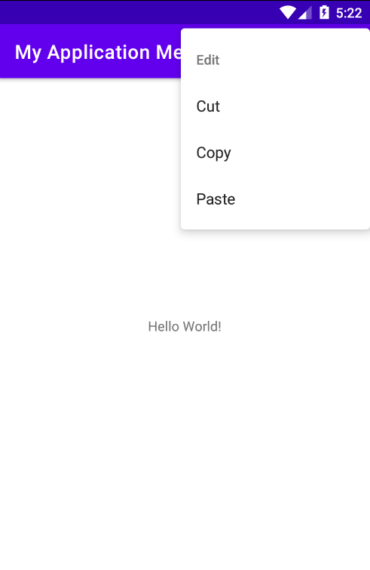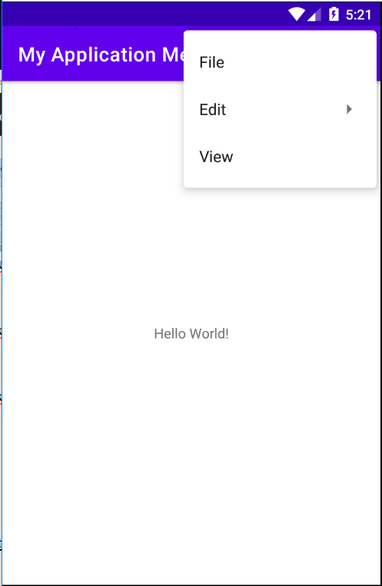

**Program No:11** **Date:27.09.2022**

**Aim:**

Develop an application that uses ArrayAdapter with ListView.

**Program Code:**

**activity_main.xml:**

*<?*xml version="1.0" encoding="utf-8"*?>*<LinearLayout xmlns:android="http://schemas.android.com/apk/res/android"  
 xmlns:app="http://schemas.android.com/apk/res-auto"  
 xmlns:tools="http://schemas.android.com/tools"  
 android:layout_width="match_parent"  
 android:layout_height="match_parent"  
 tools:context=".MainActivity">  
  
 <ListView  
 android:layout_width="match_parent"  
 android:layout_height="match_parent"  
 android:id="@+id/list"/>  
  
</LinearLayout>

**mainactivity.java:**

package com.example.myapplication10;  
import androidx.appcompat.app.AppCompatActivity;  
import android.content.Intent;  
import android.os.Bundle;  
import android.view.View;  
import android.widget.AdapterView;  
import android.widget.ArrayAdapter;  
import android.widget.ListView;  
  
public class MainActivity extends AppCompatActivity {  
 ListView list;  
 String[] p={"A.P.J.Abdul Kalam","Sachin Tendulkar","Barak Obama"};  
 @Override  
 protected void onCreate(Bundle savedInstanceState) {  
 super.onCreate(savedInstanceState);  
 setContentView(R.layout.*activity_main*);  
 list=findViewById(R.id.*list*);  
 ArrayAdapter<String> adapter=new ArrayAdapter<String>(this, android.R.layout.*simple_list_item_1*,p);  
 list.setAdapter(adapter);  
 list.setOnItemClickListener(new AdapterView.OnItemClickListener() {  
 @Override  
 public void onItemClick(AdapterView<?> adapterView, View view, int i, long l) {  
 if (i==0)  
 {  
 Intent s=new Intent(MainActivity.this,MainActivity2.class);  
 startActivity(s);  
 }  
 else if(i==1)  
 {  
 Intent s=new Intent(MainActivity.this,MainActivity3.class);  
 startActivity(s);  
 }  
 else if(i==2)  
 {  
 Intent s=new Intent(MainActivity.this,MainActivity4.class);  
 startActivity(s);  
 }  
 }  
 });  
  
 }  
}

**activity_main2.xml:**

*<?*xml version="1.0" encoding="utf-8"*?>*<LinearLayout  
 xmlns:android="http://schemas.android.com/apk/res/android"  
 xmlns:tools="http://schemas.android.com/tools"  
 android:layout_width="match_parent"  
 android:layout_height="match_parent"  
 tools:context=".MainActivity2">  
  
 <TextView  
 android:layout_width="match_parent"  
 android:layout_height="match_parent"  
 android:textColor="@android:color/holo_blue_light"  
 android:text="A.P.J.ABDUL KALAM \n\n Avul Pakir Jainulabdeen Abdul Kalam (15 October 1931 – 27 July 2015) was an Indian aerospace scientist and statesman who served as the 11th President of India from 2002 to 2007. He was born and raised in Rameswaram, Tamil Nadu and studied physics and aerospace engineering. He spent the next four decades as a scientist and science administrator, mainly at the Defence Research and Development Organisation (DRDO) and Indian Space Research Organisation (ISRO) and was intimately involved in India's civilian space programme and military missile development efforts" />  
  
</LinearLayout>

**mainactivity2.java:**

package com.example.myapplication10;  
import androidx.appcompat.app.AppCompatActivity;  
import android.os.Bundle;  
  
public class MainActivity2 extends AppCompatActivity {  
  
 @Override  
 protected void onCreate(Bundle savedInstanceState) {  
 super.onCreate(savedInstanceState);  
 setContentView(R.layout.*activity_main2*);  
 }  
}

**activity_main3.xml:**

*<?*xml version="1.0" encoding="utf-8"*?>*<LinearLayout xmlns:android="http://schemas.android.com/apk/res/android"  
 xmlns:app="http://schemas.android.com/apk/res-auto"  
 xmlns:tools="http://schemas.android.com/tools"  
 android:layout_width="match_parent"  
 android:layout_height="match_parent"  
 tools:context=".MainActivity3">  
  
 <TextView  
 android:layout_width="match_parent"  
 android:layout_height="match_parent"  
 android:textColor="@android:color/holo_orange_dark"  
 android:text="SACHIN TENDULKAR \n\n

Sachin Ramesh Tendulkar AO BR (born 24 April 1973) is an Indian former international cricketer who captained the Indian national team. He is regarded as one of the greatest batsmen in the history of cricket. He was a right-handed top-order bastmen in the Indian Cricket Team. He is known for his batting skills, technique, vision and game reading. He is the all time most runscorer in both ODI and Test Format with more then 18000 runs and 15000 runs respectively in total. He also holds the record for receiving most Man-of-the-match awards in International Cricket with all forms combined." />  
</LinearLayout>

**mainactivity3.java:**

package com.example.myapplication10;  
import androidx.appcompat.app.AppCompatActivity;  
import android.os.Bundle;  
  
public class MainActivity3 extends AppCompatActivity {  
  
 @Override  
 protected void onCreate(Bundle savedInstanceState) {  
 super.onCreate(savedInstanceState);  
 setContentView(R.layout.*activity_main3*);  
 }  
}

**activity_main4.xml:**

*<?*xml version="1.0" encoding="utf-8"*?>*<LinearLayout xmlns:android="http://schemas.android.com/apk/res/android"  
 xmlns:app="http://schemas.android.com/apk/res-auto"  
 xmlns:tools="http://schemas.android.com/tools"  
 android:layout_width="match_parent"  
 android:layout_height="match_parent"  
 tools:context=".MainActivity4">  
 <TextView  
 android:layout_width="match_parent"  
 android:layout_height="match_parent"  
 android:textColor="@android:color/holo_green_dark"  
 android:text="BARAK OBAMA \n\n

Barack Hussein Obama (born August 4, 1961) is an American politician who served as the 44th president of the United States from 2009 to 2017. A member of the Democratic Party, he was the first African-American president of the United States.Obama previously served as a U.S. senator from Illinois from 2005 to 2008 and as an Illinois state senator from 1997 to 2004." />  
  
</LinearLayout>

**mainactivity4.java:**

package com.example.myapplication10;  
import androidx.appcompat.app.AppCompatActivity;  
import android.os.Bundle;  
  
public class MainActivity4 extends AppCompatActivity {  
  
 @Override  
 protected void onCreate(Bundle savedInstanceState) {  
 super.onCreate(savedInstanceState);  
 setContentView(R.layout.*activity_main4*);  
 }  
}

**Result**

Program compiled successfully and output verified.

**Output**

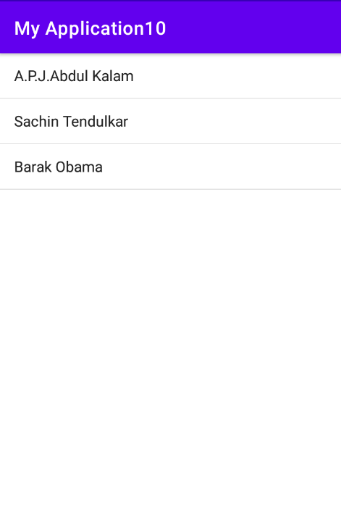



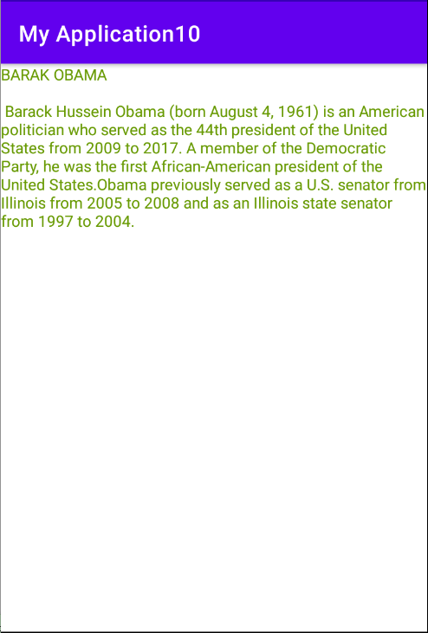

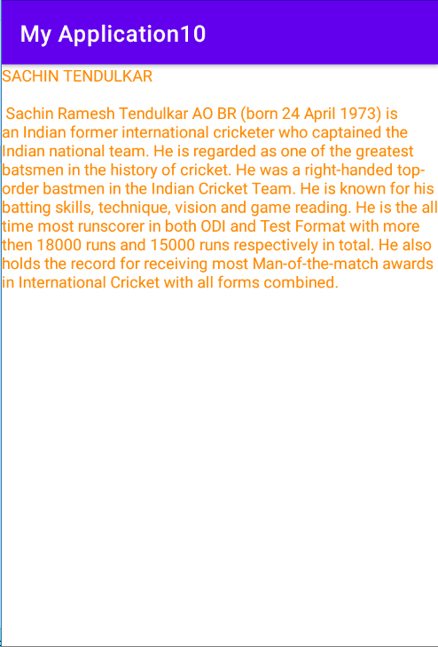**Program No:12** **Date:12.10.2022**

**Aim:**

Implement and perform exception handling..

**Program Code:**

**activity_main.xml:**

*<?*xml version="1.0" encoding="utf-8"*?>*<RelativeLayout  
 xmlns:android="http://schemas.android.com/apk/res/android"  
 xmlns:app="http://schemas.android.com/apk/res-auto"  
 xmlns:tools="http://schemas.android.com/tools"  
 android:layout_width="match_parent"  
 android:layout_height="match_parent"  
 tools:context=".MainActivity">  
  
 <TextView  
 android:layout_width="wrap_content"  
 android:layout_height="wrap_content"  
 android:id="@+id/tv1"/>  
  
</RelativeLayout>

**MainActivity.java:**

package com.example.myapplication14;  
  
import androidx.appcompat.app.AppCompatActivity;  
import android.os.Bundle;  
import android.widget.TextView;  
import android.widget.Toast;  
  
public class MainActivity extends AppCompatActivity {  
 TextView tv1;  
 @Override  
 protected void onCreate(Bundle savedInstanceState) {  
 super.onCreate(savedInstanceState);  
 setContentView(R.layout.*activity_main*);  
 try{  
 tv1.setText("WELCOME");  
 }  
 catch (Exception e){  
 Toast.*makeText*(this,e.getMessage(),Toast.*LENGTH_LONG*).show();  
 }  
 }  
}

**Result**

Program compiled successfully and output verified.

**Output**

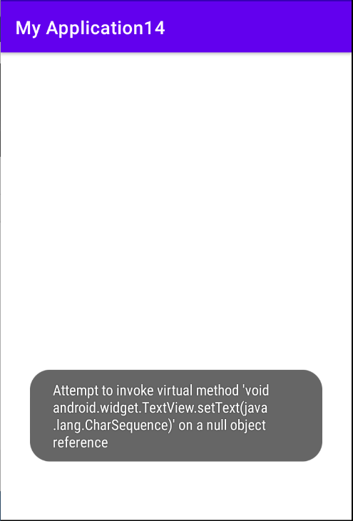

**Program No:13 Date:25-10-2022**

**Aim**:

Develop an application that use GridLayout with images and display Toast on selection.

**Program Code:**

**activity_main.xml:**

<?xml version="1.0" encoding="utf-8"?>

<GridLayout xmlns:android="http://schemas.android.com/apk/res/android"

xmlns:app="http://schemas.android.com/apk/res-auto"

xmlns:tools="http://schemas.android.com/tools"

android:layout_width="match_parent"

android:layout_height="match_parent"

tools:context=".MainActivity">

<ImageView

android:layout_width="match_parent"

android:layout_height="300dp"

android:id="@+id/img1"

android:src="@drawable/img1"

android:scaleType="centerCrop"

android:layout_row="0"

android:layout_column="0" />

<ImageView

android:layout_width="match_parent"

android:layout_height="300dp"

android:layout_column="0"

android:scaleType="centerCrop"

android:src="@drawable/img2"

android:id="@+id/img2"

android:layout_row="1"/>

</GridLayout>

**MainActivity.java:**

package com.example.gridview;

import androidx.appcompat.app.AppCompatActivity;

import android.os.Bundle;

import android.view.View;

import android.widget.Toast;

import android.widget.ImageView;

public class MainActivity extends AppCompatActivity {

ImageView image1,image2;

@Override

protected void onCreate(Bundle savedInstanceState) {

super.onCreate(savedInstanceState);

setContentView(R.layout.activity_main);

image1=findViewById(R.id.img1);

image2=findViewById(R.id.img2);

image1.setOnClickListener(new View.OnClickListener() {

@Override

public void onClick(View view) {

Toast.makeText(getApplicationContext(),"Effel Tower",Toast.LENGTH_LONG).show();

}

});

image2.setOnClickListener(new View.OnClickListener() {

@Override

public void onClick(View view) {

Toast.makeText(getApplicationContext(),"Taj Mahal",Toast.LENGTH_LONG).show();

}

});

}

}

**Result**

Program compiled successfully and output verified.

**Output**

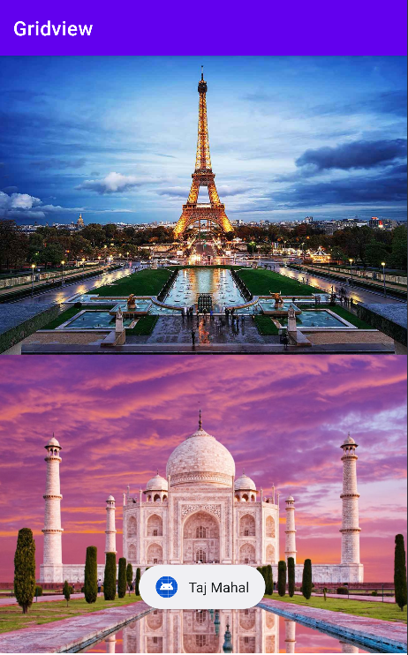

**Program No:14** **Date:28.10.2022**

**Aim:**

Develop an application that implements Spinner component and perform event handling

**Program Code:**

**activity_main.xml:**

*<?*xml version="1.0" encoding="utf-8"*?>*<RelativeLayout xmlns:android="http://schemas.android.com/apk/res/android"  
 xmlns:app="http://schemas.android.com/apk/res-auto"  
 xmlns:tools="http://schemas.android.com/tools"  
 android:layout_width="match_parent"  
 android:layout_height="match_parent"  
 tools:context=".MainActivity">  
  
 <TextView  
 android:layout_width="wrap_content"  
 android:layout_height="wrap_content"  
 android:text="Select your nation:"  
 android:id="@+id/t1"  
 android:textSize="20dp" />  
  
 <Spinner  
 android:layout_width="match_parent"  
 android:layout_height="wrap_content"  
 android:layout_below="@+id/t1"  
 android:id="@+id/spinner"/>  
  
</RelativeLayout>

**MainActivity.java:**

package com.example.Spinner;  
  
import androidx.annotation.NonNull;  
import androidx.appcompat.app.AppCompatActivity;  
import android.os.Bundle;  
import android.view.View;  
import android.widget.AdapterView;  
import android.widget.ArrayAdapter;  
import android.widget.Spinner;  
import android.widget.Toast;  
  
public class MainActivity extends AppCompatActivity implements AdapterView.OnItemSelectedListener{  
 String[] country={"India","China","U.S.A","Russia","Other"};  
 @Override  
 protected void onCreate(Bundle savedInstanceState) {  
 super.onCreate(savedInstanceState);  
 setContentView(R.layout.*activity_main*);  
 Spinner spin=(Spinner)findViewById(R.id.*spinner*);  
 spin.setOnItemSelectedListener(this);  
 ArrayAdapter ar=new ArrayAdapter(this, android.R.layout.*simple_spinner_item*,country);  
 ar.setDropDownViewResource(android.R.layout.*simple_spinner_dropdown_item*);  
 spin.setAdapter(ar);  
 }  
 @Override  
 public void onItemSelected(AdapterView arg0, View arg1, int position, long id){  
 Toast.*makeText*(getApplicationContext(),country[position] ,  
 Toast.*LENGTH_LONG*).show();  
 }  
  
 @Override  
 public void onNothingSelected(AdapterView<?> adapterView){  
  
 }  
}

**Result**

Program compiled successfully and output verified.

**Output**

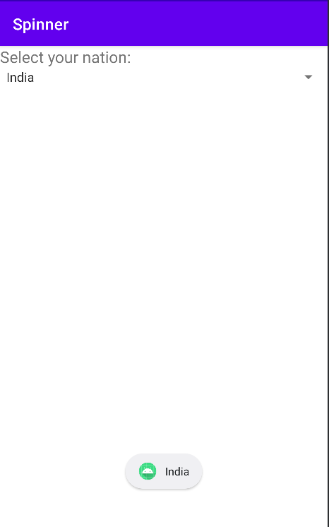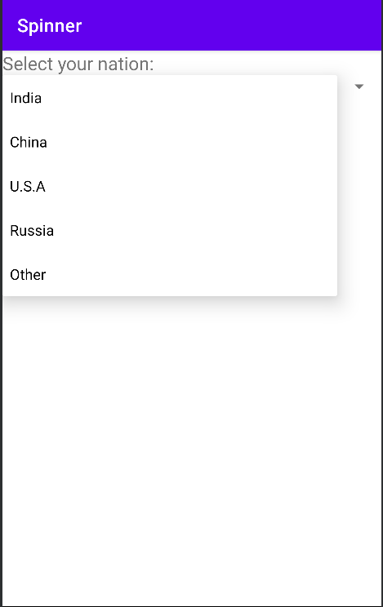

**Program No:15** **Date:04.11.2022**

**Aim:**

Implement Navigation drawer.

**Program Code:**

**activity_main.xml:**

<androidx.drawerlayout.widget.DrawerLayout  
 xmlns:android="http://schemas.android.com/apk/res/android"  
 xmlns:app="http://schemas.android.com/apk/res-auto"  
 xmlns:tools="http://schemas.android.com/tools"  
 android:id="@+id/my_drawer_layout"  
 android:layout_width="match_parent"  
 android:layout_height="match_parent"  
 tools:context=".MainActivity"  
 tools:ignore="HardcodedText">  
  
 <LinearLayout  
 android:layout_width="match_parent"  
 android:layout_height="match_parent">  
  
 <TextView  
 android:layout_width="match_parent"  
 android:layout_height="wrap_content"  
 android:layout_marginTop="128dp"  
 android:gravity="center"  
 android:text="Welcome to Galaxy"  
 android:textSize="18sp" />  
 </LinearLayout>  
  
 <com.google.android.material.navigation.NavigationView  
 android:layout_width="wrap_content"  
 android:layout_height="match_parent"  
 android:layout_gravity="start"  
 app:menu="@menu/menu" />  
  
</androidx.drawerlayout.widget.DrawerLayout>

**menu.xml:**

*<?*xml version="1.0" encoding="utf-8"*?>*<menu xmlns:android="http://schemas.android.com/apk/res/android">  
 <item  
 android:id="@+id/item1"  
 android:title="My Account"/>  
 <item  
 android:id="@+id/item2"  
 android:title="Settings"/>  
 <item  
 android:id="@+id/item3"  
 android:title="Logout"/>  
  
</menu>

**strings.xml:**

<resources>  
 <string name="app_name">Navigation Drawer</string>  
 *<!-- to toggle the open close button of the navigation drawer -->* <string name="nav_open">Open</string>  
 <string name="nav_close">Close</string>  
</resources>

**MainActivity.java:**

package com.example.myapplication16;  
  
import androidx.annotation.NonNull;  
import androidx.appcompat.app.ActionBarDrawerToggle;  
import androidx.appcompat.app.AppCompatActivity;  
import androidx.drawerlayout.widget.DrawerLayout;  
  
import android.os.Bundle;  
import android.view.MenuItem;  
  
public class MainActivity extends AppCompatActivity {  
 public DrawerLayout drawerLayout;  
 public ActionBarDrawerToggle actionBarDrawerToggle;  
  
 @Override  
 protected void onCreate(Bundle savedInstanceState) {  
 super.onCreate(savedInstanceState);  
 setContentView(R.layout.*activity_main*);  
 drawerLayout = findViewById(R.id.*my_drawer_layout*);  
 actionBarDrawerToggle = new ActionBarDrawerToggle(this, drawerLayout, R.string.*nav_open*, R.string.*nav_close*);  
 getSupportActionBar().setDisplayHomeAsUpEnabled(true);  
 }  
 @Override  
 public boolean onOptionsItemSelected(@NonNull MenuItem item){  
 if (actionBarDrawerToggle.onOptionsItemSelected(item)){  
 return true;  
 }  
 return super.onOptionsItemSelected(item);  
 }  
}

**Result**

Program compiled successfully and output verified.

**Output**

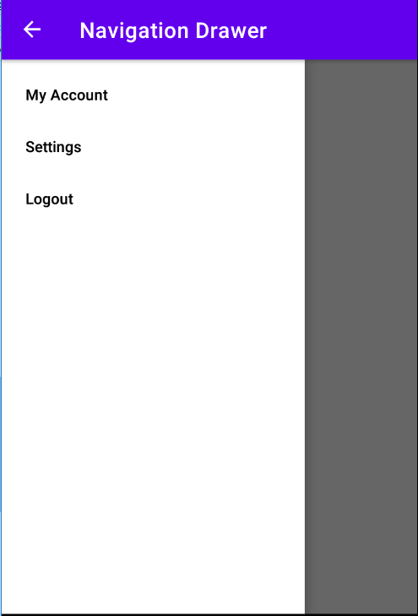

**Program No:16** **Date:11.11.2022**

**Aim:**

Create database using SQLite and perform INSERT, SELECT, UPDATE and DELETE on SQLite database.

**Program Code:**

**activity_main.xml:**

*<?*xml version="1.0" encoding="utf-8"*?>*<RelativeLayout xmlns:android="http://schemas.android.com/apk/res/android"  
 xmlns:app="http://schemas.android.com/apk/res-auto"  
 xmlns:tools="http://schemas.android.com/tools"  
 android:layout_width="match_parent"  
 android:layout_height="match_parent"  
 android:padding="10dp"  
 tools:context=".MainActivity">  
  
  
 <TextView  
 android:layout_width="match_parent"  
 android:layout_height="wrap_content"  
 android:textSize="24dp"  
 android:text="Name"  
 android:id="@+id/t1"/>  
  
 <EditText  
 android:layout_width="match_parent"  
 android:layout_height="wrap_content"  
 android:hint="Enter the Name"  
 android:textSize="24dp"  
 android:id="@+id/et1"  
 android:layout_below="@+id/t1"/>  
  
 <TextView  
 android:layout_width="match_parent"  
 android:layout_height="wrap_content"  
 android:textSize="24dp"  
 android:id="@+id/t2"  
 android:text="Contact No."  
 android:layout_below="@+id/et1"/>  
  
 <EditText  
 android:layout_width="match_parent"  
 android:layout_height="wrap_content"  
 android:hint="Enter the Contact No."  
 android:textSize="24dp"  
 android:id="@+id/et2"  
 android:layout_below="@+id/t2"/>  
  
 <TextView  
 android:layout_width="match_parent"  
 android:layout_height="wrap_content"  
 android:textSize="24dp"  
 android:text="DOB"  
 android:id="@+id/t3"  
 android:layout_below="@+id/et2"/>  
  
 <EditText  
 android:layout_width="match_parent"  
 android:layout_height="wrap_content"  
 android:hint="Enter the DOB"  
 android:textSize="24dp"  
 android:id="@+id/et3"  
 android:layout_below="@+id/t3"/>  
  
 <Button  
 android:layout_width="match_parent"  
 android:layout_height="wrap_content"  
 android:text="INSERT"  
 android:id="@+id/btn1"  
 android:textSize="24dp"  
 android:layout_marginLeft="10dp"  
 android:layout_below="@+id/et3"/>  
  
 <Button  
 android:layout_width="match_parent"  
 android:layout_height="wrap_content"  
 android:text="UPDATE"  
 android:id="@+id/btn2"  
 android:textSize="24dp"  
 android:layout_marginLeft="10dp"  
 android:layout_below="@+id/btn1"/>  
  
 <Button  
 android:layout_width="match_parent"  
 android:layout_height="wrap_content"  
 android:text=" DELETE "  
 android:id="@+id/btn3"  
 android:textSize="24dp"  
 android:layout_marginLeft="10dp"  
 android:layout_below="@+id/btn2"/>  
 <Button  
 android:layout_width="match_parent"  
 android:layout_height="wrap_content"  
 android:text="VIEW"  
 android:id="@+id/btn4"  
 android:textSize="24dp"  
 android:layout_marginLeft="10dp"  
 android:layout_below="@+id/btn3"/>  
  
</RelativeLayout>

**DBHelper.java:**

package com.example.myapplication13;  
import android.content.ContentValues;  
import android.content.Context;  
import android.database.Cursor;  
import android.database.sqlite.SQLiteDatabase;  
import android.database.sqlite.SQLiteOpenHelper;  
  
import androidx.annotation.NonNull;  
import androidx.annotation.Nullable;  
  
public class DBHelper extends SQLiteOpenHelper {  
 public DBHelper(@Nullable Context context) {  
 super(context, "userdata.db", null, 1);  
 }  
  
 @Override  
 public void onCreate(SQLiteDatabase DB) {  
 DB.execSQL("Create Table userdetails(name TEXT primary key,contact TEXT, dob TEXT)");  
 }  
  
 @Override  
 public void onUpgrade(SQLiteDatabase DB, int i, int i1) {  
 DB.execSQL("drop Table if exists userdetails");  
 }  
  
 public Boolean insertData(String name, String contact, String dob) {  
 SQLiteDatabase DB = this.getWritableDatabase();  
 ContentValues contentValues = new ContentValues();  
 contentValues.put("name", name);  
 contentValues.put("contact", contact);  
 contentValues.put("dob", dob);  
 long result = DB.insert("userdetails", null, contentValues);  
 if (result == -1)  
 return false;  
 else  
 return true;  
 }  
  
 public Boolean updateData(String name, String contact, String dob) {  
 SQLiteDatabase DB = this.getWritableDatabase();  
 ContentValues contentValues = new ContentValues();  
 contentValues.put("contact", contact);  
 contentValues.put("dob", dob);  
 Cursor cursor = DB.rawQuery("select * from userdetails where name=?", new String[]{name});  
 if (cursor.getCount() > 0) {  
  
 long result = DB.update("userdetails", contentValues, "name=?", new String[]{name});  
 if (result == -1)  
 return false;  
 else  
 return true;  
 } else {  
 return false;  
 }  
 }  
  
 public Boolean deleteData(String name) {  
 SQLiteDatabase DB = this.getWritableDatabase();  
 Cursor cursor = DB.rawQuery("select * from userdetails where name=?", new String[]{name});  
 if (cursor.getCount() > 0) {  
 long result = DB.delete("userdetails", "name=?", new String[]{name});  
 if (result == -1)  
 return false;  
 else  
 return true;  
 } else {  
 return false;  
 }  
 }  
  
 public Cursor getData() {  
 SQLiteDatabase DB = this.getWritableDatabase();  
  
 Cursor cursor = DB.rawQuery("select * from userdetails", null);  
 return cursor;  
 }  
}

**MainActivity.java:**

package com.example.myapplication13;  
  
import androidx.appcompat.app.AlertDialog;  
import androidx.appcompat.app.AppCompatActivity;  
  
import android.database.Cursor;  
import android.os.Bundle;  
import android.view.View;  
import android.widget.Button;  
import android.widget.EditText;  
import android.widget.Toast;  
  
public class MainActivity extends AppCompatActivity {  
 EditText et1,et2,et3;  
 Button Insert,Update,Delete,View;  
 DBHelper db;  
  
 @Override  
 protected void onCreate(Bundle savedInstanceState) {  
 super.onCreate(savedInstanceState);  
 setContentView(R.layout.*activity_main*);  
 et1 = findViewById(R.id.*et1*);  
 et2 = findViewById(R.id.*et2*);  
 et3 = findViewById(R.id.*et3*);  
  
 Insert = findViewById(R.id.*btn1*);  
 Update = findViewById(R.id.*btn2*);  
 Delete = findViewById(R.id.*btn3*);  
 View = findViewById(R.id.*btn4*);  
 db = new DBHelper(this);  
  
  
 Insert.setOnClickListener(new View.OnClickListener() {  
 @Override  
 public void onClick(android.view.View view) {  
 String name = et1.getText().toString();  
 String contact = et2.getText().toString();  
 String dob = et3.getText().toString();  
  
 boolean checkInsertData = db.insertData(name, contact, dob);  
 if (checkInsertData == true)  
 Toast.*makeText*(MainActivity.this, "New entry inserted", Toast.*LENGTH_LONG*).show();  
 else  
 Toast.*makeText*(MainActivity.this, "New entry Not inserted", Toast.*LENGTH_LONG*).show();  
  
 }  
 });  
  
 Update.setOnClickListener(new View.OnClickListener() {  
 @Override  
 public void onClick(android.view.View view) {  
 String name= et1.getText().toString();  
 String contact=et2.getText().toString();  
 String dob= et3.getText().toString();  
  
 boolean checkUpdateData= db.updateData(name,contact,dob);  
 if(checkUpdateData==true)  
 Toast.*makeText*(MainActivity.this,"Entry updated",Toast.*LENGTH_LONG*).show();  
 else  
 Toast.*makeText*(MainActivity.this,"Entry Not Updated",Toast.*LENGTH_LONG*).show();  
  
 }  
 });  
  
 Delete.setOnClickListener(new View.OnClickListener() {  
 @Override  
 public void onClick(android.view.View view) {  
 String name= et1.getText().toString();  
  
  
 boolean checkDeleteData= db.deleteData(name);  
 if(checkDeleteData==true)  
 Toast.*makeText*(MainActivity.this,"Entry deleted",Toast.*LENGTH_LONG*).show();  
 else  
 Toast.*makeText*(MainActivity.this,"Entry Not deleted",Toast.*LENGTH_LONG*).show();  
  
 }  
 });  
  
  
 View.setOnClickListener(new View.OnClickListener() {  
 @Override  
 public void onClick(android.view.View view) {  
 Cursor res=db.getData();  
 if (res.getCount() == 0) {  
 Toast.*makeText*(MainActivity.this, "No entry exists", Toast.*LENGTH_LONG*).show();  
 return;  
 }  
 StringBuffer buffer = new StringBuffer();  
 while (res.moveToNext()) {  
 buffer.append("name:" + res.getString(0) + "\n");  
 buffer.append("contact:" + res.getString(1) + "\n");  
 buffer.append("data of birth:" + res.getString(2) + "\n\n\n\n\n");  
 }  
 AlertDialog.Builder builder=new AlertDialog.Builder(MainActivity.this);  
 builder.setCancelable(true);  
 builder.setTitle("User Enteries");  
 builder.setMessage(buffer.toString());  
 builder.show();  
 }  
  
 });  
 }  
}

**Result**

Program compiled successfully and output verified.

**Output**

