**Program No:15** **Date:04.11.2022**

**Aim:**

Develop an application that implements navigation drawer.

**Program Code:**

**activity_main.xml:**

<androidx.drawerlayout.widget.DrawerLayout  
 xmlns:android="http://schemas.android.com/apk/res/android"  
 xmlns:app="http://schemas.android.com/apk/res-auto"  
 xmlns:tools="http://schemas.android.com/tools"  
 android:id="@+id/my_drawer_layout"  
 android:layout_width="match_parent"  
 android:layout_height="match_parent"  
 tools:context=".MainActivity"  
 tools:ignore="HardcodedText">  
  
 <LinearLayout  
 android:layout_width="match_parent"  
 android:layout_height="match_parent">  
  
 <TextView  
 android:layout_width="match_parent"  
 android:layout_height="wrap_content"  
 android:layout_marginTop="128dp"  
 android:gravity="center"  
 android:text="Welcome to Galaxy"  
 android:textSize="18sp" />  
 </LinearLayout>  
  
 <com.google.android.material.navigation.NavigationView  
 android:layout_width="wrap_content"  
 android:layout_height="match_parent"  
 android:layout_gravity="start"  
 app:menu="@menu/menu" />  
  
</androidx.drawerlayout.widget.DrawerLayout>

**menu.xml:**

*<?*xml version="1.0" encoding="utf-8"*?>*<menu xmlns:android="http://schemas.android.com/apk/res/android">  
 <item  
 android:id="@+id/item1"  
 android:title="My Account"/>  
 <item  
 android:id="@+id/item2"  
 android:title="Settings"/>  
 <item  
 android:id="@+id/item3"  
 android:title="Logout"/>  
  
</menu>

**strings.xml:**

<resources>  
 <string name="app_name">Navigation Drawer</string>  
 *<!-- to toggle the open close button of the navigation drawer -->* <string name="nav_open">Open</string>  
 <string name="nav_close">Close</string>  
</resources>

**MainActivity.java:**

package com.example.myapplication16;  
  
import androidx.annotation.NonNull;  
import androidx.appcompat.app.ActionBarDrawerToggle;  
import androidx.appcompat.app.AppCompatActivity;  
import androidx.drawerlayout.widget.DrawerLayout;  
  
import android.os.Bundle;  
import android.view.MenuItem;  
  
public class MainActivity extends AppCompatActivity {  
 public DrawerLayout drawerLayout;  
 public ActionBarDrawerToggle actionBarDrawerToggle;  
  
 @Override  
 protected void onCreate(Bundle savedInstanceState) {  
 super.onCreate(savedInstanceState);  
 setContentView(R.layout.*activity_main*);  
 drawerLayout = findViewById(R.id.*my_drawer_layout*);  
 actionBarDrawerToggle = new ActionBarDrawerToggle(this, drawerLayout, R.string.*nav_open*, R.string.*nav_close*);  
 getSupportActionBar().setDisplayHomeAsUpEnabled(true);  
 }  
 @Override  
 public boolean onOptionsItemSelected(@NonNull MenuItem item){  
 if (actionBarDrawerToggle.onOptionsItemSelected(item)){  
 return true;  
 }  
 return super.onOptionsItemSelected(item);  
  
 }  
}

**Output**

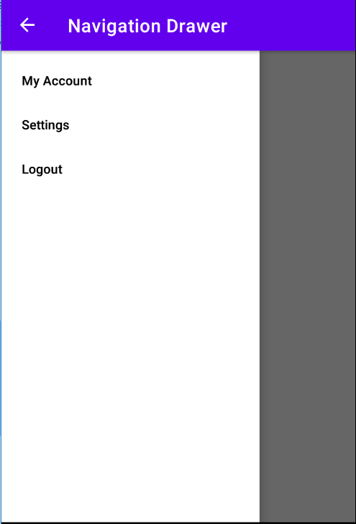

**Program No:14** **Date:04.11.2022**

**Aim:**

Create database using SQLite and perform INSERT,DELETE,UPDATE and DELETE.

**Program Code:**

**activity_main.xml:**