MCP -Model Context protocol
What is MCP server?
An "MCP server" refers to a server that runs the Model Context Protocol (MCP), a standard that allows AI models to connect to external sources (Databases, documents, Google drive ) and external tools (search engines ,calculators ,calendars )

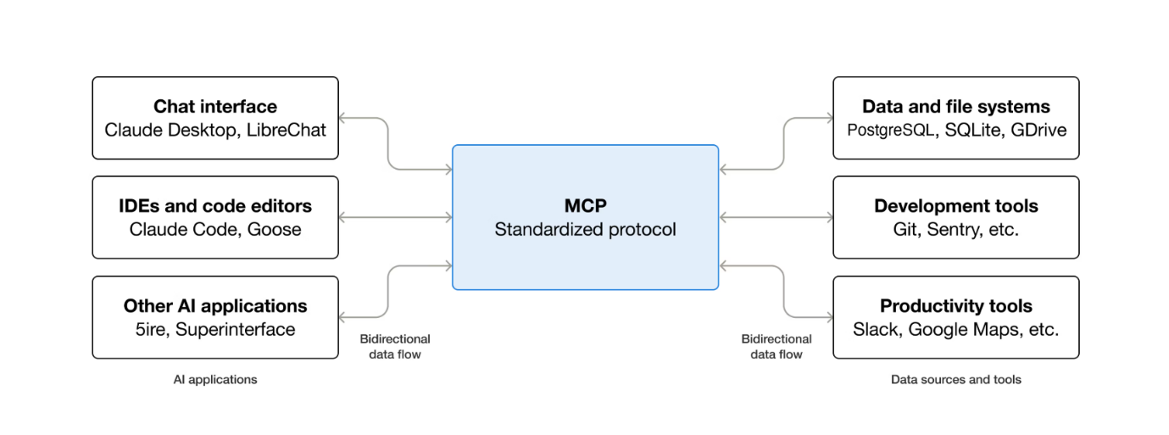

What MCP can enable?
- Agents can access your Google Calendar and Notion, acting as a more personalized AI assistant
- Claude Code can generate an entire web app using a Figma design
- AI models can create 3D designs on Blender

Why MCP Matters?
Developers: MCP reduces development time and complexity when building, or integrating with, an AI application or agent.

AI application or Agents: MCP provides access to an ecosystem of data sources, tools and apps which will enhance capabilities and improve the end-user experience.

End-users:
MCP results in more capable AI applications or agents which can access your data and take actions on your behalf when necessary.

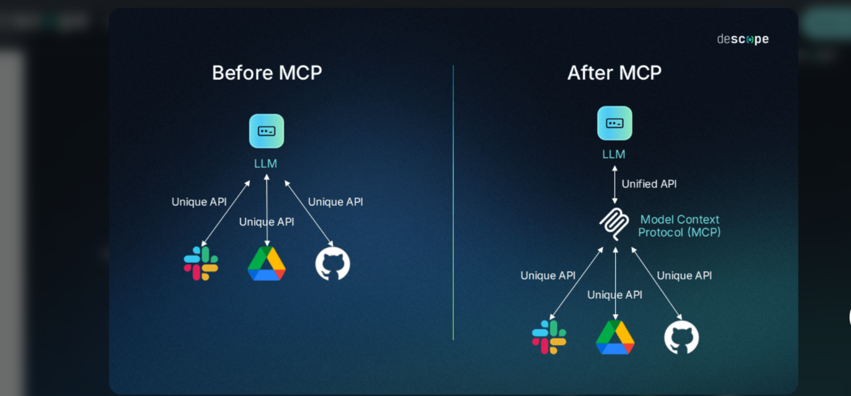

Simple lang-chain client -server code:
# client.py
import asyncio

from langchain_mcp_adapters.tools import load_mcp_tools
from langgraph.prebuilt import create_react_agent
from mcp import ClientSession, StdioServerParameters
from mcp.client.stdio import stdio_client

from llm import initialize_azure_model # Function to return langchain llm object

model = initialize_azure_model()

server_params = StdioServerParameters(
command="python",
# Make sure to update to the full absolute path to your math_server.py file
args=["langchain-simple-example/servers/math_server.py"],
)

async def run_agent():
async with stdio_client(server_params) as (read, write):
async with ClientSession(read, write) as session:
# Initialize the connection
await session.initialize()

# Get tools
tools = await load_mcp_tools(session)

# Create and run the agent
agent = create_react_agent(model=model, tools=tools)
agent_response = await agent.ainvoke(
{
"messages": "What is 3*10+5?"
}
)
return agent_response

# Run the async function
if __name__ == "__main__":
result = asyncio.run(run_agent())
print(result)

Lang Chain Loop (No Memory)

# client.py
import asyncio
from langchain_mcp_adapters.tools import load_mcp_tools
from langgraph.prebuilt import create_react_agent
from mcp import ClientSession, StdioServerParameters
from mcp.client.stdio import stdio_client
import sys

from llm import initialize_azure_model

# Set up your model (Azure OpenAI or other)
model = initialize_azure_model()

# Define server parameters (update path as needed)
server_params = StdioServerParameters(
command="python",
args=["anthropic-simple-example/servers/math_server.py"], # Change this to your server script
)

async def run_agent_loop():
try:
async with stdio_client(server_params) as (read, write):
async with ClientSession(read, write) as session:
await session.initialize()
print("MCP session initialized.")

# Load tools
tools = await load_mcp_tools(session)
print(f" Loaded tools: {[tool.name for tool in tools]}")

# Create LangChain agent
agent = create_react_agent(model=model, tools=tools)

# Run interactive chat loop
print("\nAgent ready! Type your query or 'quit' to exit.")
while True:
query = input("\n> ").strip()
if query.lower() == "quit":
print(" Goodbye!")
break

try:
result = await agent.ainvoke({"messages": query})
output = result.get("output", result)
print(f"\n {output}")
except Exception as e:
print(f" Error while processing query: {e}")

except Exception as e:
print(f" Error initializing agent: {e}")

if __name__ == "__main__":
asyncio.run(run_agent_loop())

LangChain Multi-Server (No Memory)

# client.py
import asyncio

from langchain_mcp_adapters.client import MultiServerMCPClient
from langgraph.prebuilt import create_react_agent

from llm import initialize_azure_model

async def main():
async with MultiServerMCPClient(
{
"math": {
"command": "python",
"args": ["langchain-multi-server/servers/math_server.py"],
"transport": "stdio",
},
"text": {
"command": "python",
"args": ["langchain-multi-server/servers/text_server.py"],
"transport": "stdio",
}
}
) as client:

agent = create_react_agent(model=model, tools=client.get_tools())

math_response = await agent.ainvoke({"messages": "what's (3 + 5) x 12?"})
text_response = await agent.ainvoke({"messages": "Remove the vowels from this sentence: 'Hello, my name is Andres'"})

print(math_response)
print(text_response)

if __name__ == "__main__":
model = initialize_azure_model()
asyncio.run(main())

