**INTRODUCTON :**

Overview :

* Dynamic changes in technology, the struggle for the consumer and increased competition forced the hotel enterprises consider the entire marketing activities in a new set of issues.
* In the current economics context ,hotel ,generate ,disseminate and use innovation industry makes no expection.

Purpose :

* Radission Blu has root dating back to opening of the SAS Royal Hotel in Denmark in 1960 and was the world’s first designer hotel.
* Radission Blu Edwardian hotel is a line of luxury hotels in London and monchester ,owned by Ewardian Hotels and often operating in historic building.

**PROBLEM DEFINITION & DESIGN THINKING:**

* Empathy map :

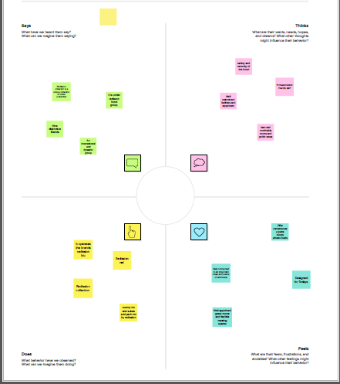

* Ideation & Brainstroming map:

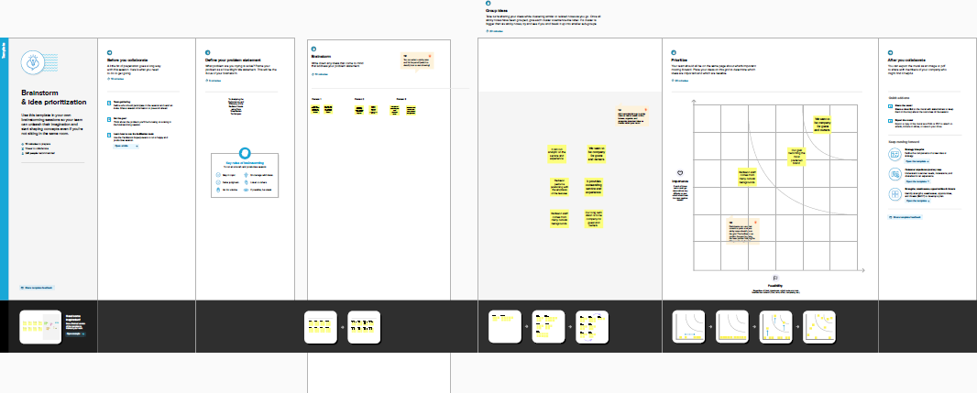

**RESULT :**

ADVANTAGES & DISADVANTAGES :

* Advantages :
* Free upgrades for the guest’s next visit.
* Exclusive discounts on future stays.
* Complementary food and beverage items at the hotel.
* Disadvantages :
* Depending On the Destination ,it can get Expensive.
* Privacy issues.
* Final Thoughts On Pros and Cons Of Staying in Hotels.

APPLICATIONS :

* A hotel is a commercial establishment that provides lodging,meal,and other services to guest.
* Hotel can range from small family-run Business to large international chains .
* Most Hotels list a variety of services, such as room , services ,laundry, and concierge.
* As a commercial enterprise, hotel are also dependent an advertising and potential customers becoming aware of their hotel and booking it.

FUTURE SCOPE:

* To bring the culture ,spirit ,environment and opportunities that empower you best to be your best.
* The hotel of the future will be an integration with a new role to play.
* Offering a memorable hotel experiences uniquely tailored to their expectations for every stays.

APPENDIX: