Natural Key vs Surrogate Key in Data Modeling
In data modeling, keys are used to uniquely identify records in a table. Two commonly used types of keys are Natural Keys and Surrogate Keys. Below is an explanation with a supporting diagram.
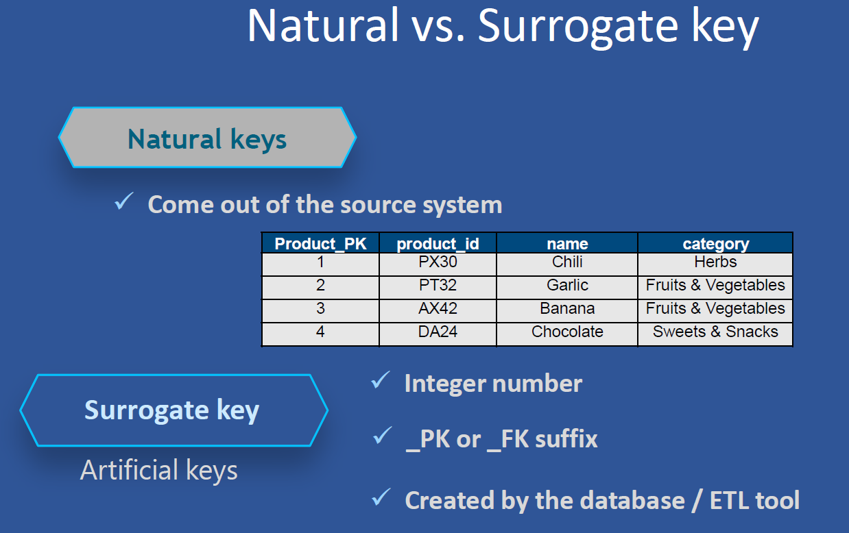

Natural Key
A natural key is a key that already exists in the source system and carries real-world meaning. Examples include product codes, email addresses, or invoice numbers. In the diagram above, the 'product_id' column (values like PX30, PT32) represents the natural key.

Surrogate Key
A surrogate key is an artificial key, typically generated by the database or ETL tool. It is an integer value with no business meaning, used internally for uniquely identifying records. In the diagram above, 'Product_PK' is the surrogate key (values like 1, 2, 3).

Summary Comparison
Feature | Natural Key | Surrogate Key
Source | Comes from source system | Generated by ETL/database
Meaning | Has business meaning | No business meaning
Format | Often alphanumeric (e.g., PX30) | Integer
Stability | Can change if business changes | Stable and unchanging
Use Case | Represents real-world entities | Used internally for joins and uniqueness

