Spring Framework, Spring Boot, JDBC, H2 & JPA
Complete Chat Transcript • IntelliJ IDEA • JDBC • H2 • Spring Data JPA
Includes code samples, troubleshooting steps, and console CRUD demos

Conversation Topics
- Spring Framework vs Spring Boot
- IntelliJ IDEA font size and code formatting shortcuts
- Employee model and SQL table creation
- JDBC with SQL Server / SSMS
- JDBC with H2 database
- Spring Boot + JdbcTemplate + H2 CRUD
- H2 Console troubleshooting
- Console-based CRUD using JdbcTemplate
- JPA concepts and benefits
- Console-based CRUD using Spring Data JPA

1. User
what is the difference between spring framework and spring boot
2. Assistant
The main difference is: Spring Framework gives you the core building blocks for developing Java enterprise applications, while Spring Boot sits on top of Spring Framework and makes it much faster and easier to configure, run, and deploy those applications.
Feature | Spring Framework | Spring Boot
Purpose | Core framework for Java applications | Simplifies Spring application development
Configuration | More manual configuration | Mostly automatic configuration
Server setup | Usually configure/deploy to a server | Embedded Tomcat/Jetty/Undertow supported
Dependencies | Choose and manage individual dependencies | Starter dependencies simplify setup
Application startup | More setup required | Can run directly with main()
Production features | Configure separately | Actuator, health checks and metrics easy to add
Development speed | More configuration work | Faster project setup

Spring Framework
Spring Framework is the foundation. It provides Dependency Injection, Inversion of Control, Spring MVC, JDBC, transaction management, AOP, security integration and data access support.
Spring Framework
│
├── Dependency Injection
├── Inversion of Control
├── Spring MVC
├── JDBC
├── Transaction Management
├── Security Integration
├── AOP
└── Data Access

@Service
public class EmployeeService {
public String getEmployee() {
return "Ravi";
}
}

Spring manages the object for us instead of creating every dependency manually. This is the idea behind Dependency Injection and IoC.

Spring Boot
Spring Boot uses Spring Framework internally and reduces configuration work. It adds auto configuration, starter dependencies, embedded servers and production-ready conveniences.
Java
↓
Spring Framework
↓
Spring Boot
↓
REST APIs / Web Apps / Microservices

Spring Boot is not a replacement for Spring Framework; it is a convenient way to build Spring applications.
@SpringBootApplication
public class EmployeeApplication {
public static void main(String[] args) {
SpringApplication.run(EmployeeApplication.class, args);
}
}

@RestController
public class EmployeeController {
@GetMapping("/hello")
public String hello() {
return "Hello Spring Boot";
}
}

Easy sentence to remember: Spring Framework provides the features. Spring Boot makes those features easier to configure, run, and deploy.
3. User
export to md to download with colorful title and professional colourful flow diagram
4. Assistant
Created a professional Markdown document with colorful titles, comparison tables, and Mermaid flow diagrams: Spring_Framework_vs_Spring_Boot_Professional_Notes.md
5. User
How to change the font size in IntelliJ IDE?
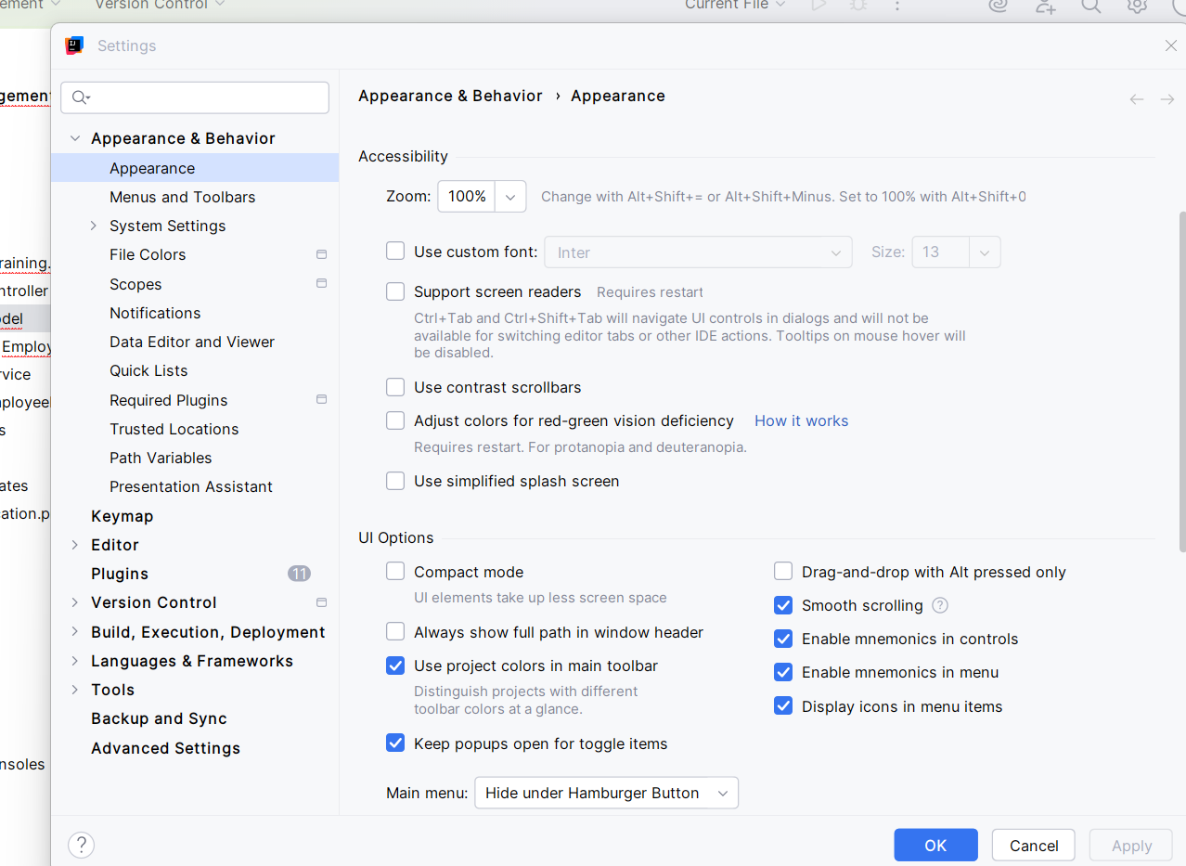
IntelliJ IDEA Appearance settings
6. Assistant
For the code editor font: File → Settings → Editor → Font → change Size (for example 16 or 18) → Apply → OK.
File
↓
Settings
↓
Editor
↓
Font
↓
Size: 16

For the entire IntelliJ user interface, use Settings → Appearance & Behavior → Appearance → Use custom font. You can also enable Ctrl + Mouse Wheel zoom under Settings → Editor → General → Mouse Control.
7. User
What is the shortcut to format the code in IntelliJ IDE?
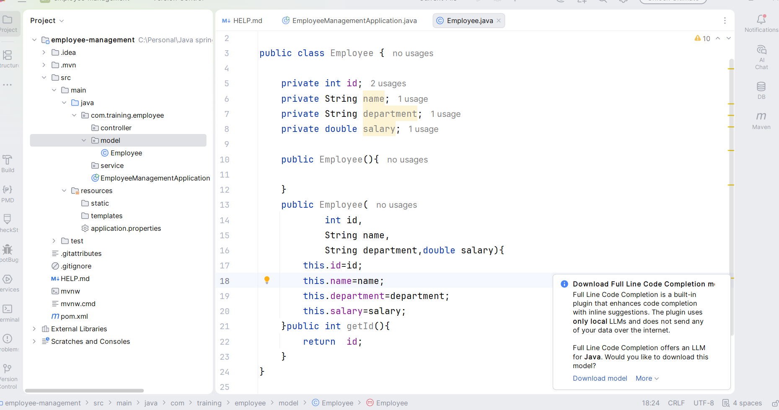
Java code in IntelliJ IDEA
8. Assistant
- Windows / Linux: Ctrl + Alt + L
- macOS: Option + Command + L
- Menu: Code → Reformat Code
The formatter fixes indentation, spacing, and general code layout.
9. User
Shared a screenshot showing updateEmployee() errors in EmployeeService.
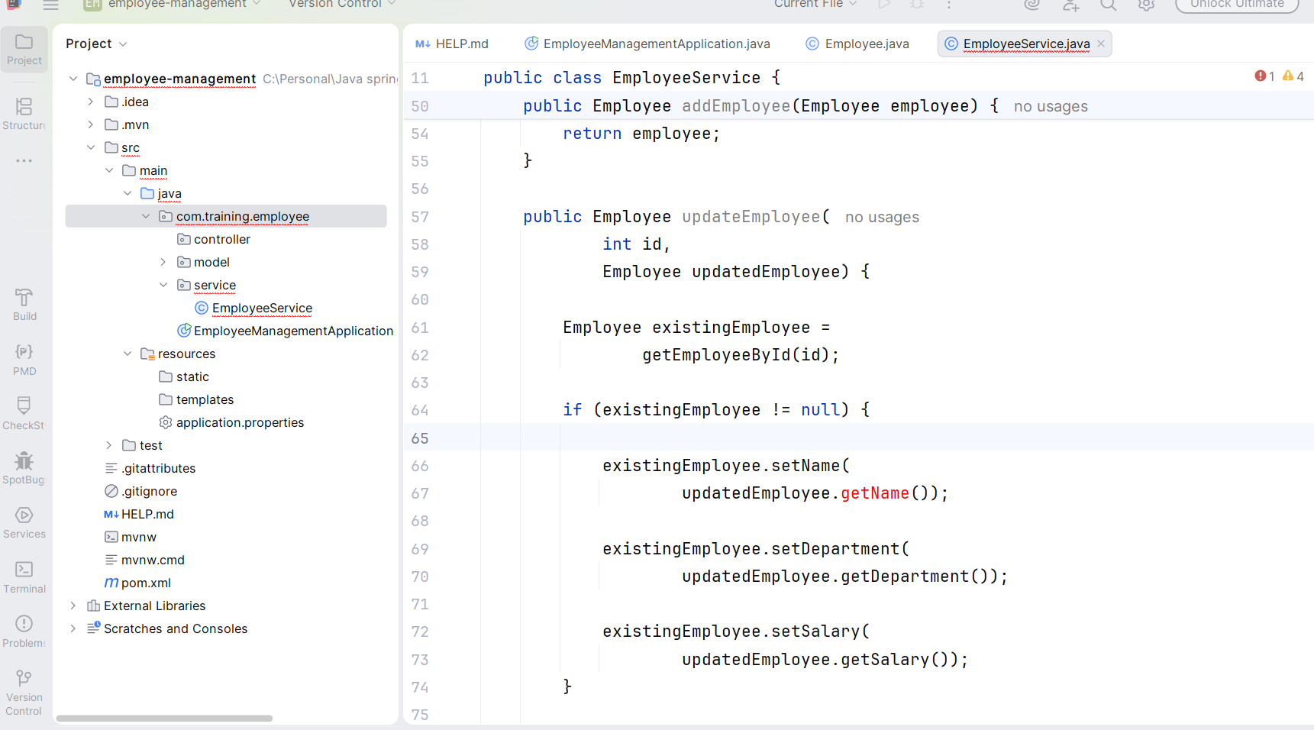
EmployeeService update code
10. Assistant
The EmployeeService code was calling getters and setters that were missing in Employee.java. Add getters/setters for name, department and salary, and return the updated employee.
public class Employee {
private int id;
private String name;
private String department;
private double salary;

public int getId() { return id; }
public void setId(int id) { this.id = id; }
public String getName() { return name; }
public void setName(String name) { this.name = name; }
public String getDepartment() { return department; }
public void setDepartment(String department) { this.department = department; }
public double getSalary() { return salary; }
public void setSalary(double salary) { this.salary = salary; }
}

public Employee updateEmployee(int id, Employee updatedEmployee) {
Employee existingEmployee = getEmployeeById(id);
if (existingEmployee != null) {
existingEmployee.setName(updatedEmployee.getName());
existingEmployee.setDepartment(updatedEmployee.getDepartment());
existingEmployee.setSalary(updatedEmployee.getSalary());
return existingEmployee;
}
return null;
}

11. User
I need a SQL script to create a table for the attached Excel / Employee fields.
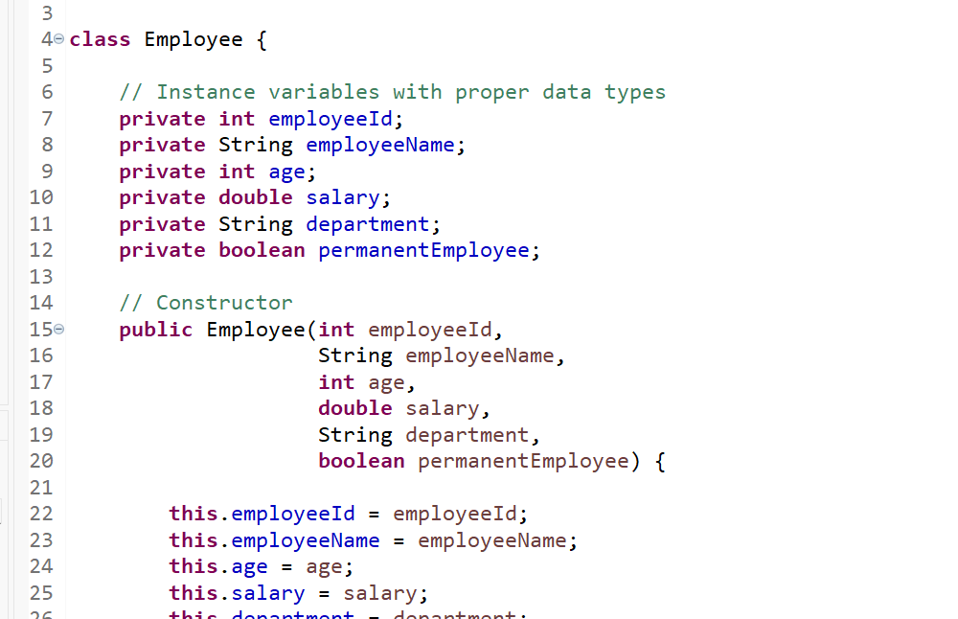
Employee fields shown in the project
12. Assistant
CREATE DATABASE IF NOT EXISTS employee_management;
USE employee_management;

CREATE TABLE employee (
employee_id INT PRIMARY KEY AUTO_INCREMENT,
employee_name VARCHAR(100) NOT NULL,
age INT NOT NULL,
salary DECIMAL(10,2) NOT NULL,
department VARCHAR(100) NOT NULL,
permanent_employee BOOLEAN NOT NULL
);

INSERT INTO employee
(employee_name, age, salary, department, permanent_employee)
VALUES
('Arun Kumar', 30, 55000.00, 'IT', TRUE),
('Priya', 28, 48000.00, 'HR', TRUE),
('Karthik', 25, 42000.00, 'Support', FALSE),
('Meena', 32, 65000.00, 'Finance', TRUE);

13. User
Asked for a simple JDBC continuation for the Employee console program using SSMS / SQL Server as separate classes.
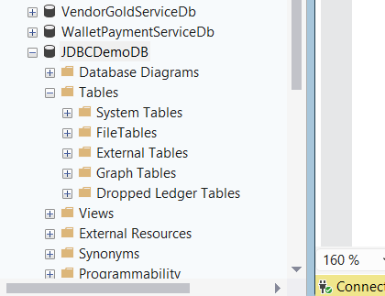
Employee Java program
14. Assistant

SQL Server Table
USE JDBCDemoDB;
GO

CREATE TABLE Employee (
employeeId INT PRIMARY KEY,
employeeName VARCHAR(100),
age INT,
salary DECIMAL(10,2),
department VARCHAR(100),
permanentEmployee BIT
);
GO

Maven JDBC Driver
<dependency>
<groupId>com.microsoft.sqlserver</groupId>
<artifactId>mssql-jdbc</artifactId>
<version>12.8.1.jre11</version>
</dependency>

DBConnection.java
package com.abc;

import java.sql.Connection;
import java.sql.DriverManager;
import java.sql.SQLException;

public class DBConnection {
private static final String URL =
"jdbc:sqlserver://localhost:1433;" +
"databaseName=JDBCDemoDB;" +
"encrypt=true;" +
"trustServerCertificate=true;";

private static final String USERNAME = "sa";
private static final String PASSWORD = "YourPassword";

public static Connection getConnection() {
Connection connection = null;
try {
connection = DriverManager.getConnection(URL, USERNAME, PASSWORD);
System.out.println("Database connected successfully.");
} catch (SQLException e) {
System.out.println("Database connection failed.");
e.printStackTrace();
}
return connection;
}
}

EmployeeDAO.java
public void saveEmployee(Employee employee) {
String sql = "INSERT INTO Employee " +
"(employeeId, employeeName, age, salary, department, permanentEmployee) " +
"VALUES (?, ?, ?, ?, ?, ?)";

try {
Connection connection = DBConnection.getConnection();
PreparedStatement statement = connection.prepareStatement(sql);
statement.setInt(1, employee.getEmployeeId());
statement.setString(2, employee.getEmployeeName());
statement.setInt(3, employee.getAge());
statement.setDouble(4, employee.getSalary());
statement.setString(5, employee.getDepartment());
statement.setBoolean(6, employee.isPermanentEmployee());
int rows = statement.executeUpdate();
if (rows > 0) System.out.println("Employee saved successfully.");
statement.close();
connection.close();
} catch (SQLException e) {
e.printStackTrace();
}
}

15. User
Shared an Eclipse/STS Maven integration error screenshot.
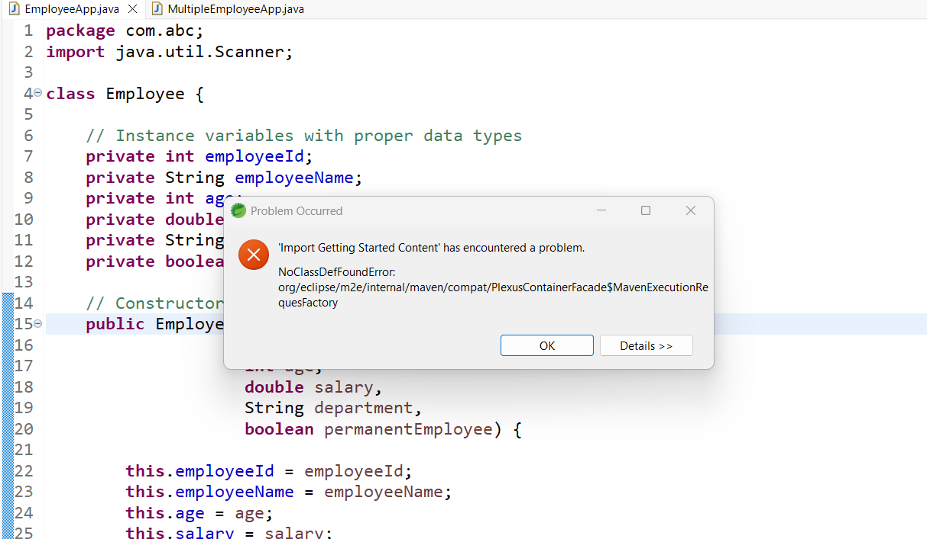
STS / Maven integration error
16. Assistant
The error was identified as an Eclipse/STS Maven m2e integration problem, not an EmployeeApp Java-code error.
NoClassDefFoundError: org/eclipse/m2e/internal/maven/compat/PlexusContainerFacade$MavenExecutionRequestFactory

- Restart STS with -clean using the actual executable.
- Help → Check for Updates.
- Maven → Update Project (Alt+F5) and force updates.
- If needed, disable/re-enable Maven nature.
- Try a clean workspace if the problem is workspace-specific.
17. User
Same code you can give it to H2 database with the JDBC connectivity.
18. Assistant
The SQL Server JDBC example was adapted to H2. A file-based H2 URL was used so data can persist between application runs.
<dependency>
<groupId>com.h2database</groupId>
<artifactId>h2</artifactId>
<version>2.3.232</version>
</dependency>

public class DBConnection {
private static final String URL = "jdbc:h2:./data/employeedb";
private static final String USERNAME = "sa";
private static final String PASSWORD = "";

public static Connection getConnection() {
Connection connection = null;
try {
connection = DriverManager.getConnection(URL, USERNAME, PASSWORD);
System.out.println("H2 Database connected successfully.");
} catch (SQLException e) {
e.printStackTrace();
}
return connection;
}
}

CREATE TABLE IF NOT EXISTS Employee (
employeeId INT PRIMARY KEY,
employeeName VARCHAR(100),
age INT,
salary DECIMAL(10,2),
department VARCHAR(100),
permanentEmployee BOOLEAN
)

Using jdbc:h2:mem:employeedb creates an in-memory database that disappears when the Java process stops.
19. User
Give me the very simple CRUD operation using JDBC connectivity with H2 database with Spring Boot application with IntelliJ IDE.
20. Assistant
A beginner-friendly Spring Boot + Spring JDBC + H2 Employee CRUD project was proposed, with Model, Repository, Service, Controller, application.properties and schema.sql.
spring.datasource.url=jdbc:h2:mem:employeedb
spring.datasource.driver-class-name=org.h2.Driver
spring.datasource.username=sa
spring.datasource.password=

spring.h2.console.enabled=true
spring.h2.console.path=/h2-console
spring.sql.init.mode=always

CREATE TABLE employee (
employee_id INT PRIMARY KEY,
employee_name VARCHAR(100),
age INT,
salary DOUBLE,
department VARCHAR(100),
permanent_employee BOOLEAN
);

JdbcTemplate was used in the repository for INSERT, SELECT, UPDATE and DELETE; REST endpoints were POST /employees, GET /employees, GET /employees/{id}, PUT /employees/{id}, and DELETE /employees/{id}.
21. User
Give a simple demo in a single class itself to perform CRUD operation using the H2 database.
22. Assistant
A single Spring Boot class used CommandLineRunner and JdbcTemplate to create the table, insert, read, update and delete.
@SpringBootApplication
public class EmployeeManagementApplication implements CommandLineRunner {

private final JdbcTemplate jdbcTemplate;

public EmployeeManagementApplication(JdbcTemplate jdbcTemplate) {
this.jdbcTemplate = jdbcTemplate;
}

public static void main(String[] args) {
SpringApplication.run(EmployeeManagementApplication.class, args);
}

@Override
public void run(String... args) {
jdbcTemplate.execute(
"CREATE TABLE employee (" +
"employee_id INT PRIMARY KEY, " +
"employee_name VARCHAR(100), " +
"age INT, salary DOUBLE, " +
"department VARCHAR(100), " +
"permanent_employee BOOLEAN)"
);

jdbcTemplate.update(
"INSERT INTO employee " +
"(employee_id, employee_name, age, salary, department, permanent_employee) " +
"VALUES (?, ?, ?, ?, ?, ?)",
101, "Ravi", 30, 55000, "IT", true
);

System.out.println(jdbcTemplate.queryForList("SELECT * FROM employee"));

jdbcTemplate.update(
"UPDATE employee SET employee_name=?, salary=?, department=? WHERE employee_id=?",
"Ravi Kumar", 65000, "Development", 101
);

jdbcTemplate.update("DELETE FROM employee WHERE employee_id=?", 101);
}
}

23. User
It is not showing the tables. Where to see?
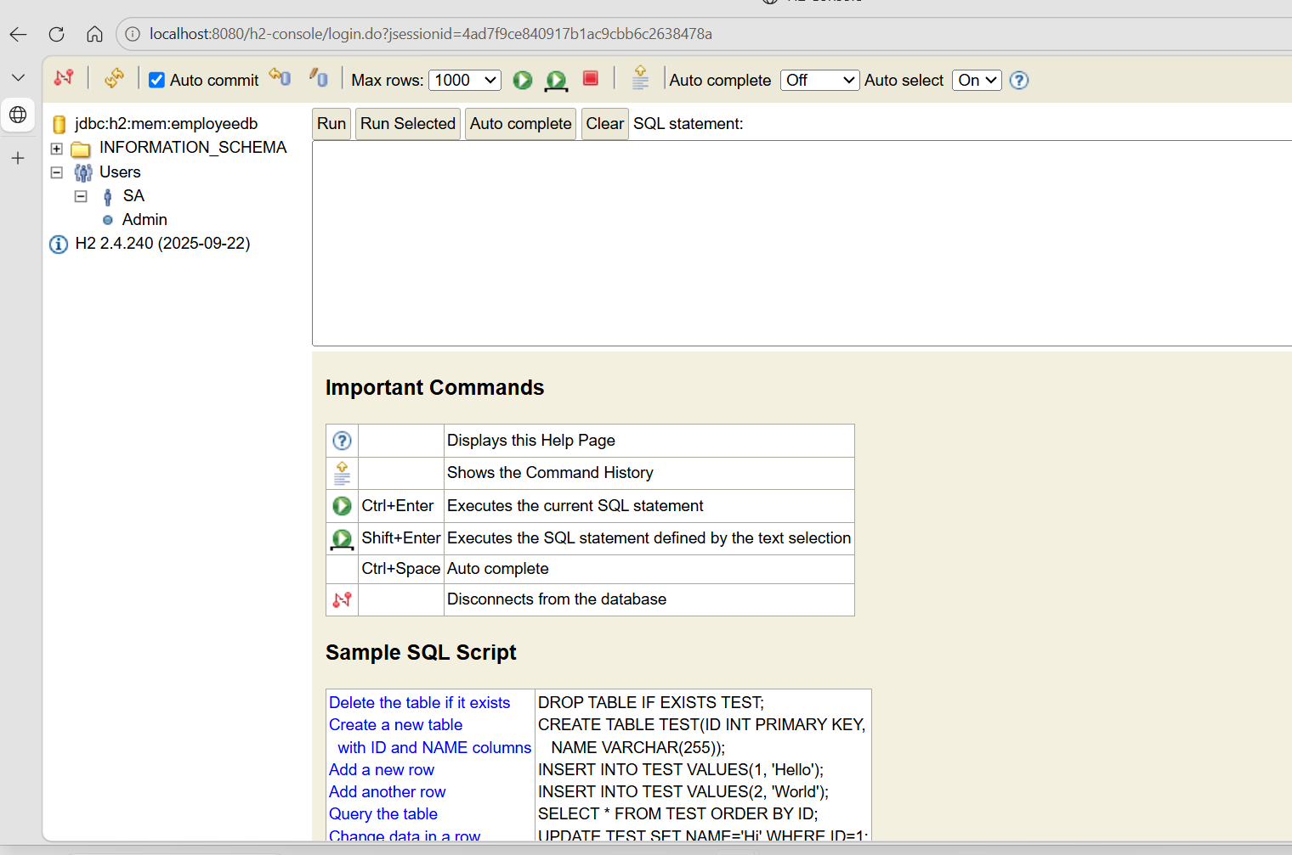
H2 Console screenshot
24. Assistant
The H2 Console was connected to jdbc:h2:mem:employeedb. With an in-memory database, the Spring Boot process must remain running. Expand PUBLIC in the left tree or run:
SHOW TABLES;

SELECT TABLE_NAME
FROM INFORMATION_SCHEMA.TABLES
WHERE TABLE_SCHEMA = 'PUBLIC';

If no table appears, verify that the CREATE TABLE code executed. For persistent training demos, jdbc:h2:file:./data/employeedb can be easier.
25. User
Shared the Spring Boot startup log. Important lines included:
HikariPool-1 - Added connection conn0: url=jdbc:h2:mem:employeedb user=SA
H2 console available at '/h2-console'. Database available at 'jdbc:h2:mem:employeedb'
Tomcat started on port 8080

26. Assistant
The log confirmed the H2 connection was correct. The table creation code needed to run inside CommandLineRunner. A corrected JdbcDemo1Application was provided.
@Override
public void run(String... args) {
jdbcTemplate.execute(
"CREATE TABLE IF NOT EXISTS employee (" +
"employee_id INT PRIMARY KEY, " +
"employee_name VARCHAR(100), " +
"age INT, salary DOUBLE, " +
"department VARCHAR(100), " +
"permanent_employee BOOLEAN)"
);

System.out.println("EMPLOYEE table created successfully");

jdbcTemplate.update(
"INSERT INTO employee " +
"(employee_id, employee_name, age, salary, department, permanent_employee) " +
"VALUES (?, ?, ?, ?, ?, ?)",
101, "Ravi", 30, 55000, "IT", true
);
}

Then connect to http://localhost:8080/h2-console with JDBC URL jdbc:h2:mem:employeedb, user sa, blank password.
27. User
Asked to insert new records from the IntelliJ console and perform update/delete CRUD operations interactively.
28. Assistant
A menu-driven console CRUD application using JdbcTemplate was provided. The user can select Insert, View All, Update, Delete, or Exit.
do {
System.out.println("1. Insert Employee");
System.out.println("2. View All Employees");
System.out.println("3. Update Employee");
System.out.println("4. Delete Employee");
System.out.println("5. Exit");

choice = scanner.nextInt();
scanner.nextLine();

switch (choice) {
case 1 -> insertEmployee(scanner);
case 2 -> viewEmployees();
case 3 -> updateEmployee(scanner);
case 4 -> deleteEmployee(scanner);
case 5 -> System.out.println("Application closed.");
default -> System.out.println("Invalid choice.");
}
} while (choice != 5);

The CRUD methods used jdbcTemplate.update() for INSERT/UPDATE/DELETE and jdbcTemplate.queryForList() for SELECT.
29. User
write a simple program to connect h2 database using JPA. Explain what is JPA ? how it is helpful when compared to previous approaches.
30. Assistant

What is JPA?
JPA stands for Java Persistence API. It is a Java specification used to map Java objects to database tables. Instead of writing SQL for every CRUD operation, you work mainly with entity objects and repository methods.
JdbcTemplate approach:
jdbcTemplate.update(
"INSERT INTO employee(employee_id, employee_name) VALUES (?, ?)",
id,
name
);

JPA approach:
employeeRepository.save(employee);

JPA is a specification; Hibernate is a common implementation. Spring Data JPA adds an even simpler repository abstraction.
Spring Data JPA
↓
JPA
↓
Hibernate
↓
H2 / MySQL / SQL Server / PostgreSQL

JDBC / JdbcTemplate | JPA
Write SQL manually | SQL usually generated automatically
Manual row mapping | Object/table mapping automatic
More CRUD boilerplate | Less CRUD code
Good for SQL learning and direct control | Good for productivity and domain models

@Entity
@Table(name = "employee")
public class Employee {
@Id
private int employeeId;
private String employeeName;
private int age;
private double salary;
private String department;
private boolean permanentEmployee;

public Employee() {}
// constructor, getters and setters
}

public interface EmployeeRepository
extends JpaRepository<Employee, Integer> {
}

spring.datasource.url=jdbc:h2:mem:employeedb
spring.datasource.driver-class-name=org.h2.Driver
spring.datasource.username=sa
spring.datasource.password=

spring.jpa.hibernate.ddl-auto=create
spring.jpa.show-sql=true

spring.h2.console.enabled=true
spring.h2.console.path=/h2-console

With Spring Data JPA, common CRUD operations become save(), findAll(), findById(), existsById() and deleteById().
31. User
Give me the CRUD operation for the same example with console based I want to give you the input that needs to be updated in my database.
32. Assistant
A complete console-based CRUD application using Spring Data JPA + H2 was provided.

Employee.java
@Entity
@Table(name = "employee")
public class Employee {

@Id
private int employeeId;
private String employeeName;
private int age;
private double salary;
private String department;
private boolean permanentEmployee;

public Employee() {}

public Employee(int employeeId, String employeeName, int age,
double salary, String department, boolean permanentEmployee) {
this.employeeId = employeeId;
this.employeeName = employeeName;
this.age = age;
this.salary = salary;
this.department = department;
this.permanentEmployee = permanentEmployee;
}

// getters, setters and toString()
}

EmployeeRepository.java
public interface EmployeeRepository
extends JpaRepository<Employee, Integer> {
}

JpaDemoApplication.java - menu structure
do {
System.out.println("1. Add Employee");
System.out.println("2. View All Employees");
System.out.println("3. View Employee By ID");
System.out.println("4. Update Employee");
System.out.println("5. Delete Employee");
System.out.println("6. Exit");

choice = scanner.nextInt();
scanner.nextLine();

switch (choice) {
case 1 -> addEmployee(scanner);
case 2 -> viewAllEmployees();
case 3 -> viewEmployeeById(scanner);
case 4 -> updateEmployee(scanner);
case 5 -> deleteEmployee(scanner);
case 6 -> System.out.println("Application closed.");
default -> System.out.println("Invalid choice.");
}
} while (choice != 6);

Create
Employee employee = new Employee(id, name, age, salary, department, permanent);
employeeRepository.save(employee);

Read
List<Employee> employees = employeeRepository.findAll();
Employee employee = employeeRepository.findById(id).orElse(null);

Update
Employee employee = employeeRepository.findById(id).orElse(null);
if (employee != null) {
employee.setEmployeeName(name);
employee.setAge(age);
employee.setSalary(salary);
employee.setDepartment(department);
employee.setPermanentEmployee(permanent);
employeeRepository.save(employee);
}

Delete
if (employeeRepository.existsById(id)) {
employeeRepository.deleteById(id);
}

CRUD mapping: CREATE → save(), READ → findAll()/findById(), UPDATE → modify entity + save(), DELETE → deleteById().

Learning Progression
Spring Framework
↓
Spring Boot
↓
Plain JDBC
↓
Spring JdbcTemplate
↓
H2 Database
↓
JPA / Hibernate
↓
Spring Data JPA
↓
Console CRUD Application

- Spring Framework provides the core application framework and dependency injection.
- Spring Boot reduces configuration and provides convenient application startup.
- Plain JDBC gives low-level database access with Connection, PreparedStatement and ResultSet.
- JdbcTemplate removes much of the repetitive JDBC plumbing while keeping SQL explicit.
- JPA maps Java entities to relational tables and reduces manual SQL for common persistence operations.
- Spring Data JPA reduces repository boilerplate further through JpaRepository.
- H2 is convenient for training and local development because it is lightweight and easy to configure.

