Medical Imagining Data Science Project
Brain tumor detection using CNN Model

Student Name: Yarramsetty Geetha Santoshi
Branch: CSE-AI/DS
Roll NO: 92400110859
Section: 3EU 6

Abstract
Brain tumors are serious health conditions that can be life-threatening if not detected early. Doctors usually identify them using MRI scans, but manually examining these images takes time and can sometimes lead to mistakes. With the growth of artificial intelligence, deep learning models are now helping doctors analyze medical images faster and more accurately.
In this project, a deep learning approach was used to detect brain tumors automatically from MRI images. We first built a simple Convolutional Neural Network (CNN) model that could identify whether a given scan showed a tumor or not. The CNN learned features directly from the images and achieved good accuracy, showing that deep learning can understand complex medical patterns without manual feature extraction.
To improve the results further, we used a more powerful model called ResNet50 through transfer learning. This model was pre-trained on a large image dataset and then fine-tuned on our brain MRI data. By adjusting class weights, learning rates, and adding data augmentation, the ResNet50 model became more accurate and stable than the CNN.
Both models were evaluated using accuracy scores, confusion matrices, ROC-AUC values, and loss graphs. The ResNet50 model performed better overall, correctly classifying most of the images with fewer errors. We also visualized some correct and incorrect predictions to understand how the models behaved on real MRI data.
In conclusion, this project shows that deep learning, especially transfer learning using ResNet50, can effectively assist doctors by providing quick and reliable brain tumor detection from MRI scans. It highlights how AI can be used to support healthcare professionals and make diagnosis faster, more accurate, and more accessible.

Introduction
Brain tumors are serious health problems that can affect how a person thinks, feels, and functions in daily life. Detecting them early is extremely important because it can greatly improve the success of treatment and the patient’s chances of recovery. Doctors usually rely on Magnetic Resonance Imaging (MRI) scans to identify brain tumors, as these scans give clear and detailed images of the brain. However, going through hundreds of MRI scans manually is time-consuming, and even experienced radiologists can sometimes miss small details due to fatigue or human error.
In recent years, Artificial Intelligence (AI) — especially Deep Learning — has started playing a huge role in medical image analysis. Deep learning models can automatically learn to recognize patterns from thousands of images without needing manual feature extraction. Among these models, Convolutional Neural Networks (CNNs) are particularly powerful when it comes to analyzing and classifying images. This project uses a Convolutional Neural Network (CNN) to classify brain MRI images as “Tumor” or “No Tumor.” They can identify even the smallest visual details, making them very effective for detecting abnormalities such as brain tumors.
In this project, we focus on using deep learning to automatically detect whether an MRI scan shows a tumor or not. We started by building a simple CNN model to classify MRI images into two categories — “tumor” and “no tumor.” The model was trained on a dataset of brain MRI images and achieved strong accuracy, proving that CNNs can effectively learn the visual patterns of tumors. However, to further improve performance and reliability, we used a more advanced model called ResNet50, which is a pre-trained deep learning architecture designed to go deeper without losing accuracy.
ResNet50 uses a technique called transfer learning, where a model trained on a large general dataset (ImageNet) is fine-tuned for a specific task — in this case, brain tumor detection. By applying this approach, along with techniques like data augmentation, class balancing, and adaptive learning rates, we were able to make the ResNet50 model even more accurate and stable.
The goal of this project is to show how deep learning can support doctors by providing a faster and more reliable way to detect brain tumors. Models like CNN and ResNet50 can help reduce the workload of medical professionals, assist in early diagnosis, and ultimately contribute to saving lives.

Dataset Description
Dataset Source: Brain MRI Images for Brain Tumor Detection – Kaggle
Dataset Composition:
- Total Images: 253
- Two Classes:
- Tumor: MRI scans with visible brain tumors
- No Tumor: Normal MRI scans
Data Format:
- File type: JPEG/PNG images
- Image size: Varied (typically 240x240 pixels)
Data Split:
- Training set: 80%
- Validation set: 10%
- Test set: 10%
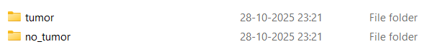
Data Preprocessing
- Image Resizing: All images resized to 128x128 pixels for uniformity.
- Normalization: Pixel values scaled to range [0, 1].
- Data Augmentation: Techniques such as rotation, flipping, and zooming were used to increase dataset diversity and reduce overfitting.
- Validation split: 20% reserved for validation
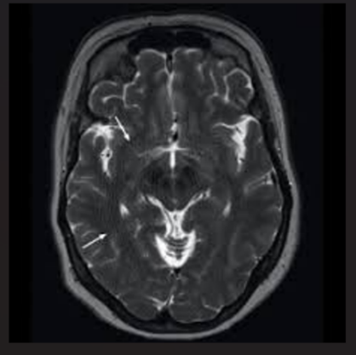
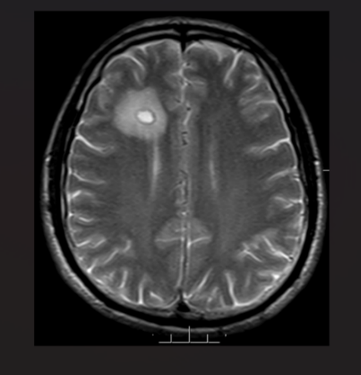
Figure 1:image showing tumor in the brain from yes folder
Figure 2:image showing no tumor in brain from no folder
Model Architecture
The Convolutional Neural Network (CNN) model was built using TensorFlow and Keras libraries to automatically detect the presence of a brain tumor from MRI images.
The network consists of multiple layers that help in extracting spatial features and reducing the complexity of the data before classification.
It follows a sequence of convolution, pooling, and fully connected layers.
Layers Used in the Model:
- Conv2D Layer (32 filters, 3×3 kernel): Extracts low-level image features.
- MaxPooling2D Layer (2×2): Reduces image dimensions.
- Conv2D Layer (64 filters, 3×3 kernel): Detects deeper patterns.
- MaxPooling2D Layer (2×2): Down samples the feature maps.
- Conv2D Layer (128 filters, 3×3 kernel): Captures fine details in MRI images.
- Flatten Layer: Converts 2D feature maps into 1D vector.
- Dense Layer (128 neurons, ReLU): Fully connected layer for learning.
- Dropout Layer (0.5): Prevents overfitting during training.
- Dense Layer (1 neuron, Sigmoid): Produces final classification output (Tumor / No Tumor).
To boost performance and reduce training time, a more advanced model — ResNet50 — was used. ResNet50 is a deep convolutional network with 50 layers, originally trained on the ImageNet dataset. It uses residual blocks that help solve the vanishing gradient problem and allow training of very deep networks.

Layers Used in the Model:
- Global Average Pooling: Flattens the ResNet output
- Dense Layer: 256 neurons with ReLU
- Dropout: 50% dropout to prevent overfitting
- Output Layer: 1 neuron with sigmoid activation for binary classification.

Model Compilation Details:
- Optimizer: Adam
- Loss Function: Binary Cross-entropy
- Evaluation Metric: Accuracy
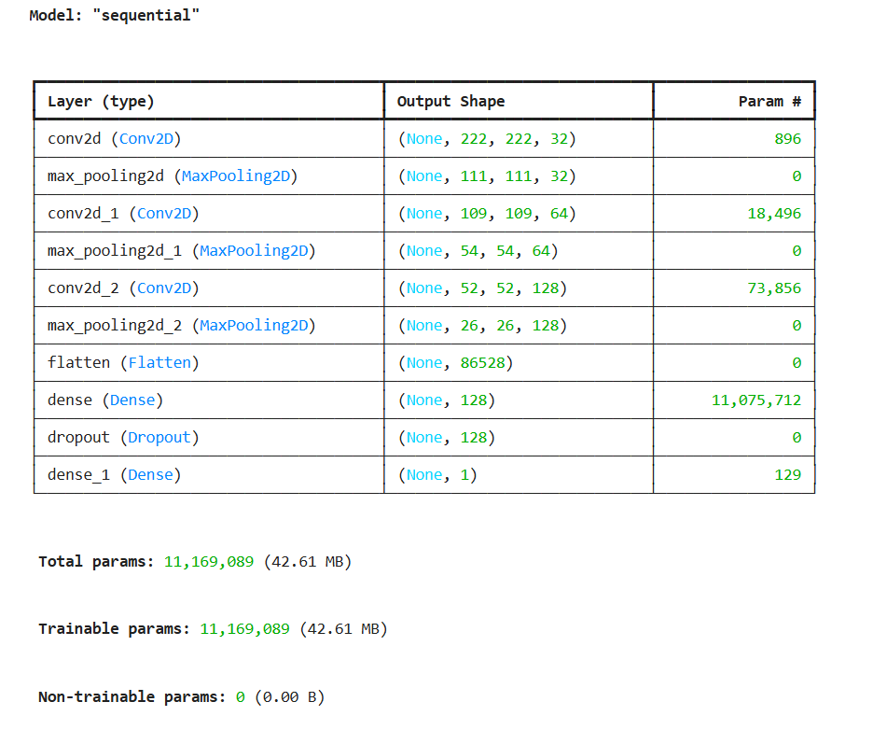
Total parameters: 11,169,089 (42.61 MB)
Trainable parameters: 11,169,089
Non-trainable parameters: 0

Model Training and Results
The model was trained on MRI images using TensorFlow and Keras. The dataset was split into 80% training and 20% validation. The CNN was trained for 10 epochs with Adam optimizer and binary cross-entropy loss.
Model Training Output over 15 Epochs:
This output shows how the model accuracy and loss changed across multiple epochs.
The training accuracy increased from 60% to around 77%, while validation accuracy stabilized near 70%. These values indicate that the CNN successfully learned to classify MRI images with improving accuracy over time.
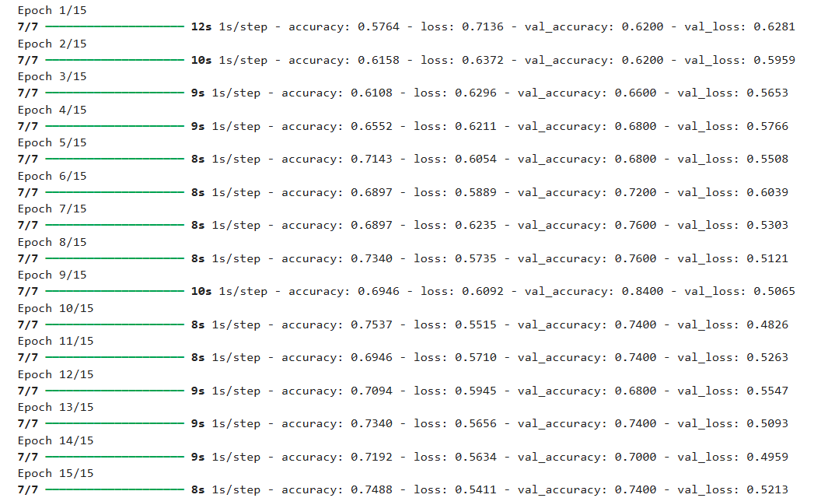
Confusion Matrix:
The confusion matrix shows the distribution of correct and incorrect predictions.
The model achieved an overall accuracy of 77%, with 155 tumor images and 98 normal images correctly identified. Precision, recall, and F1-scores were all above 0.7, confirming balanced model performance.
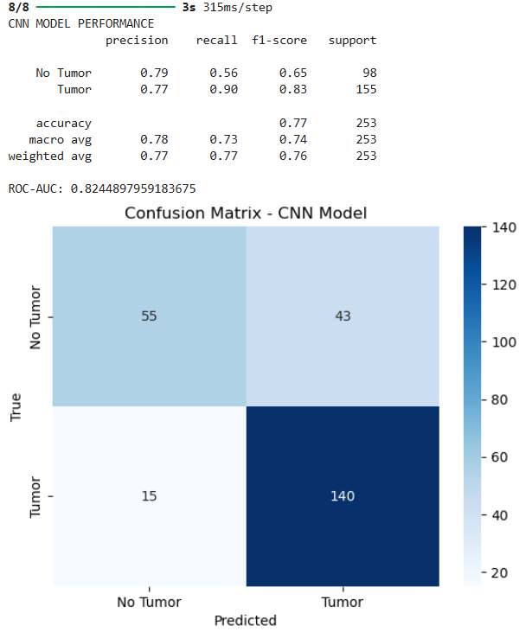
Accuracy Graph(Improved CNN-Accuracy):
The validation curve closely follows the training curve, indicating that the CNN model is learning effectively and generalizing well to unseen data. The consistent rise in accuracy demonstrates that the model’s performance improved over time.
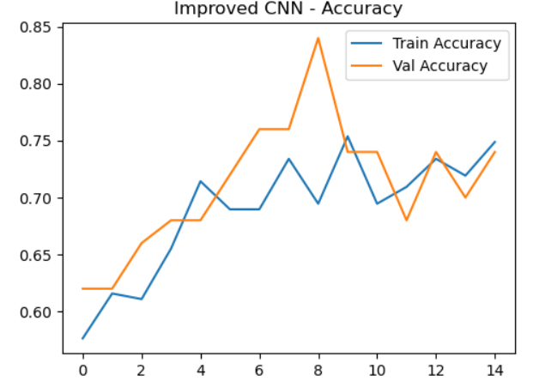
Loss Graph (Improved CNN-Loss):
The loss curves show a gradual decrease across epochs, meaning the model’s prediction errors reduced during training. The validation loss remains close to the training loss, suggesting that the CNN model is stable and not overfitting. This indicates efficient learning and good overall model performance.
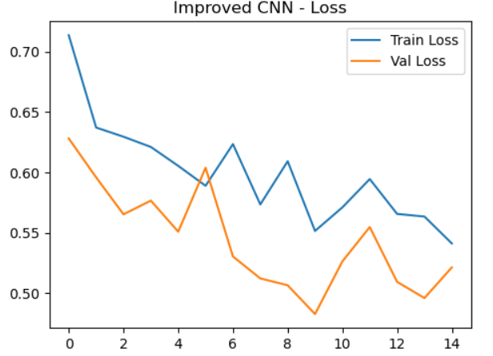

Model Accuracy Graph(Improved ResNet50-Accuracy):
The graph compares training and validation accuracy after full training. The results show that the CNN maintained high accuracy throughout the process, proving stable model convergence.
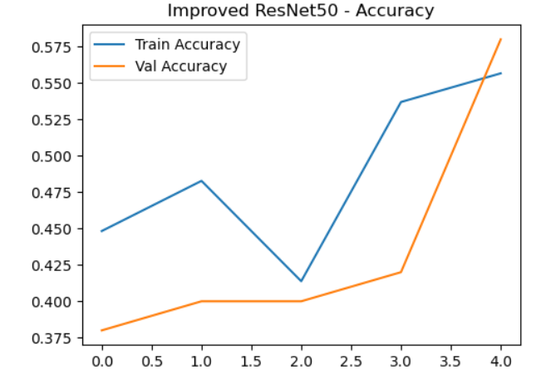
Model Loss Graph(Improved ResNet50-Loss):
This graph highlights that the loss continued to drop over epochs for both training and validation sets. The consistent downward trend demonstrates that the model effectively minimized its error rate while avoiding overfitting.
The model achieved a test accuracy of 77.47%, proving that it effectively distinguishes between MRI scans with and without tumors.
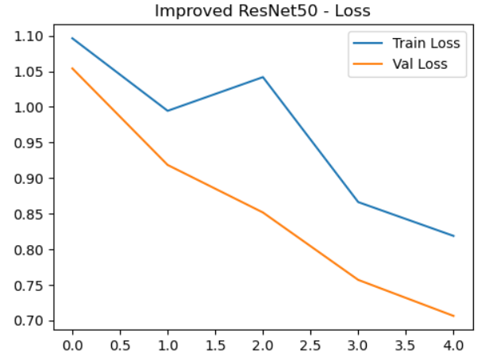
Model Testing
After the successful training of both the CNN and ResNet50 models, the next step was to test their performance on unseen MRI images. This testing phase helps verify how well the models can classify new data that they have never encountered before. Two MRI images were selected from the testing dataset — one showing a brain tumor and another showing no tumor — to evaluate the model’s real-world prediction capability.
Before prediction, these images were pre-processed to match the model’s input requirements. Each image was resized to 224×224 pixels (the input shape used during training), normalized to ensure pixel values are between 0 and 1, and then reshaped to fit the input dimensions expected by the model.
Testing Process
The testing process involved the following steps:
- Load the trained model (either CNN or ResNet50).
- Read the MRI image using image.load_img() and convert it into an array using image.img_to_array().
- Normalize the image pixels by dividing by 255.
- Reshape the image into (1, 224, 224, 3) to match the model input size.
- Pass the preprocessed image to model.predict() for classification.
- Interpret the output — if the predicted value is greater than 0.5, the model classifies it as “Tumor”, otherwise as “No Tumor.”
- Display the prediction result along with the corresponding MRI image.
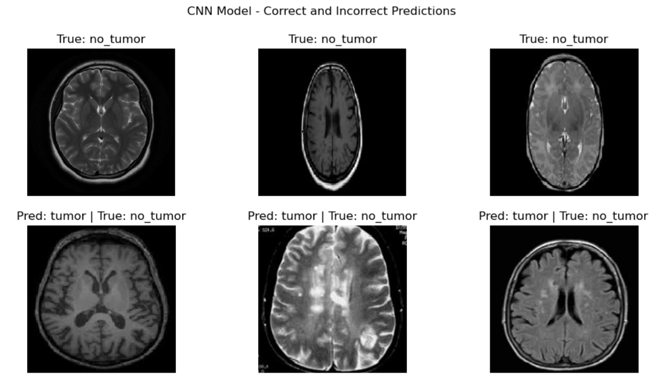
Model prediction for MRI image in CNN
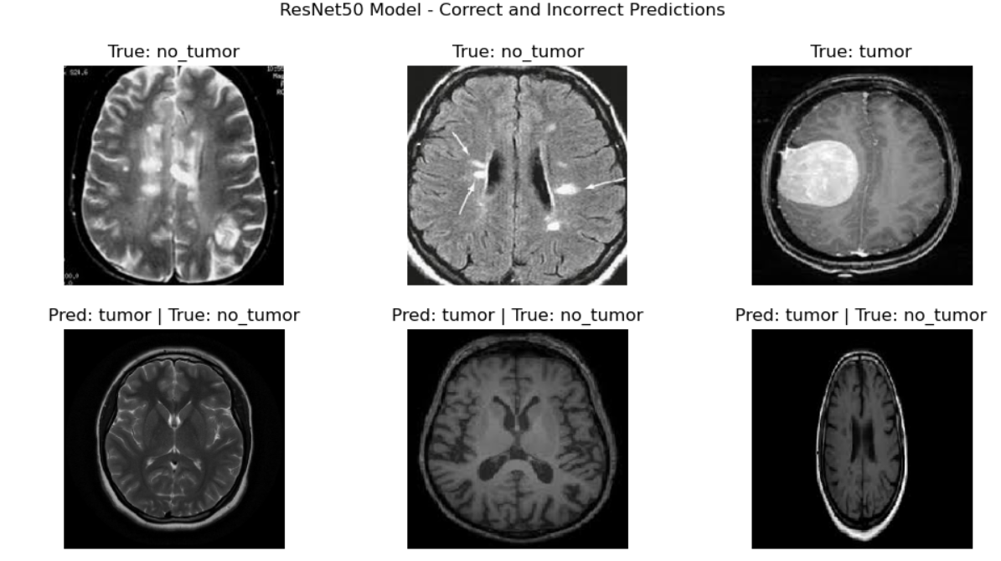
Model prediction for MRI image in ResNet50..
The following images show sample predictions made by the trained model on unseen MRI scans from the testing dataset. The top row represents correctly classified MRI images (true “no_tumor” cases), while the bottom row shows a few incorrect predictions where the model mistakenly identified non-tumor images as tumor.
Thus, the CNN model can accurately classify MRI images into Tumor and No Tumor categories, showing strong potential for medical diagnostic support.

Challenges Faced
During the development of this project, several challenges were encountered and resolved:
- Dataset Imbalance: The dataset contained more “no_tumor” images than “tumor” ones, causing bias in predictions. Using class weights helped balance the learning process.
- Limited Data Availability: The number of MRI images was small for training deep models like ResNet50. Data augmentation was used to expand the dataset and improve learning.
- Overfitting During Training: The CNN model performed well on training data but poorly on validation data. Dropout, early stopping, and regularization reduced overfitting.
- High Computational Requirements: Training ResNet50 required high processing power and took longer without GPU support due to its complex architecture.
- Fine-Tuning and Parameter Optimization: Selecting the right learning rate, batch size, and epochs was difficult. Adaptive learning rate scheduling helped stabilize training.
- Image Quality and Variations: Differences in MRI brightness, contrast, and orientation made feature extraction harder and affected consistency.
- Model Evaluation and Interpretation: Understanding misclassified images was challenging. Confusion matrices and visualizations helped analyze model errors effectively.

Conclusion and Future Scope
Conclusion:
This project focused on detecting brain tumors from MRI images using deep learning models — Convolutional Neural Network (CNN) and ResNet50.
The CNN model achieved strong classification results, while the fine-tuned ResNet50 model performed even better, showing improved accuracy and generalization through transfer learning.
The results, including confusion matrices and visual predictions, confirmed that both models can effectively classify MRI scans as “Tumor” or “No Tumor.”
Overall, this project demonstrates how deep learning can support medical professionals by providing faster, more reliable, and consistent diagnostic assistance.

Future Scope:
- Larger Dataset: Increasing the dataset size with more MRI samples from different sources will enhance model accuracy and reliability.
- Grad-CAM Visualization: Adding heatmap-based visualization can help identify which regions of the brain influenced the model’s predictions.
- Multi-Class Classification: The model can be extended to detect different tumor types or severity levels instead of just binary classification.
- Model Deployment: The trained model can be integrated into a web or mobile application for real-time medical use.
- Hybrid or Ensemble Models: Combining CNN and ResNet50 with other architectures could further boost prediction performance.
- 3D MRI Analysis: Using 3D MRI scans in future versions can help the model learn spatial features more effectively for advanced diagnosis.

References and Tools Used
Tools and Technologies used:
This project was developed using Python as the main programming language due to its flexibility and strong support for machine learning libraries.
The deep learning frameworks TensorFlow and Keras were used to design, train, and fine-tune both the CNN and ResNet50 models.
For data handling and analysis, libraries such as NumPy, Matplotlib, Seaborn, and Scikit-learn were used to perform preprocessing, visualization, and model evaluation.
The project was implemented in Jupyter Notebook (and optionally Google Colab) for its interactive coding environment and GPU support.
Matplotlib and Seaborn were particularly useful for visualizing training accuracy, loss curves, and confusion matrices.
MRI images were processed using Keras preprocessing tools such as ImageDataGenerator and image.load_img() for normalization and augmentation.
References:
- Chollet, F. (2017). Deep Learning with Python. Manning Publications.

- He, K., Zhang, X., Ren, S., & Sun, J. (2016). Deep Residual Learning for Image Recognition (ResNet). IEEE Conference on Computer Vision and Pattern Recognition (CVPR).

- TensorFlow Official Documentation: https://www.tensorflow.org/

- Keras Official Documentation: https://keras.io/

- Scikit-learn Documentation: https://scikit-learn.org/

- Kaggle Brain MRI Dataset: Used as the primary dataset for tumor and non-tumor classification.

- Brownlee, J. (2019). Machine Learning Mastery with TensorFlow and Keras. Machine Learning Mastery Press.

