Create a Database called music
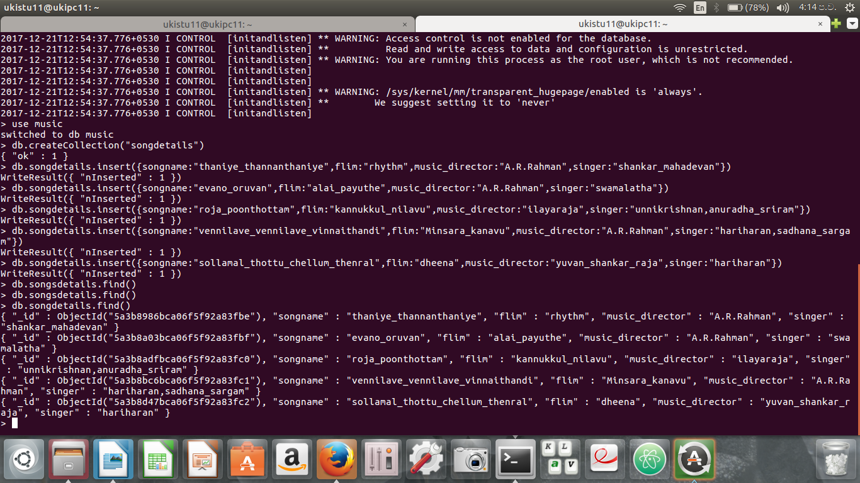
Create a collection called songdetails
create the above5 song documents

list all document created
LIST AR RAHMAN SONG S
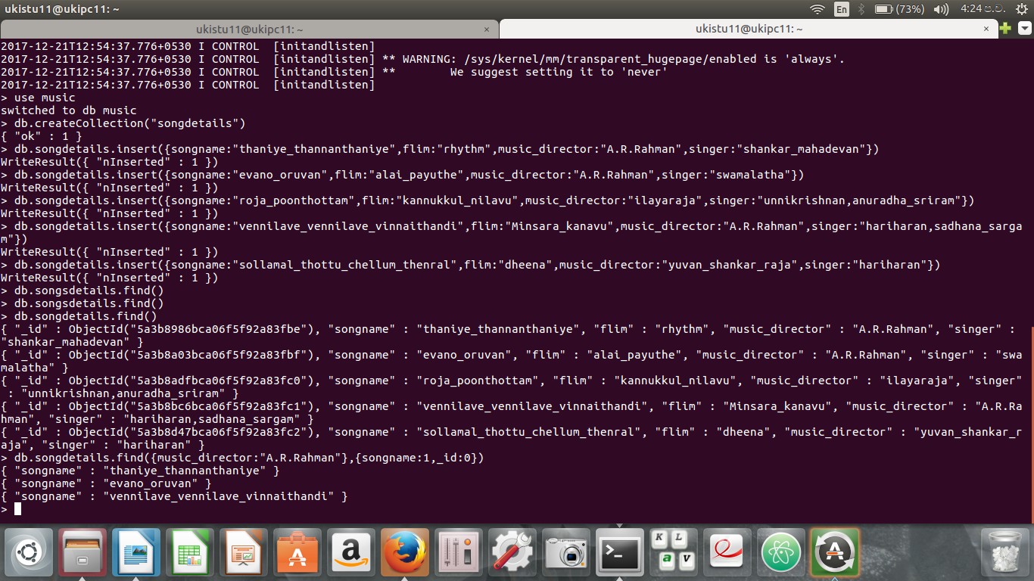

LIST AR RAHMAN SONG S SUNG BY UNNIKRISHNAN

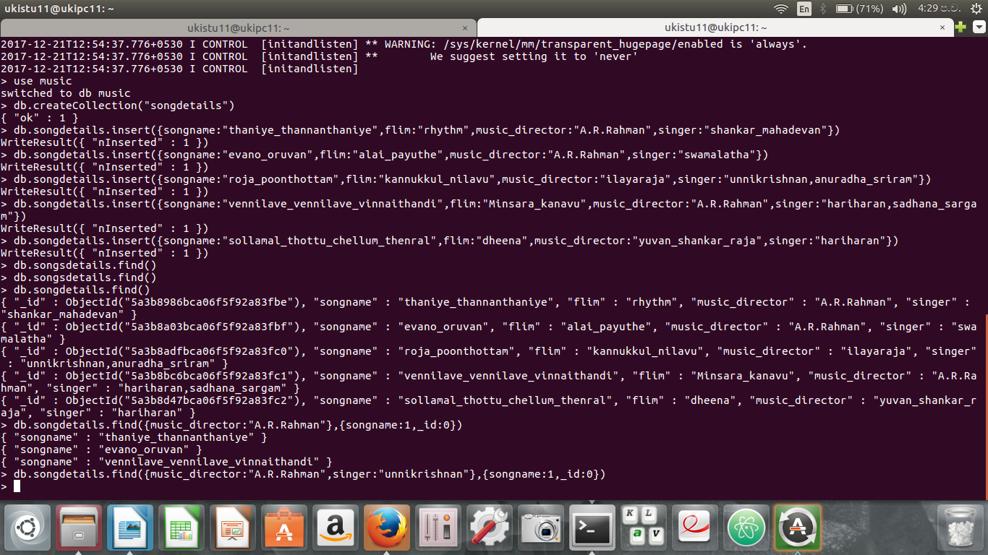
DELETE THE SONG WHICH YOU DON’T LIKE

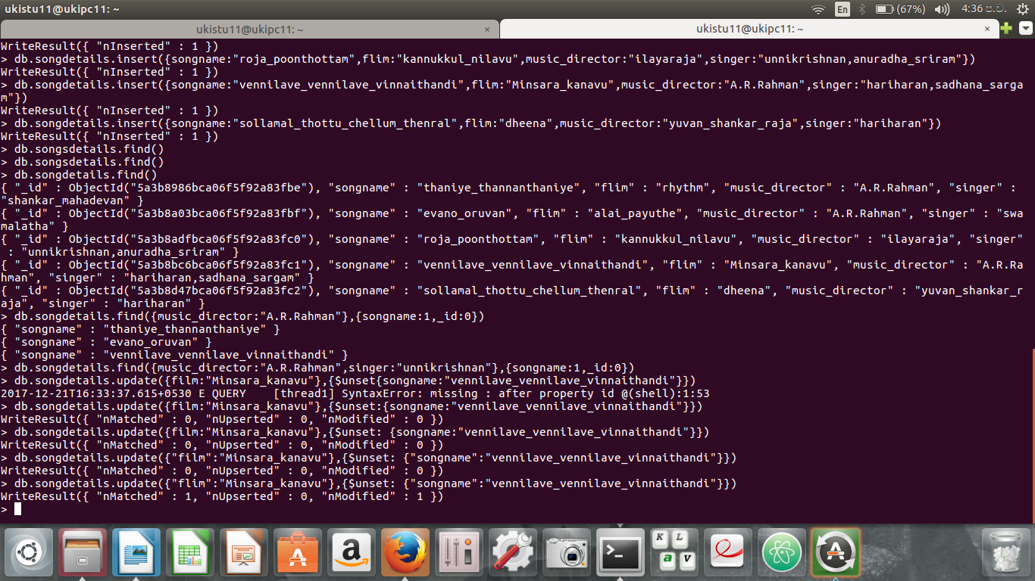
ADD THE SONG WHICH IS YOUR FAVOURITE
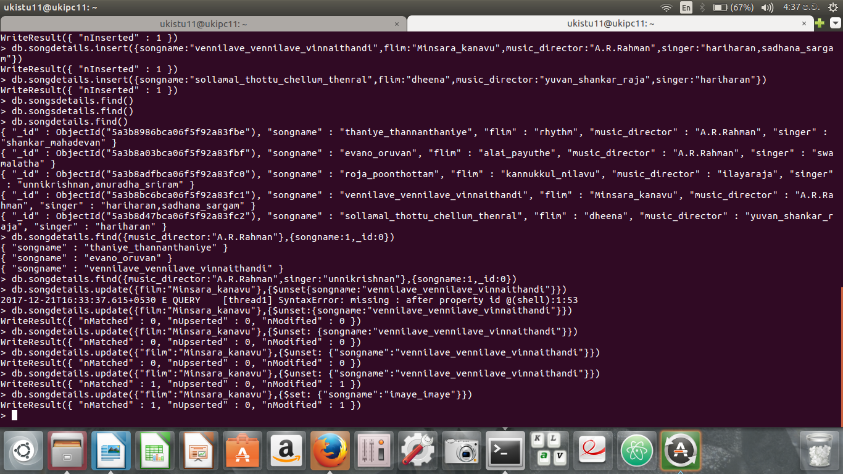
MINSARA KANAVU HARIHARAN SONG LIST
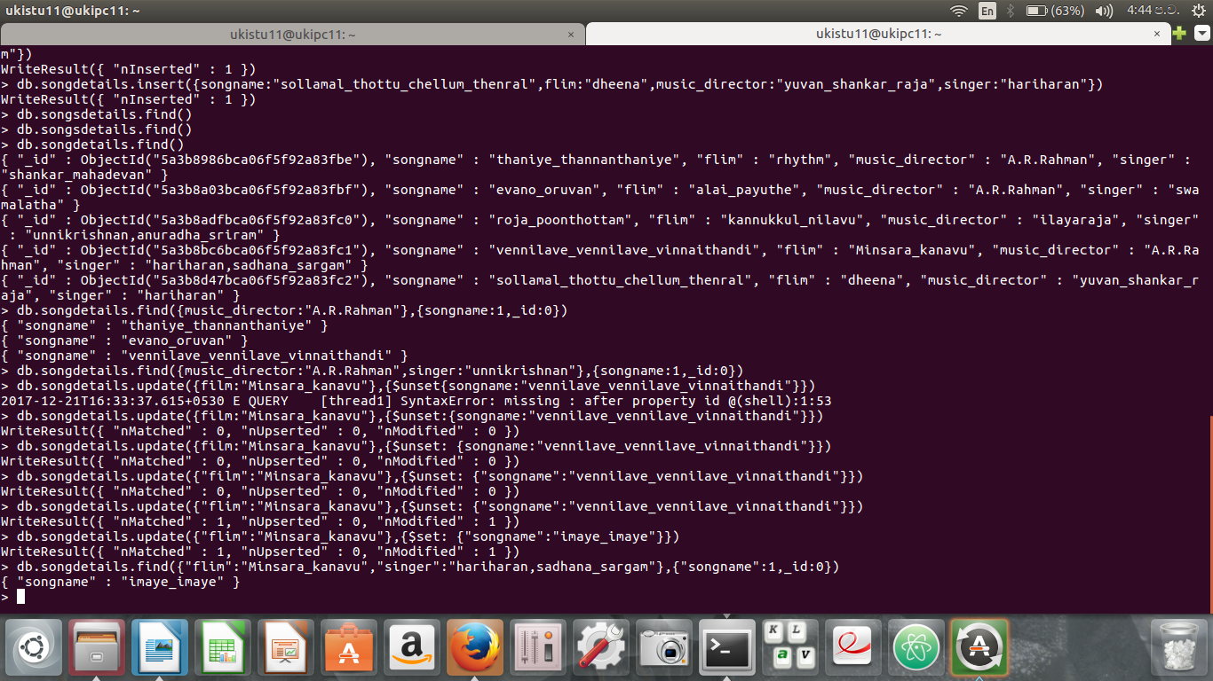
LIST OUT THE SINGERS NAME
