

NAME : GEETHASRI

GMAIL : [tthirunaharigeethasriS@gmail.com](mailto:tthirunaharigeethasriS@gmail.com)

CREATE THREE INSTANCE , INSTALL NGNIX AND APPLY **ALB**

Create three instance , install ngnix and apply ABL

Go to aws search bar and search EC2 then click on it

Now we have to create security group

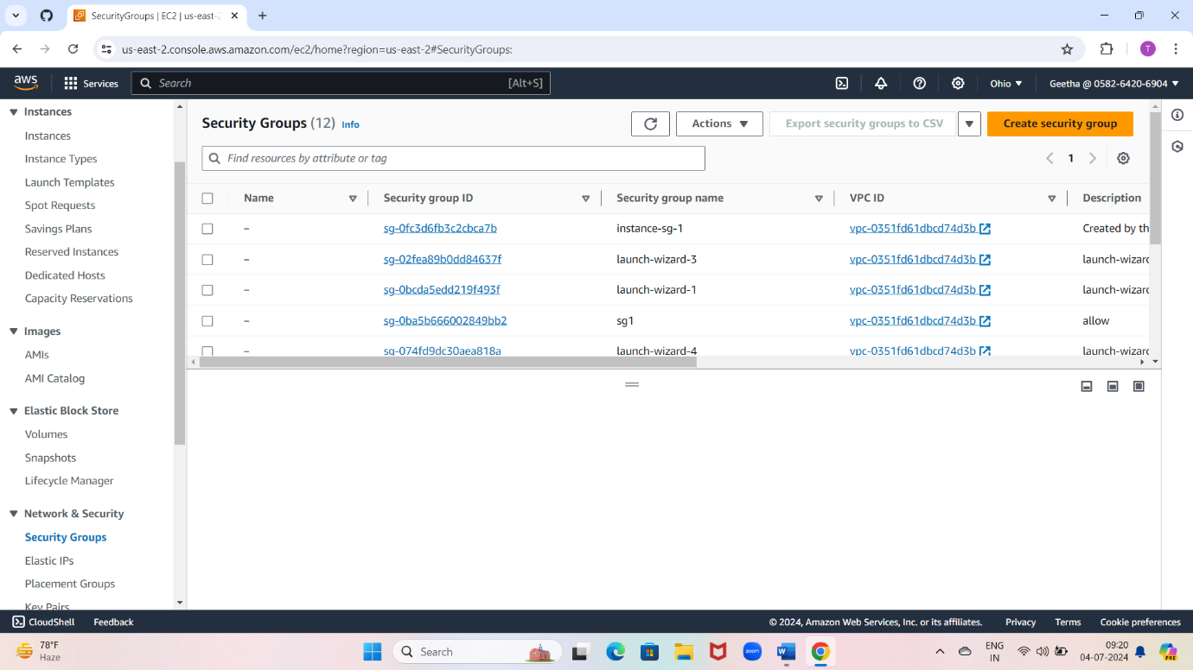

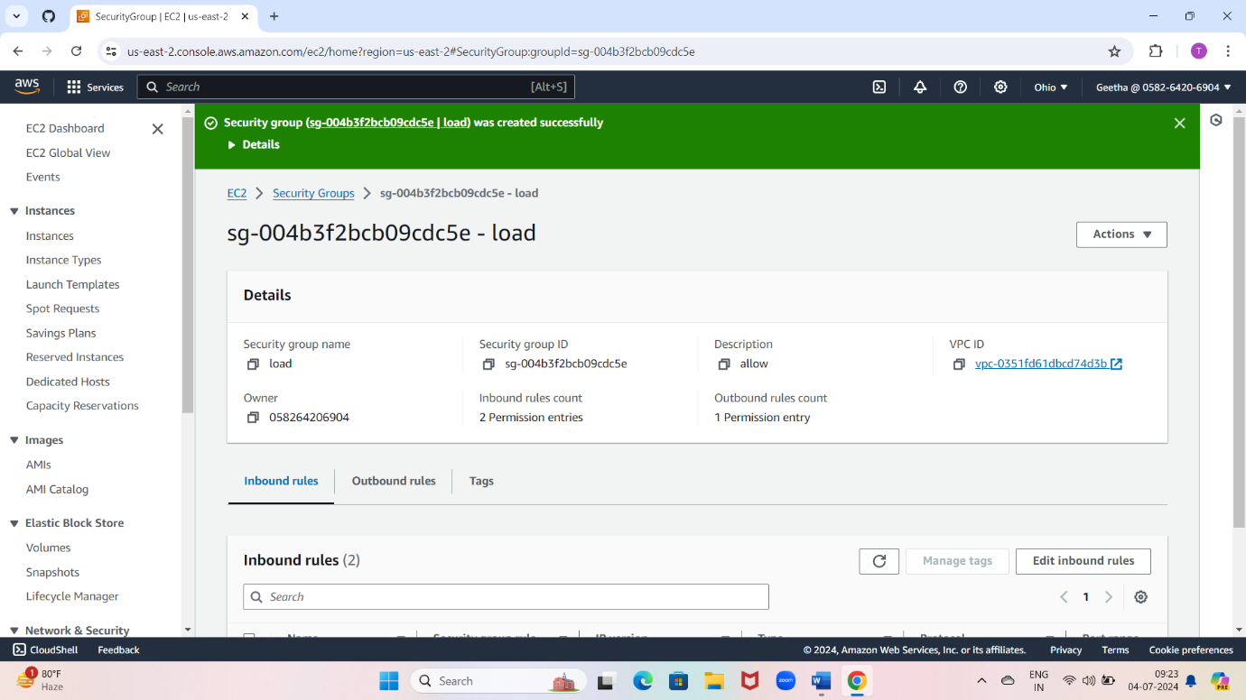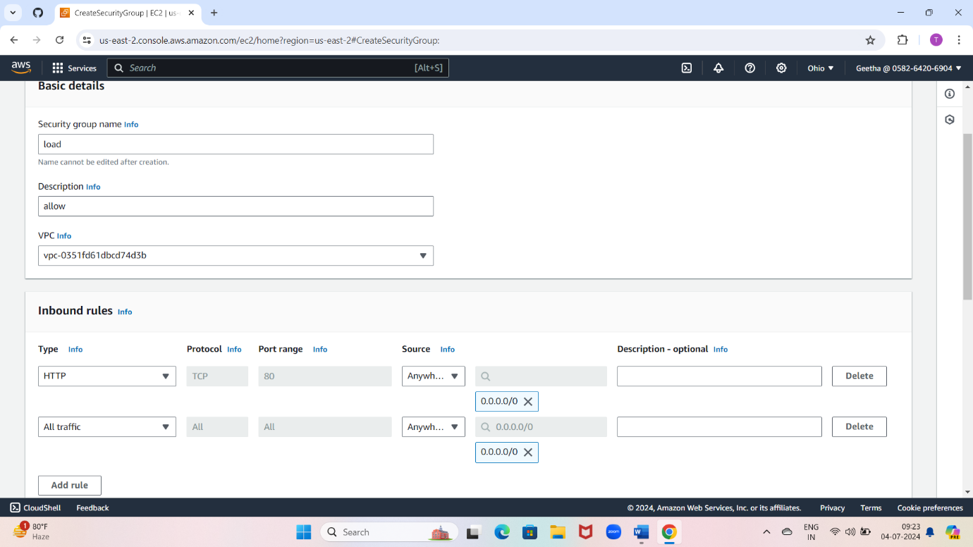

Now we have to create three instance

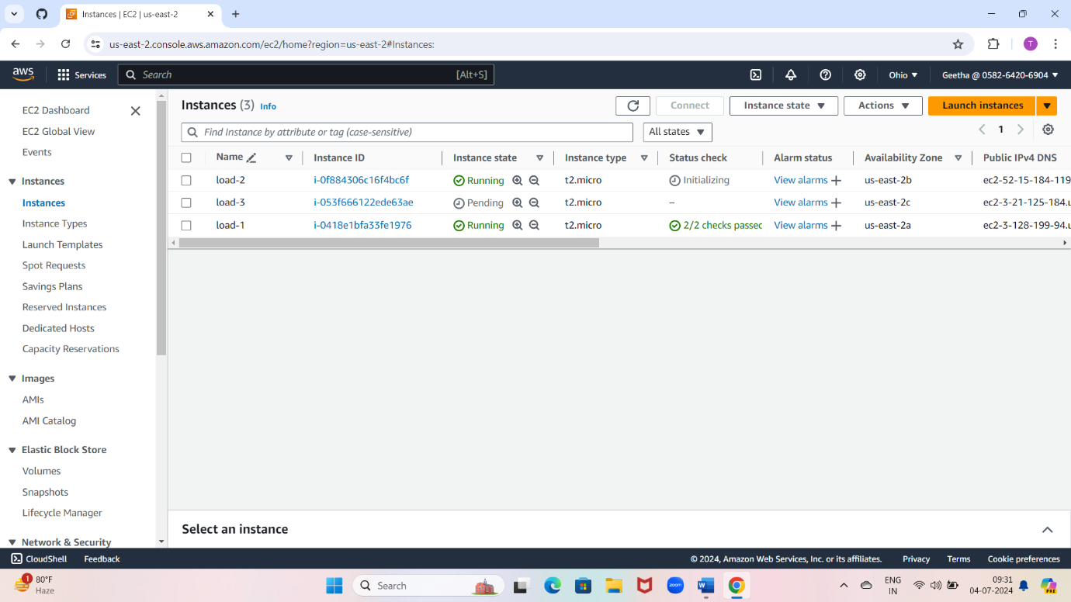

Connect load-1

Now we have to Install nginx in load-1

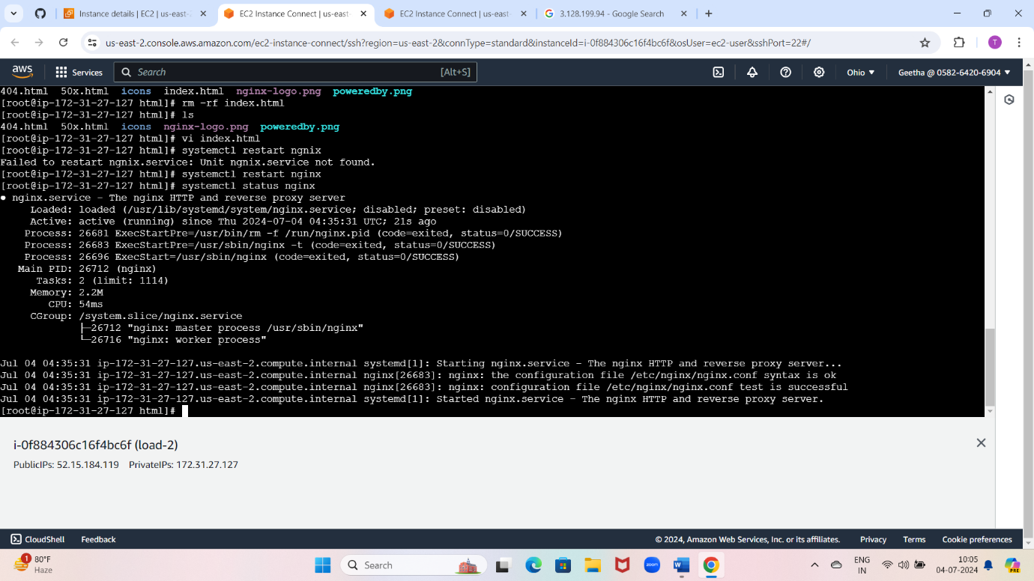

Now we have to Install nginx in load-2



Now we have to Install nginx in load-3



Now create target group

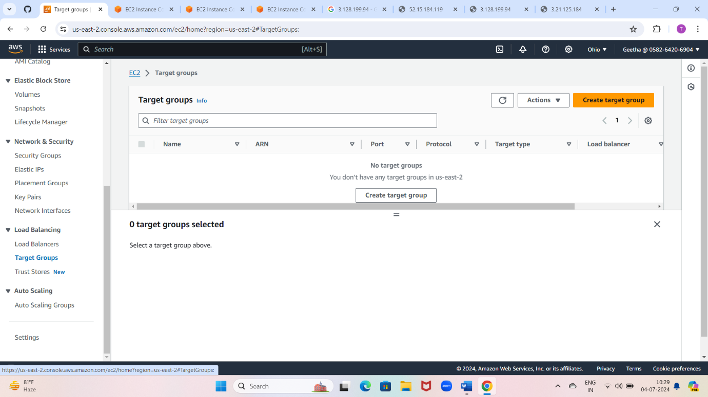

Give target group name

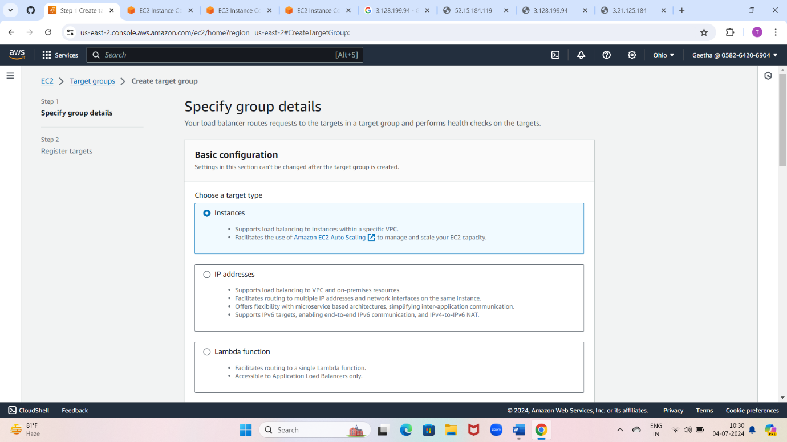

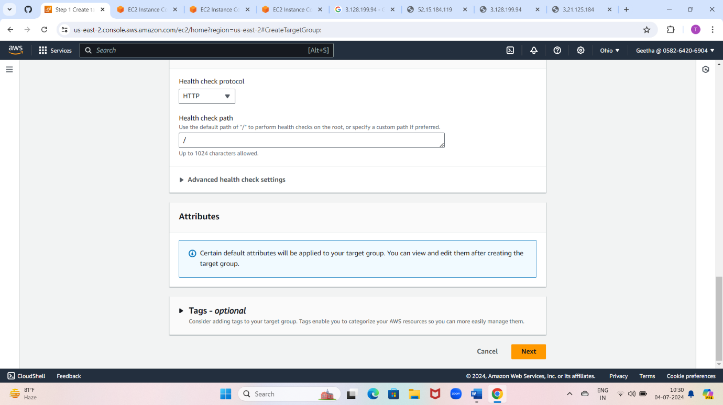

Attach instances to target group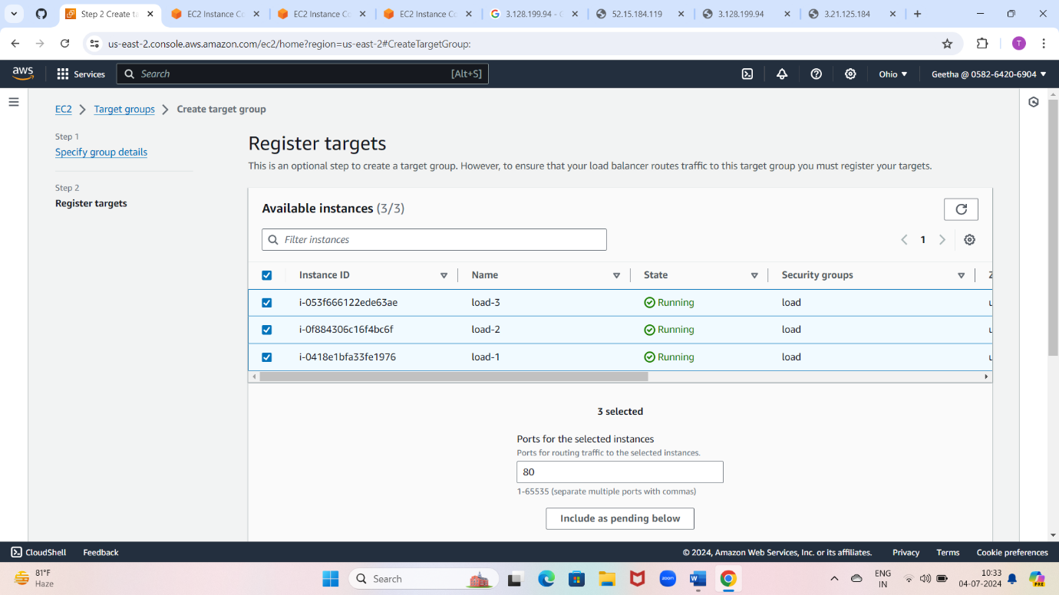

Target group will create

Create load balancer

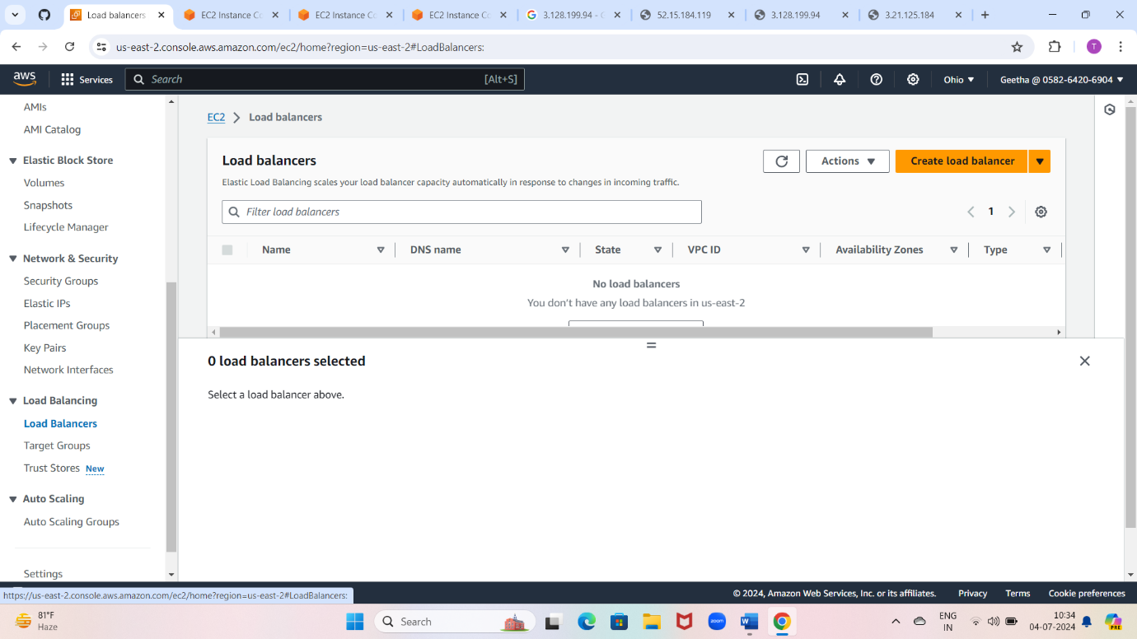

Select applications

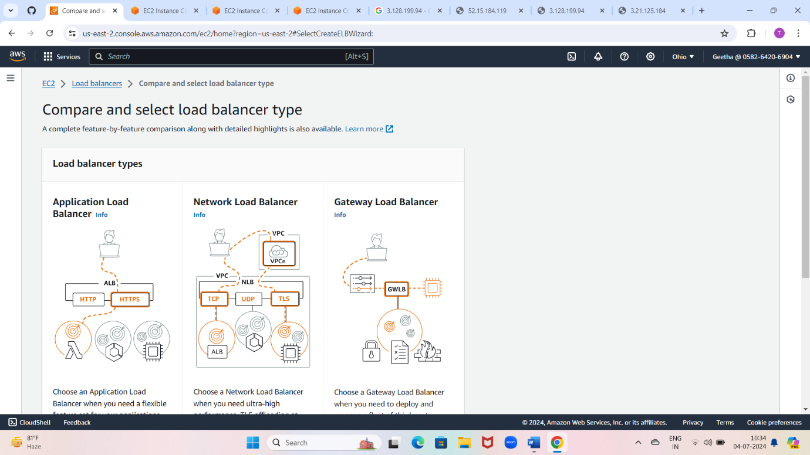

Create application load balancer (ABL)

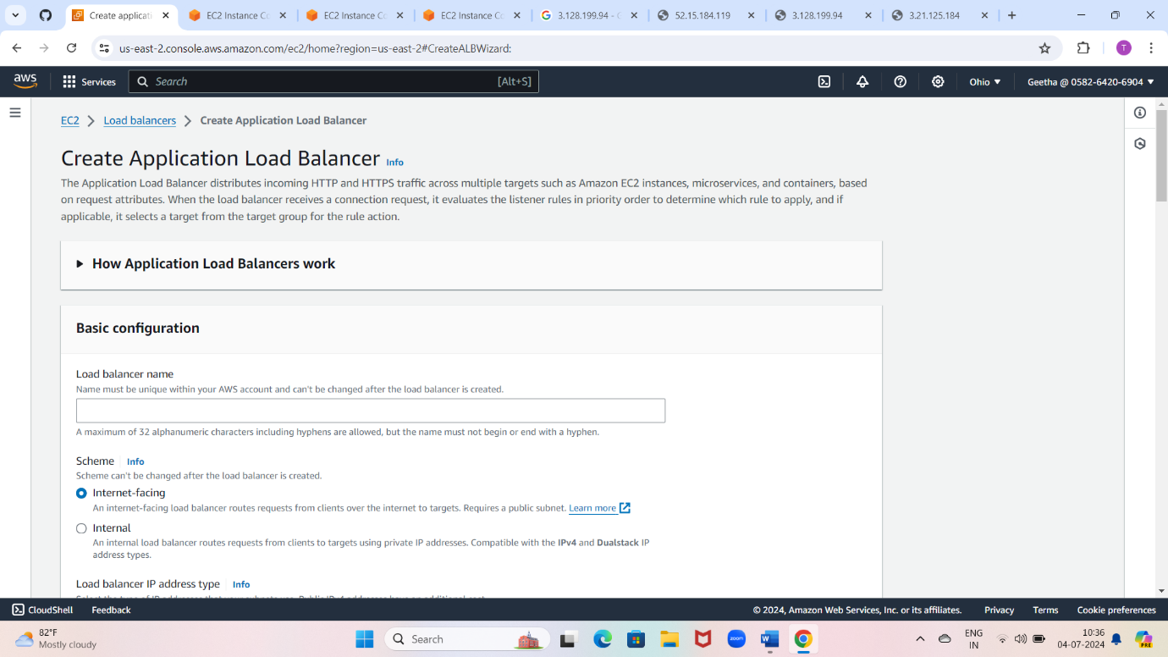

Attach security group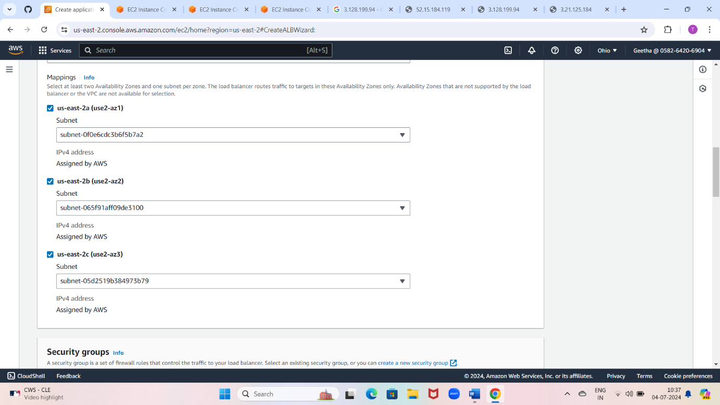

Attach target group

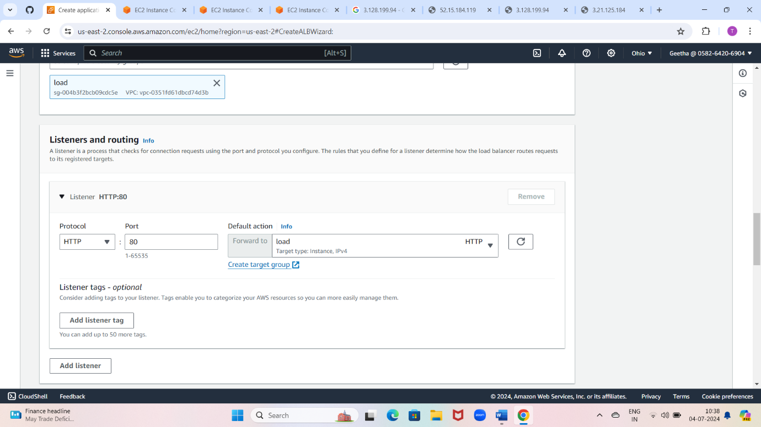

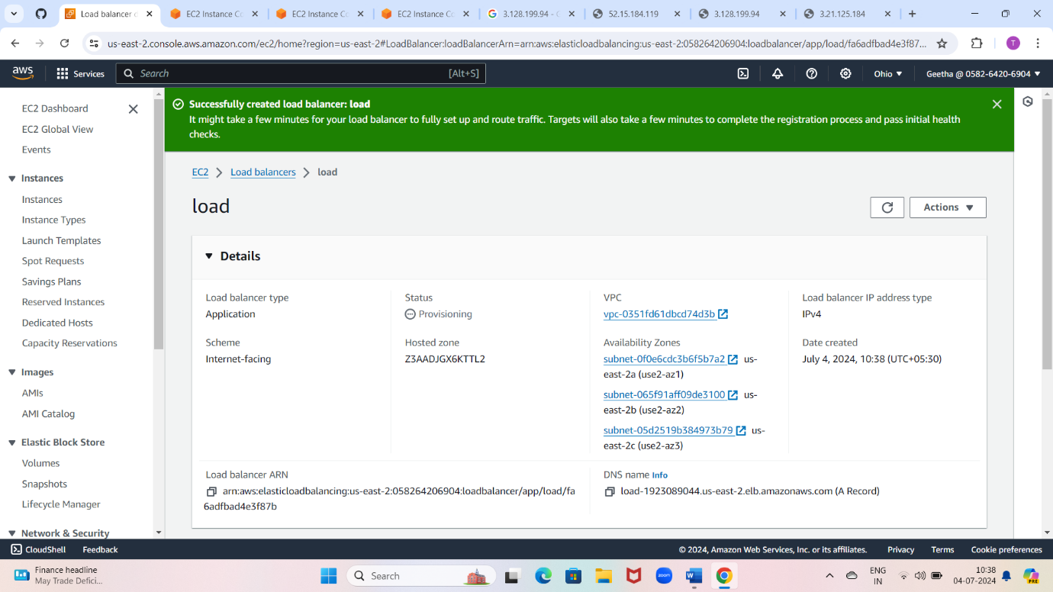

Copy DNS link and paste it on browser and the page gets update

