SIMATS ENGINEERING
ASSIGNMENT 2 : Problem Solving Assignment
COURSE NAME: ARTIFICIAL INTELLIGENCE COURSE CODE: MLA01
AND EXPERT SYSTEMS

COURSE OUTCOME COVERED
CO2: Analyze and select appropriate agent strategies for different types of environments and problem settings. (BTL 3)

Total Marks: 100 Time: 60 Mins
No. of Questions: 5
Annexure A
Problem Solving Assignment

Code of Conduct:

I _________R Geethika/192425101___________ (Name / Reg No) certify that this submission is my original work and that I have adhered to the guidelines specified for this assessment. I understand that any violation of academic integrity rules will result in disciplinary action.

Signature of the student:
Criterion | Weightage | Marks Obtained
Problem Analysis and Understanding | 15%
AI Algorithm Selection & Justification | 15%
Algorithm Design / Pseudocode | 25%
Application of AI Concepts (Greedy, A*, CSP,  Minimax, etc.) | 15%
Diagram / State Space / Search Tree  Representation | 10%
Complexity Analysis and Solution Efficiency | 10%
Originality, Critical Thinking, and Presentation | 10%
Total | 100%
Signature of the Faculty Total Marks Awarded

Answer All the Questions
Q.No | Application-Based Question | Major CO2  Concepts
1 | Smart Ambulance Navigation:  An ambulance must travel from a hospital to an emergency location through a city road network. Some roads have higher travel costs, and an estimated distance to the destination is available for each junction. Design a search-based solution to identify the best route. Using the given road network and heuristic values, determine the route selected by your algorithm, show the sequence of junctions explored, calculate the relevant evaluation values, and justify whether the route is optimal.  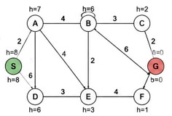 | Informed Search,  A*, Heuristic  Function
2 | Autonomous Warehouse Robot:  A robot has to move from a charging station to a target shelf in a warehouse. The robot does not know all obstacles initially and discovers some obstacles only when it reaches nearby locations. Design an intelligent search strategy for the robot. Demonstrate the robot's decisions for the given grid, explain how it reacts when a new obstacle is discovered, and compare the approach with an offline search strategy.  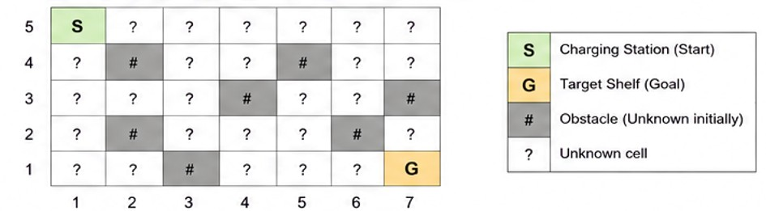 | Online Search  Agents,  Informed Search
3 | University Examination Scheduling:  A university needs to schedule six examinations (E1, E2, E3, E4, E5, and E6) into four available time slots (T1, T2, T3, and T4). Some examinations have common students and therefore cannot be conducted in the same time slot. | CSP, MRV,  Forward  Checking,  Constraints

The following constraints must be satisfied:
- E1 and E2 have common students.
- E1 and E3 have common students.
- E2 and E4 have common students.
- E3 and E5 have common students.
- E4 and E6 have common students.
- E2 and E5 have common students.
The university has three examination halls with the following capacities:

 |  | Examination Hall |  |  |  | Capacity
 |  | Hall A |  |  |  | 120 students
 |  | Hall B |  |  |  | 90 students
 |  | Hall C |  |  |  | 60 students
 |  | Examination | E1 | E2 | E3 | E4 | E5 | E6 | CSP) by  (MRV) timetable.  provide  hall-capacity
 |  | Number of  Students | 100 | 80 | 70 | 60 | 90 | 50 | CSP) by  (MRV) timetable.  provide  hall-capacity
 |  | Tasks:  - Formulate the problem as a Constraint Satisfaction Problem ( clearly defining the variables, domains, and constraints.  - Use Backtracking with the Minimum Remaining Values heuristic and Forward Checking to obtain a valid examination  - Show the domain of each variable after every assignment and the final timetable, ensuring that all student-conflict and constraints are satisfied. |  |  |  |  |  |  | CSP) by  (MRV) timetable.  provide  hall-capacity
4 |  | Game-Playing AI:  You are developing an AI opponent for a board game. The current game position produces the following possible moves and terminal scores in the supplied game tree. Determine the move the AI should make by applying Minimax. Then apply Alpha-Beta Pruning and identify the branches that do not need to be evaluated. Explain how pruning improves the efficiency of the game-playing agent. |  |  |  |  |  |  |  | Game Playing,  Minimax,  Alpha-Beta  Pruning
 | 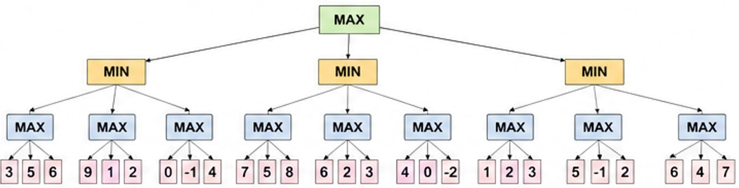
5 | Delivery Route Optimization:  A logistics company wants to minimize the total distance travelled by a delivery vehicle visiting multiple customers. An initial route and several neighboring routes are provided. Design an optimization strategy to improve the route. Apply the strategy step-by-step to the given routes, determine the final route, explain whether it represents a global optimum, and suggest how the algorithm could escape a local optimum.  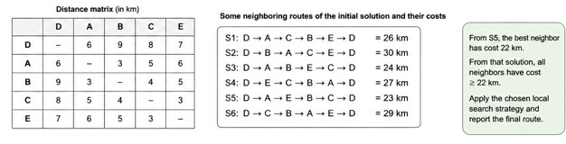 |  |  |  |  |  |  |  |  |  | Local Search,  Optimization,  Hill Climbing

1. Smart Ambulance Navigation
Concepts: Informed Search, A* Search Algorithm and Heuristic Function.
Aim: To find the shortest and least-cost route for an ambulance from the hospital to an emergency location using A* search.
A Search Algorithm:*
A* is an informed search algorithm that finds the best path by considering the actual cost and estimated cost.
The evaluation function is:
$$f\left(n\right)=g\left(n\right)+h\left(n\right)$$
Where:
- $g\left(n\right)$= Actual cost from the starting node to the current node.
- $h\left(n\right)$= Estimated cost from the current node to the goal.
- $f\left(n\right)$= Estimated total cost of the path.
Procedure:
- Start from the hospital location.
- Add the starting node to the OPEN list.
- Calculate the f(n) value for each neighbouring node.
- Select the node with the lowest f(n) value.
- Expand the selected node and calculate the costs of its neighbours.
- Repeat the process until the emergency location is reached.
- Trace the parent nodes to obtain the final route.
Optimality:
A* gives an optimal path when the heuristic is admissible, meaning it never overestimates the remaining cost.
Result: A* search helps the ambulance find a minimum-cost route to reach the emergency location efficiently.
Note: The exact road costs and heuristic values from the assignment diagram are not available in the extracted text. Therefore, the numerical route and explored-node sequence cannot be calculated reliably.
2. Autonomous Warehouse Robot
Concepts: Online Search Agents and Informed Search.
Aim: To help a warehouse robot move from a charging station to a target shelf while discovering unknown obstacles.
Online Search:
Online search is a technique in which an intelligent agent explores the environment while performing actions. The robot discovers obstacles using sensors and updates its map.
Procedure:
- Identify the starting point and target shelf.
- Create an initial map of the warehouse.
- Use an informed search algorithm such as A* to find a path.
- Move the robot step by step.
- Check the surrounding area using sensors.
- If an obstacle is detected, mark that position as blocked.
- Calculate a new path to the target.
- Continue until the target shelf is reached.
Example:
Initially, the robot plans:
START → A → B → C → GOAL
While moving, it discovers that B contains an obstacle. It updates its map and selects an alternative route:
START → D → E → C → GOAL
This demonstrates how the robot changes its path when it discovers an obstacle.
Difference Between Online and Offline Search:
Online Search | Offline Search
Works with incomplete information. | Uses a known environment map.
Explores while moving. | Plans before moving.
Updates the map when obstacles are found. | Uses the available map during planning.
Can replan dynamically. | May require replanning if the map changes.
Result: Online search helps the warehouse robot reach its target by discovering obstacles and planning alternative routes.
Note: The exact warehouse grid and obstacle locations are not available in the extracted question text.
3. University Examination Scheduling
Concepts: Constraint Satisfaction Problem (CSP), Backtracking, MRV and Forward Checking.
Aim: To schedule six examinations into four time slots without violating student-conflict constraints and hall-capacity requirements.
1. CSP Formulation
Variables:
E1, E2, E3, E4, E5 and E6.
Domains:
Each examination can be assigned one of four time slots:
$$D\left(E_{i}\right)=\left\{T , 1 , T , 2T3T4\right\}$$
Constraints:
- E1 ≠ E2
- E1 ≠ E3
- E2 ≠ E4
- E3 ≠ E5
- E4 ≠ E6
- E2 ≠ E5
2. Hall Capacity
Examination | Students | Eligible Hall
E1 | 100 | A (120)
E2 | 80 | A (120) / B (90)
E3 | 70 | A (120) / B (90)
E4 | 60 | A (120) / B (90) / C (60)
E5 | 90 | A (120) / B (90)
E6 | 50 | A (120) / B (90) / C (60)
3. Backtracking Using MRV and Forward Checking
MRV (Minimum Remaining Values): Selects the variable having the fewest available values.
Forward Checking: Removes an assigned time slot from the domains of neighbouring examinations.
Initial domains:
$$D\left(E1\right)=D\left(E2\right)=D\left(E3\right)=D\left(E4\right)=D\left(E5\right)=D\left(E6\right)$$
$$=\left\{T , 1 , T , 2T3T4\right\}$$
One valid assignment sequence is:
Step | Assignment | Remaining Domains After Forward Checking
1 | E2 = T1 | E1, E4, E5 =
2 | E1 = T2 | E3 = ; E4, E5 =
3 | E3 = T1 | E4, E5 =
4 | E4 = T2 | E5 = ; E6 =
5 | E5 = T3 | E6 =
6 | E6 = T1 | All examinations assigned
4. Final Examination Timetable
Time Slot | Hall A (120) | Hall B (90) | Hall C (60)
T1 | E3 – 70 students | E2 – 80 students | E6 – 50 students
T2 | E1 – 100 students | — | E4 – 60 students
T3 | — | E5 – 90 students | —
T4 | — | — | —
5. Verification
- E1 and E2 are in different time slots.
- E1 and E3 are in different time slots.
- E2 and E4 are in different time slots.
- E3 and E5 are in different time slots.
- E4 and E6 are in different time slots.
- E2 and E5 are in different time slots.
- All examinations are assigned to halls with sufficient capacity.
Result: The final timetable satisfies all given conflict constraints and hall-capacity requirements using CSP, MRV and Forward Checking.
4. Game-Playing AI
Concepts: Minimax Algorithm and Alpha-Beta Pruning.
Aim: To select the best possible move in a two-player game using Minimax and improve its efficiency using Alpha-Beta pruning.
Minimax Algorithm
Minimax is a decision-making algorithm used in two-player games. It assumes both players make the best possible moves.
There are two players:
- MAX: Tries to obtain the maximum score.
- MIN: Tries to obtain the minimum score.
Procedure:
- Construct the game tree from the current game position.
- Identify the terminal nodes.
- Assign scores to terminal nodes.
- At MIN nodes, select the minimum value.
- At MAX nodes, select the maximum value.
- Propagate the values upwards towards the root.
- Select the move with the best final value.
Alpha-Beta Pruning
Alpha-Beta pruning is an optimization technique used with Minimax. It reduces the number of nodes evaluated by removing branches that cannot affect the final decision.
It uses two values:
- Alpha (α): Best value currently guaranteed for MAX.
- Beta (β): Best value currently guaranteed for MIN.
The pruning condition is:
$$α≥β$$
When this condition is satisfied, the remaining branches can be pruned.
Advantages:
- Reduces unnecessary calculations.
- Improves search efficiency.
- Gives the same optimal decision as Minimax.
- Saves time by avoiding irrelevant branches.
- Helps in games such as chess and tic-tac-toe.
Result: Minimax selects the best move, while Alpha-Beta pruning improves its efficiency by avoiding unnecessary branch evaluations.
Note: The exact game tree and terminal scores are not available in the extracted question text, so numerical values and specific pruned branches cannot be calculated.
5. Delivery Route Optimization
Concepts: Local Search and Hill Climbing Algorithm.
Aim: To find an optimized delivery route with minimum total distance using Hill Climbing.
Hill Climbing Algorithm
Hill Climbing is a local search algorithm that continuously improves the current solution by selecting a better neighbouring solution.
Procedure:
- Start with an initial delivery route.
- Calculate the total distance of the route.
- Generate neighbouring routes by changing the order of delivery locations.
- Calculate the distance of each neighbouring route.
- Compare the neighbouring routes with the current route.
- Select a route with a lower total distance.
- Repeat the process until no better neighbouring route is available.
- Stop and return the best route found.
Local Optimum
A local optimum is a solution that is better than all its immediate neighbouring solutions, but it may not be the best solution overall.
Global Optimum
A global optimum is the best possible solution among all available routes.
Methods to Escape Local Optimum
- Random Restart: Start the algorithm again with a different initial route.
- Simulated Annealing: Sometimes accepts a worse solution to escape a local optimum.
- Tabu Search: Avoids recently visited solutions to prevent repeated searching.
Result: Hill Climbing improves the delivery route step by step by selecting better neighbouring routes. It is simple and efficient, but it does not always guarantee the global optimum.

EVALUATION RUBRICS

Criteria | Weightage  (%) | Excellent (Full  Marks) | Good | Average | Poor
CSP Problem  Formulation | 20% | 4% – Clearly defines all variables, domains, and problem objectives correctly. | 3% – Defines most variables and domains with minor errors. | 2% – Partial formulation with some missing components. | 0–1% –  Incorrect or incomplete formulation.
Constraint  Identification  &  Representatio n | 20% | 4% – Accurately identifies all student-conflict and hall-capacity constraints and represents them correctly. | 3% –  Identifies most constraints with minor errors. | 2% – Identifies some  constraints but misses important relationships. | 0–1% –  Constraints are largely incorrect or missing.
Application of  Backtracking,  MRV &  Forward  Checking | 30% | 6% – Correctly applies Backtracking, MRV, and Forward Checking with clear and logical steps. | 4.5% – Applies the techniques correctly with minor mistakes. | 3% – Partial application with unclear or inconsistent steps. | 0–1.5% –  Incorrect or inappropriate application of  CSP  techniques.
Step-by-Step  Execution &  Domain  Updates | 20% | 4% – Provides a complete, logical execution trace and correctly updates domains after every assignment. | 3% – Mostly correct execution with minor gaps. | 2% – Provides limited steps with some incorrect domain updates. | 0–1% –  Incomplete or incorrect execution.
Final  Timetable,  Accuracy &  Justification | 10% | 2% – Produces a valid conflict-free timetable satisfying all constraints and capacity requirements with clear justification. | 1.5% – Valid timetable with minor errors in justification. | 1% – Partially valid timetable with some constraint violations. | 0–0.5% – Invalid or missing timetable.

