1.Copying the contents from one file to another file
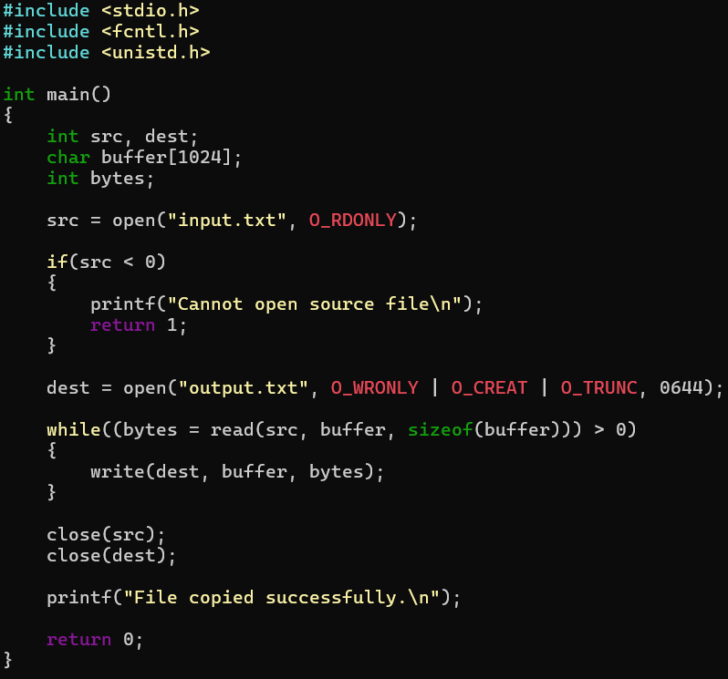
OUTPUT:
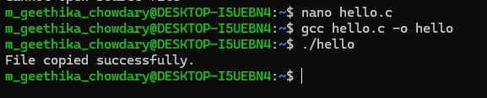

2.Hello
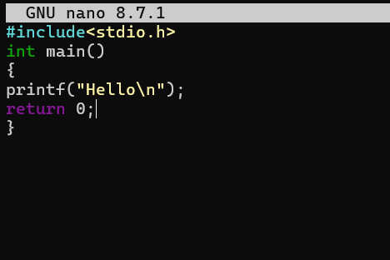
OUTPUT:
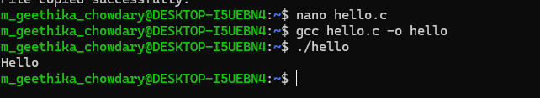
3.Readname
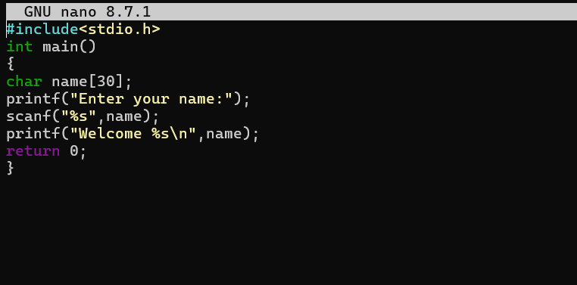
OUTPUT:
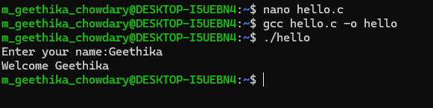
4.Display
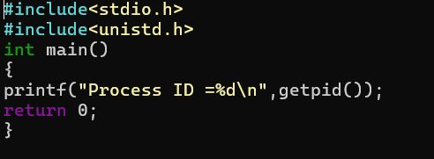
OUTPUT:
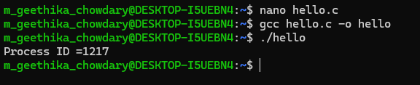
5.Fork one time
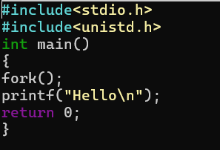
OUTPUT:
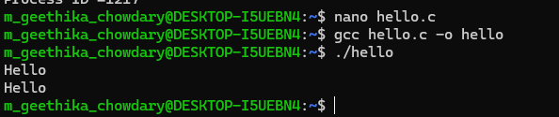
6.Fork two times
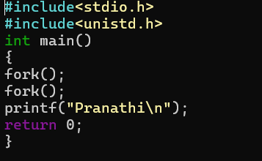
OUTPUT:
