OSSP (Operating Systems And Systems Programming) - 25CS2104E
(SKILL Content Delivery Concepts)

- To Install Linux VM, Configure GCC, Setup Git Repository, Create Project Structure, Understand Shell Architecture, Build Initial Makefile

To Analyze process abstraction, execute fork(), understand exec() family, analyze parent-child relationships, inspect process tree, practice system call tracing

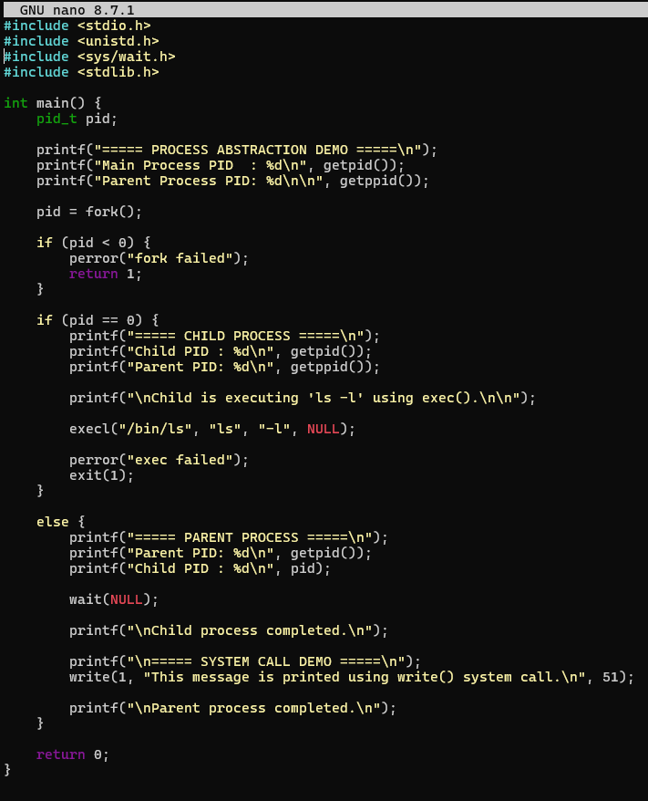

OUTPUT:
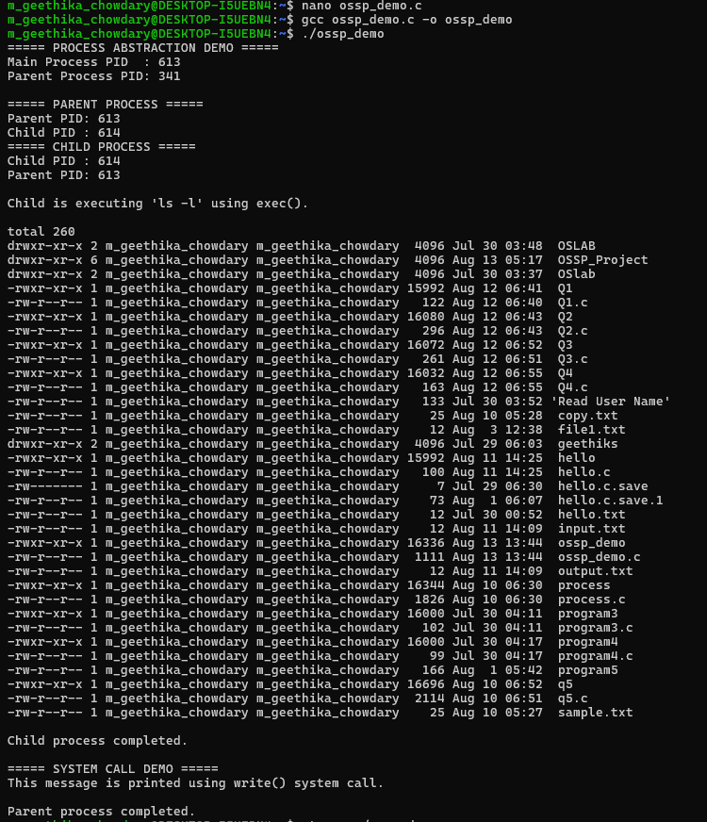

- To Create Main Loop, Display Prompt, Read User Input, Handle Exit Conditions, Design Control Flow Diagram, Test Interactive Loop
To Capture Keyboard Input, Handle Backspace, Process Enter Key, Manage Input Buffer, Support Multi-Character Commands, Test User Interaction

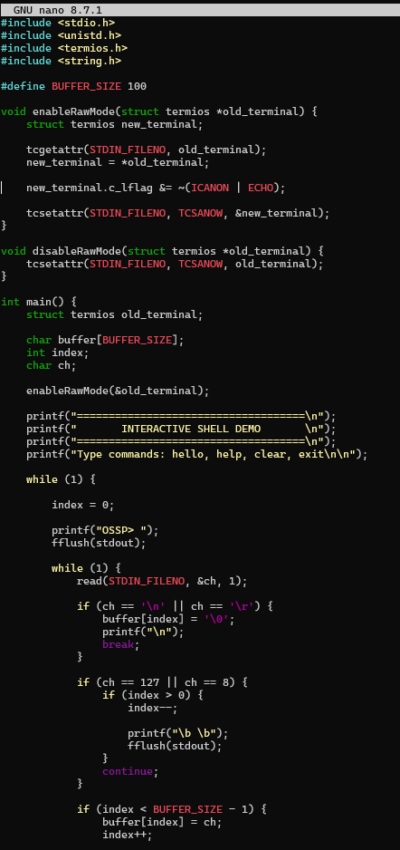
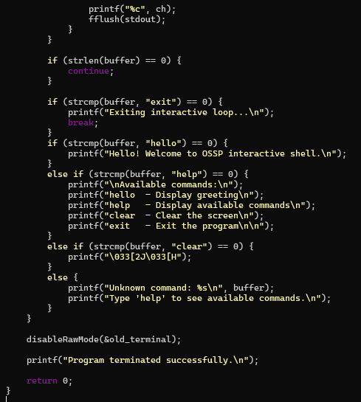
OUTPUT:
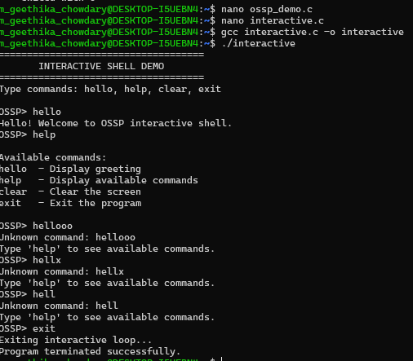

- To Apply Escape Sequences, Store Command History, Navigate Previous Commands, Navigate Next Commands, Update Input Buffer, Test Recall Functionality.
To Allocate Buffers Dynamically, Resize Arrays, Prevent Buffer Overflow, Manage Linked Lists, Release Memory Correctly, Verify with Valgrind.

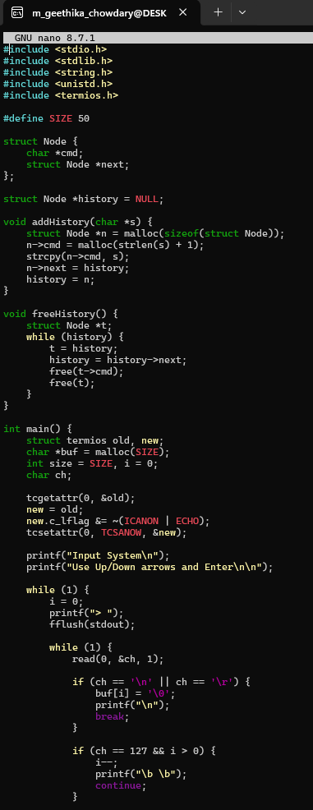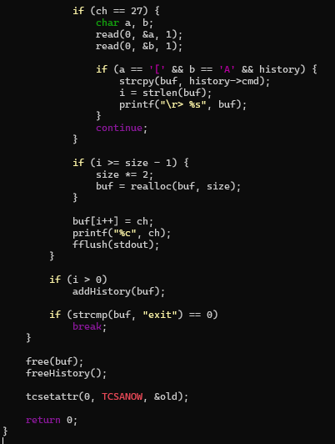
OUTPUT:
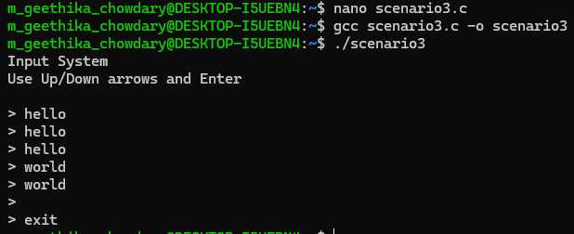

- To Split Input into Tokens, Identify Delimiters, Handle Whitespace, Create Token Structures, Validate Token Streams, Debug Parsing Output.

To Design Parser Logic, Generate Parse Trees, Validate Syntax, Detect Errors, Handle Empty Commands, Produce Execution Structures.

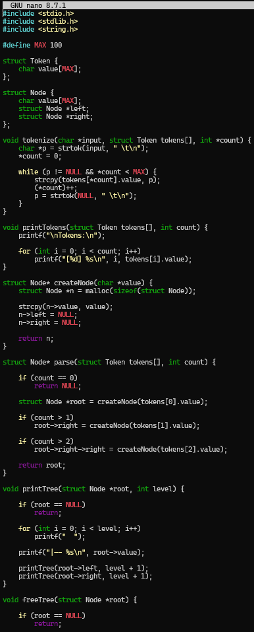

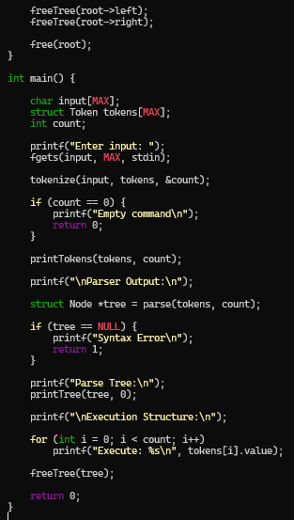
OUTPUT:
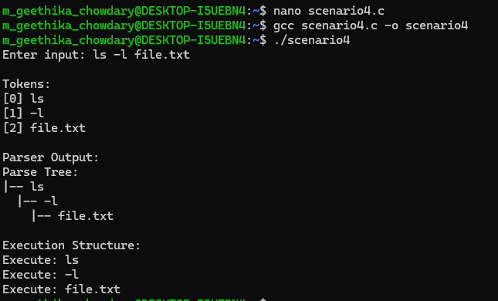
- To Apply Single Quotes, Preserve Literal Content, Ignore Variable Expansion, Store Quoted Strings, Validate Parsing Results, Test Edge Cases.
To Apply Double Quotes, Preserve Spaces, Allow Variable Expansion, Parse Nested Tokens, Validate Outputs, Test Quoted Commands.
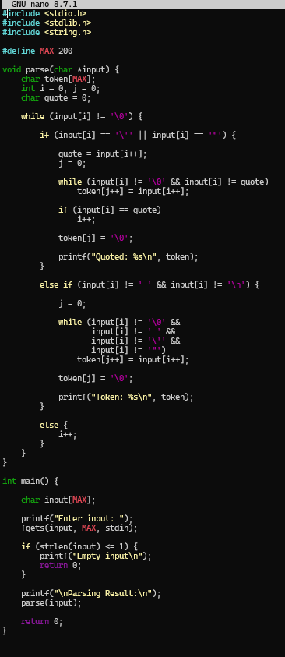

OUTPUT:
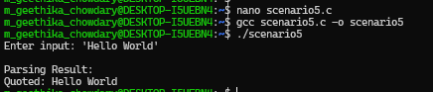

- To Create Process Escape Sequences, Handle Escaped Spaces, Escape Special Symbols, Preserve Characters, Validate Parser Output, Test Complex Inputs.
To Create Child Processes, Execute Programs, Handle Execution Errors, Pass Arguments, Manage Parent Process, Test Command Launching.

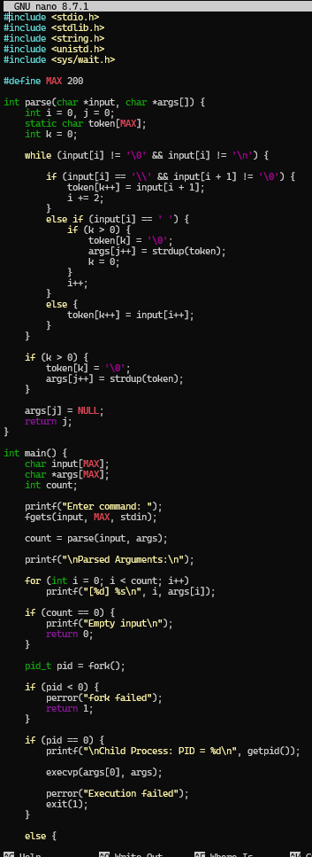
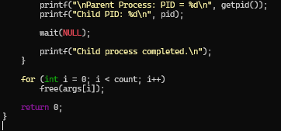

OUTPUT:
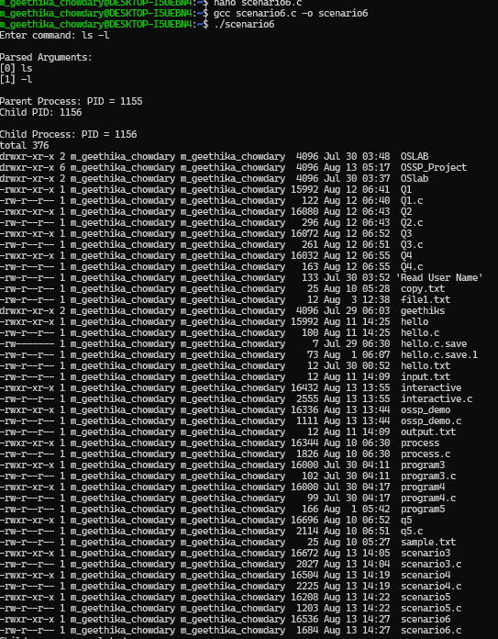

- Process Synchronization and Child Process Monitoring Using waitpid().

To Retrieve PATH Variable, Parse Search Directories, Locate Executables, Verify Permissions, Handle Missing Commands, Test Command Resolution.

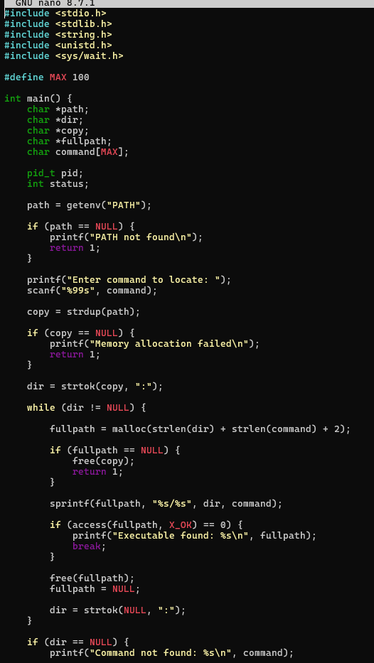
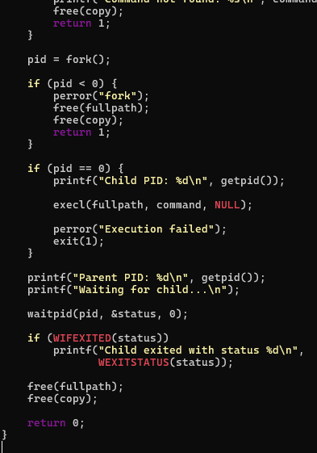
OUTPUT:
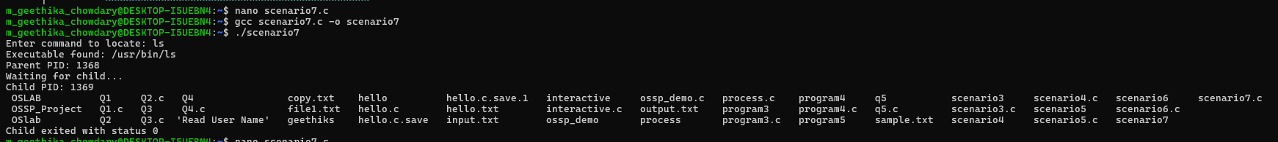

- To Detect Variable References, Expand Values, Handle Undefined Variables, Update Tokens, Support Nested Variables, Test Expansion Logic.

To Identify Built-ins, Create Dispatch Table, Execute In-Process Commands, Handle Invalid Commands, Maintain State, Test Dispatch Logic.

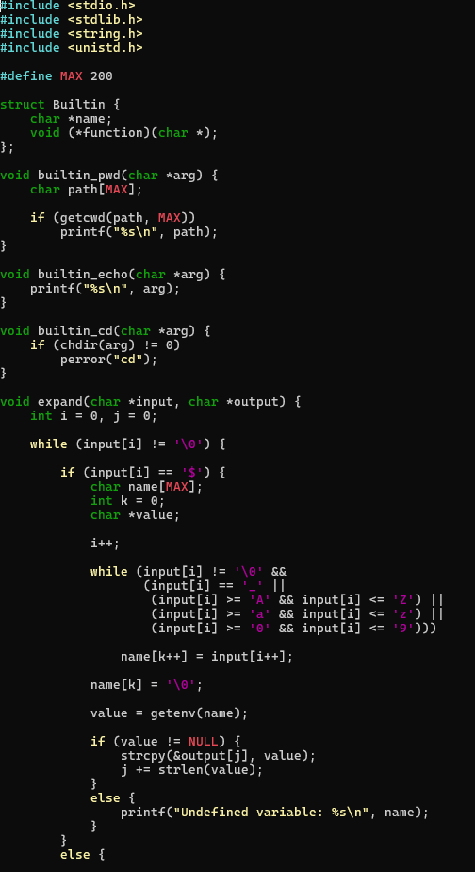
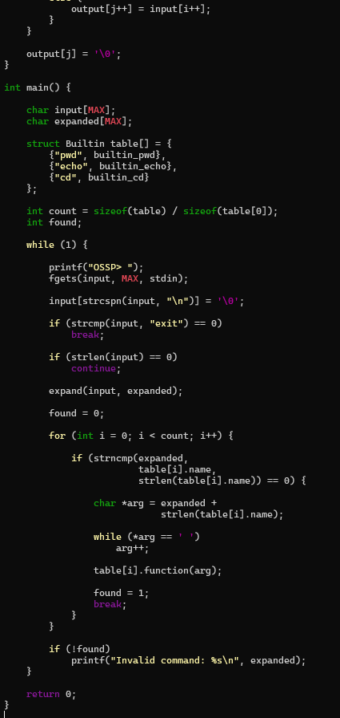

OUTPUT:
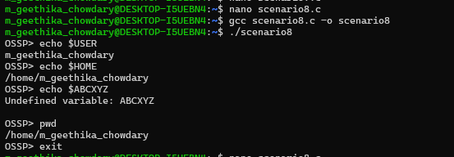

- To Change Directories, Validate Paths, Update Working Directory, Handle Errors, Maintain Previous Directory, Test Navigation.

To Identify Built-ins, Create Dispatch Table, Execute In-Process Commands, Handle Invalid Commands, Maintain State, Test Dispatch Logic.

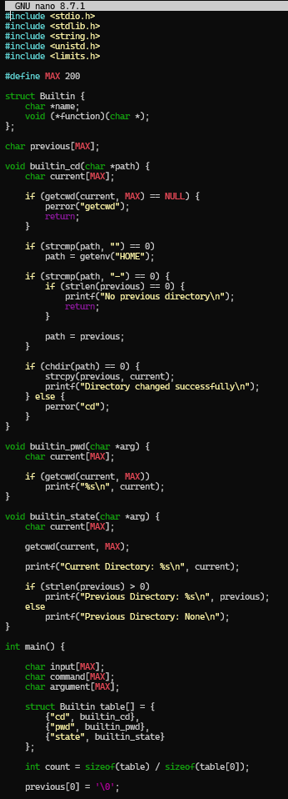
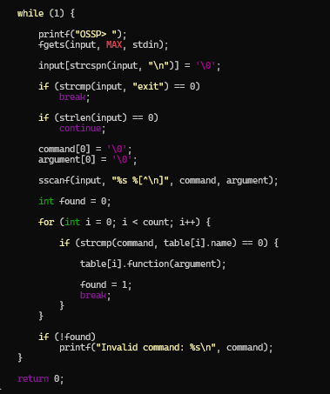
OUTPUT:
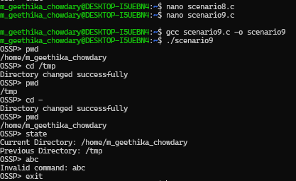

- To Store Commands, Maintain History Buffer, Handle Capacity Limits, Retrieve Entries, Display History, Validate Consistency.

To Create Pipeline Structures, Store Commands, Maintain Execution Order, Connect Processes, Validate Pipeline Layout, Test Configurations.

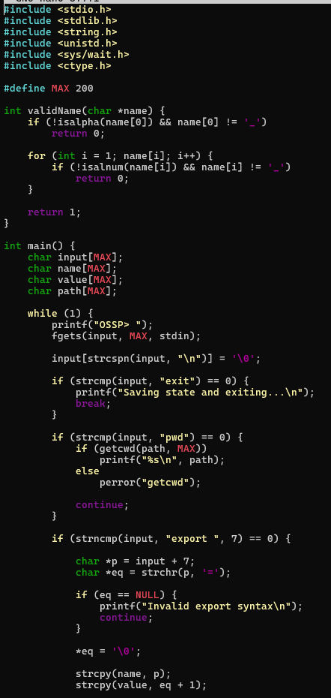

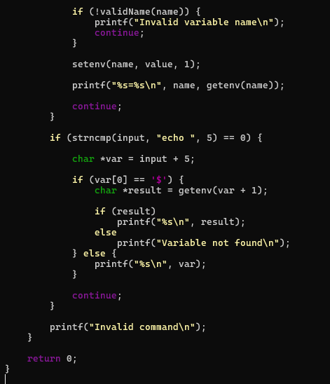
OUTPUT:
