- To Split Input into Tokens, Identify Delimiters, Handle Whitespace, Create Token Structures, Validate Token Streams, Debug Parsing Output.
To Design Parser Logic, Generate Parse Trees, Validate Syntax, Detect Errors, Handle Empty Commands, Produce Execution Structures.
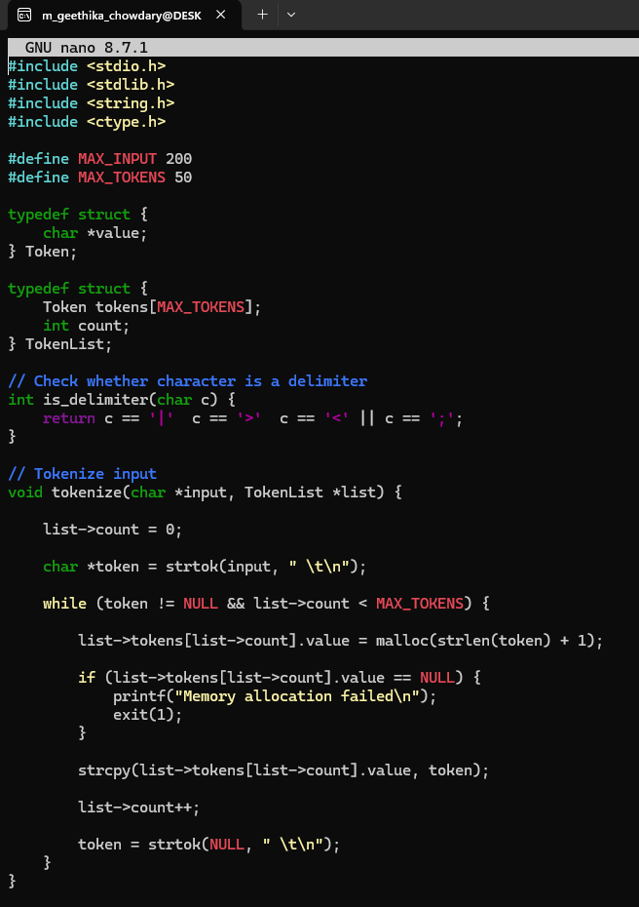
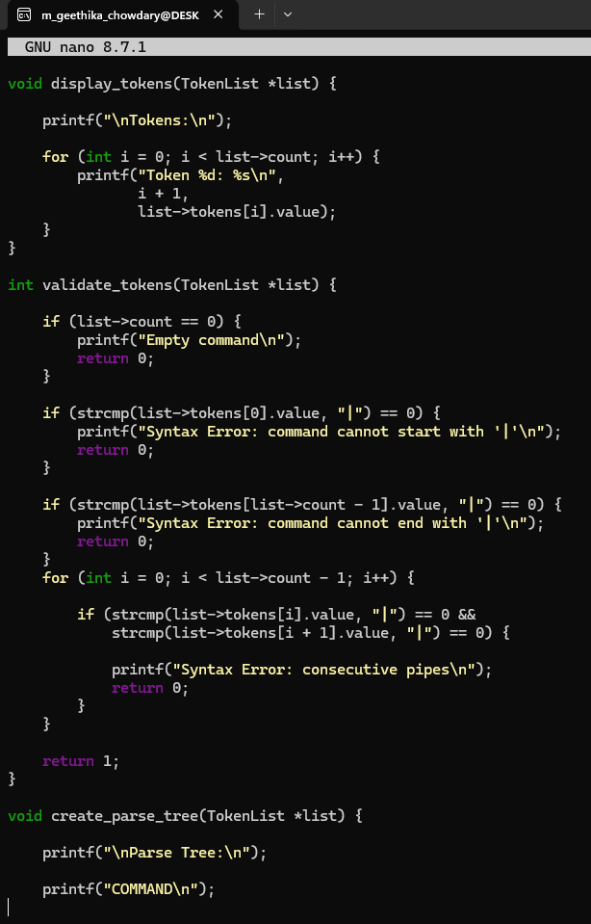
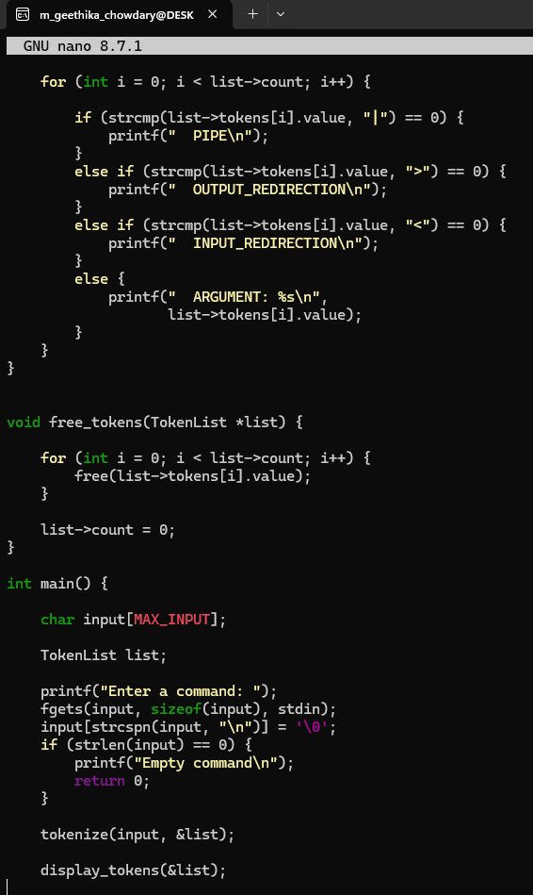
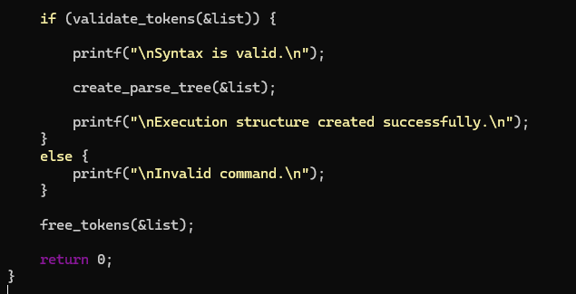
OUTPUT:
