5.Parent and Child
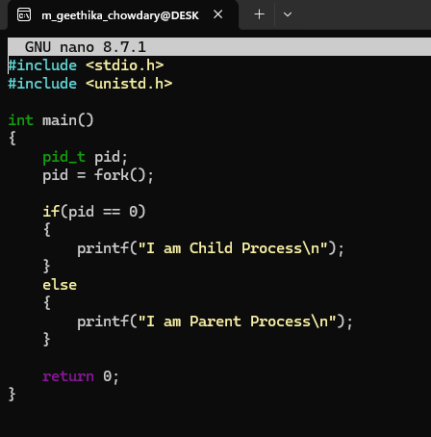
OUTPUT:
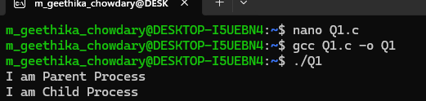

6.
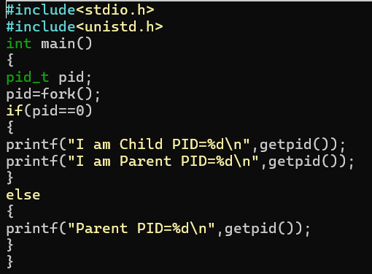

OUTPUT:
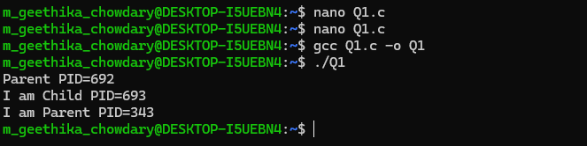

7. WAIT
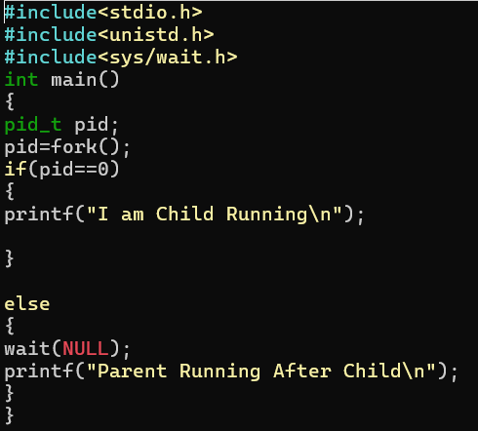S
OUTPUT:
