**1.10 HEAP SORT**

**AIM**:

To develop a efficient sorting solution.

**ALGORITHM:**

1. Build a Max Heap from the input array.

2. Swap the root (largest value) with the last element.

3. Reduce the heap size and heapify the root.

4. Repeat until the heap is reduced to 1.

**PROGRAM:**

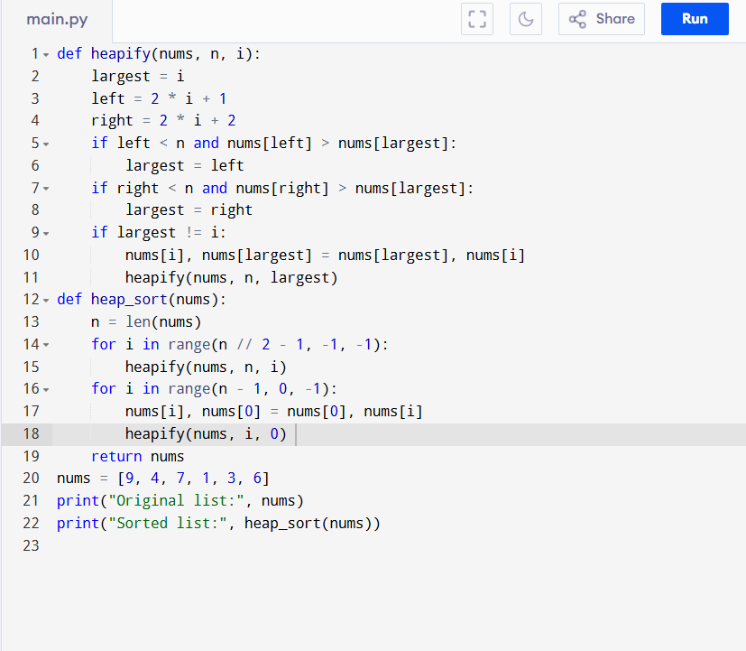

Input:

nums = [9, 4, 7, 1, 3, 6]

Output:

**RESULT:**

Thus the program is successfully executed, and the output is verified.

**PERFORMANCE ANALYSIS:**

Time complexity:

* Best Case Time O(n log n)
* Average Case Time O(n log n)
* Worst Case Time O(n log n)

Space Complexity:

* O(1) (in-place sorting)