**1.17 CHAMPAGNE TOWER – GLASS FILL SIMULATION**

**AIM**:

Given a number of champagne cups poured into the top glass of a pyramid (100 rows), determine how full the glass at position (query_row, query_glass) is after pouring.

**ALGORITHM:**

1. Create a 2D array tower with size [query_row + 2][query_row + 2] (to avoid overflow indexing).

2. Pour poured cups into tower[0][0].

3. For each row r from 0 to query_row:

• For each glass c in row r:

• If tower[r][c] > 1, compute excess = tower[r][c] - 1.

• Distribute excess / 2 to tower[r+1][c] and tower[r+1][c+1].

• Clamp current tower[r][c] to 1.

4. Return the minimum of 1 and tower[query_row][query_glass].

**PROGRAM:**

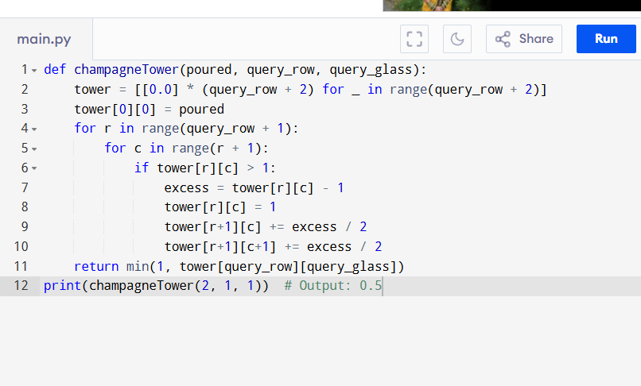

Input:

poured = 2, query_row = 1, query_glass = 1

Output:

**RESULT:**

Thus the program is successfully executed, and the output is verified.

**PERFORMANCE ANALYSIS:**

• Time Complexity: O(n²)

• Space Complexity: O(n²)