**1.5 MAXIMUM ELEMENT IN ARRAY**

**AIM**:

To find the maximum element from a given integer array efficiently.

**ALGORITHM:**

1. Initialize max_val = nums[0].

2. Traverse the array from index 1 to n-1.

3. For each element, compare with max_val:

• If current element > max_val, update max_val.

4. Return max_val as the result.

**PROGRAM:**

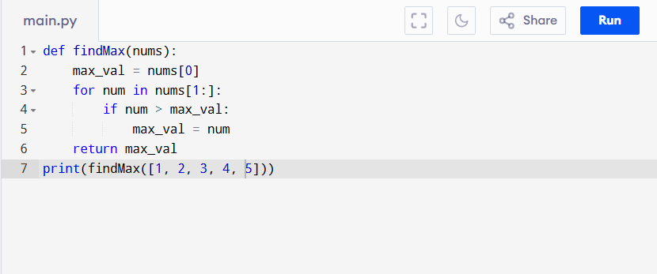

Input:

{1, 2, 3, 4, 5}

Output:

**RESULT:**

Thus the program is successfully executed, and the output is verified.

**PERFORMANCE ANALYSIS:**

• Time Complexity: O(n) (must check each element once).

• Space Complexity: O(1) (only one variable used for max)