**2.1 SORTING A LIST WITH NEGATIVE NUMBERS**

**AIM**

To write a program that sorts a list containing negative numbers in ascending order.

**ALGORITHM**

1. Start the program.

2. Define a function sort_list(arr) that uses Python’s built-in sorted().

3. Pass the list [-5, -1, -3, -2, -4] to the function.

4. The function returns the sorted list.

5. Print the result.

6. End the program.

**PROGRAM**

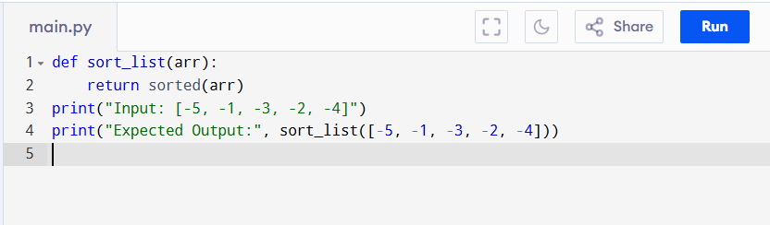

Input:

[-5, -1, -3, -2, -4]

Output:

**RESULT:**

Thus the program is successfully executed and the output is verified.

**PERFORMANCE ANALYSIS:**

Time Complexity:

* Best Case: O(n) (if already sorted).
* Average & Worst Case: O(n log n).

Space Complexity:

* O(n), due to Timsort’s auxiliary storage.