**2.10 Finding Closest Pair of Points in 2D**

**AIM**

To determine the closest pair of points and the minimum Euclidean distance between them using a brute force approach.

**ALGORITHM**

1. **Start**
2. Define a function to calculate the Euclidean distance.
3. Read the list of points.
4. Initialize min_distance = ∞ and closest_pair = None.
5. Compare each pair of points:
6. If the distance between them is smaller than min_distance:
7. Update min_distance and closest_pair.
8. Return closest_pair and min_distance
9. **End**

**PROGRAM**

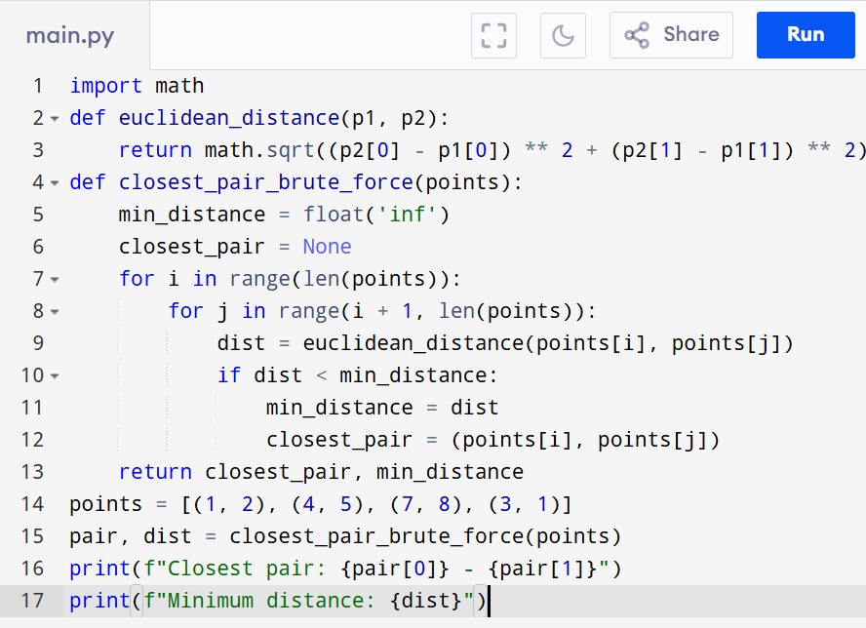

Input:

[(1, 2), (4, 5), (7, 8), (3, 1)]

Output:

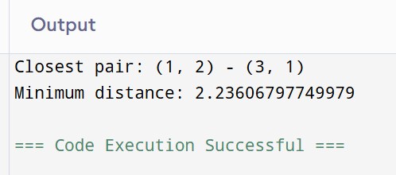

**RESULT:**

Thus the program is successfully executed and the output is verified.

**PERFORMANCE ANALYSIS:**

· **Time Complexity:** O(n²)

· **Space Complexity:** O(1)