**2.9 Finding Closest Pair of Points in 2D**

**AIM**

To find the closest pair of points and their minimum Euclidean distance from a given set of 2D points using the brute force method.

**ALGORITHM**

1. **Start and** Read the list of 2D points.
2. Initialize min_distance as infinity and closest_pair as None.
3. For each point p1 in the list
4. For each other point p2 after p1:
5. Calculate the Euclidean distance between p1 and p2.​
6. If this distance is less than min_distance:- Update min_distance with the new distance.
7. Update closest_pair with (p1, p2).
8. Return closest_pair and min_distance.

**PROGRAM**

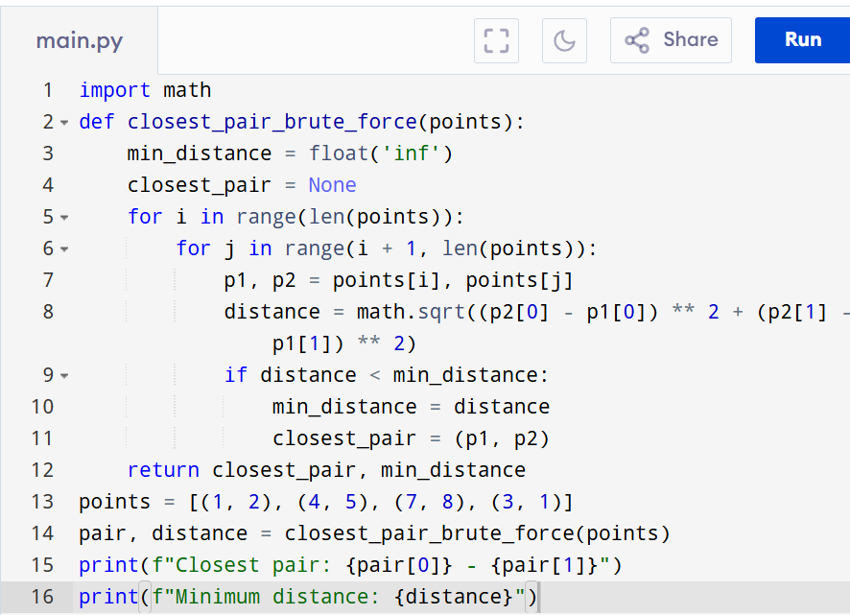

Input:

Points = [(1, 2), (4, 5), (7, 8), (3, 1)]

Output:

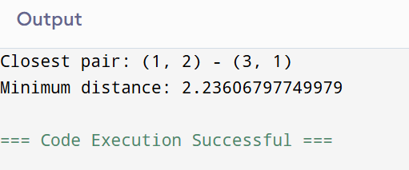

**RESULT:**

Thus the program is successfully executed and the output is verified.

**PERFORMANCE ANALYSIS:**

· **Time Complexity:** O(n²)

· **Space Complexity:** O(1)